**1.**

SELECT count(*) FROM Customers

where Country='Germany';

11

**2.**

SELECT count(*) FROM Customers

where CustomerName like '%e';

14

**3.**

Insert into Customers(CustomerName, ContactName, Address, City, PostalCode, Country)

values ('NSUEM', 'Ekaterina Rybenko', 'Kamenskaya 56', 'Novosibirsk', 11111, 'Russia');

Rows affected: 1

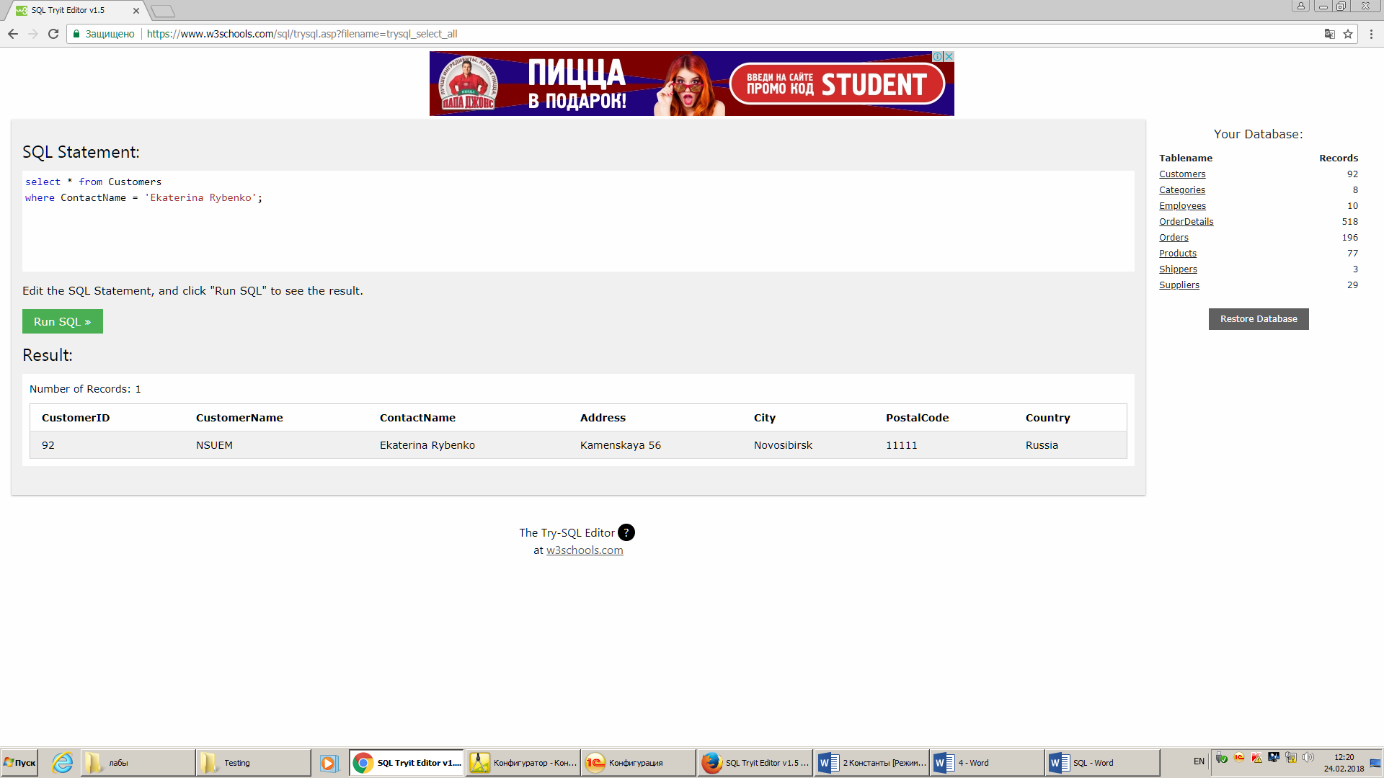

**4.**

Update Customers

SET ContactName = 'Katya Rybenko'

where ContactName = 'Ekaterina Rybenko'

Rows affected: 1

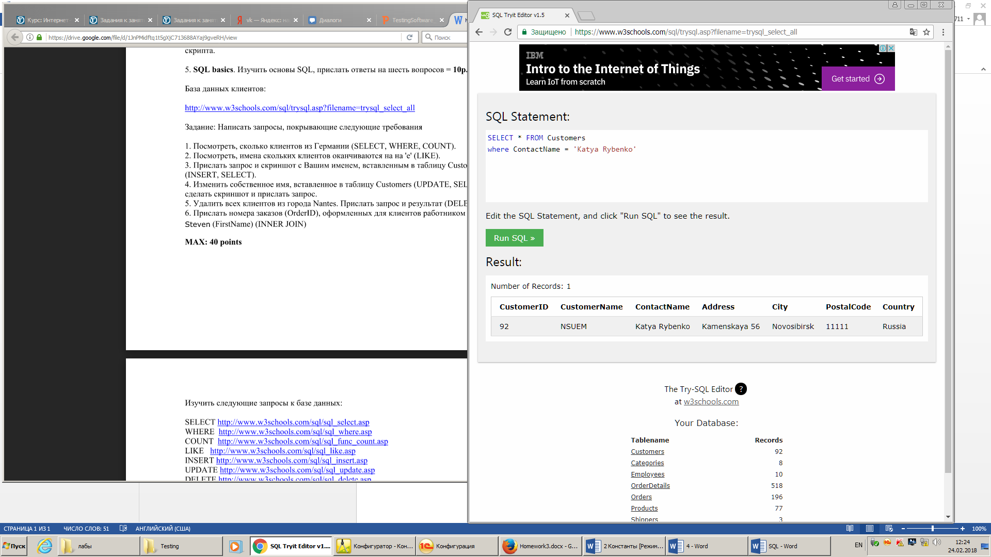

**5.**

DELETE from Customers

where City = 'Nantes';

Rows affected: 2

select * from Customers

where City = 'Nantes';

No result.

**6.**

Select O.OrderID from

(Orders as O inner join Customers as C on O.CustomerID = C.CustomerID) inner join Employees as E on O.EmployeeID = E.EmployeeID

Where E.FirstName ='Steven'

|  |
| --- |
| 10359 |
| 10358 |
| 10269 |
| 10397 |
| 10248 |
| 10297 |
| 10372 |
| 10254 |
| 10333 |
| 10378 |
| 10320 |

