Министерство образования Российской Федерации

Пензенский государственный университет

Кафедра «Вычислительная техника»

**ОТЧЕТ**

по практической работе №1

по курсу «Разработка кроссплатформенных приложений»

## на тему «Графические интерфейсы»

**Выполнила:**

студентка группы 20ВВВ1

Зацепилина Е.С.

**Приняли:**

Карамышева Н.С.

Юрова О.В.

Пенза 2023 г.

**Цель работы:** научиться разрабатывать приложения, обладающие графическим интерфейсом пользователя, с использованием библиотеки Swing.

Задание:

Вычислить определенный интеграл функции (tg(x)). Создать графический интерфейс, добавить кнопки «Вычислить», «Добавить», «Удалить», таблицу в которую заносятся значения.

Листинг:

/*

* Click nbfs://nbhost/SystemFileSystem/Templates/Licenses/license-default.txt to change this license

* Click nbfs://nbhost/SystemFileSystem/Templates/GUIForms/JFrame.java to edit this template

*/

package my.numberaddition;

import javax.swing.table.DefaultTableModel;

/**

*

* @author zakat

*/

public class ContactEditorUI extends javax.swing.JFrame {

/**

* Creates new form ContactEditorUI

*/

public ContactEditorUI() {

initComponents();

}

/**

* This method is called from within the constructor to initialize the form.

* WARNING: Do NOT modify this code. The content of this method is always

* regenerated by the Form Editor.

*/

@SuppressWarnings("unchecked")

// <editor-fold defaultstate="collapsed" desc="Generated Code">

private void initComponents() {

jPanel1 = new javax.swing.JPanel();

jButton1 = new javax.swing.JButton();

jButton2 = new javax.swing.JButton();

jButton3 = new javax.swing.JButton();

jTextField1 = new javax.swing.JTextField();

jLabel1 = new javax.swing.JLabel();

jLabel2 = new javax.swing.JLabel();

jTextField2 = new javax.swing.JTextField();

jLabel3 = new javax.swing.JLabel();

jTextField3 = new javax.swing.JTextField();

jScrollPane1 = new javax.swing.JScrollPane();

jTable1 = new javax.swing.JTable();

jLabel4 = new javax.swing.JLabel();

setDefaultCloseOperation(javax.swing.WindowConstants.EXIT_ON_CLOSE);

jButton1.setText("Добавить");

jButton1.addActionListener(new java.awt.event.ActionListener() {

public void actionPerformed(java.awt.event.ActionEvent evt) {

jButton1ActionPerformed(evt);

}

});

jButton2.setText("Удалить");

jButton2.addActionListener(new java.awt.event.ActionListener() {

public void actionPerformed(java.awt.event.ActionEvent evt) {

jButton2ActionPerformed(evt);

}

});

jButton3.setText("Вычислить");

jButton3.addActionListener(new java.awt.event.ActionListener() {

public void actionPerformed(java.awt.event.ActionEvent evt) {

jButton3ActionPerformed(evt);

}

});

jTextField1.addActionListener(new java.awt.event.ActionListener() {

public void actionPerformed(java.awt.event.ActionEvent evt) {

jTextField1ActionPerformed(evt);

}

});

jLabel1.setText("Нижняя граница");

jLabel2.setText("Верхняя граница");

jTextField2.addActionListener(new java.awt.event.ActionListener() {

public void actionPerformed(java.awt.event.ActionEvent evt) {

jTextField2ActionPerformed(evt);

}

});

jLabel3.setText("Шаг");

jTextField3.addActionListener(new java.awt.event.ActionListener() {

public void actionPerformed(java.awt.event.ActionEvent evt) {

jTextField3ActionPerformed(evt);

}

});

jTable1.setModel(new javax.swing.table.DefaultTableModel(

new Object [][] {

},

new String [] {

"Нижняя граница", "Верхняя граница", "Шаг", "Результат"

}

));

jScrollPane1.setViewportView(jTable1);

jLabel4.setFont(new java.awt.Font("Segoe UI", 0, 18)); // NOI18N

jLabel4.setText("Свойства интегрирования");

javax.swing.GroupLayout jPanel1Layout = new javax.swing.GroupLayout(jPanel1);

jPanel1.setLayout(jPanel1Layout);

jPanel1Layout.setHorizontalGroup(

jPanel1Layout.createParallelGroup(javax.swing.GroupLayout.Alignment.LEADING)

.addGroup(jPanel1Layout.createSequentialGroup()

.addGroup(jPanel1Layout.createParallelGroup(javax.swing.GroupLayout.Alignment.TRAILING)

.addGroup(javax.swing.GroupLayout.Alignment.LEADING, jPanel1Layout.createSequentialGroup()

.addContainerGap(javax.swing.GroupLayout.DEFAULT_SIZE, Short.MAX_VALUE)

.addComponent(jLabel4, javax.swing.GroupLayout.PREFERRED_SIZE, 425, javax.swing.GroupLayout.PREFERRED_SIZE))

.addGroup(javax.swing.GroupLayout.Alignment.LEADING, jPanel1Layout.createSequentialGroup()

.addGap(24, 24, 24)

.addGroup(jPanel1Layout.createParallelGroup(javax.swing.GroupLayout.Alignment.LEADING)

.addComponent(jLabel1, javax.swing.GroupLayout.DEFAULT_SIZE, javax.swing.GroupLayout.DEFAULT_SIZE, Short.MAX_VALUE)

.addComponent(jLabel2, javax.swing.GroupLayout.DEFAULT_SIZE, javax.swing.GroupLayout.DEFAULT_SIZE, Short.MAX_VALUE)

.addGroup(jPanel1Layout.createSequentialGroup()

.addComponent(jLabel3, javax.swing.GroupLayout.PREFERRED_SIZE, 108, javax.swing.GroupLayout.PREFERRED_SIZE)

.addGap(0, 84, Short.MAX_VALUE)))

.addPreferredGap(javax.swing.LayoutStyle.ComponentPlacement.RELATED)

.addGroup(jPanel1Layout.createParallelGroup(javax.swing.GroupLayout.Alignment.LEADING)

.addComponent(jTextField2, javax.swing.GroupLayout.PREFERRED_SIZE, 259, javax.swing.GroupLayout.PREFERRED_SIZE)

.addComponent(jTextField1, javax.swing.GroupLayout.PREFERRED_SIZE, 259, javax.swing.GroupLayout.PREFERRED_SIZE)

.addComponent(jTextField3, javax.swing.GroupLayout.PREFERRED_SIZE, 259, javax.swing.GroupLayout.PREFERRED_SIZE))

.addGap(67, 67, 67)))

.addGap(31, 31, 31)

.addGroup(jPanel1Layout.createParallelGroup(javax.swing.GroupLayout.Alignment.LEADING)

.addComponent(jButton3, javax.swing.GroupLayout.PREFERRED_SIZE, 94, javax.swing.GroupLayout.PREFERRED_SIZE)

.addComponent(jButton1, javax.swing.GroupLayout.PREFERRED_SIZE, 94, javax.swing.GroupLayout.PREFERRED_SIZE)

.addComponent(jButton2, javax.swing.GroupLayout.PREFERRED_SIZE, 94, javax.swing.GroupLayout.PREFERRED_SIZE))

.addContainerGap(49, Short.MAX_VALUE))

.addGroup(jPanel1Layout.createSequentialGroup()

.addGap(14, 14, 14)

.addComponent(jScrollPane1, javax.swing.GroupLayout.PREFERRED_SIZE, 604, javax.swing.GroupLayout.PREFERRED_SIZE)

.addContainerGap(javax.swing.GroupLayout.DEFAULT_SIZE, Short.MAX_VALUE))

);

jPanel1Layout.setVerticalGroup(

jPanel1Layout.createParallelGroup(javax.swing.GroupLayout.Alignment.LEADING)

.addGroup(jPanel1Layout.createSequentialGroup()

.addContainerGap()

.addComponent(jLabel4, javax.swing.GroupLayout.PREFERRED_SIZE, 54, javax.swing.GroupLayout.PREFERRED_SIZE)

.addGap(18, 18, 18)

.addGroup(jPanel1Layout.createParallelGroup(javax.swing.GroupLayout.Alignment.BASELINE)

.addComponent(jTextField1, javax.swing.GroupLayout.PREFERRED_SIZE, 36, javax.swing.GroupLayout.PREFERRED_SIZE)

.addComponent(jLabel1, javax.swing.GroupLayout.PREFERRED_SIZE, 26, javax.swing.GroupLayout.PREFERRED_SIZE)

.addComponent(jButton1, javax.swing.GroupLayout.PREFERRED_SIZE, 59, javax.swing.GroupLayout.PREFERRED_SIZE))

.addGroup(jPanel1Layout.createParallelGroup(javax.swing.GroupLayout.Alignment.LEADING)

.addGroup(jPanel1Layout.createSequentialGroup()

.addPreferredGap(javax.swing.LayoutStyle.ComponentPlacement.RELATED)

.addGroup(jPanel1Layout.createParallelGroup(javax.swing.GroupLayout.Alignment.BASELINE)

.addComponent(jLabel2, javax.swing.GroupLayout.PREFERRED_SIZE, 31, javax.swing.GroupLayout.PREFERRED_SIZE)

.addComponent(jTextField2, javax.swing.GroupLayout.PREFERRED_SIZE, 35, javax.swing.GroupLayout.PREFERRED_SIZE))

.addGap(18, 18, 18)

.addGroup(jPanel1Layout.createParallelGroup(javax.swing.GroupLayout.Alignment.BASELINE)

.addComponent(jTextField3, javax.swing.GroupLayout.PREFERRED_SIZE, 37, javax.swing.GroupLayout.PREFERRED_SIZE)

.addComponent(jLabel3, javax.swing.GroupLayout.PREFERRED_SIZE, 37, javax.swing.GroupLayout.PREFERRED_SIZE)))

.addGroup(jPanel1Layout.createSequentialGroup()

.addGap(20, 20, 20)

.addComponent(jButton2, javax.swing.GroupLayout.PREFERRED_SIZE, 54, javax.swing.GroupLayout.PREFERRED_SIZE)))

.addGap(8, 8, 8)

.addComponent(jButton3, javax.swing.GroupLayout.PREFERRED_SIZE, 58, javax.swing.GroupLayout.PREFERRED_SIZE)

.addGap(30, 30, 30)

.addComponent(jScrollPane1, javax.swing.GroupLayout.PREFERRED_SIZE, 163, javax.swing.GroupLayout.PREFERRED_SIZE)

.addContainerGap(209, Short.MAX_VALUE))

);

javax.swing.GroupLayout layout = new javax.swing.GroupLayout(getContentPane());

getContentPane().setLayout(layout);

layout.setHorizontalGroup(

layout.createParallelGroup(javax.swing.GroupLayout.Alignment.LEADING)

.addGroup(layout.createSequentialGroup()

.addContainerGap()

.addComponent(jPanel1, javax.swing.GroupLayout.DEFAULT_SIZE, javax.swing.GroupLayout.DEFAULT_SIZE, Short.MAX_VALUE)

.addContainerGap())

);

layout.setVerticalGroup(

layout.createParallelGroup(javax.swing.GroupLayout.Alignment.LEADING)

.addComponent(jPanel1, javax.swing.GroupLayout.DEFAULT_SIZE, javax.swing.GroupLayout.DEFAULT_SIZE, Short.MAX_VALUE)

);

pack();

}// </editor-fold>

private void jButton1ActionPerformed(java.awt.event.ActionEvent evt) {

DefaultTableModel model = (DefaultTableModel)jTable1.getModel();

model.addRow(new Object[]{jTextField1.getText(),jTextField2.getText(), jTextField3.getText()});

// TODO add your handling code here:

}

private void jTextField1ActionPerformed(java.awt.event.ActionEvent evt) {

// TODO add your handling code here:

}

private void jTextField3ActionPerformed(java.awt.event.ActionEvent evt) {

// TODO add your handling code here:

}

private void jButton3ActionPerformed(java.awt.event.ActionEvent evt) {

DefaultTableModel model = (DefaultTableModel)jTable1.getModel();

int row = jTable1.getSelectedRow();

model.setValueAt(

integral(

(model.getValueAt(row, 0)),

(model.getValueAt(row, 1)),

(model.getValueAt(row, 2))

),

jTable1.getSelectedRow(), 3);

//model.removeRow(table_integral.getSelectedRow());

}

public double f(double x) {

double F=Math.tan(x);

return F;

}

public double integral(Object a1, Object b1, Object h1){

int a =Integer.parseInt(a1.toString());

int b =Integer.parseInt(b1.toString());

double h = Double.parseDouble(h1.toString());

double res=0;

int n = (int)((b-a)/h);

res += f(a)+f(b);

for(int i = 1; i < n; i++){

res += 2*f(a + h*i );

}

return h*res/2;

// TODO add your handling code here:

}

private void jTextField2ActionPerformed(java.awt.event.ActionEvent evt) {

// TODO add your handling code here:

}

private void jButton2ActionPerformed(java.awt.event.ActionEvent evt) {

DefaultTableModel model = (DefaultTableModel)jTable1.getModel();

model.removeRow(jTable1.getSelectedRow());

// TODO add your handling code here:

}

/**

* @param args the command line arguments

*/

public static void main(String args[]) {

/* Set the Nimbus look and feel */

//<editor-fold defaultstate="collapsed" desc=" Look and feel setting code (optional) ">

/* If Nimbus (introduced in Java SE 6) is not available, stay with the default look and feel.

* For details see http://download.oracle.com/javase/tutorial/uiswing/lookandfeel/plaf.html

*/

try {

for (javax.swing.UIManager.LookAndFeelInfo info : javax.swing.UIManager.getInstalledLookAndFeels()) {

if ("Nimbus".equals(info.getName())) {

javax.swing.UIManager.setLookAndFeel(info.getClassName());

break;

}

}

} catch (ClassNotFoundException ex) {

java.util.logging.Logger.getLogger(ContactEditorUI.class.getName()).log(java.util.logging.Level.SEVERE, null, ex);

} catch (InstantiationException ex) {

java.util.logging.Logger.getLogger(ContactEditorUI.class.getName()).log(java.util.logging.Level.SEVERE, null, ex);

} catch (IllegalAccessException ex) {

java.util.logging.Logger.getLogger(ContactEditorUI.class.getName()).log(java.util.logging.Level.SEVERE, null, ex);

} catch (javax.swing.UnsupportedLookAndFeelException ex) {

java.util.logging.Logger.getLogger(ContactEditorUI.class.getName()).log(java.util.logging.Level.SEVERE, null, ex);

}

//</editor-fold>

/* Create and display the form */

java.awt.EventQueue.invokeLater(new Runnable() {

public void run() {

new ContactEditorUI().setVisible(true);

}

});

}

// Variables declaration - do not modify

private javax.swing.JButton jButton1;

private javax.swing.JButton jButton2;

private javax.swing.JButton jButton3;

private javax.swing.JLabel jLabel1;

private javax.swing.JLabel jLabel2;

private javax.swing.JLabel jLabel3;

private javax.swing.JLabel jLabel4;

private javax.swing.JPanel jPanel1;

private javax.swing.JScrollPane jScrollPane1;

private javax.swing.JTable jTable1;

private javax.swing.JTextField jTextField1;

private javax.swing.JTextField jTextField2;

private javax.swing.JTextField jTextField3;

// End of variables declaration

}

Результат работы:

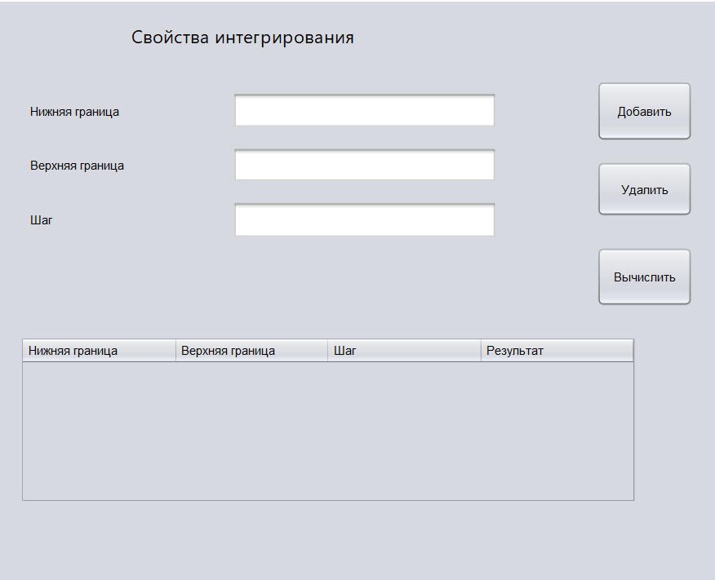

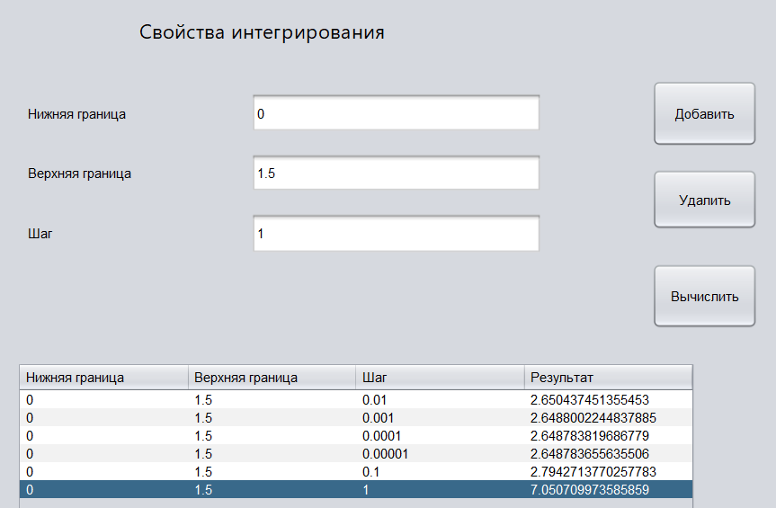

Проверка:

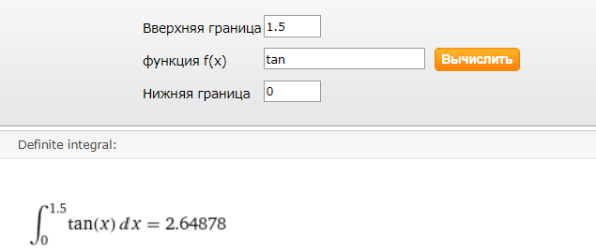

Результат интегрирования зависит от шага.

Программа работает верно с небольшой погрешностью.

Вывод: были получены навыки разработки приложения, обладающего графическим интерфейсом пользователя, с использованием библиотеки Swing.