Министерство образования Российской Федерации

Пензенский государственный университет

Кафедра «Вычислительная техника»

**ОТЧЕТ**

по практической работе №3

по курсу «Разработка кроссплатформенных приложений»

## на тему «Обработка исключительных ситуаций»

**Выполнила:**

студентка группы 20ВВВ1

Зацепилина Е.С.

**Приняли:**

Карамышева Н.С.

Юрова О.В.

Пенза 2023 г.

**Цель работы:** изучить механизм обработки исключительных ситуаций.

Задание:

Модифицировать приложение из предыдущей лабораторной работы, реализовав проверку вводимых данных с использованием механизма исключений. Необходимо создать свой класс, унаследованный от класса Exception, и генерировать исключение, если возникает попытка создать экземпляр класса RecIntegral со значениями, не являющимися числами в диапазоне от 0,000001 до 1000000.

Листинг:

**class RecIntegral**

/*

* Click nbfs://nbhost/SystemFileSystem/Templates/Licenses/license-default.txt to change this license

* Click nbfs://nbhost/SystemFileSystem/Templates/Classes/Class.java to edit this template

*/

package my.numberaddition;

import javax.swing.JOptionPane;

/**

*

* @author zakat

*/

public class RecIntegral {

public double down;

public double up;

public double step;

public double res;

public double getDown() {

return down;

}

public void setDown(double down) throws MyException {

if(!prov(down)){

throw new MyException("Нижняя граница выходит из диапазона");

}

this.down = down;

}

public double getUp() {

return up;

}

public void setUp(double up) throws MyException {

if(!prov(up)){

throw new MyException("Верхняя граница выходит из диапазона");

}

if(this.getDown()>=up){

throw new MyException("верхняя граница меньше чем нижняя");

}

this.up = up;

}

public double getStep() {

return step;

}

public void setStep(double step) throws MyException {

if(!prov(step)){

throw new MyException("Шаг выходит из диапазона");

}

if(step>(this.getUp()-this.getDown())){

throw new MyException("Шаг перевашает");

}

this.step = step;

}

public double getRes() {

return res;

}

public void setRes(double res) throws MyException {

if(!prov(res)){

throw new MyException("Res is incorrect");

}

this.res = res;

}

public boolean prov(double a){

return a>0.000001 && a<1000000;

}

public RecIntegral(Object down,Object up,Object step,Object res) throws MyException{

try {

this.setDown(Double.parseDouble(down.toString()));

this.setUp(Double.parseDouble(up.toString()));

this.setStep(Double.parseDouble(step.toString()));

this.setRes(Double.parseDouble(res.toString()));

} catch (NumberFormatException e) {

throw new MyException("ошибка встречен символ или ,", e);

}catch (MyException ex) {

JOptionPane.showMessageDialog(null, ex.getMessage(),"err",JOptionPane.ERROR_MESSAGE);

}

}

public RecIntegral(Object down,Object up,Object step) throws MyException{

try {

this.setDown(Double.parseDouble(down.toString()));

this.setUp(Double.parseDouble(up.toString()));

this.setStep(Double.parseDouble(step.toString()));

} catch (NumberFormatException e) {

throw new MyException("ошибка встречен символ или ,", e);

}catch (MyException ex) {

JOptionPane.showMessageDialog(null, ex.getMessage(),"err",JOptionPane.ERROR_MESSAGE);

}

}

}

**ContactEditorUI**

/*

* Click nbfs://nbhost/SystemFileSystem/Templates/Licenses/license-default.txt to change this license

* Click nbfs://nbhost/SystemFileSystem/Templates/GUIForms/JFrame.java to edit this template

*/

package my.numberaddition;

import java.util.LinkedList;

import java.util.List;

import javax.swing.table.DefaultTableModel;

import java.util.Iterator;

import javax.swing.JOptionPane;

/**

*

* @author zakat

*/

public class ContactEditorUI extends javax.swing.JFrame {

List<RecIntegral> list = new LinkedList<>();

/**

* Creates new form ContactEditorUI

*/

public ContactEditorUI() {

initComponents();

}

/**

* This method is called from within the constructor to initialize the form.

* WARNING: Do NOT modify this code. The content of this method is always

* regenerated by the Form Editor.

*/

@SuppressWarnings("unchecked")

// <editor-fold defaultstate="collapsed" desc="Generated Code">

private void initComponents() {

jScrollPane2 = new javax.swing.JScrollPane();

Err = new javax.swing.JOptionPane();

jPanel1 = new javax.swing.JPanel();

jButton1 = new javax.swing.JButton();

jButton2 = new javax.swing.JButton();

jButton3 = new javax.swing.JButton();

jTextField1 = new javax.swing.JTextField();

jLabel1 = new javax.swing.JLabel();

jLabel2 = new javax.swing.JLabel();

jTextField2 = new javax.swing.JTextField();

jLabel3 = new javax.swing.JLabel();

jTextField3 = new javax.swing.JTextField();

jScrollPane1 = new javax.swing.JScrollPane();

jTable1 = new javax.swing.JTable();

jLabel4 = new javax.swing.JLabel();

jButton4 = new javax.swing.JButton();

jButton6 = new javax.swing.JButton();

jButton5 = new javax.swing.JButton();

jScrollPane2.setViewportView(Err);

setDefaultCloseOperation(javax.swing.WindowConstants.EXIT_ON_CLOSE);

jButton1.setText("Добавить");

jButton1.addActionListener(new java.awt.event.ActionListener() {

public void actionPerformed(java.awt.event.ActionEvent evt) {

jButton1ActionPerformed(evt);

}

});

jButton2.setText("Удалить");

jButton2.addActionListener(new java.awt.event.ActionListener() {

public void actionPerformed(java.awt.event.ActionEvent evt) {

jButton2ActionPerformed(evt);

}

});

jButton3.setText("Вычислить");

jButton3.addActionListener(new java.awt.event.ActionListener() {

public void actionPerformed(java.awt.event.ActionEvent evt) {

jButton3ActionPerformed(evt);

}

});

jTextField1.addActionListener(new java.awt.event.ActionListener() {

public void actionPerformed(java.awt.event.ActionEvent evt) {

jTextField1ActionPerformed(evt);

}

});

jLabel1.setText("Нижняя граница");

jLabel2.setText("Верхняя граница");

jTextField2.addActionListener(new java.awt.event.ActionListener() {

public void actionPerformed(java.awt.event.ActionEvent evt) {

jTextField2ActionPerformed(evt);

}

});

jLabel3.setText("Шаг");

jTextField3.addActionListener(new java.awt.event.ActionListener() {

public void actionPerformed(java.awt.event.ActionEvent evt) {

jTextField3ActionPerformed(evt);

}

});

jTable1.setModel(new javax.swing.table.DefaultTableModel(

new Object [][] {

},

new String [] {

"Нижняя граница", "Верхняя граница", "Шаг", "Результат"

}

));

jScrollPane1.setViewportView(jTable1);

jLabel4.setFont(new java.awt.Font("Segoe UI", 0, 18)); // NOI18N

jLabel4.setText("Свойства интегрирования");

jButton4.setText("Заполнить");

jButton4.addActionListener(new java.awt.event.ActionListener() {

public void actionPerformed(java.awt.event.ActionEvent evt) {

jButton4ActionPerformed(evt);

}

});

jButton6.setText("Очистить ");

jButton6.addActionListener(new java.awt.event.ActionListener() {

public void actionPerformed(java.awt.event.ActionEvent evt) {

jButton6ActionPerformed(evt);

}

});

jButton5.setText("Добавить в лист");

jButton5.addActionListener(new java.awt.event.ActionListener() {

public void actionPerformed(java.awt.event.ActionEvent evt) {

jButton5ActionPerformed(evt);

}

});

javax.swing.GroupLayout jPanel1Layout = new javax.swing.GroupLayout(jPanel1);

jPanel1.setLayout(jPanel1Layout);

jPanel1Layout.setHorizontalGroup(

jPanel1Layout.createParallelGroup(javax.swing.GroupLayout.Alignment.LEADING)

.addGroup(jPanel1Layout.createSequentialGroup()

.addGroup(jPanel1Layout.createParallelGroup(javax.swing.GroupLayout.Alignment.TRAILING)

.addGroup(javax.swing.GroupLayout.Alignment.LEADING, jPanel1Layout.createSequentialGroup()

.addContainerGap(javax.swing.GroupLayout.DEFAULT_SIZE, Short.MAX_VALUE)

.addComponent(jLabel4, javax.swing.GroupLayout.PREFERRED_SIZE, 425, javax.swing.GroupLayout.PREFERRED_SIZE))

.addGroup(javax.swing.GroupLayout.Alignment.LEADING, jPanel1Layout.createSequentialGroup()

.addGap(24, 24, 24)

.addGroup(jPanel1Layout.createParallelGroup(javax.swing.GroupLayout.Alignment.LEADING)

.addComponent(jLabel1, javax.swing.GroupLayout.DEFAULT_SIZE, javax.swing.GroupLayout.DEFAULT_SIZE, Short.MAX_VALUE)

.addComponent(jLabel2, javax.swing.GroupLayout.DEFAULT_SIZE, javax.swing.GroupLayout.DEFAULT_SIZE, Short.MAX_VALUE)

.addGroup(jPanel1Layout.createSequentialGroup()

.addComponent(jLabel3, javax.swing.GroupLayout.PREFERRED_SIZE, 79, javax.swing.GroupLayout.PREFERRED_SIZE)

.addGap(0, 0, Short.MAX_VALUE)))

.addPreferredGap(javax.swing.LayoutStyle.ComponentPlacement.RELATED)

.addGroup(jPanel1Layout.createParallelGroup(javax.swing.GroupLayout.Alignment.TRAILING)

.addGroup(jPanel1Layout.createSequentialGroup()

.addComponent(jTextField3, javax.swing.GroupLayout.PREFERRED_SIZE, 259, javax.swing.GroupLayout.PREFERRED_SIZE)

.addPreferredGap(javax.swing.LayoutStyle.ComponentPlacement.RELATED, javax.swing.GroupLayout.DEFAULT_SIZE, Short.MAX_VALUE)

.addComponent(jButton3, javax.swing.GroupLayout.PREFERRED_SIZE, 94, javax.swing.GroupLayout.PREFERRED_SIZE))

.addGroup(jPanel1Layout.createSequentialGroup()

.addComponent(jTextField1, javax.swing.GroupLayout.PREFERRED_SIZE, 259, javax.swing.GroupLayout.PREFERRED_SIZE)

.addPreferredGap(javax.swing.LayoutStyle.ComponentPlacement.RELATED, javax.swing.GroupLayout.DEFAULT_SIZE, Short.MAX_VALUE)

.addComponent(jButton1, javax.swing.GroupLayout.PREFERRED_SIZE, 94, javax.swing.GroupLayout.PREFERRED_SIZE))

.addGroup(jPanel1Layout.createSequentialGroup()

.addComponent(jTextField2, javax.swing.GroupLayout.PREFERRED_SIZE, 259, javax.swing.GroupLayout.PREFERRED_SIZE)

.addPreferredGap(javax.swing.LayoutStyle.ComponentPlacement.RELATED, javax.swing.GroupLayout.DEFAULT_SIZE, Short.MAX_VALUE)

.addComponent(jButton2, javax.swing.GroupLayout.PREFERRED_SIZE, 94, javax.swing.GroupLayout.PREFERRED_SIZE)))

.addGap(113, 113, 113)))

.addContainerGap(javax.swing.GroupLayout.DEFAULT_SIZE, Short.MAX_VALUE))

.addGroup(jPanel1Layout.createSequentialGroup()

.addGap(86, 86, 86)

.addGroup(jPanel1Layout.createParallelGroup(javax.swing.GroupLayout.Alignment.LEADING, false)

.addGroup(jPanel1Layout.createSequentialGroup()

.addComponent(jButton4, javax.swing.GroupLayout.PREFERRED_SIZE, 139, javax.swing.GroupLayout.PREFERRED_SIZE)

.addGap(57, 57, 57)

.addComponent(jButton5, javax.swing.GroupLayout.PREFERRED_SIZE, 160, javax.swing.GroupLayout.PREFERRED_SIZE)

.addPreferredGap(javax.swing.LayoutStyle.ComponentPlacement.RELATED, javax.swing.GroupLayout.DEFAULT_SIZE, Short.MAX_VALUE)

.addComponent(jButton6, javax.swing.GroupLayout.PREFERRED_SIZE, 142, javax.swing.GroupLayout.PREFERRED_SIZE))

.addComponent(jScrollPane1, javax.swing.GroupLayout.PREFERRED_SIZE, 604, javax.swing.GroupLayout.PREFERRED_SIZE))

.addContainerGap(451, Short.MAX_VALUE))

);

jPanel1Layout.setVerticalGroup(

jPanel1Layout.createParallelGroup(javax.swing.GroupLayout.Alignment.LEADING)

.addGroup(jPanel1Layout.createSequentialGroup()

.addContainerGap()

.addComponent(jLabel4, javax.swing.GroupLayout.PREFERRED_SIZE, 54, javax.swing.GroupLayout.PREFERRED_SIZE)

.addGap(18, 18, 18)

.addGroup(jPanel1Layout.createParallelGroup(javax.swing.GroupLayout.Alignment.BASELINE)

.addComponent(jTextField1, javax.swing.GroupLayout.PREFERRED_SIZE, 36, javax.swing.GroupLayout.PREFERRED_SIZE)

.addComponent(jLabel1, javax.swing.GroupLayout.PREFERRED_SIZE, 26, javax.swing.GroupLayout.PREFERRED_SIZE)

.addComponent(jButton1, javax.swing.GroupLayout.PREFERRED_SIZE, 59, javax.swing.GroupLayout.PREFERRED_SIZE))

.addPreferredGap(javax.swing.LayoutStyle.ComponentPlacement.RELATED)

.addGroup(jPanel1Layout.createParallelGroup(javax.swing.GroupLayout.Alignment.BASELINE)

.addComponent(jLabel2, javax.swing.GroupLayout.PREFERRED_SIZE, 31, javax.swing.GroupLayout.PREFERRED_SIZE)

.addComponent(jTextField2, javax.swing.GroupLayout.PREFERRED_SIZE, 35, javax.swing.GroupLayout.PREFERRED_SIZE)

.addComponent(jButton2, javax.swing.GroupLayout.PREFERRED_SIZE, 54, javax.swing.GroupLayout.PREFERRED_SIZE))

.addGap(18, 18, 18)

.addGroup(jPanel1Layout.createParallelGroup(javax.swing.GroupLayout.Alignment.BASELINE)

.addComponent(jTextField3, javax.swing.GroupLayout.PREFERRED_SIZE, 37, javax.swing.GroupLayout.PREFERRED_SIZE)

.addComponent(jLabel3, javax.swing.GroupLayout.PREFERRED_SIZE, 38, javax.swing.GroupLayout.PREFERRED_SIZE)

.addComponent(jButton3, javax.swing.GroupLayout.PREFERRED_SIZE, 58, javax.swing.GroupLayout.PREFERRED_SIZE))

.addGap(40, 40, 40)

.addComponent(jScrollPane1, javax.swing.GroupLayout.PREFERRED_SIZE, 163, javax.swing.GroupLayout.PREFERRED_SIZE)

.addGap(18, 18, 18)

.addGroup(jPanel1Layout.createParallelGroup(javax.swing.GroupLayout.Alignment.BASELINE)

.addComponent(jButton4, javax.swing.GroupLayout.PREFERRED_SIZE, 38, javax.swing.GroupLayout.PREFERRED_SIZE)

.addComponent(jButton5, javax.swing.GroupLayout.PREFERRED_SIZE, 38, javax.swing.GroupLayout.PREFERRED_SIZE)

.addComponent(jButton6, javax.swing.GroupLayout.PREFERRED_SIZE, 34, javax.swing.GroupLayout.PREFERRED_SIZE))

.addContainerGap(181, Short.MAX_VALUE))

);

javax.swing.GroupLayout layout = new javax.swing.GroupLayout(getContentPane());

getContentPane().setLayout(layout);

layout.setHorizontalGroup(

layout.createParallelGroup(javax.swing.GroupLayout.Alignment.LEADING)

.addGroup(layout.createSequentialGroup()

.addComponent(jPanel1, javax.swing.GroupLayout.PREFERRED_SIZE, javax.swing.GroupLayout.DEFAULT_SIZE, javax.swing.GroupLayout.PREFERRED_SIZE)

.addGap(0, 12, Short.MAX_VALUE))

);

layout.setVerticalGroup(

layout.createParallelGroup(javax.swing.GroupLayout.Alignment.LEADING)

.addComponent(jPanel1, javax.swing.GroupLayout.DEFAULT_SIZE, javax.swing.GroupLayout.DEFAULT_SIZE, Short.MAX_VALUE)

);

pack();

}// </editor-fold>

private void jButton1ActionPerformed(java.awt.event.ActionEvent evt) {

DefaultTableModel model = (DefaultTableModel)jTable1.getModel(); // добавить

model.addRow(new Object[]{jTextField1.getText(),jTextField2.getText(), jTextField3.getText()});

// TODO add your handling code here:

}

private void jTextField1ActionPerformed(java.awt.event.ActionEvent evt) {

// TODO add your handling code here:

}

private void jTextField3ActionPerformed(java.awt.event.ActionEvent evt) {

// TODO add your handling code here:

}

private void jButton3ActionPerformed(java.awt.event.ActionEvent evt) {

DefaultTableModel model = (DefaultTableModel)jTable1.getModel(); // вычислить

int row = jTable1.getSelectedRow();

model.setValueAt(

integral(

(model.getValueAt(row, 0)),

(model.getValueAt(row, 1)),

(model.getValueAt(row, 2))

),

jTable1.getSelectedRow(), 3);

//model.removeRow(table_integral.getSelectedRow());

// TODO add your handling code here:

}

private void jTextField2ActionPerformed(java.awt.event.ActionEvent evt) {

// TODO add your handling code here:

}

private void jButton2ActionPerformed(java.awt.event.ActionEvent evt) {

DefaultTableModel model = (DefaultTableModel)jTable1.getModel(); // удалить

model.removeRow(jTable1.getSelectedRow());

// TODO add your handling code here:

}

private void jButton4ActionPerformed(java.awt.event.ActionEvent evt) {

DefaultTableModel model = (DefaultTableModel)jTable1.getModel(); // заполнить

Iterator <RecIntegral> iterator = list.iterator();

while(iterator.hasNext()){

RecIntegral rec = iterator.next();

model.addRow(new Object[]{rec.down,rec.up,rec.step,rec.res});

iterator.remove();

}

// TODO add your handling code here:

}

private void jButton6ActionPerformed(java.awt.event.ActionEvent evt) {

DefaultTableModel model = (DefaultTableModel)jTable1.getModel();

model.setRowCount(0);

}

private void jButton5ActionPerformed(java.awt.event.ActionEvent evt) {

DefaultTableModel model = (DefaultTableModel)jTable1.getModel();

for (int i=0;i<model.getRowCount();i++){

if(model.getValueAt(i, 3)== null){

try {

list.add(new RecIntegral(model.getValueAt(i, 0),model.getValueAt(i, 1),model.getValueAt(i, 2)));

} catch (MyException e) {

JOptionPane.showMessageDialog(null, e.getMessage()+" ("+e.getCause()+")","err",JOptionPane.ERROR_MESSAGE);

}

}

else{

try {

list.add(new RecIntegral(model.getValueAt(i, 0),model.getValueAt(i, 1),model.getValueAt(i, 2),model.getValueAt(i, 3)));

} catch (MyException e) {

JOptionPane.showMessageDialog(null, e.getMessage()+" ("+e.getCause()+")","err",JOptionPane.ERROR_MESSAGE);

}

}}

// TODO add your handling code here:

}

public double f(double x) {

double F=Math.tan(x);

return F;

}

public double integral(Object a1, Object b1, Object h1){

double a = Double.parseDouble(a1.toString());

double b = Double.parseDouble(b1.toString());

double h = Double.parseDouble(h1.toString());

double res=0;

int n = (int)((b-a)/h);

res += f(a)+f(b);

for(int i = 1; i < n; i++){

res += 2*f(a + h*i );

}

return h*res/2;

}

/**

* @param args the command line arguments

*/

public static void main(String args[]) {

/* Set the Nimbus look and feel */

//<editor-fold defaultstate="collapsed" desc=" Look and feel setting code (optional) ">

/* If Nimbus (introduced in Java SE 6) is not available, stay with the default look and feel.

* For details see http://download.oracle.com/javase/tutorial/uiswing/lookandfeel/plaf.html

*/

try {

for (javax.swing.UIManager.LookAndFeelInfo info : javax.swing.UIManager.getInstalledLookAndFeels()) {

if ("Nimbus".equals(info.getName())) {

javax.swing.UIManager.setLookAndFeel(info.getClassName());

break;

}

}

} catch (ClassNotFoundException ex) {

java.util.logging.Logger.getLogger(ContactEditorUI.class.getName()).log(java.util.logging.Level.SEVERE, null, ex);

} catch (InstantiationException ex) {

java.util.logging.Logger.getLogger(ContactEditorUI.class.getName()).log(java.util.logging.Level.SEVERE, null, ex);

} catch (IllegalAccessException ex) {

java.util.logging.Logger.getLogger(ContactEditorUI.class.getName()).log(java.util.logging.Level.SEVERE, null, ex);

} catch (javax.swing.UnsupportedLookAndFeelException ex) {

java.util.logging.Logger.getLogger(ContactEditorUI.class.getName()).log(java.util.logging.Level.SEVERE, null, ex);

}

//</editor-fold>

/* Create and display the form */

java.awt.EventQueue.invokeLater(new Runnable() {

public void run() {

new ContactEditorUI().setVisible(true);

}

});

}

// Variables declaration - do not modify

private javax.swing.JOptionPane Err;

private javax.swing.JButton jButton1;

private javax.swing.JButton jButton2;

private javax.swing.JButton jButton3;

private javax.swing.JButton jButton4;

private javax.swing.JButton jButton5;

private javax.swing.JButton jButton6;

private javax.swing.JLabel jLabel1;

private javax.swing.JLabel jLabel2;

private javax.swing.JLabel jLabel3;

private javax.swing.JLabel jLabel4;

private javax.swing.JPanel jPanel1;

private javax.swing.JScrollPane jScrollPane1;

private javax.swing.JScrollPane jScrollPane2;

private javax.swing.JTable jTable1;

private javax.swing.JTextField jTextField1;

private javax.swing.JTextField jTextField2;

private javax.swing.JTextField jTextField3;

// End of variables declaration

}

**class** **MyException**

/*

* Click nbfs://nbhost/SystemFileSystem/Templates/Licenses/license-default.txt to change this license

* Click nbfs://nbhost/SystemFileSystem/Templates/Classes/Class.java to edit this template

*/

package my.numberaddition;

/**

*

* @author zakat

*/

public class MyException extends Exception{

public MyException() {

}

public MyException(String message) {

super(message);

}

public MyException(String message, Throwable cause) {

super(message, cause);

}

public MyException(Throwable cause) {

super(cause);

}

public MyException(String message, Throwable cause, boolean enableSuppression, boolean writableStackTrace) {

super(message, cause, enableSuppression, writableStackTrace);

}

}

Результат работы:

Были добавлены кнопки: Заполнить/Добавить в лист/Очистить

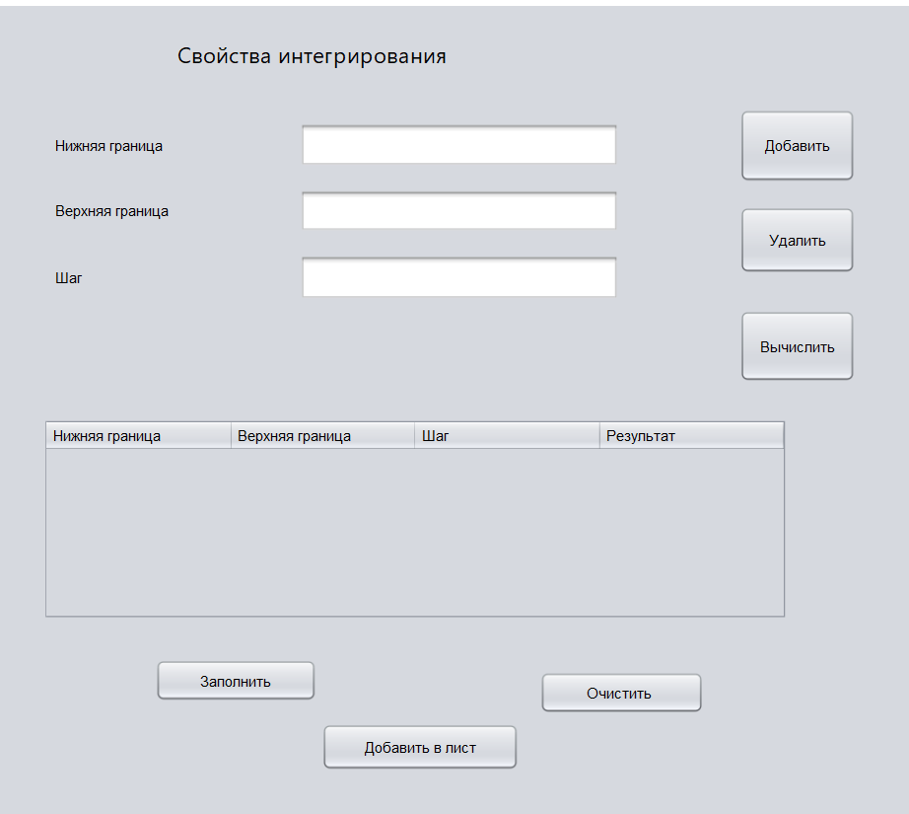

Таблица заполнена

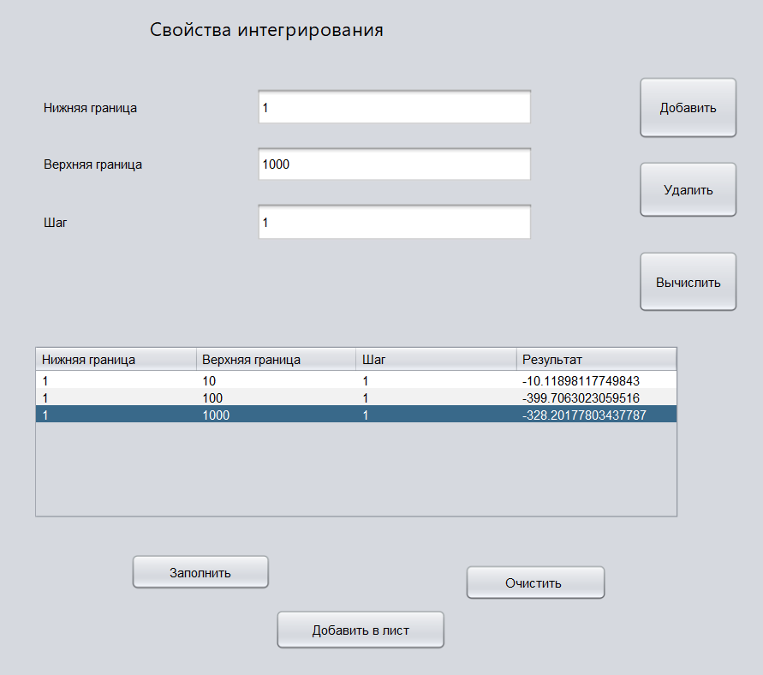

Добавляем данные таблицы в лист. И очищаем ее

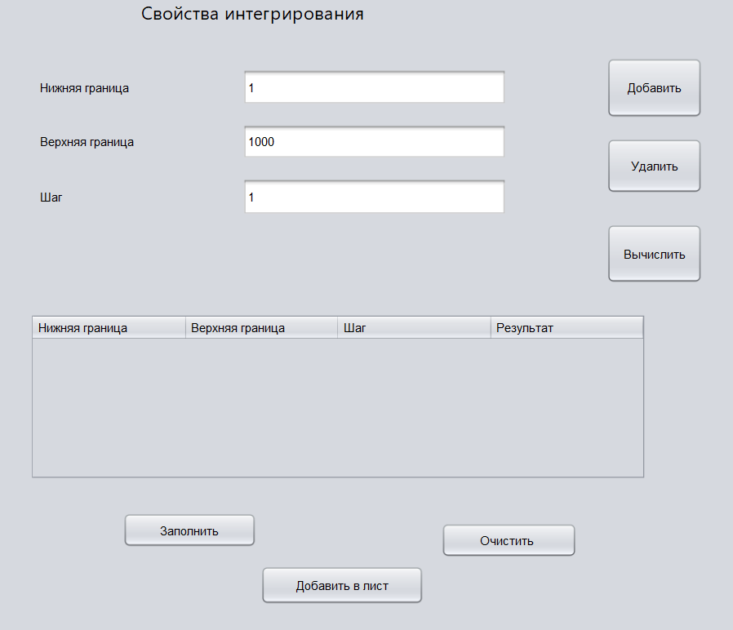

Заполняем таблицу

Программа выдает ряд ошибок:

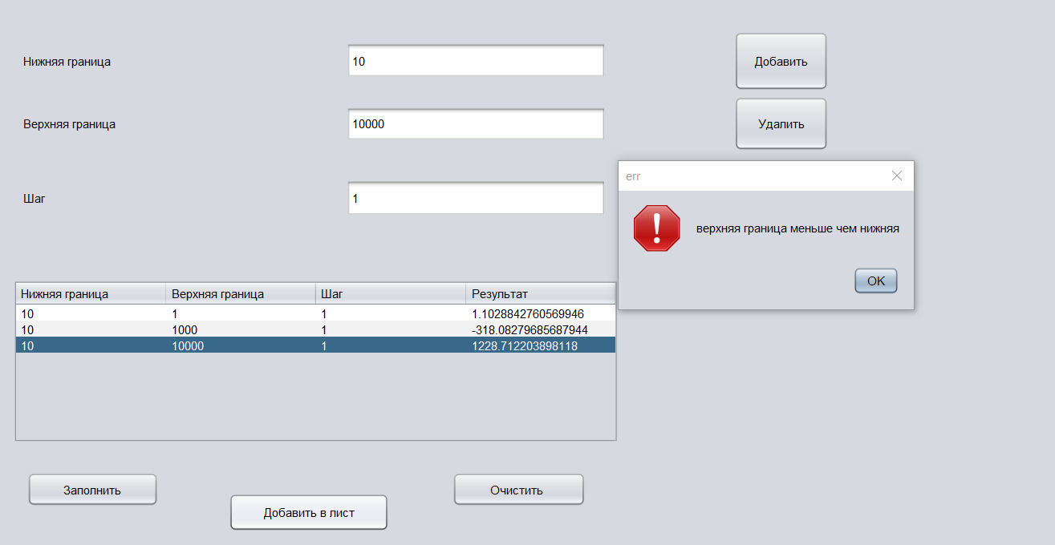

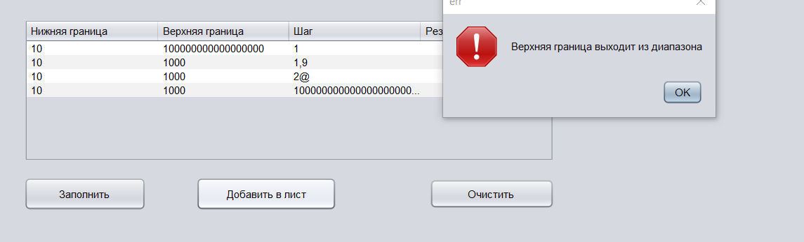

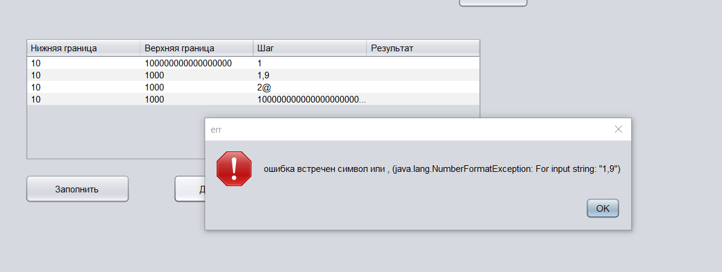

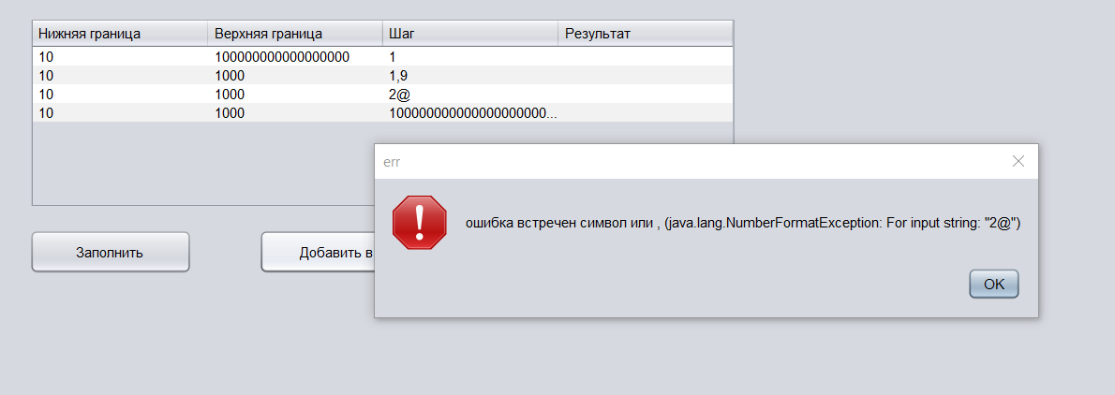

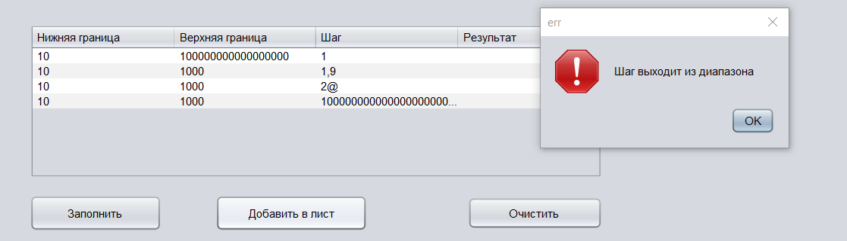

Вывод: был изучен механизм обработки исключительных ситуаций.