Customer Purchase Behaviour Analysis
- Project Overview
This project analyzes customer purchasing behavior using transactional retail data. The objective is to identify trends in sales, customer activity, product performance, and returns. SQL, Python, and Power BI were used to clean, transform, analyze, and visually present insights. The final dashboard helps understand revenue patterns, top products, key customers, and return behavior.
- Dataset Summary
-Rows:401605
-Columns:10
-Column names: InvoiceNo, StockCode, Description, Quantity, InvoiceDate, UnitPrice, CustomerID, Country, Isreturn, Revenue

3.Tools Used
- Python (Pandas) – cleaning + feature creation
- SQL – analysis queries
- Power BI – dashboard creation
- DAX – measures (TotalRevenue, AOV, TotalCustomers)

4. Exploratory Data Analysis
-Data Loading:Done using pandas
-Initial Exploration:Used df.info() to check structure and describe() for statistical summary
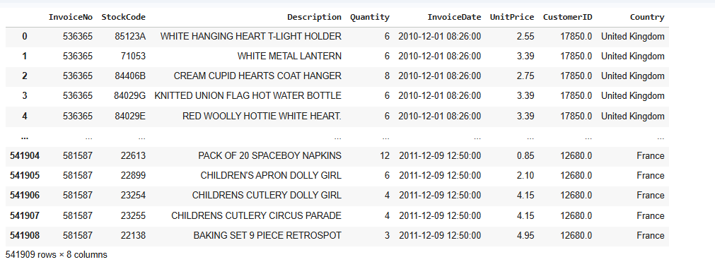
-Missing Data Handling:with help of info(),isnull()find the null values and with the help of
Fillna filled them.
-Drop duplicate values
-Created a new column Revenue

5.Data Analysis Using Sql
-Table Creation
CREATE TABLE retail_analysis (
InvoiceNO varchar(40),
StockCode VARCHAR(20),
Description text,
Quantity int,
InvoiceDate date,
UnitPrice float,
CustomerID varchar(40),
Country varchar(40),
Isreturn int,
Revenue float
);

Data Loading
LOAD DATA INFILE 'E:/DA/projects/p1/1/Online_Retail_cleaned.csv'
INTO TABLE retail_analysis
FIELDS TERMINATED BY ','
OPTIONALLY ENCLOSED BY '"'
LINES TERMINATED BY '\r\n'
IGNORE 1 ROWS;

Queries
1.Total Revenue
select sum(revenue) as totalrevenue from retail_analysis
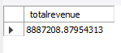

2.Top customers
select Customerid,round(sum(revenue),2) as Totalsales
from retail_analysis group by Customerid order by
Totalsales desc limit 10

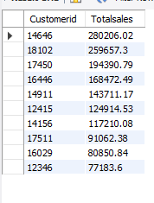

3.Customer Purchase Frequency
SELECT customerid, COUNT(DISTINCT invoiceno) AS purchase_count
FROM retail_analysis
GROUP BY customerid
ORDER BY purchase_count DESC;
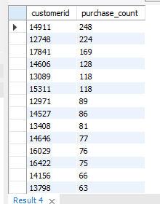

4.Sales Per Month
select month(InvoiceDate) as month,sum(revenue) as Totalrevenue
from retail_analysis
group by month(InvoiceDate) order by Totalrevenue desc
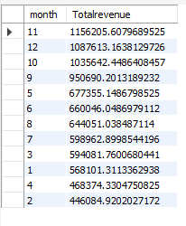

5.How many unique customers?
select count(distinct customerid) as uniqcustomers from retail_analysis
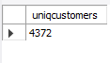
6.How many total orders?
select count(*) as torders from retail_analysis
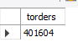

7.Which customers purchase most recently?
select customerid from retail_analysis order by invoicedate desc limit 1
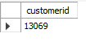

8.Top 10 selling products
select StockCode,sum(revenue) as TotalRevenue
from retail_analysis
group by StockCode
order by TotalRevenue desc limit 10
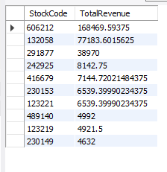

9.Products with high return rates
select stockcode,count(*) as totalreturns
from retail_analysis
where isreturn=1
group by stockcode
order by totalreturns desc limit 1
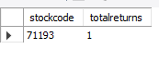
10.Which products generate the most revenue?
select StockCode,sum(revenue) as TotalRevenue
from retail_analysis
group by StockCode
order by TotalRevenue desc limit 1
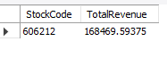

11.Highest Sale Month
select month(InvoiceDate) as month,sum(revenue) as Totalrevenue
from retail_analysis where year(InvoiceDate)=2011
group by month(InvoiceDate) order by Totalrevenue desc limit 1
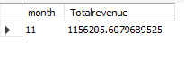
12. What day of week customers buy the most?
select dayname(InvoiceDate) as month,sum(revenue) as Totalrevenue
from retail_analysis where year(InvoiceDate)=2011
group by dayname(InvoiceDate) order by Totalrevenue desc limit 1
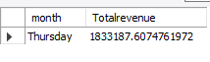
6.Power BI Dashboard
Finally,we built interactive dashboard using power bi
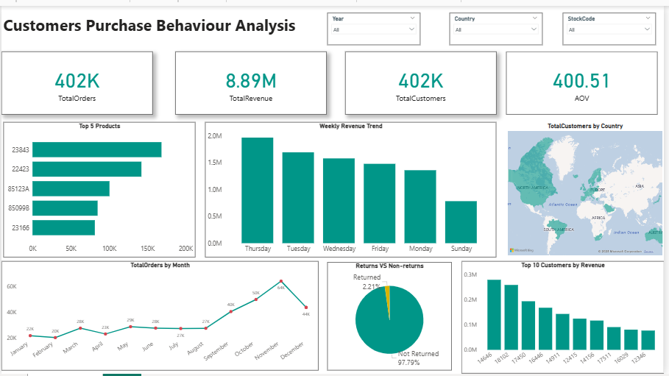

7.Key Insights
- Thursday generated the highest weekly revenue.
- November had the highest monthly orders (seasonality effect).
- Top 10 customers contributed ~20% of revenue.
- Returns were very low (~2.21%), showing stable customer behavior.
- UK contributed the largest customer base.
- A few product codes dominate revenue (Pareto effect).
8.Final Business Recommendations
- Promote top-selling products to increase sales.
- Target inactive customers with email campaigns.
- Offer special deals mid-week since Thursday performs best.
- Analyze high-value customers for loyalty programs.
- Reduce returns by analyzing reasons for negative invoices.

