HR Employee Attrition Analysis
- Project Overview
Employee attrition is a major challenge for HR departments across industries. High attrition increases hiring costs, slows productivity, and affects team stability.
To understand the root causes of employee attrition, an interactive Power BI dashboard was developed. This dashboard helps HR identify patterns, analyze different factors, and make data-driven decisions.
The company is facing increased employee turnover. However, HR lacks a consolidated system to analyze:
- Which departments have high attrition
- Whether salary, overtime, or hike percentage impacts employee exit
- How gender and work conditions influence attrition
The goal is to build a dashboard that gives clear insights and helps management reduce attrition.

2.Dataset Summary
Rows:1470
Columns:35
Columns: Age,Attrition,BusinessTravel,DailyRate,Department,DistanceFromHome,Education, EducationField,EmployeeCount,EmployeeNumber,EnvironmentSatisfaction,Gender, HourlyRate,JobInvolvement,JobLevel,JobRole,JobSatisfaction,MaritalStatus,MonthlyIncome, MonthlyRate,NumCompaniesWorked,Over18,OverTime, PercentSalaryHike,PerformanceRating, RelationshipSatisfaction,StandardHours,StockOptionLevel,TotalWorkingYears, TrainingTimesLastYear,WorkLifeBalance,YearsAtCompany,YearsInCurrentRole, YearsSinceLastPromotion,YearsWithCurrManager

3.Tools Used
- SQL – analysis queries
- Power BI – dashboard creation
- DAX – measures
4.Analysis through SQL
- Table Creation
create table HR_Data(
Age int,
Attrition varchar(10),
BusinessTravel varchar(30),
DailyRate int,
Department varchar(50),
DistanceFromHome int,
Education int,
EducationField varchar(70),
EmployeeCount int,
EmployeeNumber int,
EnvironmentSatisfaction int,
Gender varchar(10),
HourlyRate int,
JobInvolvement int,
JobLevel int,
JobRole varchar(50),
JobSatisfaction int,
MaritalStatus varchar(10),
MonthlyIncome int,
MonthlyRate int,
NumCompaniesWorked int,
Over18 varchar(10),
OverTime varchar(10),
PercentSalaryHike int,
PerformanceRating int,
RelationshipSatisfaction int,
StandardHours int,
StockOptionLevel int,
TotalWorkingYears int,
TrainingTimesLastYear int,
WorkLifeBalance int,
YearsAtCompany int,
YearsInCurrentRole int,
YearsSinceLastPromotion int,
YearsWithCurrManager int
);

- Data Loading
LOAD DATA INFILE 'E:/DA/projects/p1/HR_Analytics/WA_Fn-UseC_-HR-Employee-Attrition.csv'
INTO TABLE HR_Data
FIELDS TERMINATED BY ','
OPTIONALLY ENCLOSED BY '"'
LINES TERMINATED BY '\r\n'
IGNORE 1 ROWS;

Queries:
1.Total Employees
select count(*) from HR_Data
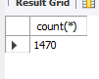

2.which age category has high attrition?
select
count(case when Age Between 18 and 24 then 1 end)as Young,
count(case when Age Between 25 and 31 then 1 end)as Young_Adult,
count(case when Age Between 32 and 38 then 1 end)as Middle_Aged_Adult,
count(case when Age Between 39 and 45 then 1 end)as Old_Aged_Adult,
count(case when Age Between 46 and 52 then 1 end)as Senior,
count(case when Age Between 53 and 60 then 1 end)as Supersenior
from HR_Data where attrition='Yes'

Insight:People from 32-38 are leaving more

3.Avg age of employee who are leaving the company
select avg(Age) as Avg_age from HR_Data where Attrition='Yes'
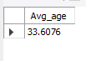
Insight:Average age of people who are leaving is 33

4.Total emp who are leaving
select count(*) as Total_emp from HR_Data where attrition='Yes'
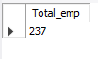

5.Does travelling effect attrition?
select BusinessTravel,count(Attrition) as Total
from HR_Data where Attrition='yes'
group by BusinessTravel order by Total desc;

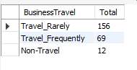
Insight:Travelling doesn’t affecting attrition

6.which department has high attrition?
select Department,count(Attrition) as Total
from HR_Data where Attrition='yes'
group by department order by Total desc;

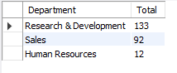
Insight:People from Research&Development are leaving more

7.Does distance effect attrition?
select
count(case when DistanceFromHome Between 1 and 5 then 1 end)as L0,
count(case when DistanceFromHome Between 6 and 10 then 1 end)as L1,
count(case when DistanceFromHome Between 11 and 15 then 1 end)as L2,
count(case when DistanceFromHome Between 16 and 20 then 1 end)as L3,
count(case when DistanceFromHome Between 21 and 25 then 1 end)as L4
count(case when DistanceFromHome Between 26 and 30 then 1 end)as L5
from HR_Data where attrition='Yes'

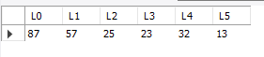
Insight:Distance is not affection attrition because people who have<5km are leaving more

8.which background people are leaving?
SELECT EducationField, COUNT(*) as Total
FROM hr_data
WHERE Attrition = 'Yes'
GROUP BY EducationField;

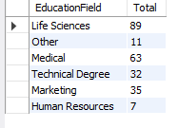

9.Does Emp satisfy with environment?
SELECT EnvironmentSatisfaction, COUNT(*) as Total
FROM hr_data
WHERE Attrition = 'Yes'
GROUP BY EnvironmentSatisfaction order by total desc;

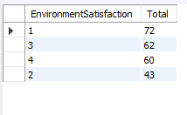
Insight:People are not with the environment

10.which gender is leaving more?
select Gender,count(*) as Total
from HR_Data where Attrition='yes'
group by Gender order by Total desc;

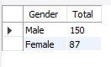
Insight:Male are leaving more than others

11.which JobRole are leaving?
select JobRole,count(Attrition) as Total
from HR_Data where Attrition='yes'
group by JobRole order by Total desc;

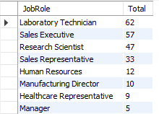

Insight:People in Laboratory Technician role are leaving more

12.Does salary is affecting?
select
count(case when Monthlyincome<5000 then 1 end)as L0,
count(case when Monthlyincome Between 5001 and 10000 then 1 end)as L1,
count(case when Monthlyincome Between 10001 and 15000 then 1 end)as L2,
from HR_Data where attrition='Yes';

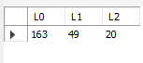
Insight:People with less salary are leaving more

13.PercentSalaryHike vs Attrition
select
count(case when PercentSalaryHike<15 then 1 end)as L0,
count(case when PercentSalaryHike Between 15 and 20 then 1 end)as L1,
count(case when NumCompaniesWorked>20 then 1 end)as L2
from HR_Data where attrition='Yes';

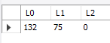
Insight:People with less hike are leaving more

14.relationshipSatisfaction vs Attrition
SELECT relationshipSatisfaction, COUNT(*) as Total
FROM hr_data
WHERE Attrition = 'Yes'
GROUP BY relationshipSatisfaction order by total desc ;

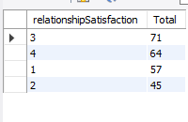

7. Dashboard Components

KPI Cards
- Total Employees
- Attrition Count
- Attrition Rate

Visuals Used
- Gender-wise Attrition (Pie Chart)
- Department-wise Attrition (Treemap)
- Salary Category-wise Attrition (Bar Chart)
- Hike Category Trend (Ribbon Chart)
- OverTime vs Attrition (Donut Chart)
- Environment Satisfaction (Bar Chart)

Slicers
- Age_Category
- Department
- RelationshipStatus

8. Key Dashboard Insights

1. High Attrition in Sales Department
Research&Development has the highest number of employees leaving the company.

2. Salary is the major factor
Employees with Low Salary show the maximum attrition.

3. Overtime employees leave more
OverTime = "Yes" category shows significantly higher attrition.

4. Hike Category Trends
Employees with:
- Less Hike → highest attrition
- Normal Hike → moderate
- High Hike → lowest attrition

5. Gender Insights
Male employees show slightly higher attrition than female employees.

6. Environment Satisfaction Impact
Employees with low satisfaction scores have higher chances of leaving.
9. Results of the Project
The dashboard successfully:
- Provides real-time, interactive HR insights
- Identifies major attrition drivers
- Helps HR optimize retention strategies
- Highlights areas for salary revision, workload balancing, and employee satisfaction

10. Conclusion
The HR Attrition Analysis Dashboard provides a clear understanding of employee turnover. By analyzing salary, department, hike percentage, overtime, and satisfaction levels, management can take preventive measures to reduce attrition. This dashboard can be updated regularly and used by HR teams for better workforce planning.
11.Dashboard

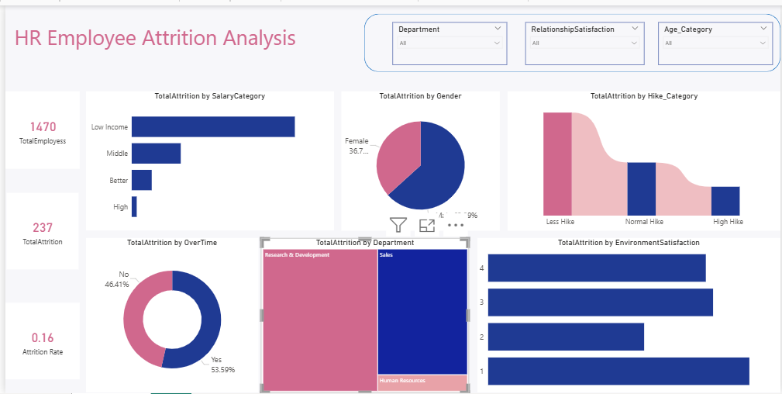
12.Recommendations

Revise salary bands, especially for low-salary employees, to reduce high attrition.
- Reduce overtime workload by optimizing staffing and balancing tasks.
- Provide better hike percentages for consistent and high performers.
- Focus on high-attrition departments like Sales and R&D with targeted retention strategies.
- Improve work environment satisfaction through engagement programs, flexible policies, and employee support initiatives.

