**CURRÍCULO**

**Kauan Victor Ramos dos Santos**

(Trabalho Senai LIMA)

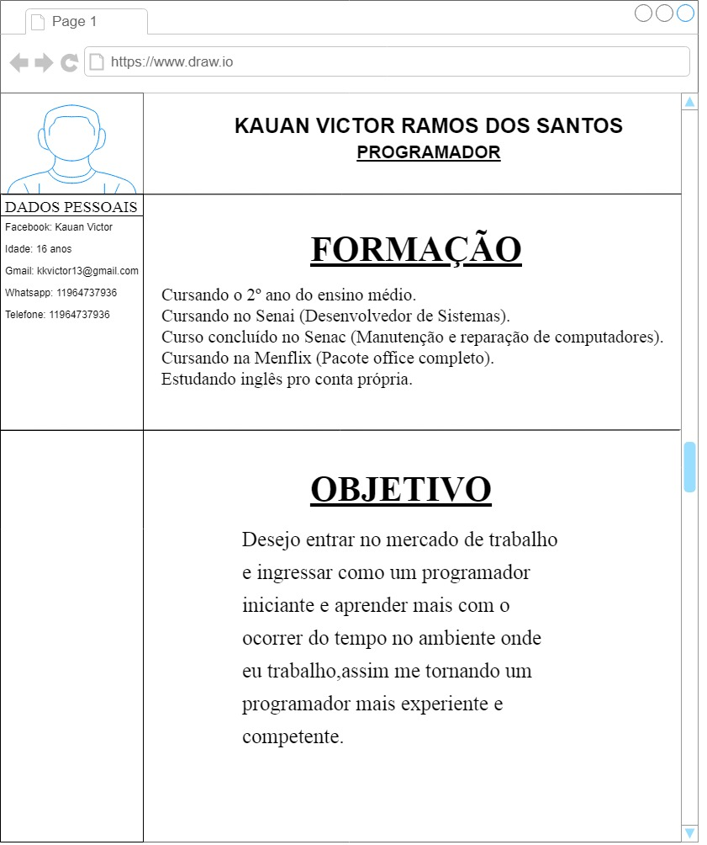

LINK GITHUB: <https://github.com/Kauan-16/Kauan/blob/master/CURR%C3%8DCULO.docx>