Exercício 01 - A)

A B C H S

0 0 0 0 1

0 0 0 1 1

0 0 1 0 1

0 0 1 1 0

0 1 0 0 0

0 1 0 1 0

0 1 1 0 1

0 1 1 1 1

1 0 0 0 1

1 0 0 1 1

1 0 1 0 0

1 0 1 1 0

1 1 0 0 0

1 1 0 1 0

1 1 1 0 1

1 1 1 1 1

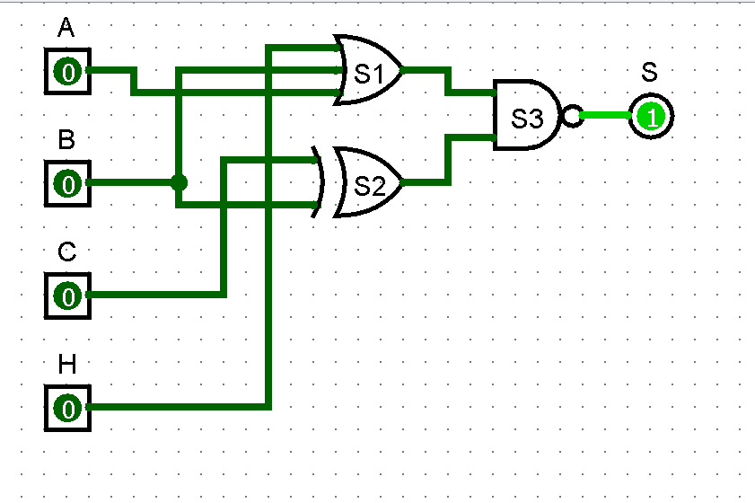

Exercício 01 - B)

A B C H D S

0 0 0 0 0 0

0 0 0 0 1 1

0 0 0 1 0 0

0 0 0 1 1 1

0 0 1 0 0 0

0 0 1 0 1 0

0 0 1 1 0 0

0 0 1 1 1 0

0 1 0 0 0 1

0 1 0 0 1 1

0 1 0 1 0 1

0 1 0 1 1 1

0 1 1 0 0 1

0 1 1 0 1 1

0 1 1 1 0 1

0 1 1 1 1 1

1 0 0 0 0 1

1 0 0 0 1 1

1 0 0 1 0 1

1 0 0 1 1 1

1 0 1 0 0 1

1 0 1 0 1 1

1 0 1 1 0 1

1 0 1 1 1 1

1 1 0 0 0 0

1 1 0 0 1 1

1 1 0 1 0 0

1 1 0 1 1 1

1 1 1 0 0 0

1 1 1 0 1 1

1 1 1 1 0 0

1 1 1 1 1 1

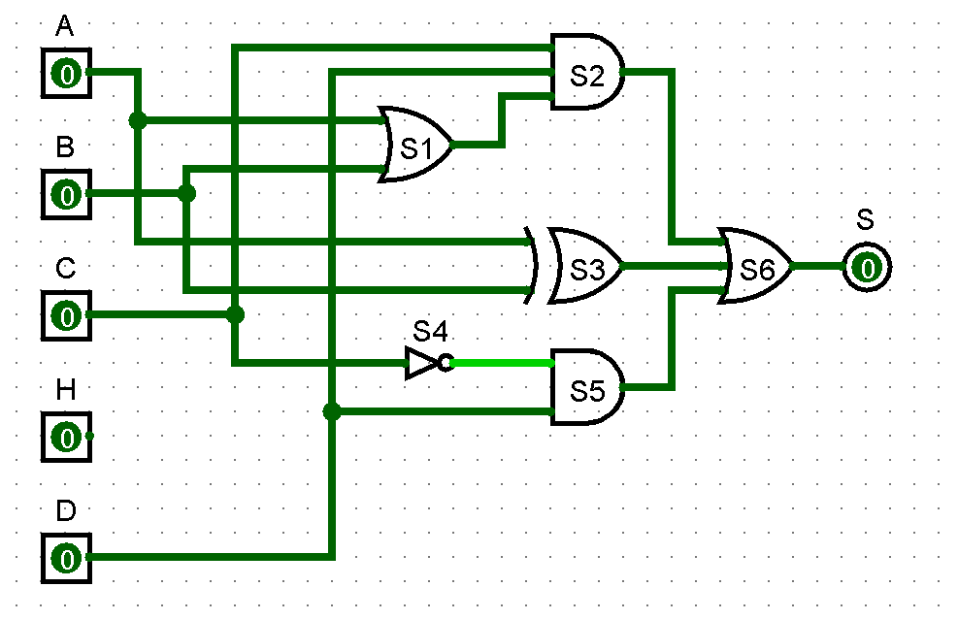

Exercício 02: Equação logica

S = (!chovendo \* !dinheiro \* tempo \* !nuggets)

+ (!chovendo \* !dinheiro \* tempo \* nuggets)

+ (chovendo \* !dinheiro \* !tempo \* !nuggets)

+ (chovendo \* !dinheiro \* tempo \* nuggets)

+ (chovendo \* dinheiro \* tempo \* nuggets)