ANOTACOES AULA 08/04/2024
EXERCICIOS TINKER CAD
1)Ligando led colorida, e normal pela placa de ensaio:
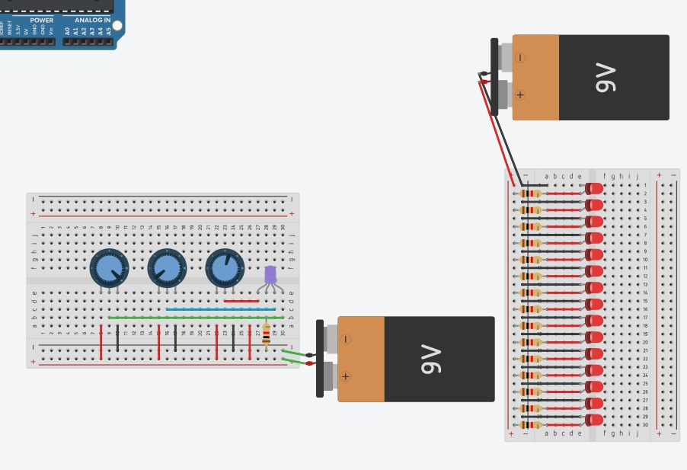
2) Sistema de botão para ligar a led:
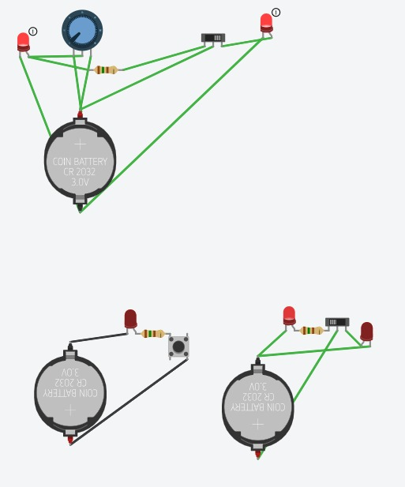
3) Sistema e código do semáforo: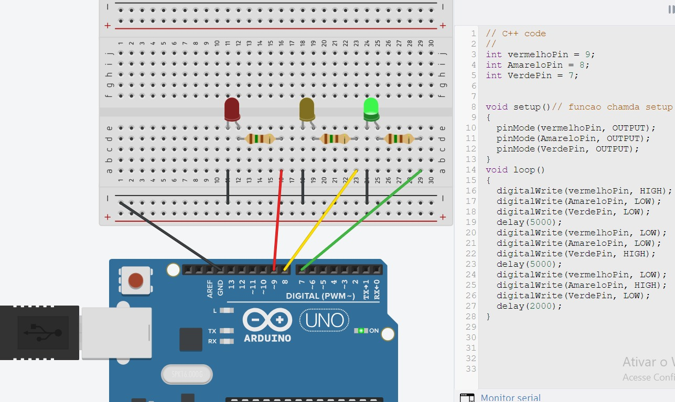
4) Tabela da verdade – Binario
SISTEMA:
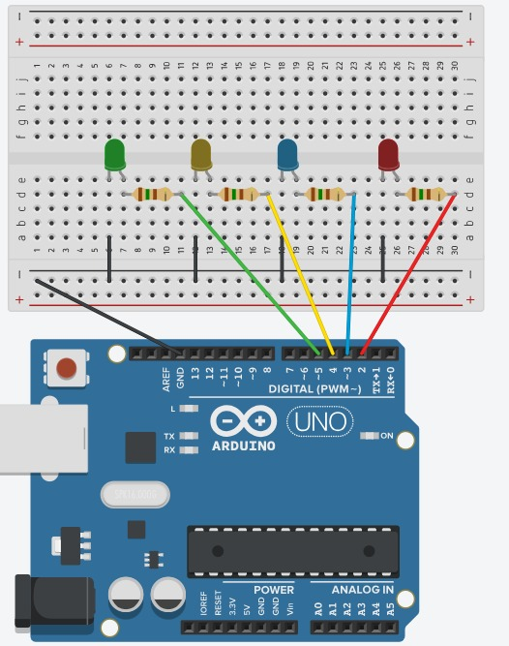
CODIGO:
// C++ code
//
int VerdePin = 5;
int AmareloPin = 4;
int AzulPin = 3;
int VermelhoPin = 2;

void setup()
{
pinMode(VerdePin, OUTPUT);
pinMode(AmareloPin, OUTPUT);
pinMode(AzulPin, OUTPUT);
pinMode(VermelhoPin, OUTPUT);
}

void loop()
{
digitalWrite(VerdePin, LOW);
digitalWrite(AmareloPin, LOW);
digitalWrite(AzulPin, LOW);
digitalWrite(VermelhoPin, LOW);
delay(1500);
// 0000
digitalWrite(VerdePin, LOW);
digitalWrite(AmareloPin, LOW);
digitalWrite(AzulPin, LOW);
digitalWrite(VermelhoPin, HIGH);
delay(1500);
//0001
digitalWrite(VerdePin, LOW);
digitalWrite(AmareloPin, LOW);
digitalWrite(AzulPin, HIGH);
digitalWrite(VermelhoPin, LOW);
delay(1500);
//0002
digitalWrite(VerdePin, LOW);
digitalWrite(AmareloPin, LOW);
digitalWrite(AzulPin, HIGH);
digitalWrite(VermelhoPin, HIGH);
delay(1500);
//0003
digitalWrite(VerdePin, LOW);
digitalWrite(AmareloPin, HIGH);
digitalWrite(AzulPin, LOW);
digitalWrite(VermelhoPin, LOW);
delay(1500);
//0004
digitalWrite(VerdePin, LOW);
digitalWrite(AmareloPin, HIGH);
digitalWrite(AzulPin, LOW);
digitalWrite(VermelhoPin, HIGH);
delay(1500);
//0005
digitalWrite(VerdePin, LOW);
digitalWrite(AmareloPin, HIGH);
digitalWrite(AzulPin, HIGH);
digitalWrite(VermelhoPin, LOW);
delay(1500);
//0006
digitalWrite(VerdePin, LOW);
digitalWrite(AmareloPin, HIGH);
digitalWrite(AzulPin, HIGH);
digitalWrite(VermelhoPin, HIGH);
delay(1500);
//0007
digitalWrite(VerdePin, HIGH);
digitalWrite(AmareloPin, LOW);
digitalWrite(AzulPin, LOW);
digitalWrite(VermelhoPin, LOW);
delay(1500);
//0008
digitalWrite(VerdePin, HIGH);
digitalWrite(AmareloPin, LOW);
digitalWrite(AzulPin, LOW);
digitalWrite(VermelhoPin, HIGH);
delay(1500);
//0009
digitalWrite(VerdePin, HIGH);
digitalWrite(AmareloPin, LOW);
digitalWrite(AzulPin, HIGH);
digitalWrite(VermelhoPin, LOW);
delay(1500);
//0010
digitalWrite(VerdePin, HIGH);
digitalWrite(AmareloPin, LOW);
digitalWrite(AzulPin, HIGH);
digitalWrite(VermelhoPin, HIGH);
delay(1500);
//0011
digitalWrite(VerdePin, HIGH);
digitalWrite(AmareloPin, HIGH);
digitalWrite(AzulPin, LOW);
digitalWrite(VermelhoPin, LOW);
delay(1500);
//0012
digitalWrite(VerdePin, HIGH);
digitalWrite(AmareloPin, HIGH);
digitalWrite(AzulPin, LOW);
digitalWrite(VermelhoPin, HIGH);
delay(1500);
//0013
digitalWrite(VerdePin, HIGH);
digitalWrite(AmareloPin, HIGH);
digitalWrite(AzulPin, HIGH);
digitalWrite(VermelhoPin, LOW);
delay(1500);
//0014
digitalWrite(VerdePin, HIGH);
digitalWrite(AmareloPin, HIGH);
digitalWrite(AzulPin, HIGH);
digitalWrite(VermelhoPin, HIGH);
//0015
delay(1500);

}

