TINKER CAD – SENSOR DE UMIDADE
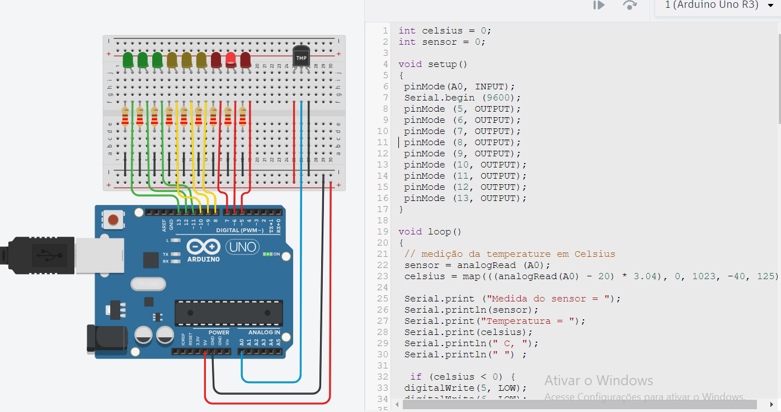

CODIGO:
int celsius = 0;
int sensor = 0;

void setup ()
{
pinMode(A0, INPUT);
Serial.begin (9600);
pinMode (5, OUTPUT);
pinMode (6, OUTPUT);
pinMode (7, OUTPUT);
pinMode (8, OUTPUT);
pinMode (9, OUTPUT);
pinMode (10, OUTPUT);
pinMode (11, OUTPUT);
pinMode (12, OUTPUT);
pinMode (13, OUTPUT);
}

void loop()
{
// medição da temperature em Celsius
sensor = analogRead (A0);
celsius = map(((analogRead(A0) - 20) * 3.04), 0, 1023, -40, 125);

Serial.print ("Medida do sensor = ");
Serial.println(sensor);
Serial.print("Temperatura = ");
Serial.print(celsius);
Serial.println(" C, ");
Serial.println(" ") ;

if (celsius < 0) {
digitalWrite(5, LOW);
digitalWrite(6, LOW);
digitalWrite(7, LOW);
digitalWrite(8, LOW);
digitalWrite(9, LOW);
digitalWrite(10, LOW);
digitalWrite(11, LOW);
digitalWrite(12, LOW);
digitalWrite(13, HIGH);
}
if (celsius > 0 && celsius <= 10) {
digitalWrite(5, LOW);
digitalWrite(6, LOW);
digitalWrite(7, LOW);
digitalWrite(8, LOW);
digitalWrite(9, LOW);
digitalWrite(10, LOW);
digitalWrite(11, LOW);
digitalWrite(12, HIGH);
digitalWrite(13, LOW);
}
if (celsius > 10 && celsius <= 20) {
digitalWrite(5, LOW);
digitalWrite(6, LOW);
digitalWrite(7, LOW);
digitalWrite(8, LOW);
digitalWrite(9, LOW);
digitalWrite(10, LOW);
digitalWrite(11, HIGH);
digitalWrite(12, LOW);
digitalWrite(13, LOW);
}
if (celsius > 20 && celsius <= 30) {
digitalWrite(5, LOW);
digitalWrite(6, LOW);
digitalWrite(7, LOW);
digitalWrite(8, LOW);
digitalWrite(9, LOW);
digitalWrite(10, HIGH);
digitalWrite(11, LOW);
digitalWrite(12, LOW);
digitalWrite(13, LOW);
}
if (celsius > 30 && celsius <= 40) {
digitalWrite(5, LOW);
digitalWrite(6, LOW);
digitalWrite(7, LOW);
digitalWrite(8, LOW);
digitalWrite(9, HIGH);
digitalWrite(10, LOW);
digitalWrite(11, LOW);
digitalWrite(12, LOW);
digitalWrite(13, LOW);
}
if (celsius > 40 && celsius <= 50) {
digitalWrite(5, LOW);
digitalWrite(6, LOW);
digitalWrite(7, LOW);
digitalWrite(8, HIGH);
digitalWrite(9, LOW);
digitalWrite(10, LOW);
digitalWrite(11, LOW);
digitalWrite(12, LOW);
digitalWrite(13, LOW);
}
if (celsius > 50 && celsius <= 60) {
digitalWrite(5, LOW);
digitalWrite(6, LOW);
digitalWrite(7, HIGH);
digitalWrite(8, LOW);
digitalWrite(9, LOW);
digitalWrite(10, LOW);
digitalWrite(11, LOW);
digitalWrite(12, LOW);
digitalWrite(13, LOW);
}
if (celsius > 60 && celsius <= 70) {
digitalWrite(5, LOW);
digitalWrite(6, HIGH);
digitalWrite(7, LOW);
digitalWrite(8, LOW);
digitalWrite(9, LOW);
digitalWrite(10, LOW);
digitalWrite(11, LOW);
digitalWrite(12, LOW);
digitalWrite(13, LOW);
}
if (celsius > 70) {
digitalWrite(5, HIGH);
digitalWrite(6, LOW);
digitalWrite(7, LOW);
digitalWrite(8, LOW);
digitalWrite(9, LOW);
digitalWrite(10, LOW);
digitalWrite(11, LOW);
digitalWrite(12, LOW);
digitalWrite(13, LOW);
}
delay(500);
}

