**ANOTACOES AULA 08/04/2024**

***EXERCICIOS TINKER CAD***

***1)Ligando led colorida, e normal pela placa de ensaio:***

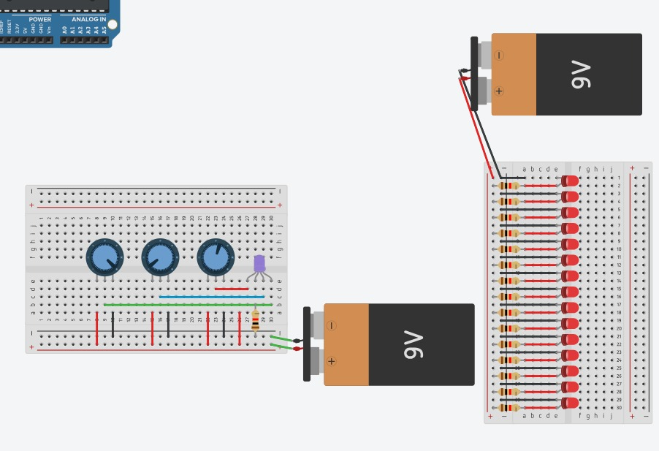

***2) Sistema de botão para ligar a led:***

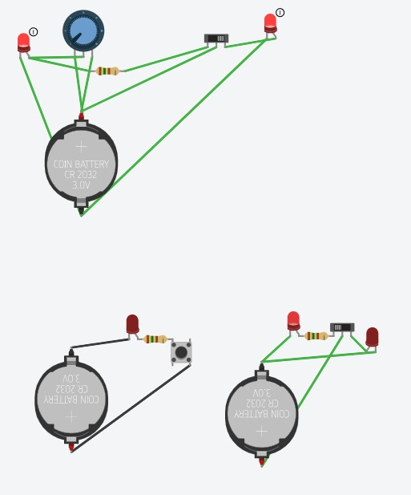

***3) Sistema e código do semáforo:***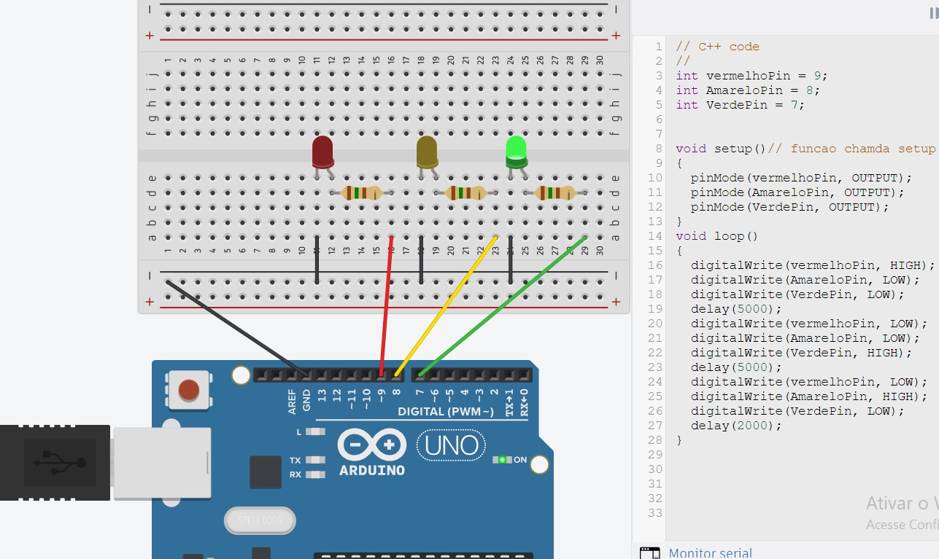

***4) Tabela da verdade – Binario***

***SISTEMA:***

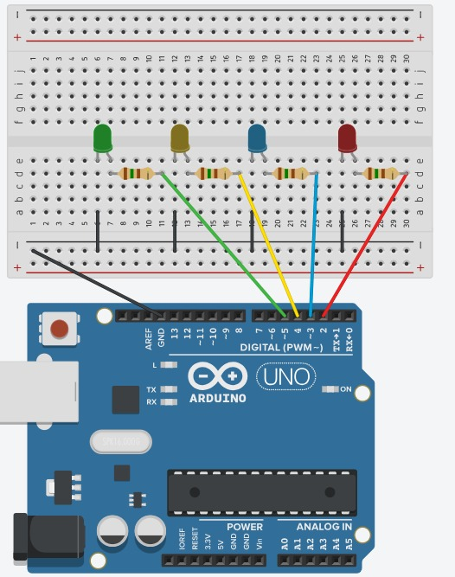

***CODIGO:***

// C++ code

//

int VerdePin = 5;

int AmareloPin = 4;

int AzulPin = 3;

int VermelhoPin = 2;

void setup()

{

pinMode(VerdePin, OUTPUT);

pinMode(AmareloPin, OUTPUT);

pinMode(AzulPin, OUTPUT);

pinMode(VermelhoPin, OUTPUT);

}

void loop()

{

digitalWrite(VerdePin, LOW);

digitalWrite(AmareloPin, LOW);

digitalWrite(AzulPin, LOW);

digitalWrite(VermelhoPin, LOW);

delay(1500);

// 0000

digitalWrite(VerdePin, LOW);

digitalWrite(AmareloPin, LOW);

digitalWrite(AzulPin, LOW);

digitalWrite(VermelhoPin, HIGH);

delay(1500);

//0001

digitalWrite(VerdePin, LOW);

digitalWrite(AmareloPin, LOW);

digitalWrite(AzulPin, HIGH);

digitalWrite(VermelhoPin, LOW);

delay(1500);

//0002

digitalWrite(VerdePin, LOW);

digitalWrite(AmareloPin, LOW);

digitalWrite(AzulPin, HIGH);

digitalWrite(VermelhoPin, HIGH);

delay(1500);

//0003

digitalWrite(VerdePin, LOW);

digitalWrite(AmareloPin, HIGH);

digitalWrite(AzulPin, LOW);

digitalWrite(VermelhoPin, LOW);

delay(1500);

//0004

digitalWrite(VerdePin, LOW);

digitalWrite(AmareloPin, HIGH);

digitalWrite(AzulPin, LOW);

digitalWrite(VermelhoPin, HIGH);

delay(1500);

//0005

digitalWrite(VerdePin, LOW);

digitalWrite(AmareloPin, HIGH);

digitalWrite(AzulPin, HIGH);

digitalWrite(VermelhoPin, LOW);

delay(1500);

//0006

digitalWrite(VerdePin, LOW);

digitalWrite(AmareloPin, HIGH);

digitalWrite(AzulPin, HIGH);

digitalWrite(VermelhoPin, HIGH);

delay(1500);

//0007

digitalWrite(VerdePin, HIGH);

digitalWrite(AmareloPin, LOW);

digitalWrite(AzulPin, LOW);

digitalWrite(VermelhoPin, LOW);

delay(1500);

//0008

digitalWrite(VerdePin, HIGH);

digitalWrite(AmareloPin, LOW);

digitalWrite(AzulPin, LOW);

digitalWrite(VermelhoPin, HIGH);

delay(1500);

//0009

digitalWrite(VerdePin, HIGH);

digitalWrite(AmareloPin, LOW);

digitalWrite(AzulPin, HIGH);

digitalWrite(VermelhoPin, LOW);

delay(1500);

//0010

digitalWrite(VerdePin, HIGH);

digitalWrite(AmareloPin, LOW);

digitalWrite(AzulPin, HIGH);

digitalWrite(VermelhoPin, HIGH);

delay(1500);

//0011

digitalWrite(VerdePin, HIGH);

digitalWrite(AmareloPin, HIGH);

digitalWrite(AzulPin, LOW);

digitalWrite(VermelhoPin, LOW);

delay(1500);

//0012

digitalWrite(VerdePin, HIGH);

digitalWrite(AmareloPin, HIGH);

digitalWrite(AzulPin, LOW);

digitalWrite(VermelhoPin, HIGH);

delay(1500);

//0013

digitalWrite(VerdePin, HIGH);

digitalWrite(AmareloPin, HIGH);

digitalWrite(AzulPin, HIGH);

digitalWrite(VermelhoPin, LOW);

delay(1500);

//0014

digitalWrite(VerdePin, HIGH);

digitalWrite(AmareloPin, HIGH);

digitalWrite(AzulPin, HIGH);

digitalWrite(VermelhoPin, HIGH);

//0015

delay(1500);

}