**Question 4 Screenshots**

Below are screenshots from the SQL Developer showing all the data stored in the FEE table's data entry.

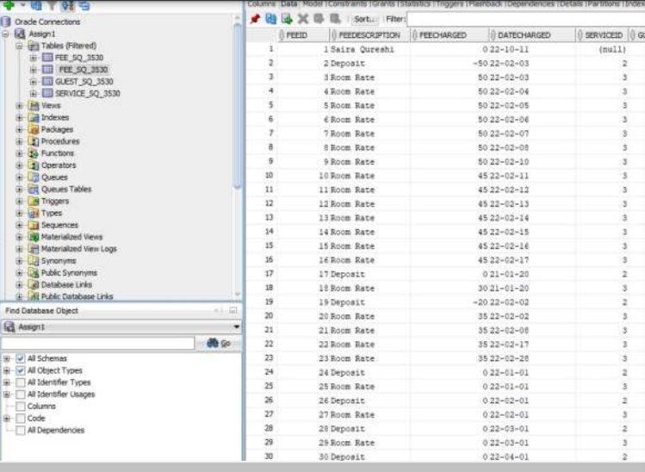

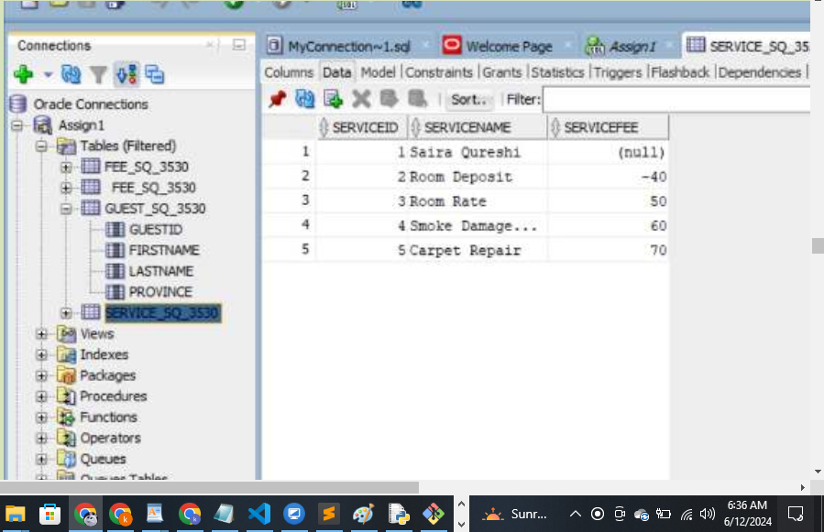

Below is the screenshot of the Guest data

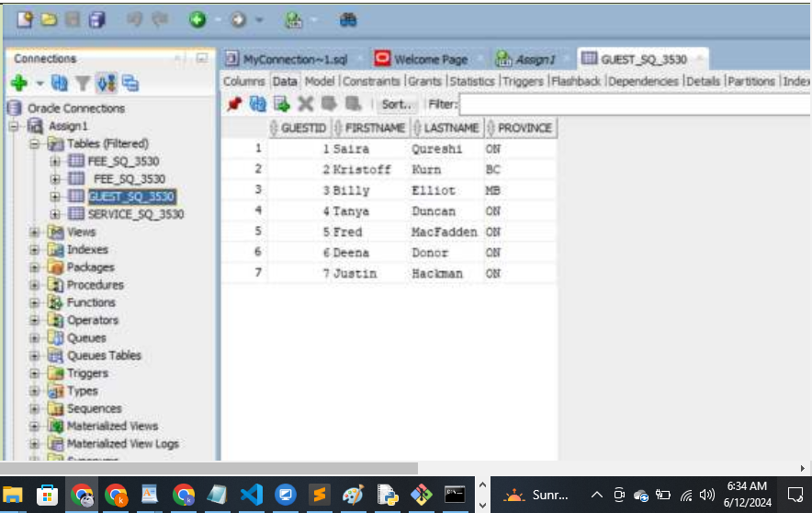

Question 5

