Github Repo
https://github.com/KaunazDagaz/Assingnment6/tree/Assignment7

Logic V1 contract
https://sepolia.etherscan.io/address/0xdcaf6767e5333b2de808231B6db6E0421Eb22A37

Proxy
https://sepolia.etherscan.io/address/0xFb1dff9B35e674D455bf542B881b95501f5ea05B

Token transfer
https://sepolia.etherscan.io/tx/0x42151dd8cfe6cc245549a9d926ea90f863bab6fd2f9d9777d009a26e8452553d
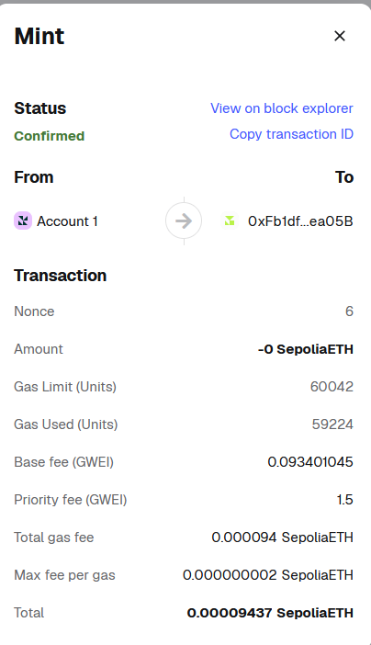

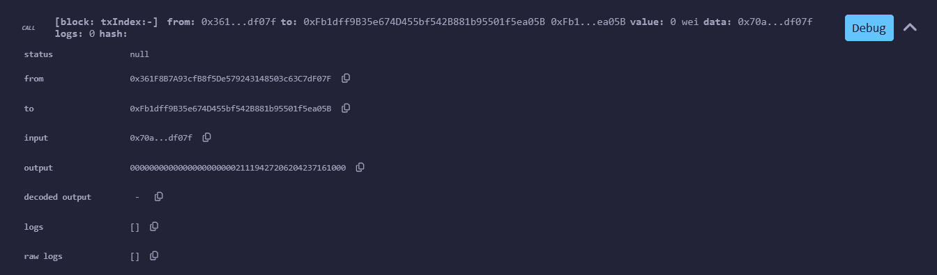
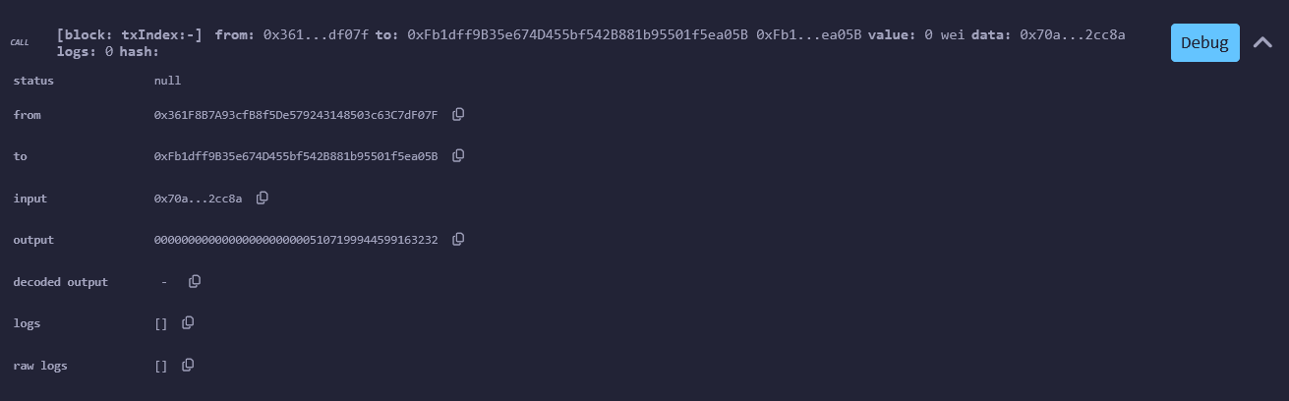

V2 Contract deployed
https://sepolia.etherscan.io/address/0x8F9d51707B0212dc7bFACEF67bf8a8EC342ca0a7

Upgraded Contract
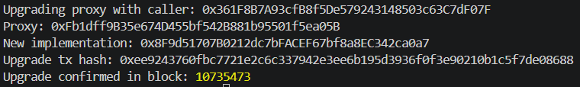

Upgrade Validation
