Date: _________________

Save

R2 Rec. Stock 3

JNJ

R2 Rec. Stock 2

JNJ

R2 Rec. Stock 1

JNJ

R1 Rec. Stock 3

JNJ

R1 Rec. Stock 2

JNJ

R1 Rec. Stock 1

JNJ

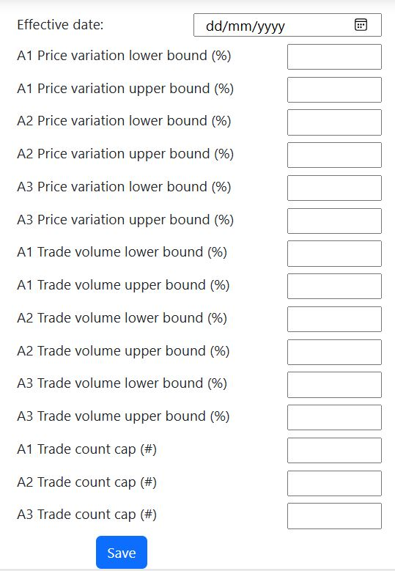

Update Stock Info

JNJ

Sector

Asset Class

Stock name

Stock Price Variation Parameters

R1 Trade Analytics

r1RecommendedStock3: Stock

r1RecommendedStock2: Stock

r1RecommendedStock1: Stock

Recommended_Stock

date: LocalDate

MoneyPort Admin Menu

Analytics

Manage Stock Info

Manage Stock Recommendations

Manage Learning Space