**CS330 A Security Device**

**Memo**

**My Thoughts for this project**

When I see the instructions, I have some different ways to write codes for that. The first one and the easiest way is to use of/else and compare one number at a time in a while infinite loop. Another way I think of is to use arrays of six to store the access code and use array comparison to compare it. Every time the user input it will go to a temporary array and when input have six numbers then use array comparison to compare with either lock or unlock. If the comparison is equal print Lock/Unlock else all number will shift to top by one place and the digit in the highest will go out of array. Then it will compare again and so on. But it is only for thinking when I write for that it is too complex so I need to use if/else instead in this project. For if/else it is pretty simple in every if statement include another if and also before every if statement there would be a scanner for input or random for random number generator that will take an integer variable to compare in following if statement. If the first input is equal to fist number in access code the program will ask for input again and generate another if statement to compare second number and so on until it have compared to the last number of the access code and the program will print either lock/unlock depending on what’s the last digit you typed in. For the first part I don’t put any state to check whether the condition of the device before in lock statement or unlock statement. Because I think even the device is locked and you can print a lock to notify user that it is locked, same in unlock. But in real life lock there will be only about 10 chance of typing the access code and if all are wrong there will be some kind on notification alarm sound coming out from device.

**Bug solved as**

When taking an input there can be inputs like negative and integer greater than 9. I solved this as when there is negative integer, I change it to positive and when there is number bigger than 9, I just mark the access code as wrong and will start from the start the checking of next input from the starting part again.

**Finite Automata**

A finite automaton (FA) is a simple idealized machine used to recognize patterns within input taken from some character set (or alphabet) C. The job of an FA is to accept or reject an input depending on whether the pattern defined by the FA occurs in the input. The sequence of characters that we input into the FSA is often called a string, and the set of all strings that can be accepted by a particular FSA is called its language.

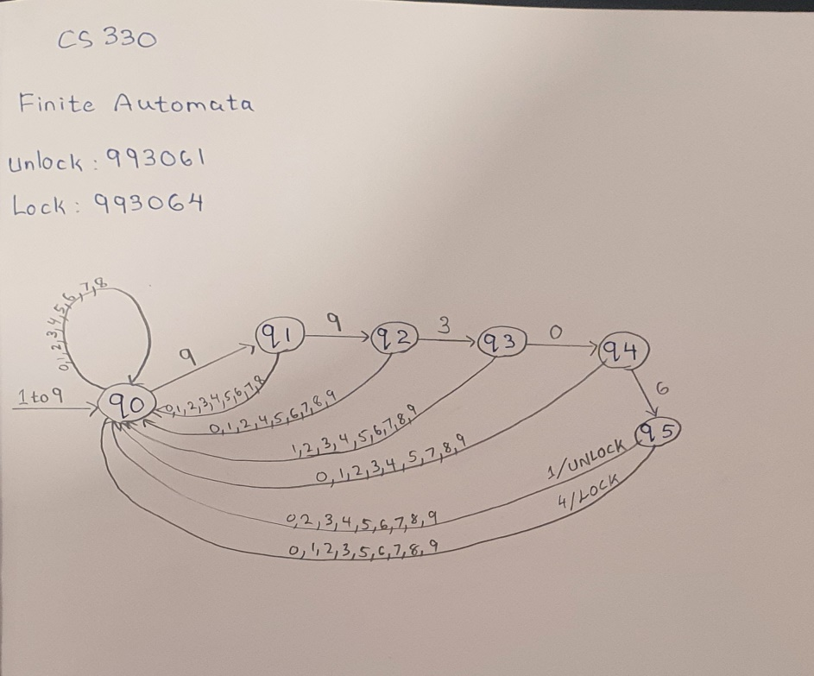Here is what I have draw and list for my FA:

**Part 2 max min average**

**564416, 765282, 331570, 1258321, 2768798, 3517487, 703407, 907251, 18095, 260461**

Maximum to unlock: 3517487

Minimum to unlock: 18095

Average: 1109508.8

**Problems Faced**

The main problem that I faced for this project is the use of power shell or Linux to run a code and the use of Gradle for unit test. I overcome the problem of using power shell but still not 100% understand about Gradle stuff. I just follow the steps from the demo that professor share, I am not pretty sure whether I am right or not for unit test step, but at least I do. This project is challenging but I learn many new stuffs.