Entity Relationship Diagram for Lift system

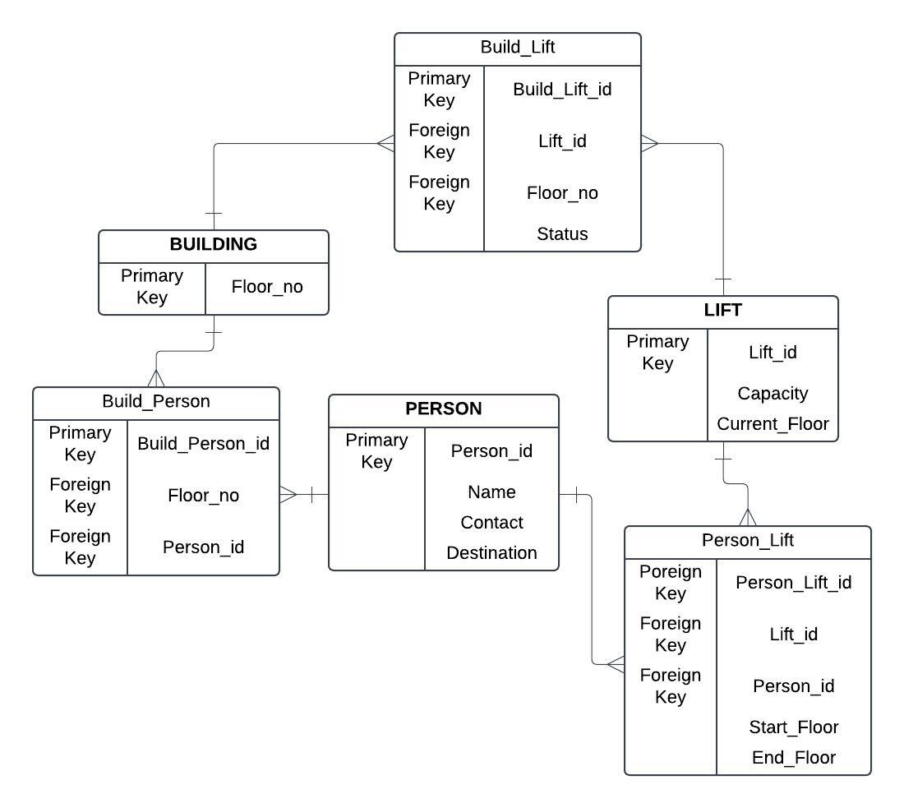

- Person_Lift track which person uses which lift and travel details.
- Build_Lift tracks which lift is serving which floor.
- Build_Person tracks which person visits which floor.

Database creation

CREATE TABLE Building ( floor_no INTEGER PRIMARY KEY NOT NULL );

CREATE TABLE Person (
person_id INTEGER PRIMARY KEY AUTOINCREMENT,
name VARCHAR(50) NOT NULL,
contact VARCHAR(15),
destination INT
);

CREATE TABLE Lift (
lift_id INTEGER PRIMARY KEY AUTOINCREMENT,
capacity INT NOT NULL,
current_floor INT NOT NULL
);

CREATE TABLE Build_Person(
Build_Person_id INTEGER PRIMARY KEY AUTOINCREMENT,
person_id INT NOT NULL,
floor_no INT NOT NULL,
FOREIGN KEY (person_id) REFERENCES Person(person_id),
FOREIGN KEY (floor_no) REFERENCES Building(floor_no)
);

CREATE TABLE Build_Lift (
lift_build_id INTEGER PRIMARY KEY AUTOINCREMENT,
lift_id INT NOT NULL,
floor_no INT NOT NULL,
status VARCHAR(20) NOT NULL,
FOREIGN KEY (lift_id) REFERENCES Lift(lift_id),
FOREIGN KEY (floor_no) REFERENCES Building(floor_no)
);

CREATE TABLE Person_Lift (
person_lift_id INTEGER PRIMARY KEY AUTOINCREMENT,
lift_id INT NOT NULL,
person_id INT NOT NULL,
start_floor INT NOT NULL,
end_floor INT NOT NULL,
FOREIGN KEY (lift_id) REFERENCES Lift(lift_id),
FOREIGN KEY (person_id) REFERENCES Person(person_id)
);
Inserting Values into Tables

INSERT INTO Building (floor_no)
VALUES
(1),
(2),
(3),
(4),
(5);

INSERT INTO Person (name, contact, destination)
VALUES
('pradeep', '1234567890', 1),
('abhishek', '9876543210', 5),
('arjun', '4567891230', 2),
('moiz', '7891234560', 4),
('parth', '3216549870', 3);

INSERT INTO Lift (capacity, current_floor)
VALUES
(10, 1),
(8, 3),
(15, 2),
(12, 4),
(6, 5);

INSERT INTO Build_Person (person_id, floor_no)
VALUES
(1, 1),
(2, 2),
(3, 3),
(4, 4),
(5, 5);

INSERT INTO Build_Lift (lift_id, floor_no, status)
VALUES
(1, 1, 'active'),
(2, 2, 'active'),
(3, 3, 'inactive'),
(4, 4, 'active'),
(5, 5, 'maintenance');

INSERT INTO Person_Lift (lift_id, person_id, start_floor, end_floor)
VALUES
(1, 1, 1, 1),
(2, 2, 3, 5),
(3, 3, 2, 2),
(4, 4, 4, 3),
(5, 5, 5, 4);

Queries and there output

SELECT * FROM Person;

1|pradeep|1234567890|1
2|abhishek|9876543210|5
3|arjun|4567891230|2
4|moiz|7891234560|4
5|parth|3216549870|3

SELECT bp.Build_Person_id, p.name, b.floor_no
FROM Build_Person bp
JOIN Person p ON bp.person_id = p.person_id
JOIN Building b ON bp.floor_no = b.floor_no;

1|pradeep|1
2|abhishek|2
3|arjun|3
4|moiz|4
5|parth|5

SELECT p.name, p.contact, p.destination
FROM Person p
WHERE p.destination = 5;

abhishek|9876543210|5

SELECT l.lift_id, l.capacity, l.current_floor
FROM Lift l
WHERE l.capacity > 10;

3|15|2
4|12|4

UPDATE Build_Lift
SET status = 'active'
WHERE lift_id = 3;

SELECT status FROM Build_Lift ;

active
active
Active (updated)
active
maintenance

SELECT floor_no, COUNT(person_id)
FROM Build_Person
GROUP BY floor_no;

1|1
2|1
3|1
4|1
5|1

SELECT destination, COUNT(person_id)
FROM Person
GROUP BY destination;

1|1
2|1
3|1
4|1
5|1

SELECT current_floor, SUM(capacity)
FROM Lift
GROUP BY current_floor;

1|10
2|15
3|8
4|12
5|6

