==



DATABASE

SPECIFICATIONS

Next-Gen Restaurant Application
Kavuri Lakshmi Kausalya, lkk5341@psu.edu

School of Graduate Professional Studies
Information Science Department
IN SC 521 - Introduction to Database Concepts

December, 2021

Document Control

Work carried out by:
Name | Email Address | Other
Kavuri Lakshmi Kausalya | lkk5341@psu.edu

Revision Sheet

Release No. | Date | Revision Description
1. | 11/01/2021 | Data Requirements into the Database were updated.
2. | 11/03/2021 | Added relevant requirements and deleted the irrelevant updates and updated.
3. | 11/08/2021 | Added the ER diagram along with the Assumptions and Constraints.
4. | 11/15/2021 | Made the relevant changes to the Conceptual ER Diagram.
5. | 11/15/2021 | Added the Logical ER Diagram along with the Functional Dependencies.
6. | 11/21/2021 | Made the relevant changes to the Logical ER Diagram.
7. | 11/21/2021 | Added Normalized tables.
8. | 12/02/2021 | Added a new Table of Contents and also made changes for FDs.
9. | 12/05/2021 | Added Physical Design, primary and foreign keys along with SQL code.
10. | 12/10/2021 | Made changes as per recommendations Milestone 5 and added SQL Queries.

DATABASE SPECIFICATIONS

TABLE OF CONTENTS

MILESTONE 1: DATA REQUIREMENTS 1
System Name or Title 1
Core requirements 1
MILESTONE 2: CONCEPTUAL DESIGN 2
Diagrams 2
Assumptions and Constraints 3

MILESTONE 3: LOGICAL DESIGN 6
Functional Dependencies 6
Entity Relationship Diagram 10
Assumptions and Constraints 10

MILESTONE 4: NORMALIZATION 10
Tables 10
Assumptions and Constraints 20
Naming Convention 20

MILESTONE 5: PHYSICAL DESIGN 10
Tables 10
Assumptions and Constraints 20
Naming Convention 20

MILESTONE 6: SQL QUERIES 20

Milestone 1: Data Requirements

System Name or Title
Online registration system for Gotham University
No. | Requirement | Referenced page in SRS | Referenced Section in SRS | Referenced Paragraph in Section
1 | The Database should contain information about Menu, price and description of each item, classification of the items. | 5 | 2.1 | 2
2 | The Database should contain information about stakeholders, their name, date of birth, phone number, number of leaves allocated to them and work schedule.  The Database should have permissions to the stakeholders based on the roles. | 6  11 | 2.3  3.1 | 1, 2  3.1.2
3 | The Database should contain information about all the table layouts for customers to select the seating.  The Database should contain information about the table occupancy and wait queue. | 10 | 3.5 | 3.5.2.1  3.5.2.3  3.5.2.4
4 | The Database should contain information about the various modes of payment that are available including debit card, credit card.  The Database should include the various history of transaction details, the gratuities paid to the server. | 9 | 3.5 | 3.5.1.5  3.5.1.9
5 | The Database should contain information about customers, their name, email, phone number, date of birth. The Database should contain information about login details of customers with passwords hashed and not saved as plain text.  The Database should keep track of customer traffic. | 5  11  13  42 | 2.2  3.1  5.1  8.1 | 1  3.1.1  5.1.1  8.1.23
6 | The Database should contain information about reservation the customers make along with timestamp and customer details.  The Database allows booking for walk-in customers and online customers. | 3  5  12 | 1.2  2.1  3.5 | 3  1,2  3.5.6.4  3.5.6.5  3.5.6.7
7. | The Database should contain information about the orders. The order should include the details of customer, order quantity and the price.  The Database should contain information about ingredients/inventory used on a timely basis. | 4  8 | 2.1  2.4 | 1  8
8. | The Database should also contain information about bar tabs. | 10 | 3.5.1 | 3.5.1.10  3.5.1.11

Core requirements

Milestone 2: Conceptual Design

Diagram
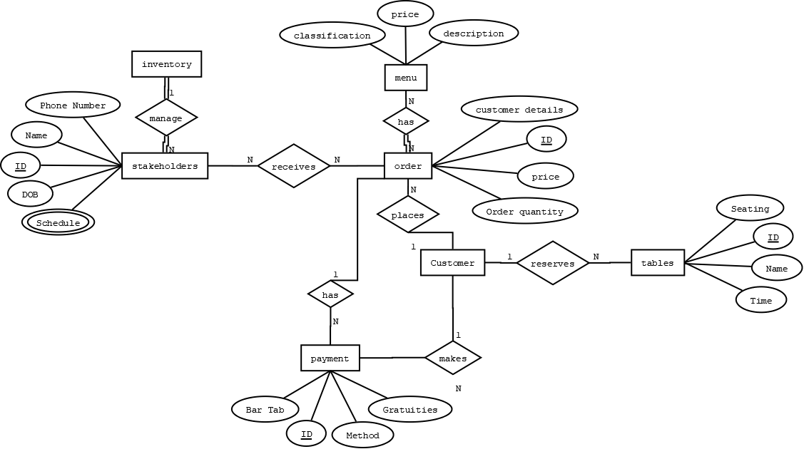

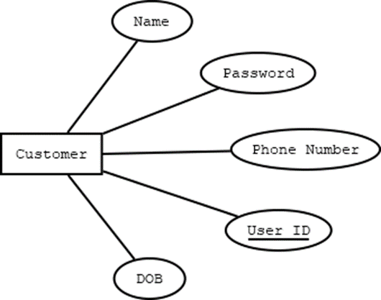

Assumptions and Constraints
The Customer who opens a bar tab is definitely above 18 years age.
The Customer who reserves a table at the hotel should know the table layout & can book multiple tables.
The table occupancy and wait queue will be calculated using Tables above.

Milestone 3: Logical Design

Entity Relationship Diagram
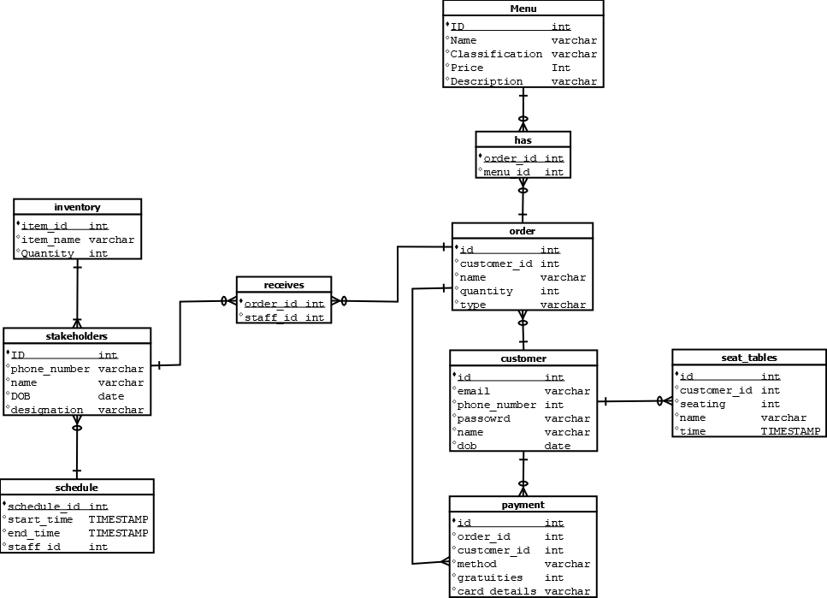

Entity name: Inventory
Attributes: Item Name, Item ID, Quantity
Functional dependencies: Item ID → Item Name, Quantity
Attributes not in FD | Attributes on the left | Attributes on both sides | Attributes on the right side
 | Item ID |  | Item Name, Quantity

Attribute closures (if any):
(Item ID) + = Item Name, Quantity
Unique keys: Item ID

Entity name: Stakeholders
Attributes: ID, Phone Number, Name, DOB, Schedule, Designation.
Functional dependencies: ID → Phone Number, Name, DOB, Schedule, Designation.
Attributes not in FD | Attributes on the left | Attributes on both sides | Attributes on the right side
 | ID |  | Phone Number, Name, DOB, Schedule, Designation.

Attribute closures (if any):
ID + = Phone Number, Name, DOB, Schedule, Designation.
Unique keys: ID

Entity name: Schedule
Attributes: Schedule ID, Start time, end time, Staff ID
Functional dependencies: Schedule ID → Start time, end time, Staff ID
Attributes not in FD | Attributes on the left | Attributes on both sides | Attributes on the right side
 | Schedule ID |  | Start time, End time, Staff ID

Attribute closures (if any):
(Schedule ID) + = Start time, End time, Staff ID
Unique keys: Schedule ID

Entity name: Menu
Attributes: ID, Name, Classification, Price, Description
Functional dependencies: ID → Name, Classification, Price, Description
Attributes not in FD | Attributes on the left | Attributes on both sides | Attributes on the right side
 | ID |  | Name, Classification, Price, Description

Attribute closures (if any):
ID + = Name, Classification, Price, Description
Unique keys: ID

Entity name: Order
Attributes: ID, Name, Quantity, Type, customer id
Functional dependencies: ID → Quantity, Type
Attributes not in FD | Attributes on the left | Attributes on both sides | Attributes on the right side
 | ID |  | Name, Quantity, Type, customer id

Attribute closures (if any):
ID + = Name, Quantity, Type, customer id
Unique keys: ID

Entity name: Customer
Attributes: ID, email, Phone Number, Password, Name, DOB.
Functional dependencies: ID → email, Phone Number, Password, Name, DOB.
Attributes not in FD | Attributes on the left | Attributes on both sides | Attributes on the right side
 | ID |  | email, Phone Number, Password, Name, DOB

Attribute closures (if any):
ID + = email, Phone Number, Password, Name, DOB.
Unique keys: ID

Entity name: Payment
Attributes: ID, order id, customer id, Method, Gratuities, Card details
Functional dependencies: ID → Method, Gratuities, Card details
Attributes not in FD | Attributes on the left | Attributes on both sides | Attributes on the right side
 | ID |  | order id, customer id, Gratuities, Card details, Method

Attribute closures (if any):
ID + = order id, customer id, Gratuities, Card details, Method
Unique keys: ID

Entity name: seat_tables
Attributes: ID, Seating, Name, Time
Functional dependencies: ID → Seating, Name, Time, Customer ID
Attributes not in FD | Attributes on the left | Attributes on both sides | Attributes on the right side
 | ID |  | Seating, Name, Time

Attribute closures (if any):
ID + = Seating, Name, Time
Unique keys: ID

Assumptions and Constrain

Milestone 4: Normalization and

Milestone 5: Physical Design

Assumptions and Constraints

Naming Conventions

Discuss the naming standards and conventions that you have used for table creation.

Tables
1.
 | Name of the table | menu
 | Description | Menu is something which has the list of items being prepared along with the description and the price for the better understanding of customer.
 | Attribute | Description |  | Type | Examples of values | Notes
 | ID | Id of the menu |  | int | 1 to 99999999
 | Name | Name of the item |  | varchar | Rice | Cannot be null
 | Classification | Classification of the type of item |  | varchar | Starters, Soups, Main course
 | Price | Price of the item |  | int | $9.99
 | Description | Description of the item |  | varchar | List of ingredients
 | Functional Dependencies and Keys
 | Functional dependencies | ID → Name, Classification, Price, Description
 | Candidate keys | ID
 | Normalization
 | 1NF | Yes | There are no repeated values in either columns or rows.
 | 2NF | Yes | There is no Partial Dependency
 | 3NF | Yes | There is no Transitive Dependency
 | BCNF | Yes | All the attributes depend only on the key
 | Physical Design
 | Primary Key | ID
 | Foreign Keys | -
 | SQL Code | CREATE TABLE menu (  id int NOT NULL,  name varchar(100) NOT NULL,  classification varchar(200),  price int NOT NULL,  description varchar(500),  PRIMARY KEY(id)  );
 | Count of records in the table | 20

2.
 | Name of the table | stakeholders
 | Description | Stakeholders are people who either are a part of restaurant and people who work in the restaurant.
 | Attribute | Description |  | Type | Examples of values | Notes
 | ID | ID of the stakeholder. |  | int | 1 to 9999
 | Phone Number | Phone number of the stakeholder. |  | varchar | +14847169062
 | schedule | Schedule of the stakeholder |  | varchar | Mon 9:00 AM
 | Name | Name of the stakeholder. |  | varchar | Sid
 | DOB | Date of Birth of the stakeholder. |  | Date | 11/22/1985 | Should be born before 2003.
 | Designation | Role of their work |  | varchar | Manager
 | Item ID | ID of the item in inventory. |  | int | 1 to 999
 | Schedule ID | ID of the schedule |  | int | 1 to 99
 | Functional Dependencies and Keys
 | Functional dependencies | ID → Phone Number, Name, DOB, Schedule, Designation, Item ID, Schedule ID
 | Candidate keys | ID
 | Normalization
 | 1NF | Yes | There are no repeated values in either columns or rows.
 | 2NF | Yes | There is no Partial Dependency
 | 3NF | Yes | There is no Transitive Dependency
 | BCNF | Yes | All the attributes depend only on the key
 | Physical Design
 | Primary Key | ID
 | Foreign Keys | Item ID, Schedule ID
 | SQL Code | CREATE TABLE stakeholders  (  id int NOT NULL,  phone_number varchar(100) NOT NULL,  name varchar(200) NOT NULL,  dob date,  schedule varchar(100),  designation varchar(500) NOT NULL,  PRIMARY KEY(id)  CONSTRAINT fk_iid_stakeholders FOREIGN KEY(item id) REFERENCES inventory(item id)  CONSTRAINT fk_sid_stakeholders FOREIGN KEY(schedule id) REFERENCES schedule(schedule id)  );
 | Count of records in the table | 20

3.
 | Name of the table | Inventory
 | Description | Inventory is a storage place which contains all the ingredients required by the hotel to cook.
 | Attribute | Description |  | Type | Examples of values | Notes
 | Item Name | Name of the item in the inventory |  | varchar | Mushroom
 | Item ID | ID of the item in inventory. |  | int | 1 to 999
 | Quantity | Quantity of the item in Inventory |  | int | 1 to 99
 | Functional Dependencies and Keys
 | Functional dependencies | Item ID → Item Name, Quantity
 | Candidate keys | Item ID
 | Normalization
 | 1NF | Yes | There are no repeated values in either columns or rows.
 | 2NF | Yes | There is no Partial Dependency
 | 3NF | Yes | There is no Transitive Dependency
 | BCNF | Yes | All the attributes depend only on the key
 | Physical Design
 | Primary Key | Item ID
 | Foreign Keys | -
 | SQL Code | CREATE TABLE inventory (  itemid int NOT NULL,  quantity int NOT NULL,  itemname varchar(100),  PRIMARY KEY(itemid)  );
 | Count of records in the table | 20

4.
 | Name of the table | Schedule
 | Description | Schedule of the stakeholders
 | Attribute | Description |  | Type | Examples of values | Notes
 | Schedule ID | ID of the schedule |  | int | 1 to 99
 | Start time | Start time of the schedule |  | TIMESTAMP | 11/22/2021  9:00:00
 | End time | End time of the schedule |  | TIMESTAMP | 11/22/2021  19:00:00
 | Staff ID | ID of the staff |  | int | 1 to 9999
 | Functional Dependencies and Keys
 | Functional dependencies | Schedule ID → Start time, end time, Staff ID
 | Candidate keys | Schedule ID
 | Normalization
 | 1NF | Yes | There are no repeated values in either columns or rows.
 | 2NF | Yes | There is no Partial Dependency
 | 3NF | Yes | There is no Transitive Dependency
 | BCNF | Yes | All the attributes depend only on the key
 | Physical Design
 | Primary Key | Schedule ID
 | Foreign Keys | Staff ID
 | SQL Code | CREATE TABLE schedule (  schedule_id int NOT NULL,  starttime TIMESTAMP NOT NULL,  endtime TIMESTAMP NOT NULL,  staffid int NOT NULL,  PRIMARY KEY(id),  CONSTRAINT fk_sid_schedule FOREIGN KEY(staffid) REFERENCES stakeholders(id)  );
 | Count of records in the table | 20

5.
 | Name of the table | order
 | Description | Order contains the orders placed by customers.
 | Attribute | Description |  | Type | Examples of values | Notes
 | ID | ID of the order |  | int | 1 to 9999
 | Name | Name of the item |  | varchar | Soup
 | Customer ID | ID for the customer |  | int | 1 to 999999
 | Quantity | Quantity of the item |  | int | 1 to 99
 | Type | Type of the order |  | varchar | Starters
 | Functional Dependencies and Keys
 | Functional dependencies | ID → Name, Customer ID, Quantity, Type.
 | Candidate keys | ID
 | Normalization
 | 1NF | Yes | There are no repeated values in either columns or rows.
 | 2NF | Yes | There is no Partial Dependency
 | 3NF | Yes | There is no Transitive Dependency
 | BCNF | Yes | All the attributes depend only on the key
 | Physical Design
 | Primary Key | ID
 | Foreign Keys | Customer ID
 | SQL Code | CREATE TABLE orders (  id int NOT NULL,  customerid int NOT NULL,  quantity int,  type varchar(100) NOT NULL,  PRIMARY KEY(id),  CONSTRAINT fk_cid_order FOREIGN KEY(customerid) REFERENCES customer(id)  );
 | Count of records in the table | 20

6.
 | Name of the table | customer
 | Description | The table contains details about customers of the restaurant.
 | Attribute | Description |  | Type | Examples of values | Notes
 | ID | ID of the customer |  | int | 1 to 999
 | email | Email of the customer |  | varchar | Lkk5220@psu.edu
 | Phone Number | Phone number of the customer. |  | varchar | +14847169062
 | Password | Encrypted password of the login details of customer. |  | varchar | $%&dvf
 | Name | Name of customer |  | varchar | Sid
 | DOB | Date of Birth of customer |  | Date | 11/22/2000
 | Functional Dependencies and Keys
 | Functional dependencies | ID → email, Phone Number, Password, Name, DOB.
 | Candidate keys | ID
 | Normalization
 | 1NF | Yes | There are no repeated values in either columns or rows.
 | 2NF | Yes | There is no Partial Dependency
 | 3NF | Yes | There is no Transitive Dependency
 | BCNF | Yes | All the attributes depend only on the key
 | Physical Design
 | Primary Key | ID
 | Foreign Keys | -
 | SQL Code | CREATE TABLE customer (  id int NOT NULL,  name varchar(100) NOT NULL,  dob date,  phonenumber varchar(12),  email varchar(100) NOT NULL,  password varchar(20),  PRIMARY KEY(id)  );
 | Count of records in the table | 20

7.
 | Name of the table | payment
 | Description | Payment made by the customer.
 | Attribute | Description |  | Type | Examples of values | Notes
 | ID | Payment ID |  | int | 1 to 99999
 | Order ID | ID of the order |  | int | 1 to 9999
 | Customer ID | ID of customer paying |  | int | 1 to 99999
 | Method | Type of payment |  | varchar | Credit, Debit
 | Gratuities | Gratuities paid by customer. |  | int | 1 to 99
 | Card Details | Card Details of the customers |  | varchar | 4011301120111011
 | Functional Dependencies and Keys
 | Functional dependencies | ID → Customer ID, Order ID, Method, Gratuities, Card details
 | Candidate keys | ID
 | Normalization
 | 1NF | Yes | There are no repeated values in either columns or rows.
 | 2NF | Yes | There is no Partial Dependency
 | 3NF | Yes | There is no Transitive Dependency
 | BCNF | Yes | All the attributes depend only on the key
 | Physical Design
 | Primary Key | ID
 | Foreign Keys | Order ID
 | SQL Code | CREATE TABLE payment  (  id int NOT NULL,  orderid int NOT NULL,  payment_method varchar(100) NOT NULL,  gratuities int,  carddetails varchar(100),  PRIMARY KEY(id),  CONSTRAINT fk_oid_payment FOREIGN KEY(orderid) REFERENCES orders(id)  );
 | Count of records in the table | 20

8.
 | Name of the table | seat_tables
 | Description | Contains details of tables for reservations and allocations
 | Attribute | Description |  | Type | Examples of values | Notes
 | ID | ID of the table. |  | int | 1 to 999
 | Seating | Number of seatings |  | int | 1 to 9
 | Name | Name of the table |  | varchar | Rooftop 1
 | Time | Time of reservation for the table |  | TIMESTAMP | 11/22/2021  18:00:00
 | Functional Dependencies and Keys
 | Functional dependencies | ID → Customer ID, Seating, Name, Time
 | Candidate keys | ID
 | Normalization
 | 1NF | Yes | There are no repeated values in either columns or rows.
 | 2NF | Yes | There is no Partial Dependency
 | 3NF | Yes | There is no Transitive Dependency
 | BCNF | Yes | All the attributes depend only on the key
 | Physical Design
 | Primary Key | ID
 | Foreign Keys | Customer ID
 | SQL Code | CREATE TABLE tables_booked (  id int NOT NULL,  customerid int NOT NULL,  seating int NOT NULL,  name varchar(100) NOT NULL,  times TIMESTAMP NOT NULL,  PRIMARY KEY(id),  CONSTRAINT fk_cid_tables FOREIGN KEY(customerid) REFERENCES customer(id)  );
 | Count of records in the table | 20

Milestone 6: SQL queries and

Note: Please make sure you add/have 25 records in each table, on average.

Query 1
English version | Return the name, email, phone number, date of birth for the most first customer.
Source for the query need in the SRS document
SQL sentence | select name, email, phonenumber, dob from customer where id in (select min(id) from customer)
Example of returned rows (cropped screen caption) | 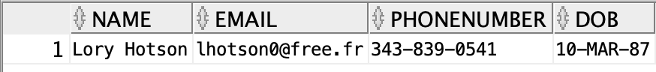

Query 2
English version | Return the various roles of restaurant Stakeholders’ in the database.
Source for the query need in the SRS document
SQL sentence | select distinct (designation) from stakeholders
Example of returned rows (cropped screen caption) | 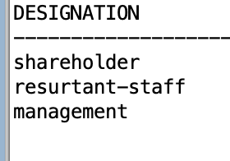

Query 3
English version | Return the item along with it’s quantity in the inventory.
Source for the query need in the SRS document
SQL sentence | select itemname, quantity  from inventory  group by itemname, quantity  order by quantity
Example of returned rows (cropped screen caption) | 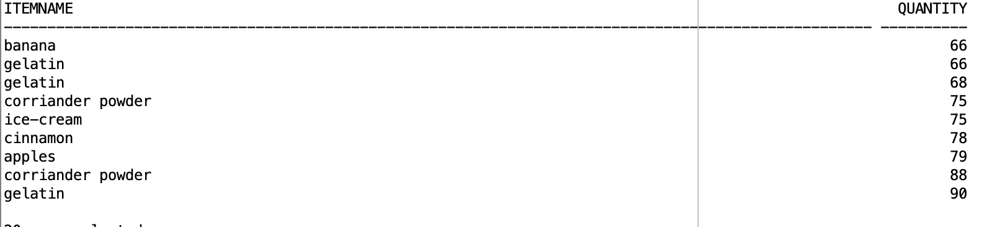

Query 4
English version | Return Customer contact details who has the highest payment in the restaurant to give coupon.
Source for the query need in the SRS document
SQL sentence | select gratuities, phonenumber, email, name  from customer c, orders r, payment p  where c.id = r.customerid and p.orderid = r.id and gratuities = (select max(gratuities) from payment)
Example of returned rows (cropped screen caption)

Query 5
English version | Return Customer and stakeholders’ born in the month of May.
Source for the query need in the SRS document
SQL sentence | select dob, name from customer where dob like '%MAY%'  UNION  select dob,name from stakeholders where dob like '%MAY%'  select dob from stakeholders where dob like '%MAY%'
Example of returned rows (cropped screen caption) | 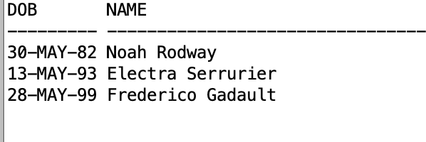

Query 6
English version | Return the table which has been booked more than 5 times.
Source for the query need in the SRS document
SQL sentence | select name, count(*) as number_times_booked  from seat_table  group by name  having count (*) > 5
Example of returned rows (cropped screen caption) | 



