**CREATE AND CONFIGURE CLIENT PROFILE**

1. 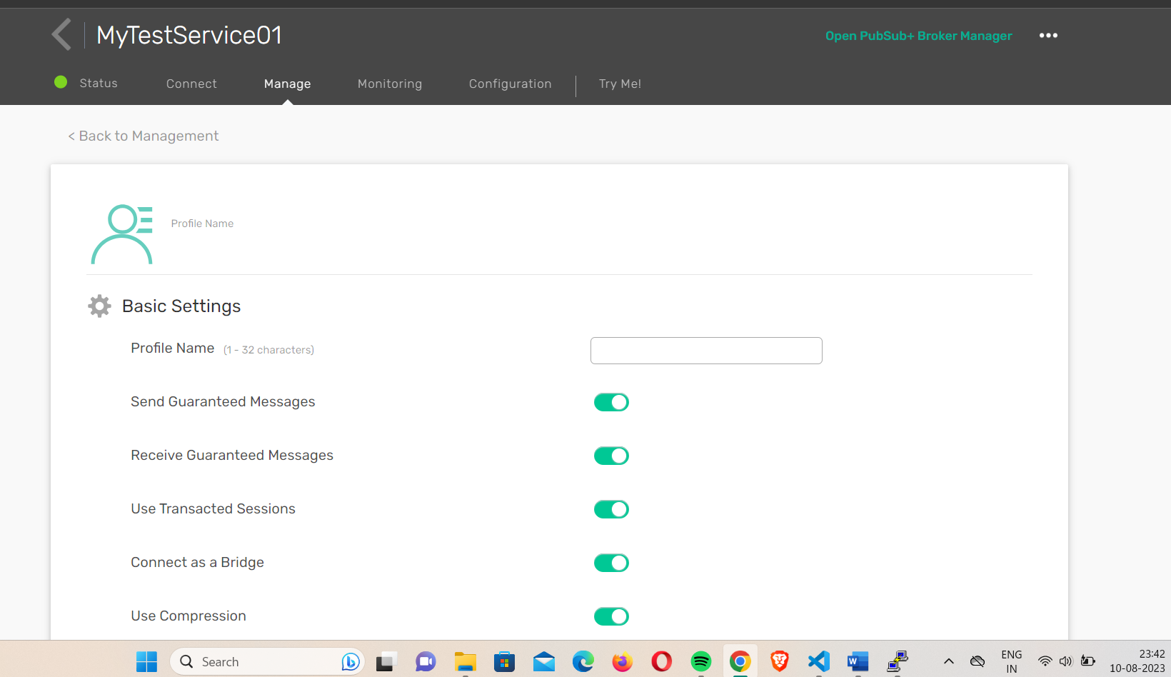

Solace Pubsub+ > Cluster manager>Manage>Client Profiles>Add NEW(Profile name: clnt10, Minimum Keepalive Timeout (sec)=100)> SAVE

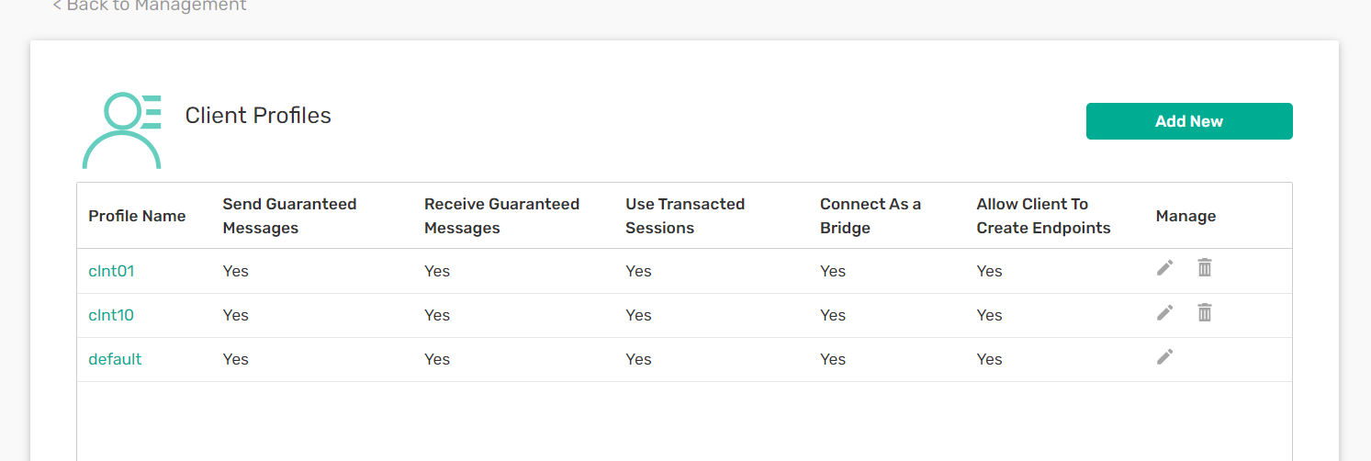

2. Check the created client profile in access control.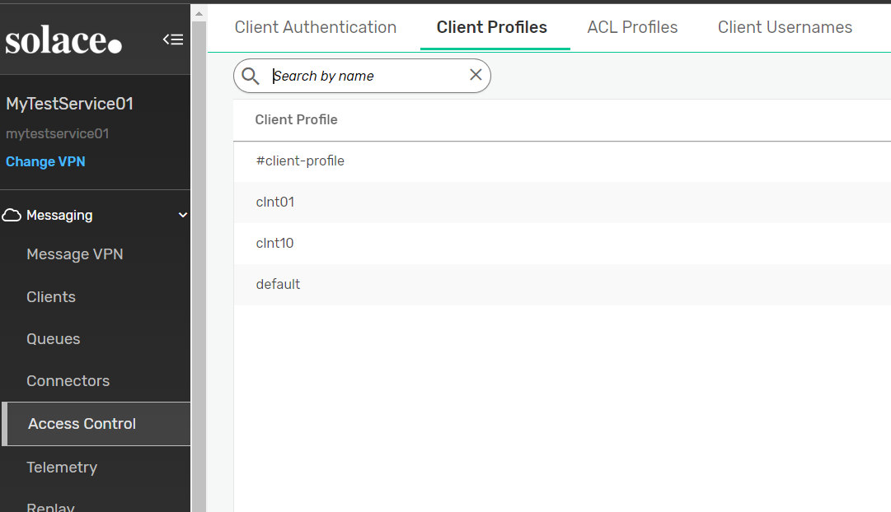

Open Pubsub+ Broker Manager>Access control>Client Profiles-clnt10

3.Create a new client username to bind with ACL Profile and client profile

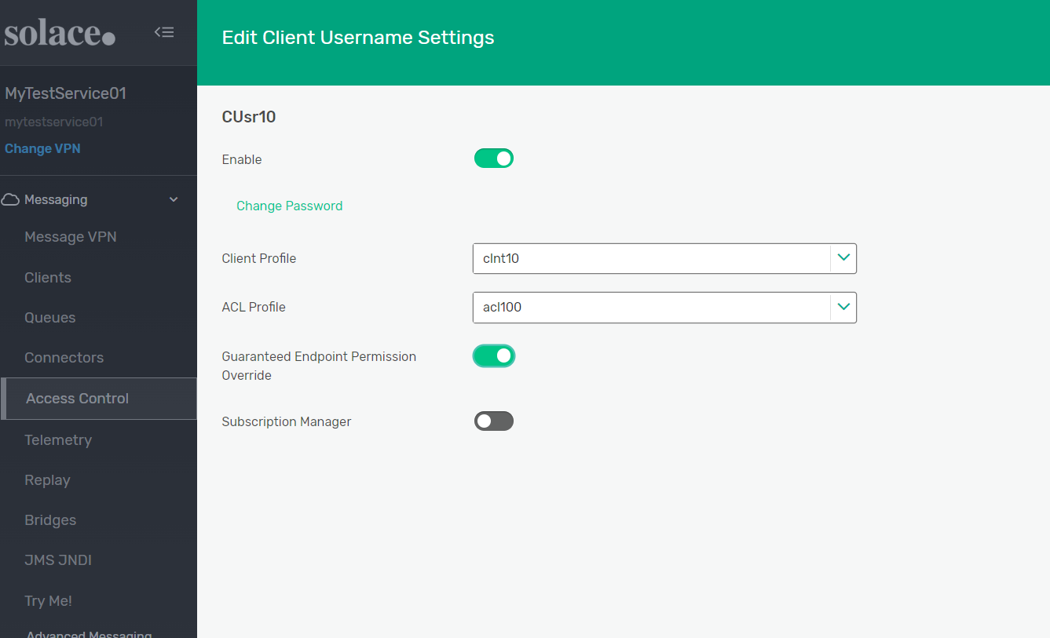

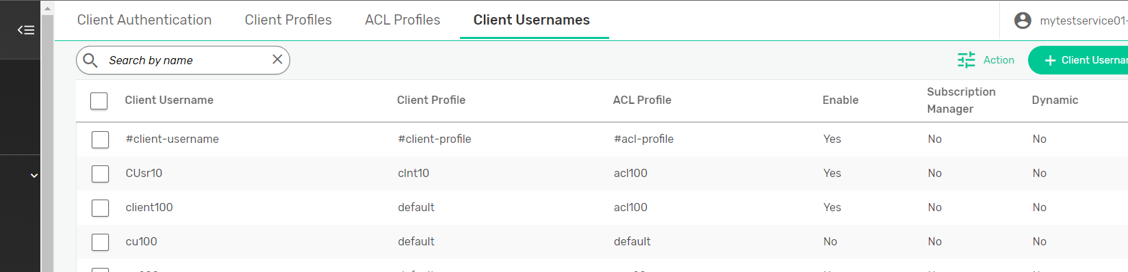

4. Create a new queue and bind it with new client username

