Sine-wave simulation of the split-core current transformer
FEMM and Octave, real steel, wire and conductor data, 300 A and 500 A line current, with rectifier, charger, core loss and temperature
Shashi Bhooshan, 26 October 2026

1. Summary
The energy-harvesting current transformer of the design report was rebuilt in FEMM with the dimensions chosen for cutting (outer 51 × 47 mm, window 27 × 23 mm, limb 12 mm, stack 34 mm, two 0.2 mm joints, mass 499.0 g). FEMM has no AC in its nonlinear solver, so the 50 Hz line current is stepped through a cycle in Octave and FEMM is solved at every instant. The material data come from published datasheets; the few assumed items (diodes, charger, heat transfer) are marked in Section 2. The loss in the steel, the leakage including the end turns, the position of the line conductor, a diode bridge with a battery charger, and the temperature rise are all simulated. The main results are:
- At the design current of 300 A rms the core is not saturated (1.40 T in the limb, 1.45 T in the steel). The open-circuit voltage is 16.2 V rms. On the 9.88 Ω burden of the report the load gets 12.4 V, 1.26 A and 15.6 W, and 16.4 W is possible at the best burden, 7.07 Ω.
- With the real load, a Schottky bridge feeding an input-regulated charger, the dc link takes 12.2 W at 9.1 V. After the diodes, the winding and the 90 % buck stage, 11.0 W reaches a 2S battery as 1.3 to 1.8 A, so a 3 Ah pack charges in about 2 hours.
- The leakage inductance, including the end turns that a 2D model misses, is 0.29 mH, 1.3 % of the magnetizing inductance. The report assumed 62 % from the thesis hardware, and that is the main reason it predicts 9.5 W where the simulation gives 16 W. The built CT must be measured to settle this.
- At 500 A rms the steel saturates (1.93 T). The open-circuit voltage is 23.7 V rms with 28 % distortion and a 38 V peak. Through the bridge the dc link takes 33 W, but the winding reaches about 127 °C and the core 114 °C in still air, so 500 A can only be a short-time condition.
- At 300 A the winding settles near 64 °C with the line at 75 °C. This is above the softening temperature of PLA (about 60 °C), so the PLA bobbins of the report should be replaced by a higher-temperature material.
- The conductor position changes the flux linkage by less than 0.1 % (open secondary) and about 1 % (loaded). Skin and proximity effect in the winding and the field of the neighbouring phases are negligible. The numerical method agrees with direct FEMM solves to 0.8 % (300 A) and 1.0 % (500 A) of peak flux linkage.
Table 1. Main results
Quantity | 300 A rms | 500 A rms
Open-circuit voltage | 16.23 V rms | 23.71 V rms (38.1 V peak)
Peak flux density, limb average / in the steel | 1.40 T / 1.45 T | 1.86 T / 1.93 T
Highest local flux density in the core | 1.66 T | 1.95 T
Distortion of the open-circuit EMF | 0.4 % | 27.6 %
Resistor 9.88 Ω: voltage, current, power | 12.43 V, 1.258 A, 15.6 W | 19.55 V, 1.979 A, 38.7 W
Best resistor | 7.07 Ω, 16.4 W | 6.26 Ω, 43.6 W
Bridge into the dc link: best Vdc, power | 9.1 V, 12.2 W | 13.6 V, 33.0 W
To the 2S battery (buck 90 %) | 11.0 W, 1.3 to 1.8 A | 29.7 W, 3.4 to 4.5 A
Winding / diode / core loss at the bridge point | 2.1 W / 1.5 W / 0.15 W | 8.0 W / 2.9 W / 0.42 W
Temperature, winding / core (still air, line hot) | 64 °C / 61 °C | 127 °C / 114 °C

2. Design data and where it comes from
Nothing in the model is a round number picked by hand. The table lists each input and its source. Items marked assumed are the ones that a measurement on the real parts should replace.
Table 2. Inputs of the simulation
Item | Value | Source
Core | Outer 51 × 47 mm, window 27 × 23 mm, limb 12 mm, stack 34 mm, two joints of 0.2 mm (top and bottom limb) | Chosen for cutting (Option A)
Core steel | Grain-oriented M-4, 0.27 mm, 7.65 g/cm³, saturation 2.035 T, stacking factor 0.965 | ATI Allegheny Ludlum GOES bulletin 2012, Tables 1 and 7
B-H curve | From the typical peak permeability 25 800 to 42 300 (0.2 to 1.6 T); B = 1.85 T at 800 A/m; 1.6 to 1.85 T interpolated; approach to saturation above | Same bulletin, Tables 15 and 18
Core loss | Typical 50 Hz and 60 Hz loss from 1.0 to 1.8 T (0.792 W/kg at 1.5 T, 1.144 W/kg at 1.7 T, 50 Hz), split into hysteresis and eddy part | Same bulletin, Table 13
Steel thermal data | Conductivity 29.9 W/mK, heat capacity 502 J/kgK, resistivity 48 μΩcm | Same bulletin, Table 1
Winding | AWG 22, bare 0.644 mm, enamelled 0.70 mm (heavy build MW 35-C), 64 turns per limb in 3 layers (30 + 30 + 4), N2 = 128 | Magnet wire catalogues (0.69 to 0.71 mm); turns from the report
Winding resistance | 0.741 Ω at 20 °C from the real layer lengths (14.0 m of wire, 40.9 g); 0.901 Ω at 75 °C, 1.047 Ω at 125 °C | Calculated, copper 1.724×10⁻⁸ Ωm, 0.393 %/K
Bobbin | 2 mm wall, 1 mm flanges, PLA, 13.6 g | Design report (bobbin wall modelled as air)
Line conductor | ACSR Dog, 14.15 mm; steel core 4.71 mm (7 × 1.57 mm), aluminium ring 105 mm² | IS 398 Part II / BS 215 tables
Diodes | Schottky SS34, 0.5 V at about 3 A, 0.03 Ω dynamic resistance | Datasheet maximum Vf; resistance assumed
Charger and battery | Input-regulated buck stage 90 %, 2S Li-ion 6.0 / 7.4 / 8.4 V, 0.12 Ω internal resistance, 3 Ah pack | Assumed typical values
Environment | Ambient 40 °C, still air h = 10 W/m²K (5 and 20 also run), line at 75 °C at 300 A and scaled with I² | Assumed

Mass budget: steel 444.6 g (core area 1771 mm² × 34 mm × 0.965 stacking factor), copper 40.9 g, bobbins 13.6 g, total 499.0 g. The core is therefore within the 500 g target, but the resin cradle, epoxy and terminals are not counted.

3. The FEMM model
The model is a 2D planar drawing of the front view with the out-of-plane depth set to the stack depth. The two joints cut the core into a left and a right half, each carrying one coil, so the CT can be opened around the line. The line conductor is drawn as a steel core with an aluminium ring, the same outside diameter as the real cable. Each coil is a polygon with 60 turns in two full layers and 4 turns in a short third layer at the top end, on both the window side and the outer side of its limb, all in one series circuit. The bobbin wall is air. An open boundary of seven shells and 120 mm radius surrounds the model, and the joints have a 0.05 mm mesh.
The magnetization curve is the typical M-4 data described above. In the field solution it is single valued; the hysteresis and eddy loss are added separately from the datasheet loss data (Section 5). Typical values are listed in Table 3.
Table 3. Magnetization curve of the M-4 steel used in FEMM
B (T) | 0.2 | 0.6 | 1.0 | 1.2 | 1.4 | 1.5 | 1.6 | 1.7 | 1.8 | 1.85
H (A/m) | 6.2 | 13.9 | 19.7 | 22.6 | 28.3 | 35.2 | 52.5 | 156* | 462* | 796
μr | 25 800 | 34 400 | 40 400 | 42 300 | 39 400 | 33 900 | 24 200 | 8 700* | 3 100* | 1 850

* interpolated between the 1.6 T table value and the datasheet value of 1.85 T at 796 A/m.
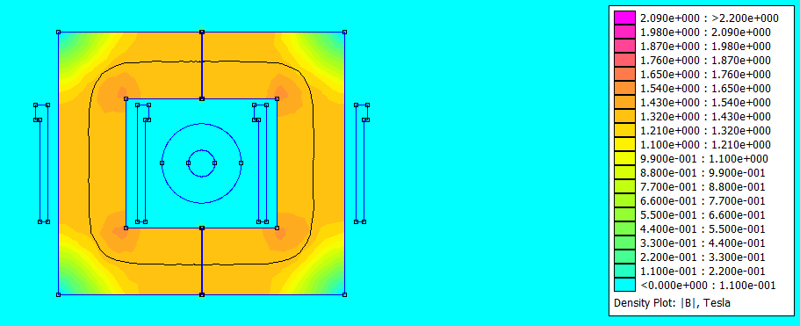
Figure 1a. Flux density in the model at the peak of the line current, 300 A rms, secondary open. Joints at the top and bottom, coils on the two side limbs, ACSR with its steel core in the window.
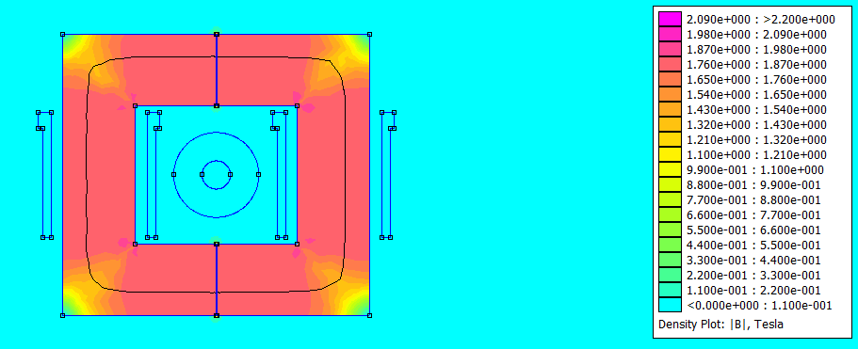
Figure 1b. The same at 500 A rms. The limbs are at 1.76 to 1.87 T on the average field of FEMM.

4. Check against the hand calculation
The geometry was first checked with the harmonic solver at 50 Hz and a linear core (μr = 42 345, the flat part of the M-4 curve), secondary open, 300 A rms, and compared with the lumped-path formula of the report using the new dimensions and a total gap of 0.4 mm.
Table 4. Open-circuit check, linear core
Quantity | Hand calculation | FEMM | Difference
Magnetizing inductance Lm (secondary side) | 20.09 mH | 22.08 mH | +9.9 %
Open-circuit voltage | 14.79 V rms | 16.26 V rms | +9.9 %

FEMM is 10 % above the lumped formula. The formula uses a single path length and a single gap area, so it leaves out the spreading of flux around the joints and at the corners. The difference is the size expected from such a simple magnetic circuit.

5. How the simulation is done
The nonlinear FEMM problem is magnetostatic: it has no time. The time dependence is therefore handled in Octave and FEMM is used as a function that gives the flux for given currents. At every instant the field is quasi-static, which is justified at 50 Hz in 0.27 mm laminations.
- Line current. i1(t) = I1pk sin(ωt) with I1pk = √2 × I1rms, applied to the aluminium ring of the cable (primary, one turn).
- Open circuit. The field solution has no hysteresis, so the flux depends only on the instantaneous current: λ2(−i) = −λ2(i) and λ2(T/2 − t) = λ2(t). FEMM is solved for a quarter cycle (13 instants) and the full cycle of 48 points follows. The EMF is dλ2/dt from an FFT derivative. The flux density across the limb comes from the change of the vector potential, and 1770 points in the core are sampled at the current peak to get a map of the local flux density.
- Table for the loaded cases. A resistor or a rectifier cannot be put in FEMM, so FEMM gives λ2 for a grid of line current i1 and secondary current i2 (13 × 13 solves at 300 A, 15 × 13 at 500 A). The model is odd in (i1, i2), so only i1 ≥ 0 is solved. The table is resampled finely and interpolated.
- Circuit equation. The secondary terminals obey the equation below, with the load deciding the terminal voltage vt. For a resistor vt = −RL i2. For the bridge vt = ±(Vdc + 2Vf + 2 rd |i2|) while a diode pair conducts and i2 = 0 otherwise. The equation is stepped with a fourth-order Runge-Kutta method for 10 cycles from zero flux, and the last cycle is used. i2 is the FEMM circuit current, so the current leaving the winding is −i2.
dλ2/dt = −R1 i2 + vt λ2 = F(i1, i2) i1 = I1pk sin(ωt)
- Core loss. The loss of the steel is computed from the flux density waveform. The hysteresis part goes with the peak flux density, the eddy and anomalous part with the mean square of dB/dt, so a flat-topped saturated wave pays for its steep edges. The peak flux density of every point of the core map scales with the limb waveform. The part of the line current that feeds this loss does not magnetize the core, which is put into the circuit equation through a resistance Rfe across the induced voltage, found from the open-circuit loss.
- Charger. The bridge feeds a dc link held at Vdc by an input-regulated buck stage of 90 % efficiency. Vdc is swept to find the maximum power, and for each battery voltage Vdc is at least Vbat + 1.5 V. The battery current follows from Pbat = (Vbat + Rbat I) I.
- Temperature. The losses from the simulation drive a two-node thermal model (core, winding) with the winding resistance at its own temperature (Section 11).

6. Results at 300 A rms

Open circuit
The flux linkage and the EMF are almost pure sines (Figure 2, top row). The peak flux density is 1.40 T in the limb, 1.45 T in the steel, where the relative permeability is still about 36 000; the highest local value, at the inner corners of the core, is 1.66 T. The core is not saturated at the design current and the joints decide the inductance.
Table 5. Open circuit, 300 A rms
Quantity | Value
Peak flux linkage λ2 | 0.0730 Wb-turn
Peak flux density, limb / steel / highest local | 1.399 T / 1.449 T / 1.658 T
Open-circuit voltage | 16.23 V rms, 22.8 V peak
Distortion of the EMF | 0.4 %
Lm from the fundamental of λ2 | 22.05 mH
Core loss at the current peak, local map / limb average | 0.28 W / 0.33 W (hysteresis 0.36, eddy 0.37 W/kg)
Equivalent core loss resistance Rfe | 940 Ω (secondary side)

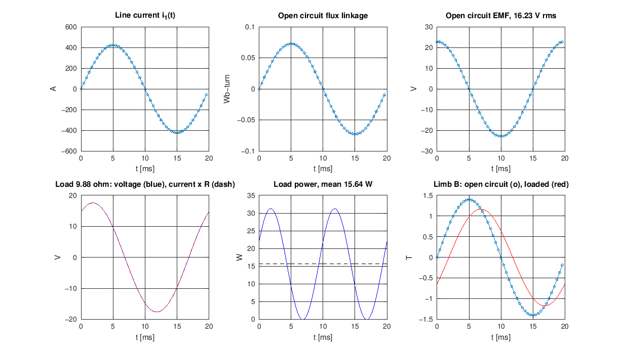
Figure 2. 300 A rms. Top: line current, open-circuit flux linkage and EMF (points are FEMM solves). Bottom: voltage, power and flux density with the 9.88 Ω load.

Resistor load
On the 9.88 Ω burden of the report the load gets 12.43 V and 1.258 A, which is 15.6 W. The winding loss is 1.4 W and the core loss 0.19 W. The peak limb flux density falls to 1.17 T because the secondary current opposes the line current. Starting from zero flux does not push the core above that. Maximum power is at RL = 7.07 Ω, with 16.4 W, 88 % of the power taken from the line. The best burden is the magnitude of the secondary impedance, and it is lower than the 9.88 Ω of the report because the leakage is smaller (Section 8).
Table 6. Resistor sweep, limb flux density
RL (Ω) | P 300 A (W) | I 300 A (A) | B 300 A (T) | P 500 A (W) | I 500 A (A) | B 500 A (T)
1.00 | 4.97 | 2.230 | 0.366 | 13.65 | 3.694 | 0.652
2.00 | 9.10 | 2.133 | 0.534 | 24.86 | 3.526 | 0.926
4.00 | 14.30 | 1.891 | 0.799 | 38.97 | 3.121 | 1.359
6.00 | 16.22 | 1.644 | 0.979 | 43.57 | 2.695 | 1.635
8.00 | 16.31 | 1.428 | 1.096 | 42.00 | 2.291 | 1.768
9.88 (report) | 15.64 | 1.258 | 1.170 | 38.69 | 1.979 | 1.820
12.00 | 14.59 | 1.102 | 1.227 | 34.98 | 1.707 | 1.843
16.00 | 12.54 | 0.885 | 1.290 | 29.18 | 1.350 | 1.856
24.00 | 9.42 | 0.627 | 1.345 | 21.46 | 0.946 | 1.858
40.00 | 6.11 | 0.391 | 1.378 | 13.84 | 0.588 | 1.859
Best | 7.07 Ω: 16.42 | 1.523 | 1.048 | 6.26 Ω: 43.63 | 2.639 | 1.660

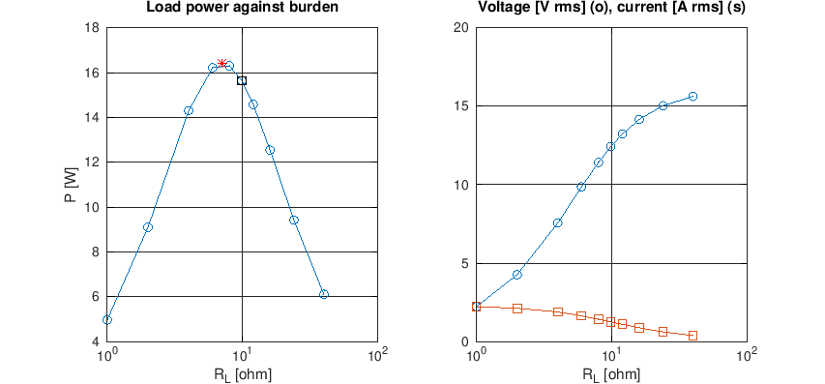
Figure 3. Load power, voltage and current against burden, 300 A rms. The red star is the best burden and the square is 9.88 Ω.

Flux density in the core and core loss
The map of the flux density in the steel (Figure 4) shows the limbs and the yokes at about 1.45 T and the outer corners lightly loaded, as in a normal rectangular core. The inner corners of the window are the highest, up to 1.66 T. The core loss is small, 0.28 W open circuit and 0.15 to 0.19 W under load, because the flux density falls with load and the core is only 0.44 kg.
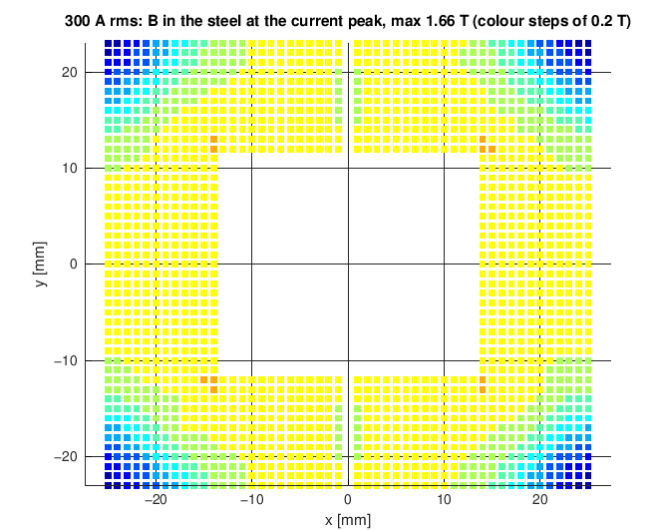
Figure 4. Flux density in the steel at the current peak, 300 A rms, secondary open (1 mm sampling grid, colour steps of 0.2 T).

Bridge rectifier, charger and battery
With a diode bridge the secondary current is not a sine and the terminal voltage is a square wave at ±(Vdc + 1 V) (Figure 5). Because the circuit is strongly inductive the current flows for the whole cycle when Vdc is below about 10 V. The power into the dc link has a maximum of 12.2 W at Vdc = 9.1 V. At that point the winding loses 2.1 W, the diodes 1.5 W and the core 0.15 W, and the equivalent ac resistance seen by the bridge is 6.7 Ω. This is below the 16 W of the pure resistor because of the diode drops and the higher winding loss at the larger rms current.
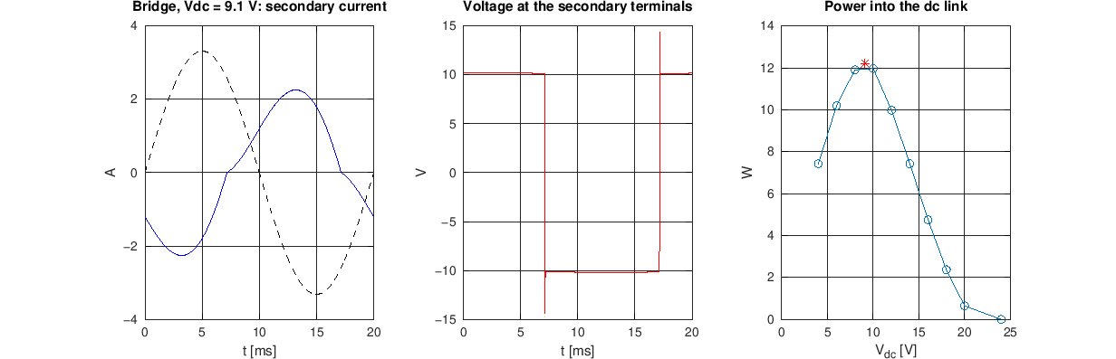
Figure 5. 300 A rms, bridge into a 9.1 V dc link: secondary current (blue) with the line current divided by N2 (dashed), terminal voltage, and power against dc link voltage.
Table 7. Charging a 2S battery, 300 A rms
Battery voltage | Vdc used | Power in dc link | Power to battery | Charging current | Time for 3 Ah
6.0 V | 9.1 V | 12.20 W | 10.98 W | 1.77 A | 2.0 h
7.4 V | 9.1 V | 12.20 W | 10.98 W | 1.45 A | 2.0 h
8.4 V | 9.9 V | 12.02 W | 10.81 W | 1.26 A | 2.0 h

The charging current is 0.4 to 0.6 C for a 3 Ah pack, so no current limit is needed. At full voltage the charger moves to constant voltage and the current tapers, so the last part of the charge takes longer than the 2 hours estimated from the average power.

7. Results at 500 A rms
Open circuit. The flux density follows a straight line up to about 1.5 T (line current around 450 A peak, 320 A rms) and then bends over. At 500 A the peak in the limb is 1.86 T instead of the 2.33 T of a linear core, 1.93 T in the steel, and the relative permeability falls to about 1100. The open-circuit voltage rises by a factor of only 1.46 instead of 1.67. The flux is flat topped, so the EMF is close to zero for part of the cycle and then rises sharply, with 28 % distortion and a 38 V peak (23.7 V rms). The highest local flux density is 1.95 T, 0.09 T below the saturation induction of 2.035 T.
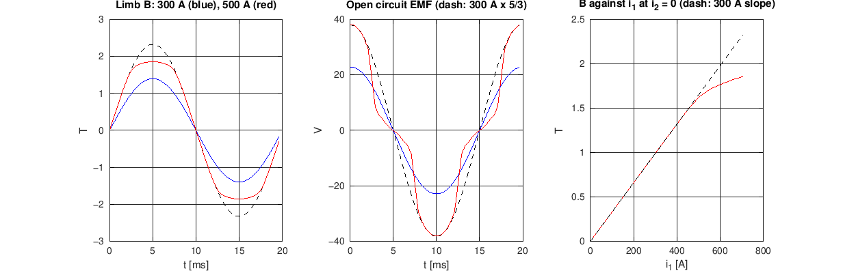
Figure 6. Open circuit at 300 A (blue) and 500 A (red). The dashed lines are the 300 A curves scaled by 5/3, which is what a linear core would give. Right: flux density against line current at i2 = 0.
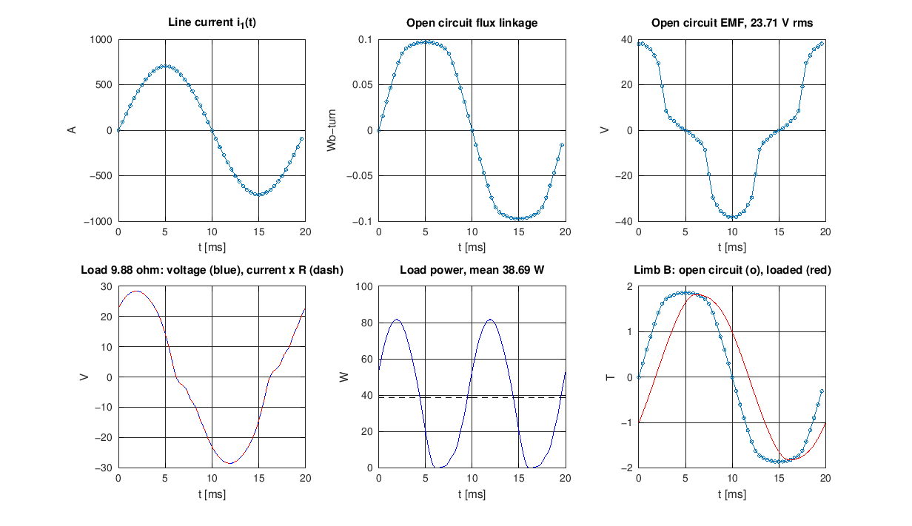
Figure 7. 500 A rms. Top: line current, open-circuit flux linkage and EMF. Bottom: voltage, power and flux density with the 9.88 Ω load.
Loaded. With a load, the secondary current takes part of the line ampere-turns and the core sees less flux. At the best burden of 6.26 Ω the peak limb flux density is 1.66 T and the CT delivers 43.6 W at 16.5 V and 2.64 A, with 7.3 W in the winding. On the 9.88 Ω burden the core is back in saturation (1.82 T) and the output is 38.7 W. For any burden above 12 Ω the flux density sits at about 1.85 T and does not change (Table 6).
Bridge and charger. The best dc link voltage is 13.6 V with 33.0 W into the dc link, 8.0 W in the winding, 2.9 W in the diodes and 0.42 W in the core. The battery would get 29.7 W, which is 3.4 to 4.5 A, more than 1 C for a 3 Ah pack. The charger would have to limit the current, which lowers the power drawn.
Table 8. Bridge into a dc link, power and secondary current against dc link voltage
Vdc (V) | P dc, 300 A (W) | Iac rms, 300 A (A) | P dc, 500 A (W) | Iac rms, 500 A (A)
4 | 7.43 | 2.071 | 13.01 | 3.622
6 | 10.20 | 1.905 | 18.91 | 3.512
8 | 11.91 | 1.683 | 24.13 | 3.369
10 | 11.97 | 1.383 | 28.61 | 3.203
12 | 9.99 | 1.011 | 31.94 | 2.995
14 | 7.43 | 0.685 | 32.85 | 2.684
16 | 4.75 | 0.415 | 31.41 | 2.316
18 | 2.37 | 0.205 | 28.91 | 1.964
20 | 0.65 | 0.060 | 25.65 | 1.633
24 | 0.00 | 0.000 | 18.20 | 1.053
Best | 9.1 V: 12.20 | 1.530 | 13.6 V: 33.00 | 2.767

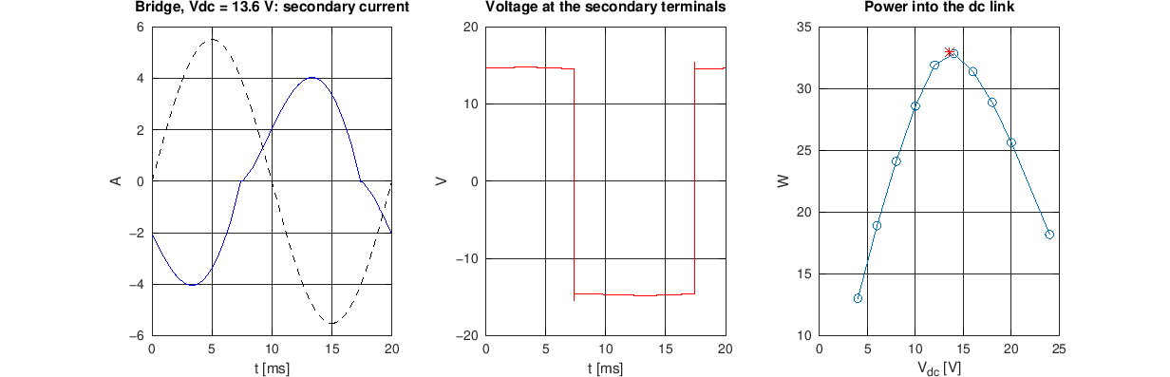
Figure 8. 500 A rms, bridge into a 13.6 V dc link.
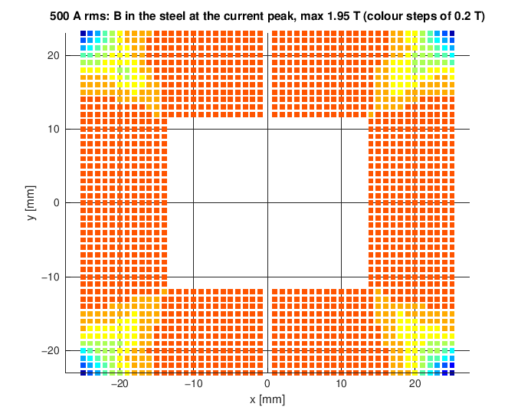
Figure 9. Flux density in the steel at the current peak, 500 A rms, secondary open. Most of the core is above 1.8 T.
Table 9. Core loss from the datasheet loss data
Case | 300 A rms | 500 A rms
Open circuit, local map (limb average) | 0.28 W (0.33 W) | 0.76 W (0.89 W)
Resistor 9.88 Ω | 0.19 W | 0.63 W
Best resistor | 0.15 W | 0.46 W
Bridge, best Vdc | 0.15 W | 0.42 W
Hysteresis / eddy at open circuit | 0.36 / 0.37 W/kg | 0.88 / 1.12 W/kg

The loss tables of the datasheet end at 1.8 T, and at 500 A the steel is at 1.93 T, so the 500 A core loss is an extrapolation along the log-log line of the last two points. Even if it were twice as large it would be small next to the winding loss.

8. Leakage inductance
The report assumed a leakage inductance of 62 % of Lm, taken from the thesis hardware. The leakage was calculated in three steps (ct_leakage.m).
- 2D model. With the harmonic solver and a linear core, the mutual inductance M (line current only) and the secondary self inductance L2 (1 A in the secondary only) give Lm = N2 M = 22.08 mH and a leakage L2 − Lm = 0.275 mH, which is 1.2 % of Lm.
- End turns. The 2D model holds only the straight sides of the coil (68 mm per turn of the 109 mm real mean turn). To scale the leakage correctly, the leakage per unit length of a straight side was compared with that of a round coil in an axisymmetric (pot core) FEMM model, both with a core of μr = 10⁵ and no joints, where the energy outside the iron is the leakage energy. K = L/(μ0 N² MLT) is 0.233 for the straight side and 0.150 for the round coil. With the real mean turn the leakage becomes 0.275 mH × 1.04 = 0.29 mH, or 1.3 % of Lm.
- Formula. The usual formula for a coil on a core leg, L = μ0 N² MLT (a + b/3)/h with a = 2 mm clearance, b = 2.1 mm winding thickness and h = 21 mm, gives K = 0.129 and 0.145 mH for the two coils, which is of the same size as the axisymmetric result.
So the leakage of this layout is about 1 %, not 62 %. The thesis CT was built differently, so its leakage does not apply. A hand-made winding with loose turns, a larger clearance to the limb or a coil spread over a different part of the limb will leak more, which is why the leakage of the built CT must be measured (open and short circuit tests).
Table 10. Loaded result from the FEMM harmonic solver (linear core), 300 A rms
Quantity | Harmonic solver | Time stepping, nonlinear
Voltage, current, power at 9.88 Ω | 12.49 V, 1.264 A, 15.78 W | 12.43 V, 1.258 A, 15.64 W
Best burden, power | 7.08 Ω, 16.56 W | 7.07 Ω, 16.42 W

The two methods agree to 0.9 % in power. The small difference is the 5 % lower permeability of the nonlinear steel at 1.4 T compared with the linear value.

9. Position of the line conductor
The ACSR cable is flexible and will not sit in the centre of the window. The model was redrawn with the conductor moved by 3 mm sideways and 4 mm up or down (the window leaves about 3 mm and 4.4 mm of room for the 14.15 mm cable) and solved at the current peak, for an open and a nearly shorted secondary.
Table 11. Change of the flux linkage with the position of the conductor, 300 A rms
Offset x, y (mm) | Open secondary | Loaded (i2 = −0.9 i1/N2) | Limb B, open
+3, 0 | +0.06 % | +0.49 % | +0.33 %
−3, 0 | +0.05 % | +0.48 % | −0.20 %
0, +4 | −0.04 % | −0.85 % | −0.07 %
0, −4 | −0.07 % | −1.14 % | −0.07 %
+3, +4 | +0.02 % | −0.19 % | +0.25 %
−3, −4 | −0.01 % | −0.50 % | −0.26 %

The position of the conductor has no practical effect on the output. The loaded column is a small difference of two large terms, so its percentages look larger than the real effect on the voltage, which stays within a few tenths of a percent.

10. Skin effect, proximity effect and neighbouring phases
At 50 Hz the skin depth of copper at 75 °C is 10.3 mm and the AWG 22 wire is 0.644 mm thick (ratio 0.06). The proximity effect of the three layers by the Dowell formula raises the ac resistance by 0.0006 %, so the dc resistance can be used. The aluminium of the ACSR has a skin depth of 13.2 mm against a strand ring of 4.7 mm, so the current is nearly uniform and the magnetic result does not change.
The other two phases of a line with 3 to 4.5 m spacing produce at most 38 to 57 μT at the CT. Taking all of that as flux collected by the whole core gives at most 1.9 to 2.8 mV rms induced in the secondary, against 16 V, and a core flux of 7 to 10 × 10⁻⁸ Wb against 5.7 × 10⁻⁴ Wb. The neighbouring phases are therefore negligible.

11. Temperature rise
The winding loss (current × current × R1 at the winding temperature) and the core loss from Section 6 heat a two-node model of the core and the winding, with convection and radiation to the ambient air and to the warm air of the window, which the hot line conductor heats. The bobbin wall couples the winding to the core. The winding resistance rises with temperature, so the loss and the temperature were solved together.
Table 12. Steady temperatures with the bridge load (a resistor load gives 0 to 7 K less), ambient 40 °C
Heat transfer h (W/m²K) | 300 A: winding / core | 500 A: winding / core
5 (still air, no wind) | 83 °C / 79 °C | 231 °C / 213 °C
10 (used for the other results) | 64 °C / 61 °C | 127 °C / 114 °C
20 (light wind) | 55 °C / 52 °C | 90 °C / 79 °C

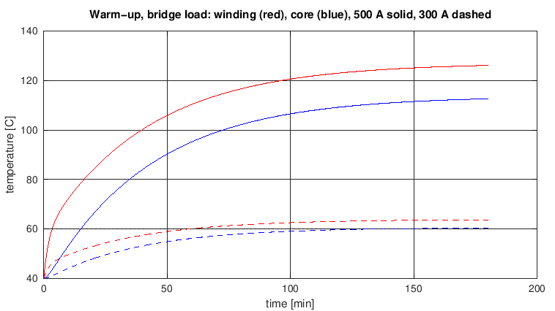
Figure 10. Warm-up from 40 °C with the bridge load. Solid 500 A, dashed 300 A; winding red, core blue.
At 300 A the winding settles at about 64 °C with the line at 75 °C, which is above the softening temperature of PLA, about 60 °C, reached after 59 minutes. A bobbin of PETG, ABS or a resin with a higher temperature rating should be used. The enamel of the wire is not a problem at these temperatures. At 500 A the winding reaches 60 °C after 3 minutes, 93 °C after 30 minutes and 126 °C after 3 hours (the line itself would be above 130 °C), so 500 A can only be a short excursion. The winding resistance of 0.901 Ω used for the 300 A runs corresponds to 75 °C, the thermal result is 64 °C, which changes the power by about 0.5 %. The 500 A runs use 125 °C, in line with the 127 °C found.

12. Accuracy checks
Table 13. Checks on the numerical method
Check | 300 A rms | 500 A rms
Interpolated table against the open-circuit solves (worst error, % of peak λ2) | 0.008 % | 0.083 %
Table against direct FEMM solves at 16 points of the loaded cycles (worst error, % of peak λ2) | 0.76 % | 1.04 %
Loaded power against the harmonic solver at 9.88 Ω | 15.64 W against 15.78 W (0.9 %) | not available (linear solver)
Loaded cycle repeats (difference between the last two cycles) | 2 × 10⁻¹⁵ A | 3 × 10⁻¹⁵ A
Position of the conductor (flux linkage, open secondary) | within 0.07 % | not run

The largest error is at points with a small line current, where the flux comes mostly from the secondary current and the spline of the table is least accurate, and at 500 A where the core bends over quickly between table points. About 1 % of peak flux linkage is small next to the uncertainty of the material data.

13. What the simulation does not tell, and what to measure
- The field solution has no hysteresis loop, so the phase lag of the magnetizing current from hysteresis is not in the waveforms; the loss is added from the datasheet instead. The B-H curve is the typical curve of M-4 steel, interpolated between 1.6 and 1.85 T. The steel that is actually bought will differ, and its datasheet curve should replace the one in ct_params.m.
- The end-turn leakage is estimated from an axisymmetric model and a formula, not from a full 3D solve. The result is small and the two estimates agree, but the built CT should be measured.
- The temperature comes from a lumped model with an assumed heat transfer coefficient and line temperature. A 2D thermal simulation cannot represent the cooling through the front and back faces of the stack. The sensitivity to the coefficient is shown in Table 12.
- The charger is an ideal input-regulated buck stage of 90 % efficiency, the diodes have a constant voltage drop, and the battery is a voltage source with a resistance. The real charger controller should be checked on the bench.
- To close these items, measure on the built CT: Lm and the leakage by open and short circuit tests, R1 with a milliohm meter, the open-circuit voltage and the voltage and current on the real load at 300 A, and the temperature of the winding after one hour. Then replace the inputs in ct_params.m by the measured ones and rerun.

Appendix A. Files and how to run
All files are in the folder final_sim. FEMM 4.2 (C:\femm42) and Octave are needed. The line current is set by the variable I1rms, 300 by default.
File | What it does
ct_params.m | All dimensions, material data (B-H, loss, wire, conductor, diode, battery) in one place
ct_draw_model.m | Draws the CT in FEMM; the conductor position and the core material are arguments
ct_build_model.m | Builds the model and runs the 50 Hz check (Table 4)
ct_sine_femm.m | Steps the sine through FEMM: open circuit, core flux map and the (i1, i2) table. About 35 to 50 minutes per current
ct_core_loss.m | Core loss of the steel for any flux waveform
ct_load_sim.m | Resistor and rectifier runs, charger, figures and the results_<I>A.txt files. Octave only, about 15 minutes
ct_leakage.m | Leakage with end turns (Section 8)
ct_offset_study.m | Position of the conductor (Section 9)
ct_thermal.m | Temperature rise (Section 11)
ct_sine_check.m | Direct FEMM check of the loaded runs (Table 13)
ct_analytic.m, ct_bmap_plot.m, ct_field_plot.m | Skin effect, neighbouring phases, mass; flux density map; field pictures

octave-cli --eval "I1rms=500; ct_sine_femm"
octave-cli --eval "I1rms=500; Tw=125; ct_load_sim"

Appendix B. Points for the presentation
- What was done: the CT of the report, with the dimensions chosen for cutting, was drawn in FEMM with real steel, wire and cable data, and a 50 Hz sine line current was stepped through it from Octave, including loss, leakage, the bridge with a battery charger, and temperature.
- Design point, 300 A: no saturation (1.40 T), 16 W at the best resistor, 12 W into the dc link behind a bridge, 11 W into the battery (about 2 hours for 3 Ah). Mass 499 g.
- Report against simulation: the report gave 9.5 W because it assumed 62 % leakage. FEMM, with end turns, gives 1.3 %. A measurement on the built CT will decide.
- 500 A: the steel saturates (1.93 T), the open-circuit voltage is distorted (28 %) and peaks at 38 V. With a matched load the core stays below the knee and 33 W reaches the dc link, but the winding reaches 127 °C, so only a short excursion is acceptable.
- Temperature at 300 A: 64 °C winding in still air, so the PLA bobbin must be replaced by a higher temperature material.
- How sure are we: the method agrees with direct FEMM to 1 % and with the FEMM harmonic solver to 0.9 %; the conductor position and the neighbouring phases do not matter. The uncertainty is in the material data and the real leakage.

Likely questions
- Why not use the FEMM AC solver? It treats the steel as linear, so it cannot show the flux flattening at 500 A. It was used as a cross-check at 300 A (Table 10).
- Where do the material data come from? The ATI Allegheny Ludlum bulletin for M-4 0.27 mm (typical values), the IS 398 table for ACSR Dog and wire catalogues; Table 2 lists each one.
- Why is the best burden 7.1 Ω and not 9.88 Ω? The best burden is the magnitude of the secondary impedance. With only 1.3 % leakage the impedance is lower than the report assumed.
- Is the end-turn leakage included? Yes, estimated with an axisymmetric FEMM model and cross-checked with a formula (Section 8).
- What about the battery and rectifier? They are in the circuit equation: Schottky bridge, input-regulated buck stage at 90 %, 2S pack (Section 6, Table 7).

Sources of the data
- ATI Allegheny Ludlum, Grain-Oriented Electrical Steel technical data, 2012 (spacematdb.com/spacemat/manudatasheets/crgo.pdf): M-4 loss, permeability, density, stacking factor and thermal data.
- IS 398 Part II (1996) and BS 215 (1970): ACSR Dog, 6/4.72 mm aluminium and 7/1.57 mm steel, 14.15 mm, 118.5 mm².
- Magnet wire catalogues, 22 AWG MW 35-C heavy build, 0.693 to 0.71 mm overall diameter (Remington Industries, Belden).
- Multicomp, Vishay and onsemi SS34 Schottky rectifier datasheets: forward voltage 0.5 to 0.55 V at 3 A.
- Design report, Revision 3 (split winding), and the model ct_femm_model_v2.m.

