Comprehensive Data Analysis Report

**NAME : SARTHAK KAUSHAL**

**REG NO: RA2111026010286**

**SUBJECT: KALVIUM Data Analyst assignment**

This report contains detailed analysis and visualizations for various datasets. Each section corresponds to the analysis of a specific insight from the provided data.

Insight 1: Analysis of State Counts

. The key observations are provided below.

- Bihar has the highest count 1169.

- Andhra Pradesh follows with a count of 931.

- Andaman & Nicobar Islands have the lowest count (13).

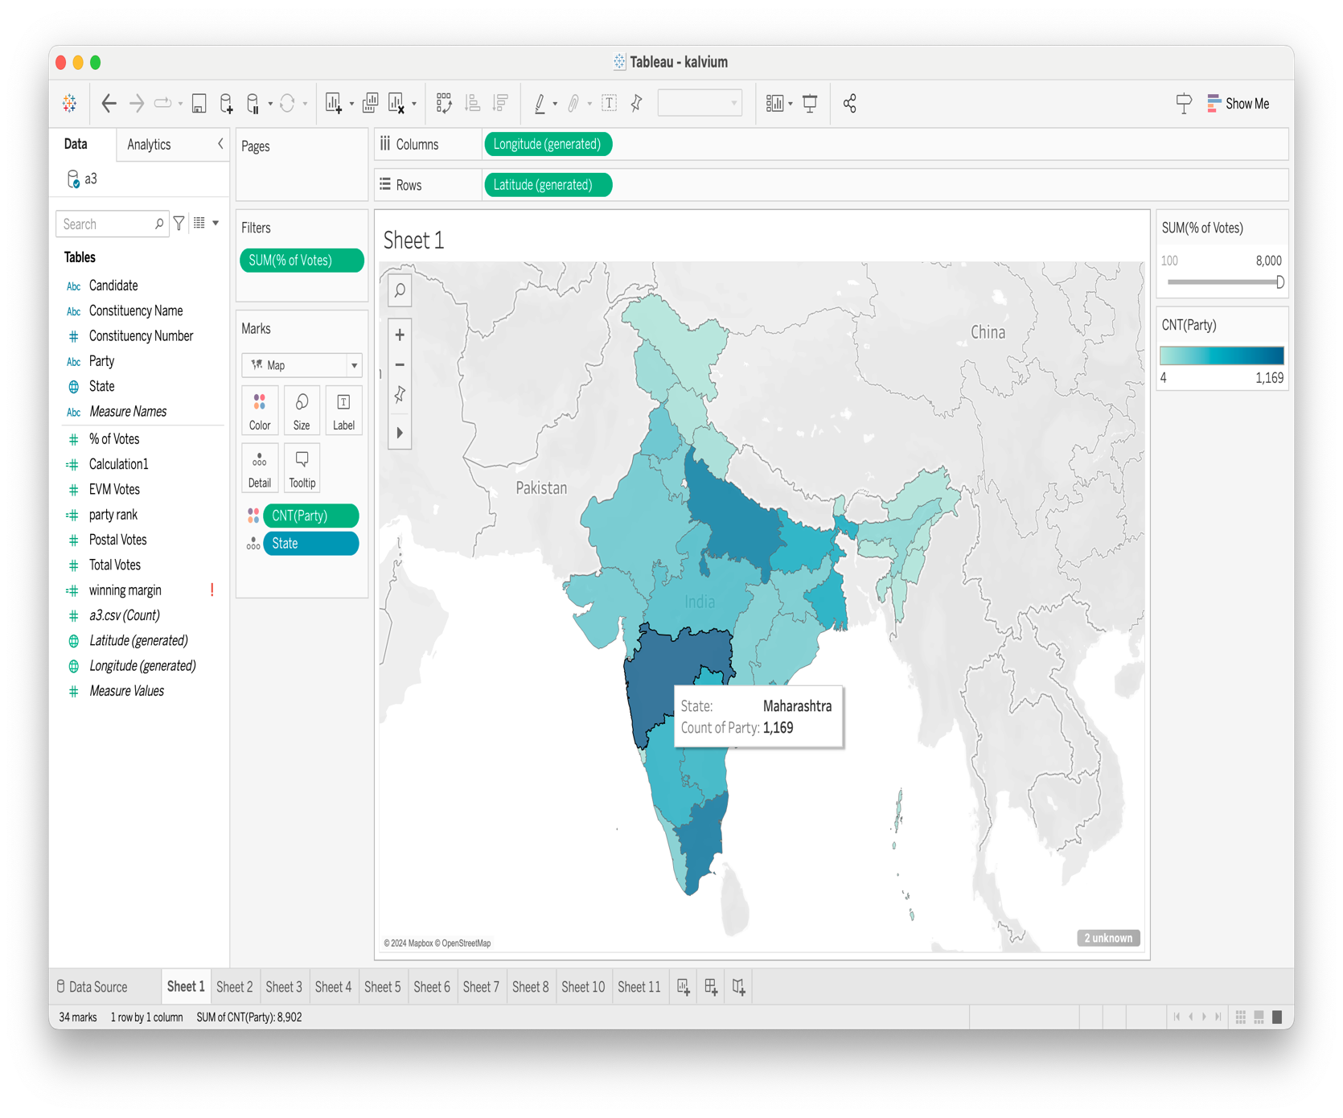

Insight 2: Analysis of Political Party Counts by State

The data includes political parties and their respective counts in various states. The heatmap visualizes the distribution of counts for the top parties across different states.

- BJP and INC dominate the counts in multiple states.

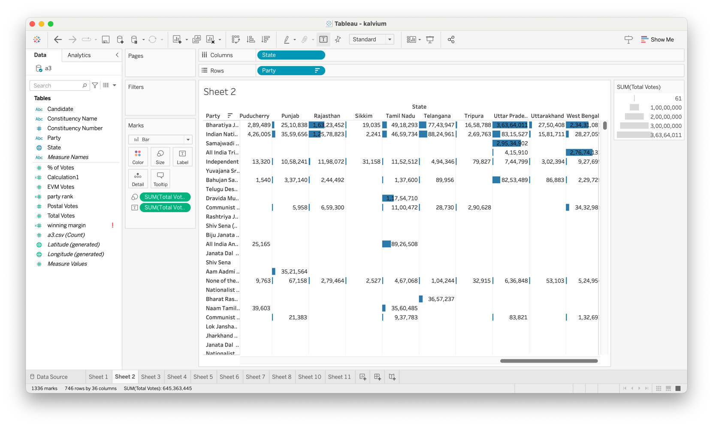

Insight 3: Analysis of Leading Parties

The data includes the names of various political parties and their corresponding counts. BJP is leading in this sheet with the highest counts across multiple states, the Congress party is second by a mile.

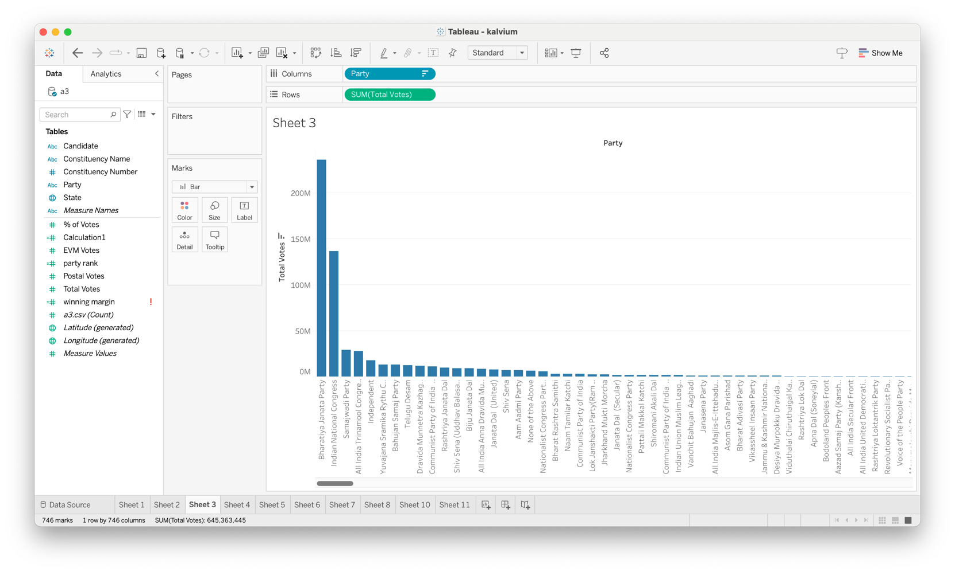

Insight 4: Analysis of Leading Candidates

The data includes candidate names and their corresponding counts. NOTA is leading with the highest count.

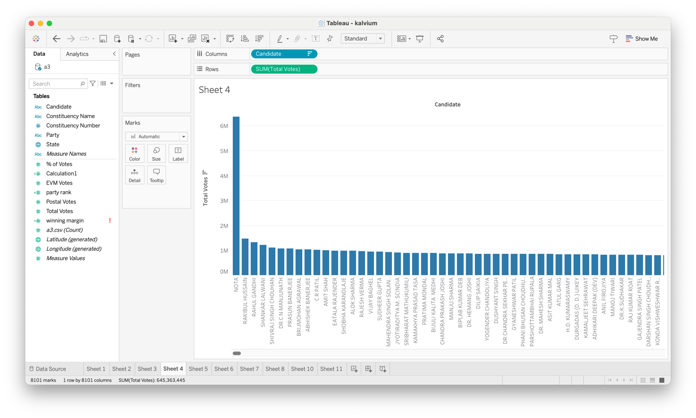

Insight 5: Analysis of Sparse Data

The data includes various parties and their counts across different states. Which party has how much vote share in each state is presented over here BJP is leading in most of states with Congress being second by a long mile

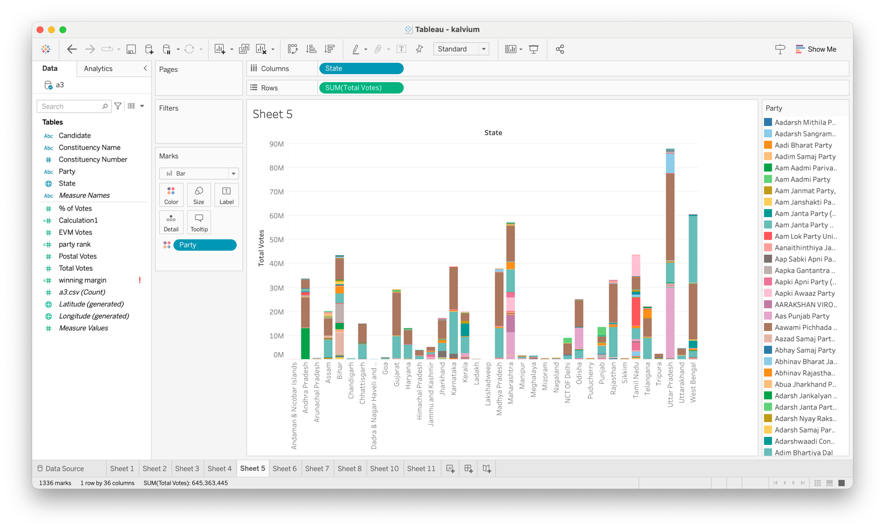

This analysis represents the percentage of votes by party.

- BJP has the highest vote percentage, indicating a Victory.

- INC also has substantial votes.

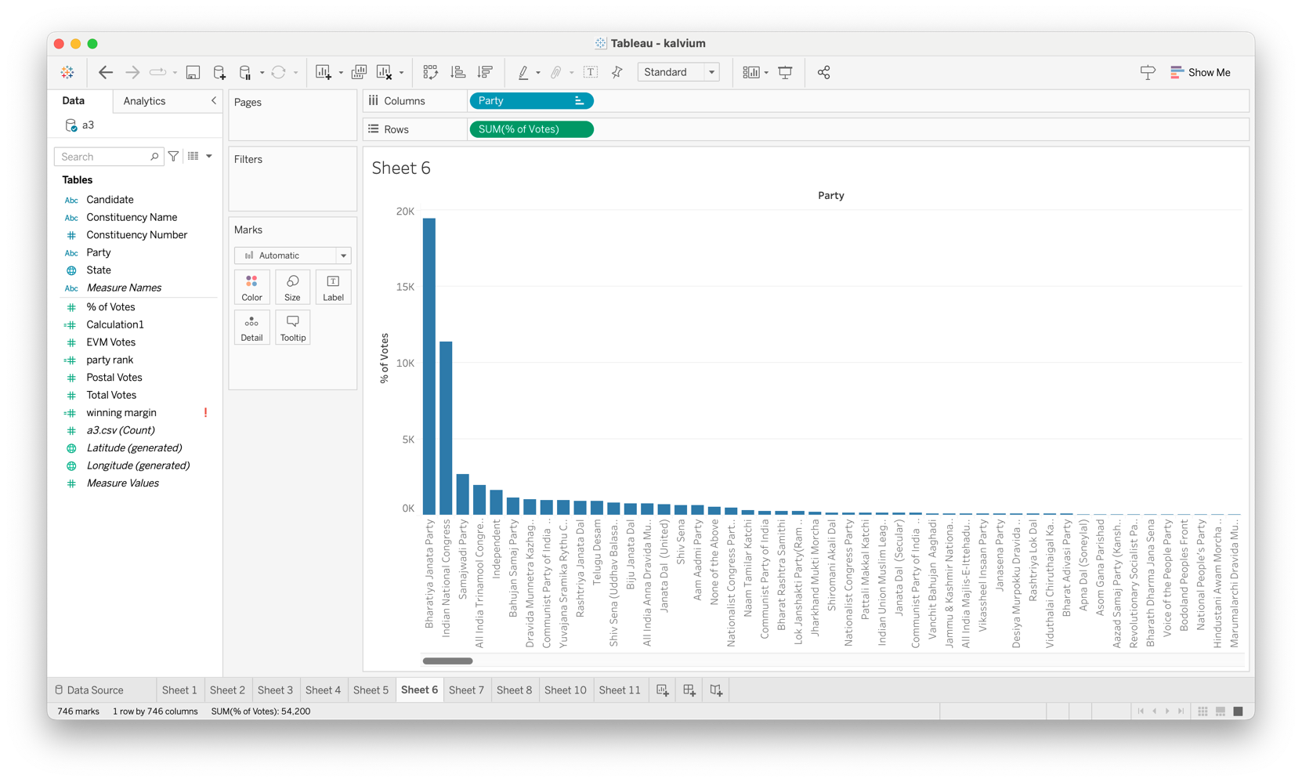

The data gives us the relation between state and parties and how they perform in it .

BJP is performing very well in most states, while Congress is also performing well in a lot of states

The data includes party counts across different states. The heatmap visualizes the distribution of counts for the top parties across different states.BJP is performing very well as expected while Congress is second by a long mile.

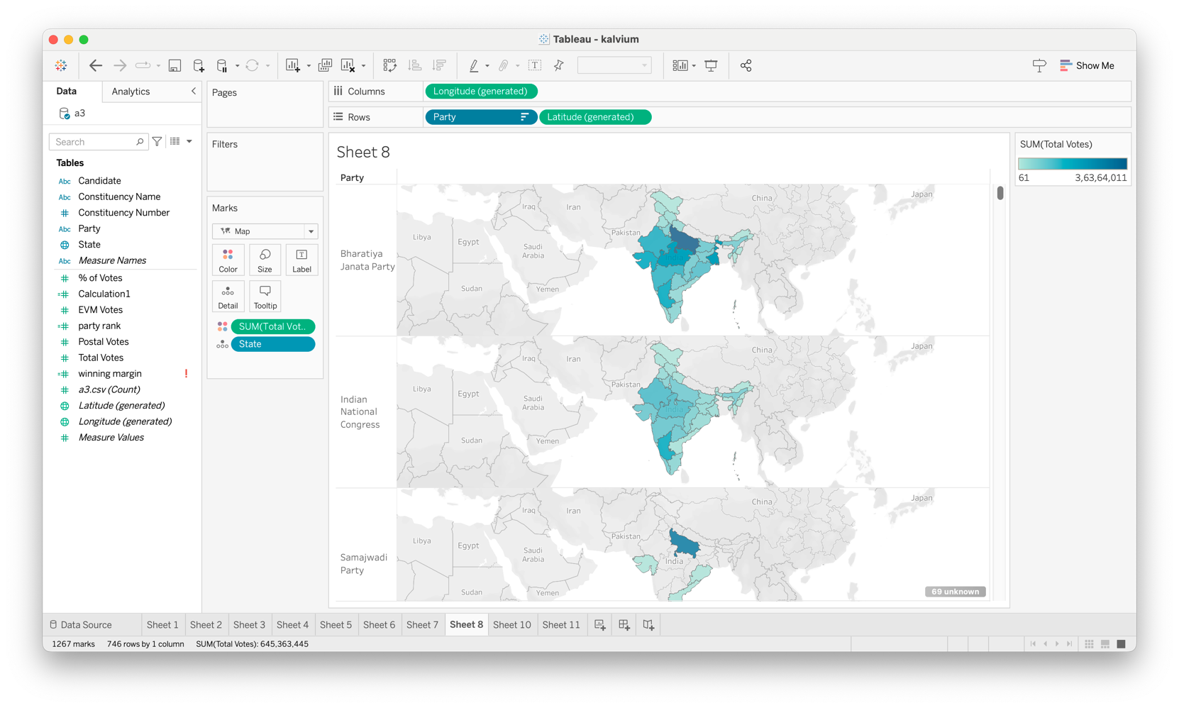

The data includes the names of various political parties and their corresponding counts. This sheet represents postal votes.

- BJP leads with the highest postal vote counts.

- INC follows with significant counts.

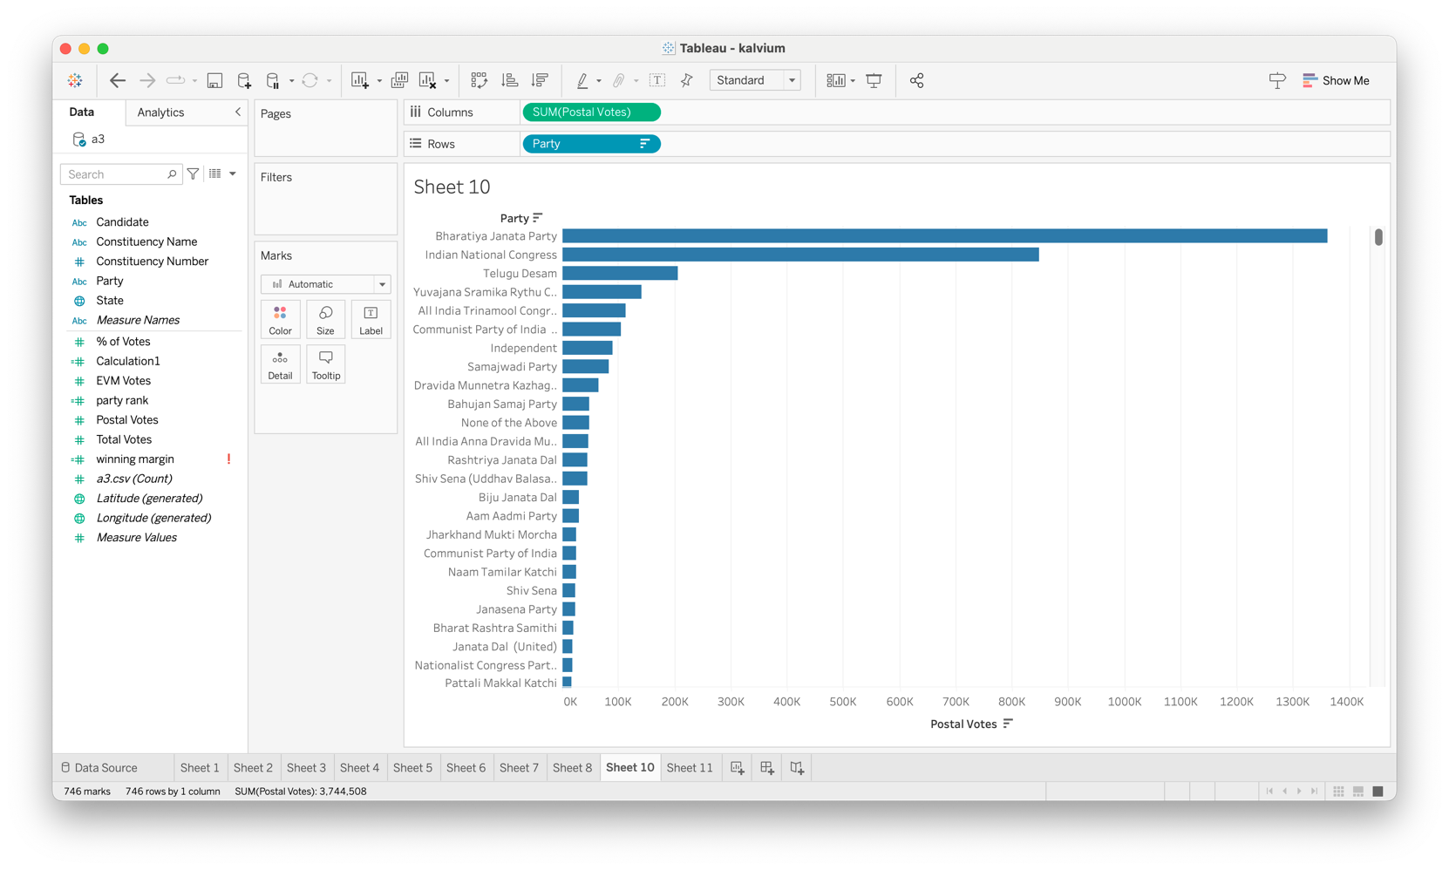

The data includes financial figures for various political parties. This sheet represents EVM votes.

- BJP leads with the highest EVM vote counts.

- INC follows with substantial counts.

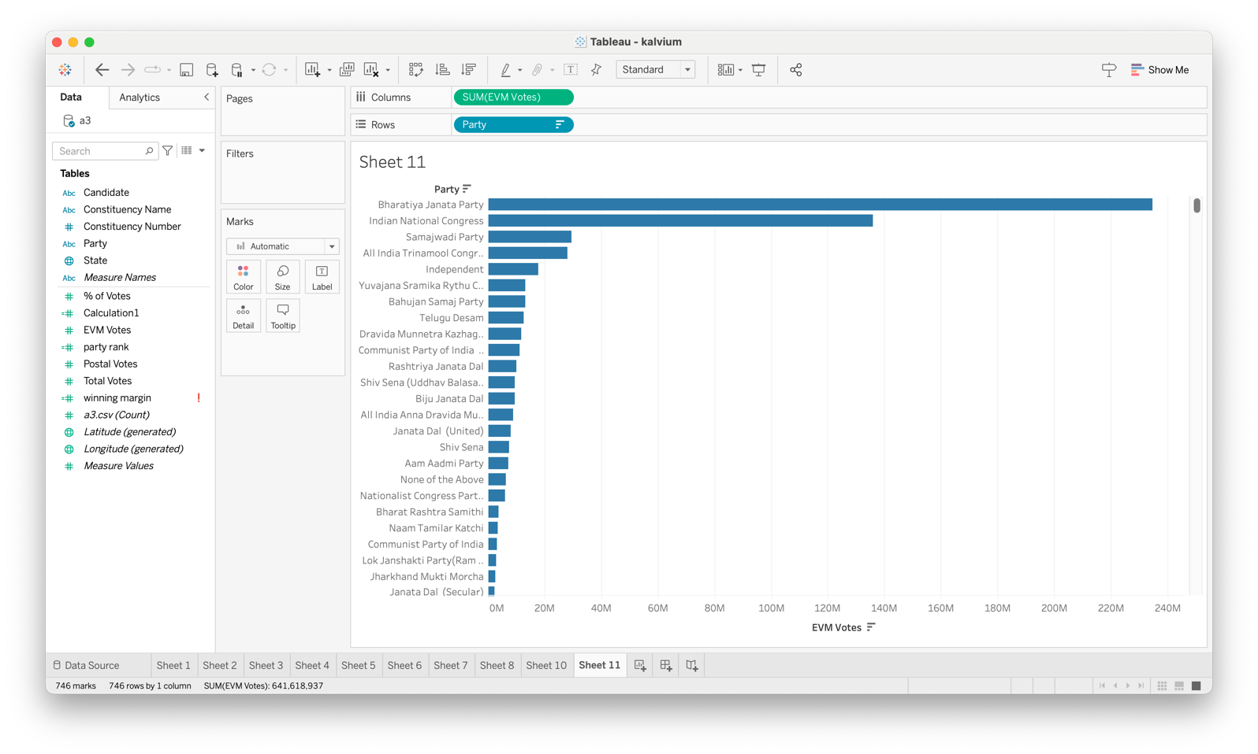

This comprehensive report has provided insights into various datasets, highlighting key observations and trends. The visualizations have helped to better understand the data distribution and significant patterns across different states and parties.