

Case Tools Lab File
05.2.2022
─
Kaushal kumar Singh
ROLL.NO:-B20625.
CLASS:SY-.BCA

INDEX
S.NO | DATE | TOPIC
1
2

\DATE:18/03/22

Unit 1
Version Control Tool
Aim: To study of a version control tool: Git
Introduction: GIT was created by Linus Torvald, who is the creator of Linux, in 2005. They are Open source projects used for the distributed version control system to develop several types of commercial and non-commercial projects as GIT is a distributed version, they could be used as a server for managing repositories. The main goal of it is that they support non-linear developments with good speed and can handle large projects deliberately.
In earlier days, we keep track of our work to make a copy, modification the files, but after version control, we can manage files in a professional manner explicating folder concepts.
most interestingly, it allows us to restore previous versions of project work. So, GIT helps in tracking codes by storing them in versions on its own local repository called GITHUB. GITHUB is a website where we can upload a copy of files stored in the repository. GIT uses a low-level language called C language.

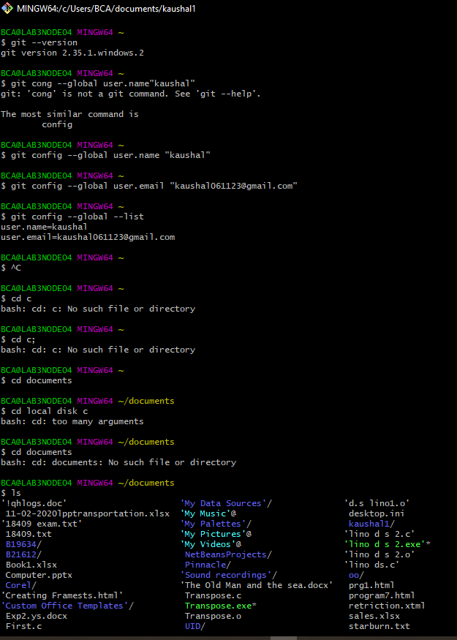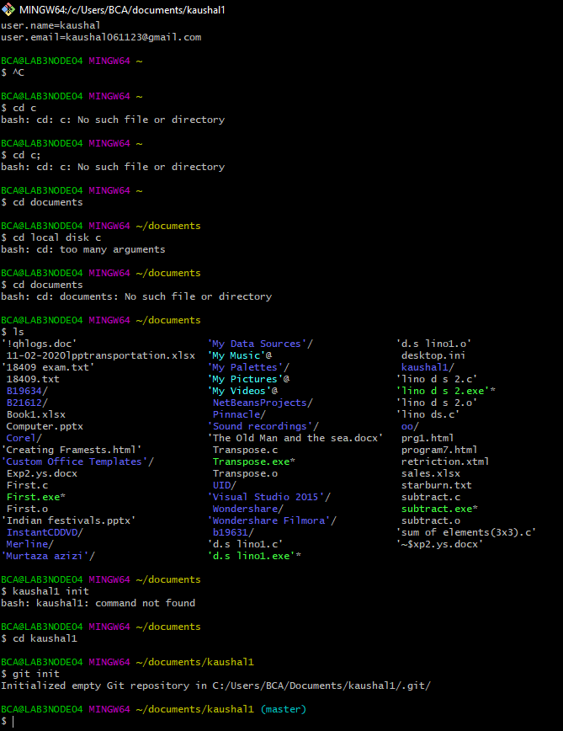

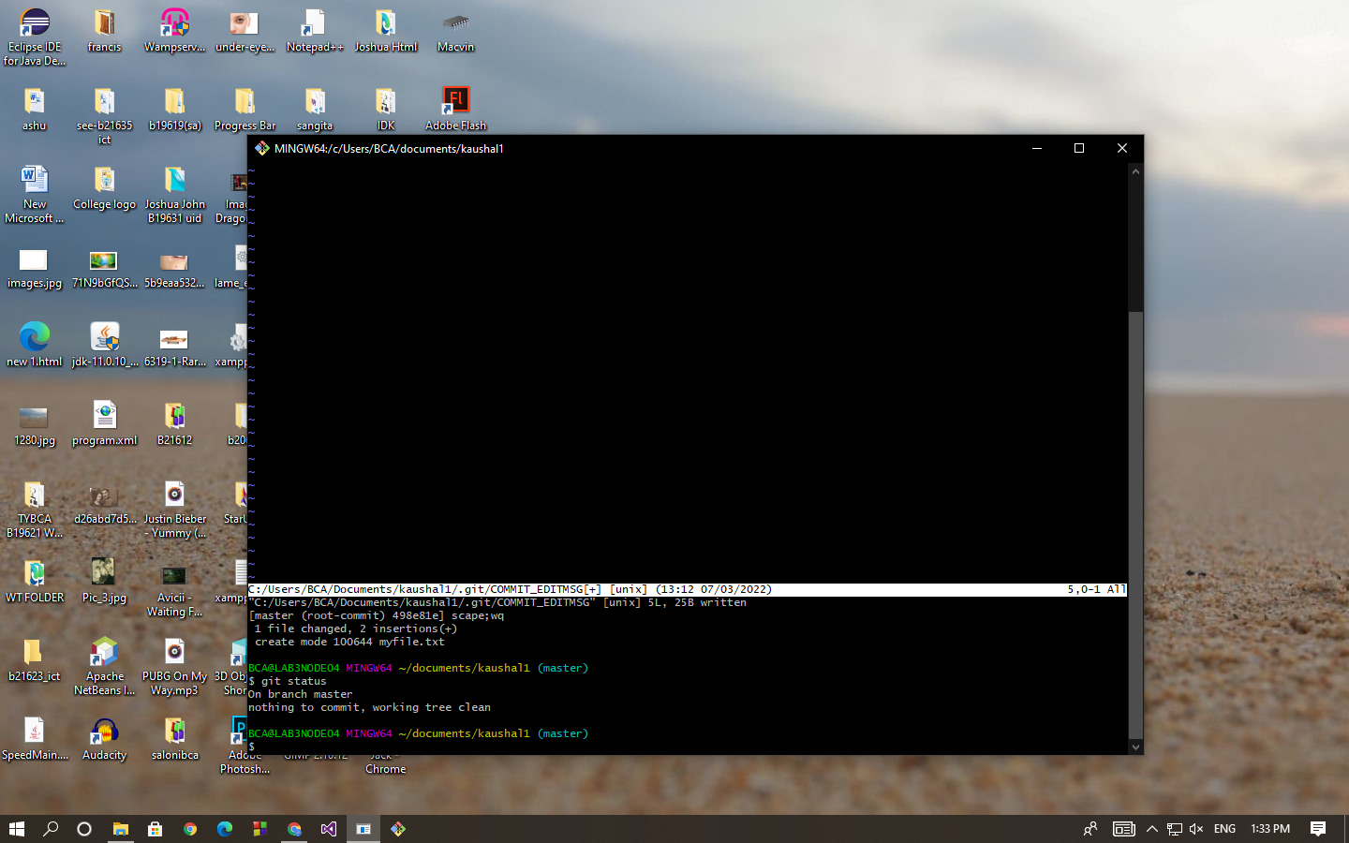

12/3/22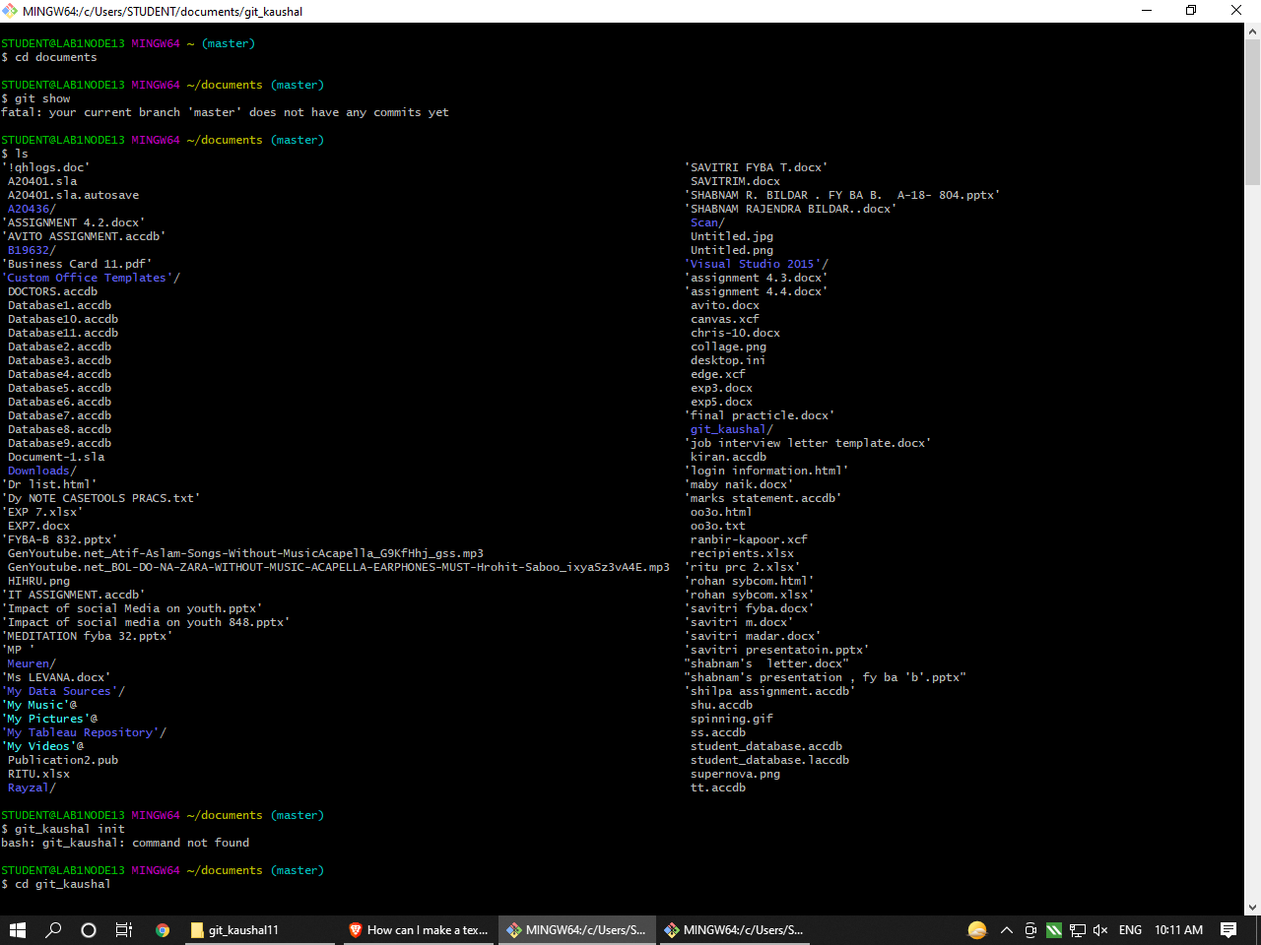

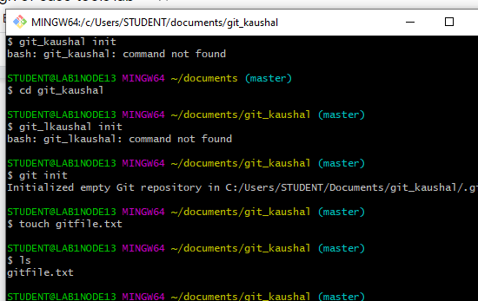

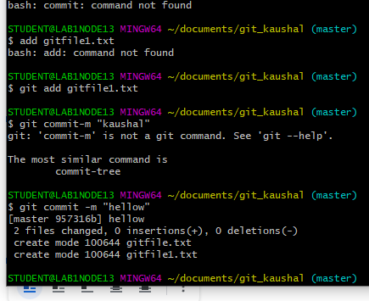

14/03/22

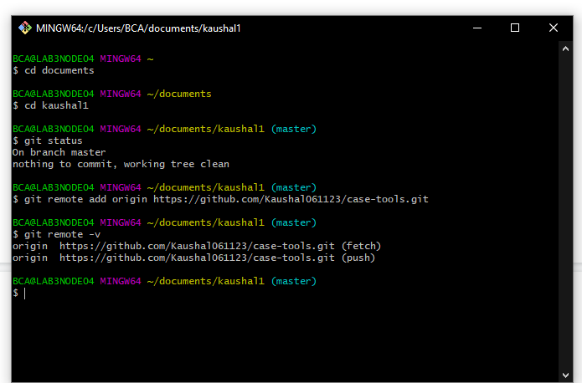

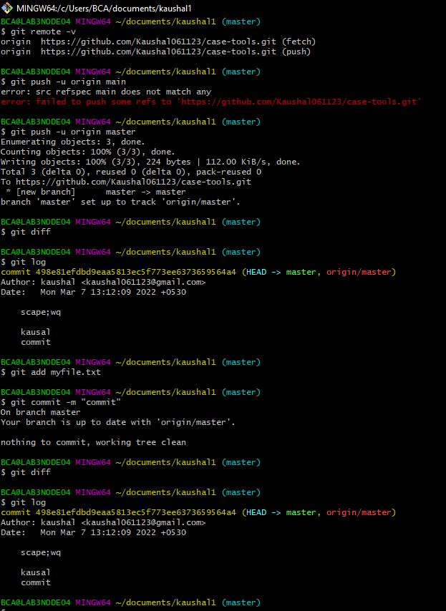

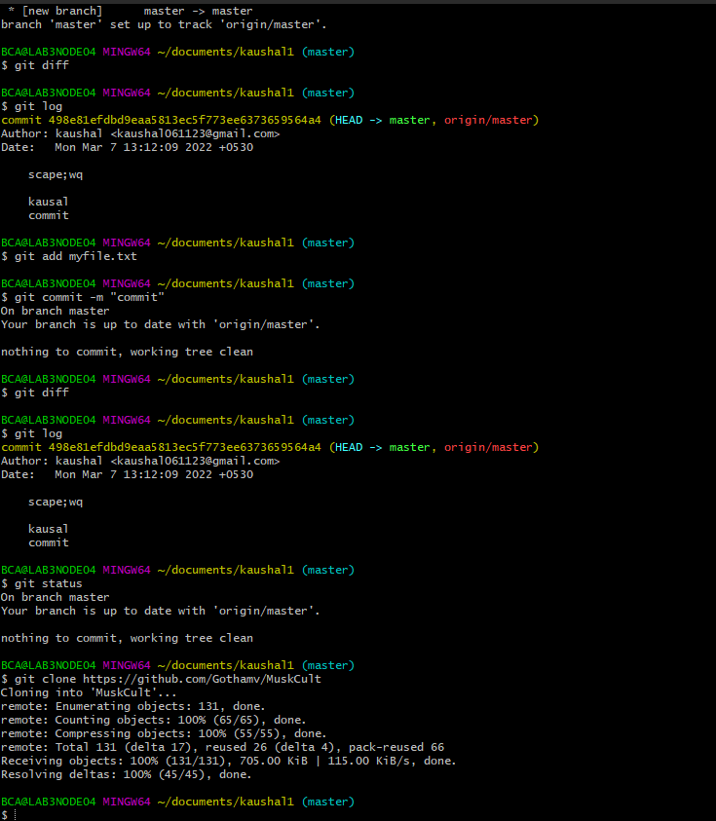

19/3/2022
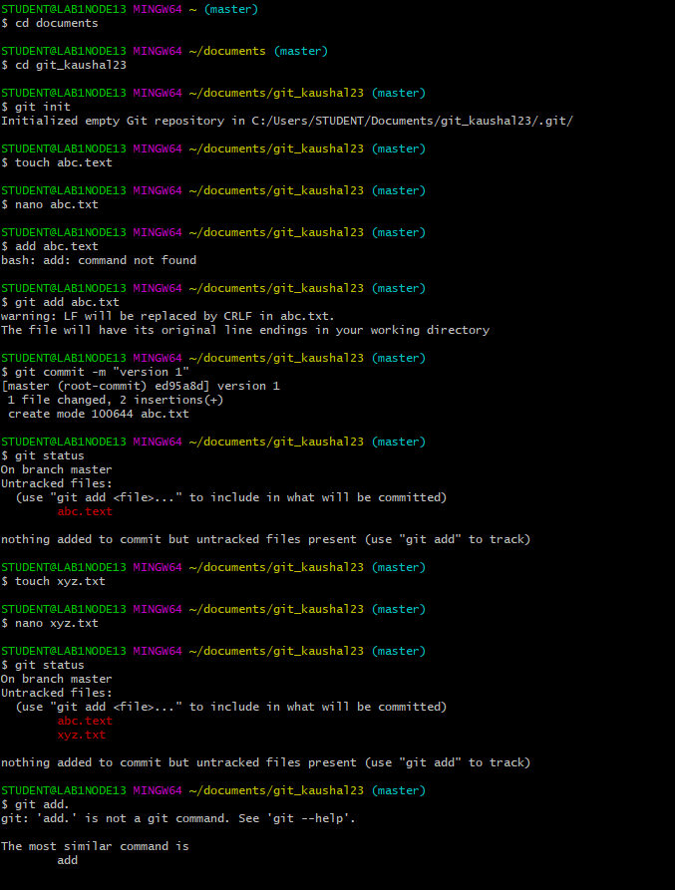
Date:28 MARCH 2022

Unit:2 Testing.

Step .1 . Install Development kit.(JDK) on your Machine.
Step 2. Visit https://junit.org/junit4/ Download and install:
1.Junit.jar.
2.Hamcrest -core.jar.
Step 3: Go To C: DRIVE(C/:) Create a folder junit and paste two files that are download ( Junit.jar.
,Hamcrest -core.jar.)
Step 4: Setting environment variables
. Click advanced system settings
called click on new variables and JUNIT HOME and add path.
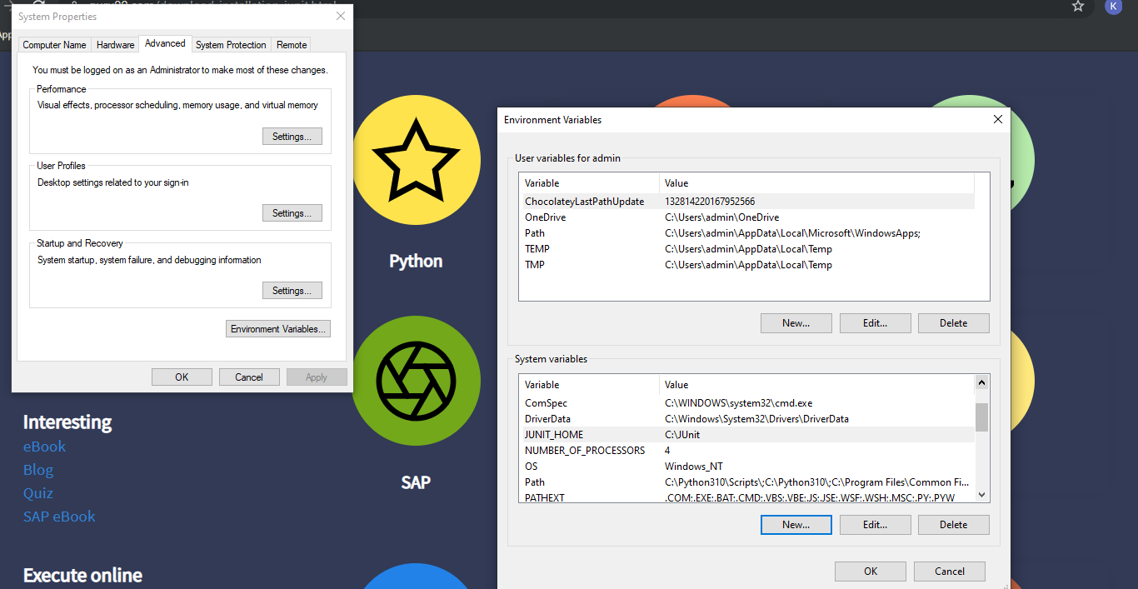

4/04/2022
Create a eclipse test file and
import org.junit.Test;
public class MyjunitTest
{
@Test
public void mysample()
{
System.out.println("HI");

}
}
Output:

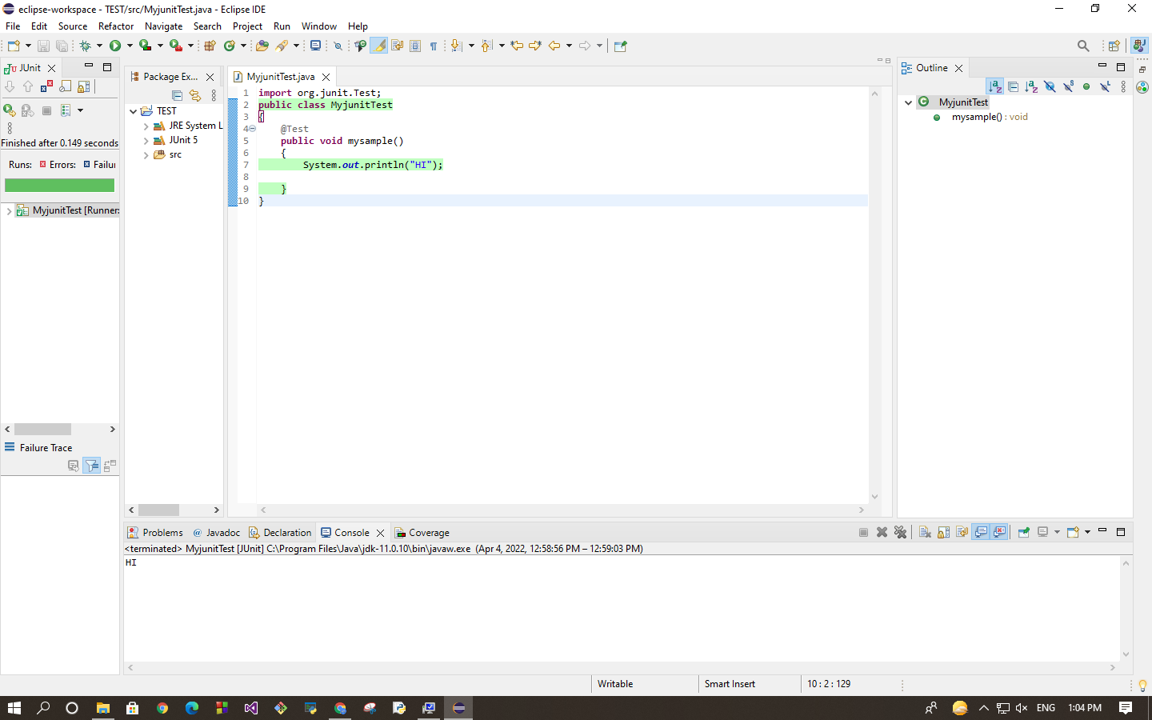

//package testingjunit5;
import static org.junit.Assert.assertTrue;

import org.junit.Test;
public class MyAssertTrueTest
{
public boolean isEvenNumber(int number)
{

boolean result =false;
if (number%2==0)
{
result =true;
}
return result;
}
@Test
public void EvenNumberTest()
{
MyAssertTrueTest asft =new MyAssertTrueTest();
assertTrue(asft.isEvenNumber(12));
}
}
OUTPUT: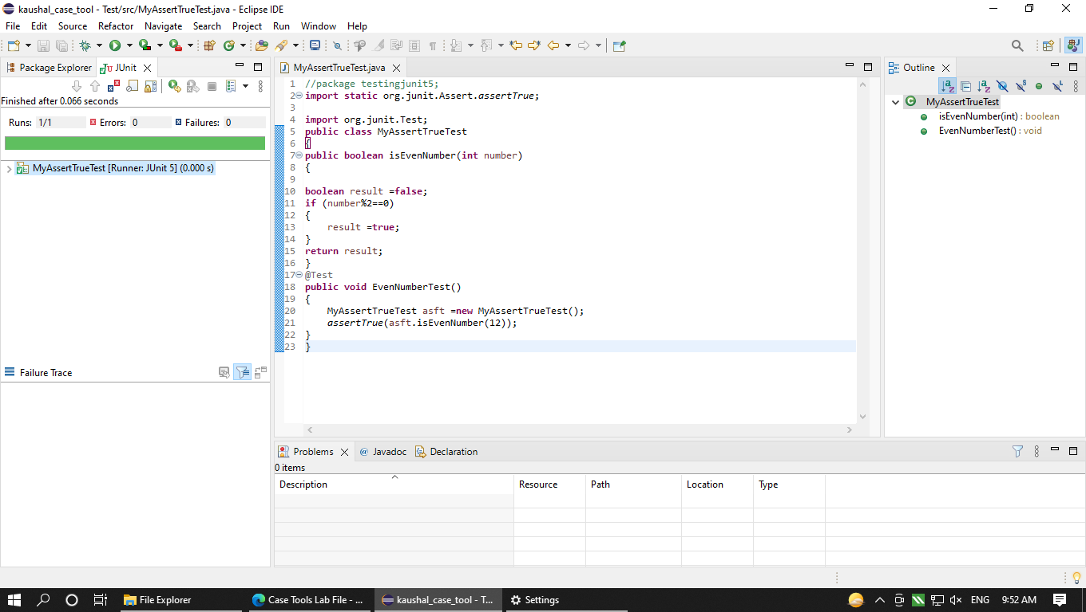
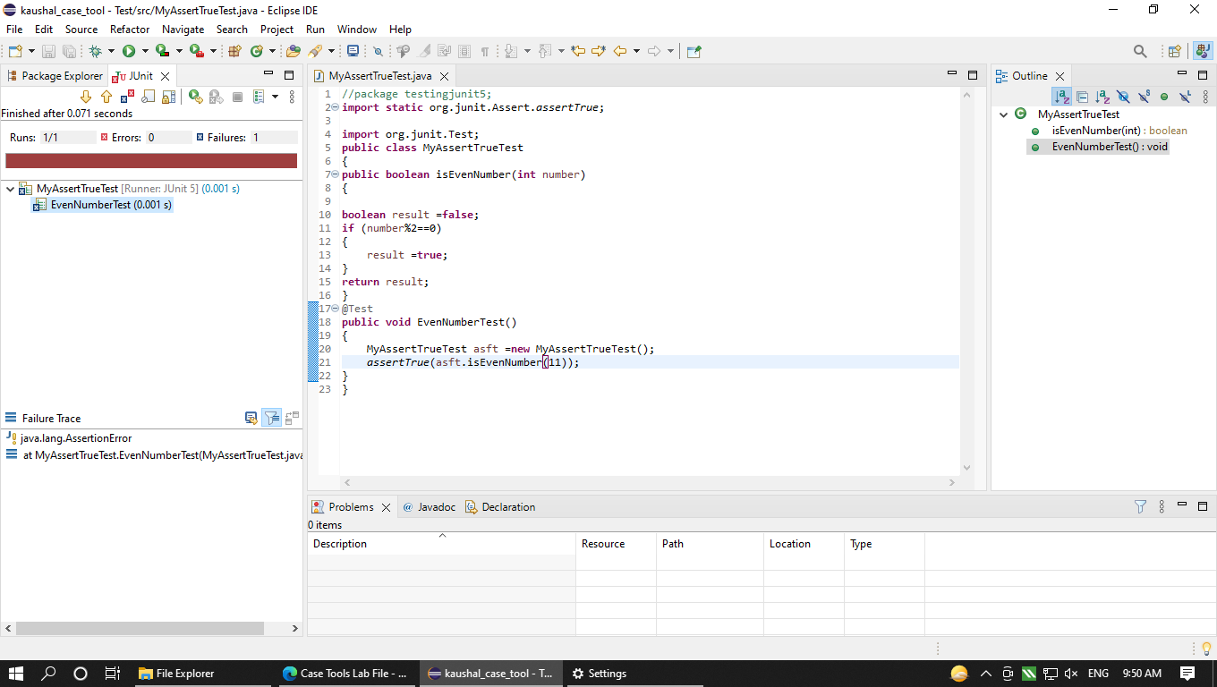

18/4/22

Input:
import static org.junit.Assert.assertEquals;

import org.junit.jupiter.api.Test;

class square {
@Test
void test()
{
JunitTest t=new JunitTest();
int o=t.square(5);
assertEquals(25,o);
}
}
output: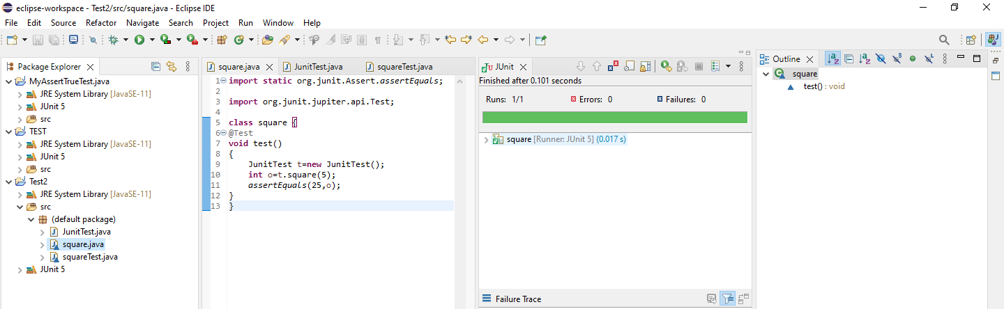

Input:
import static org.junit.Assert.assertEquals;

import java.util.Scanner;

import org.junit.jupiter.api.Test;

class squareTest {
@Test
void test()
{
JunitTest t=new JunitTest();
Scanner sc = new Scanner(System.in);
System.out.println("Enter a number:");
int n =sc.nextInt();

int o=t.square(n);
assertEquals(25,o);
sc.close();
}
}
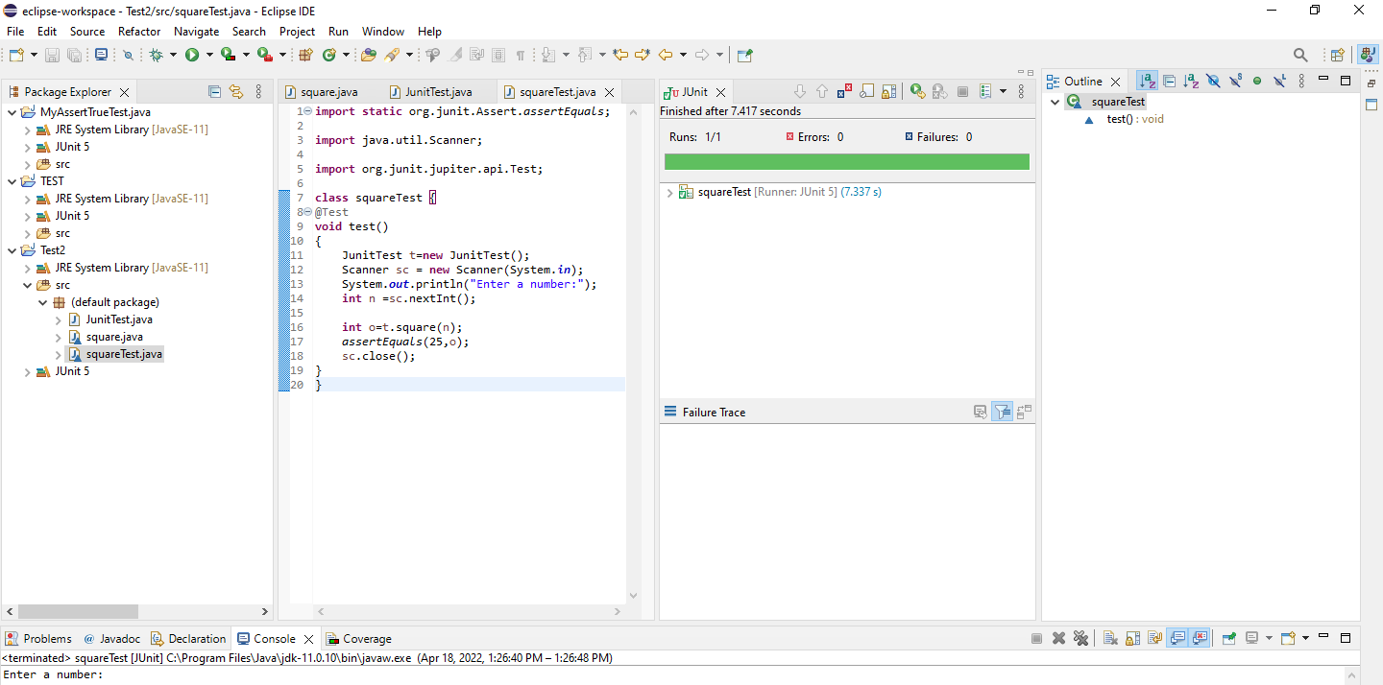
INPUT:
import static org.junit.Assert.assertEquals;
Import org.junit.jupiter.api.Test;

public class countTest
{
@Test
void testCount()
{JunitTest a=new JunitTest();
int count=a.countA("kaushal");
assertEquals(2,count);
}
}
OUTPUT:
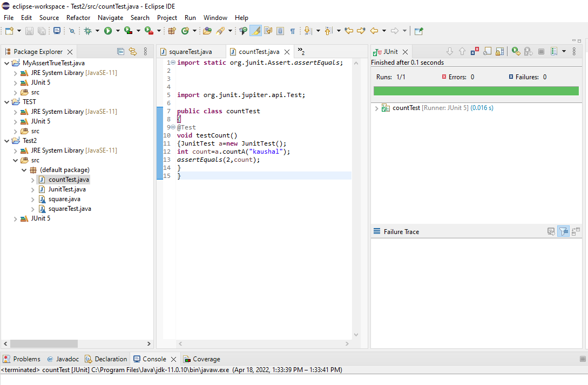

J uit test for factorial of a number :

Method
package test;
public class factorial
{
public int numfact(int n)
{

int fact=1;
for(int i=1;i<=n;i++)
{
fact=fact*i;
}

return fact;
}
}
TEST CASE
package test;
import org.junit.jupiter.api.Test;

import static org.junit.Assert.assertEquals;

public class factorialTest
{
@Test
void test()
{
factorial fac= new factorial();
assertEquals(24,fac.numfact(4));
}
}
OUTPUT:
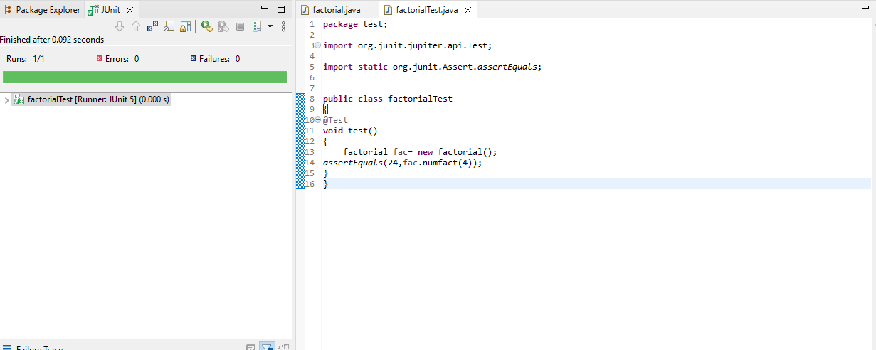

Prime number :

package test;

public class primenumber
{
public static boolean isnumber(int n) {
if (n<= 1) {

return false;

}

for (int i = 2; i< n; i++) {

if (n % i == 0) {

return false;

}

}

return true;

}

}

import java.util.Scanner;
import static org.junit.Assert.assertEquals;

import org.junit.jupiter.api.Test;

class JunitTest
{
@Test
void Test()
PositvenNumber t=new PositvenNumber ();
Scanner sc = new Scanner(System.in);
System.out.println("Enter a number:");
int n =sc.nextInt();

boolean o=t.PositvenNumber(n);
assertfalse(o)
sc.close();
}
}

public class positive_negative
{
public boolean PositvenNumber(int num)
{
boolean result =false;
if (num>0)
{
result=true;
}return result ;
}
}

package test;

public class JunitTest
{
public int square(int x)
{
return x*x;
}
public int countA(String w)
{
int c=0;
for(int i=0;i<w.length();i++)
{
if(w.charAt(i)=='a' || w.charAt(i)=='A')
c++;
}
return c;
}
}
—-------------------------------------------------------------------------------------------------------------------------

package test;
import static org.junit.jupiter.api.Assertions.*;

import java.util.Scanner;
import org.junit.Test;

class squareTest
{
@Test
void test()
{
JunitTest t = new JunitTest();
Scanner sc = new Scanner(System.in);
System.out.println(“Enter any Number: “);
int n = sc.nextInt();
int o = t.square(n);
assertEquals(24,o);
sc.close();
}
}

Q.To test prime number program using assert true .
public class PrimeTest
{
boolean primenum(int n)
{
boolean flag=true;
int m=n/2;

if(n==0||n==1)
{
flag=false;
}

else
{
for(int i=2;i<=m;i++)
{
if(n%1==0)
{
flag=false;
break;
}
}

}
return flag;
}
}
—---------------------------------------------------------------------------------------------
//Test
import static org.junit.jupiter.api.Assertions.*;

import org.junit.jupiter.api.Test;

public class JunitTest1
{
@Test
void TestPrime()
{
PrimeTest prm = new PrimeTest();
assertTrue(prm.primenum(2));
}
}
public class PN
{
boolean Method(int n)
{
if(n>0)
{
return true;
}
else
{
return false;
}
}
}
—------------------
------------------------------------------------------------------------------
import static org.junit.jupiter.api.Assertions.*;

import org.junit.jupiter.api.Test;

public class JunitTest2
{
@Test
void Test()
{
PN obj = new PN();
assertFalse(obj.Method(-3));
}
}

public class Pythag
{
int Pyt(int n,int m)
{

int hyp = (int)Math.sqrt((n*n)+(m*m));
return hyp;
}
}
—------------------------------------------------------------------------------------------------
import static org.junit.jupiter.api.Assertions.*;

import org.junit.jupiter.api.Test;

public class JunitTest
{
@Test
void Test()
{
Pythag obj = new Pythag();
assertEquals(obj.Pyt(4,3),5);
}
}

public class AreaCircle
{
public double Carea(double r)
{

double Area = 3.14*r*r;
return Area;
}
}
___________________________________________________________________

import static org.junit.jupiter.api.Assertions.*;

import org.junit.jupiter.api.Test;

public class JunitTest
{
@Test
void Test()
{
AreaCircle obj = new AreaCircle();
assertEquals(obj.Carea(2),12.56);
}
}
UNIT 3
DOCUMENTATION :1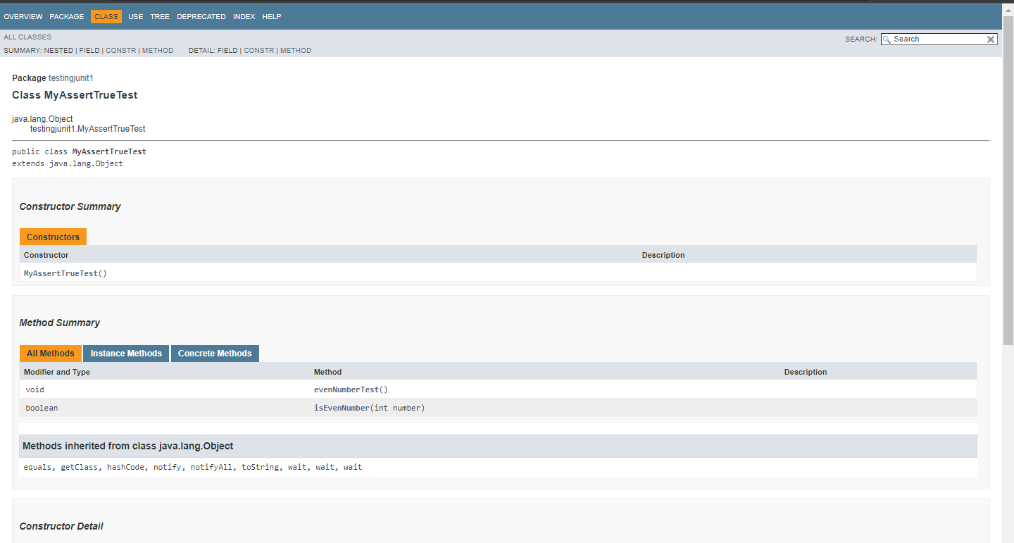
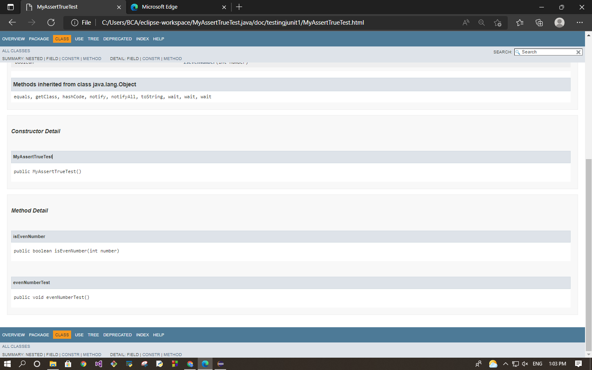

2.

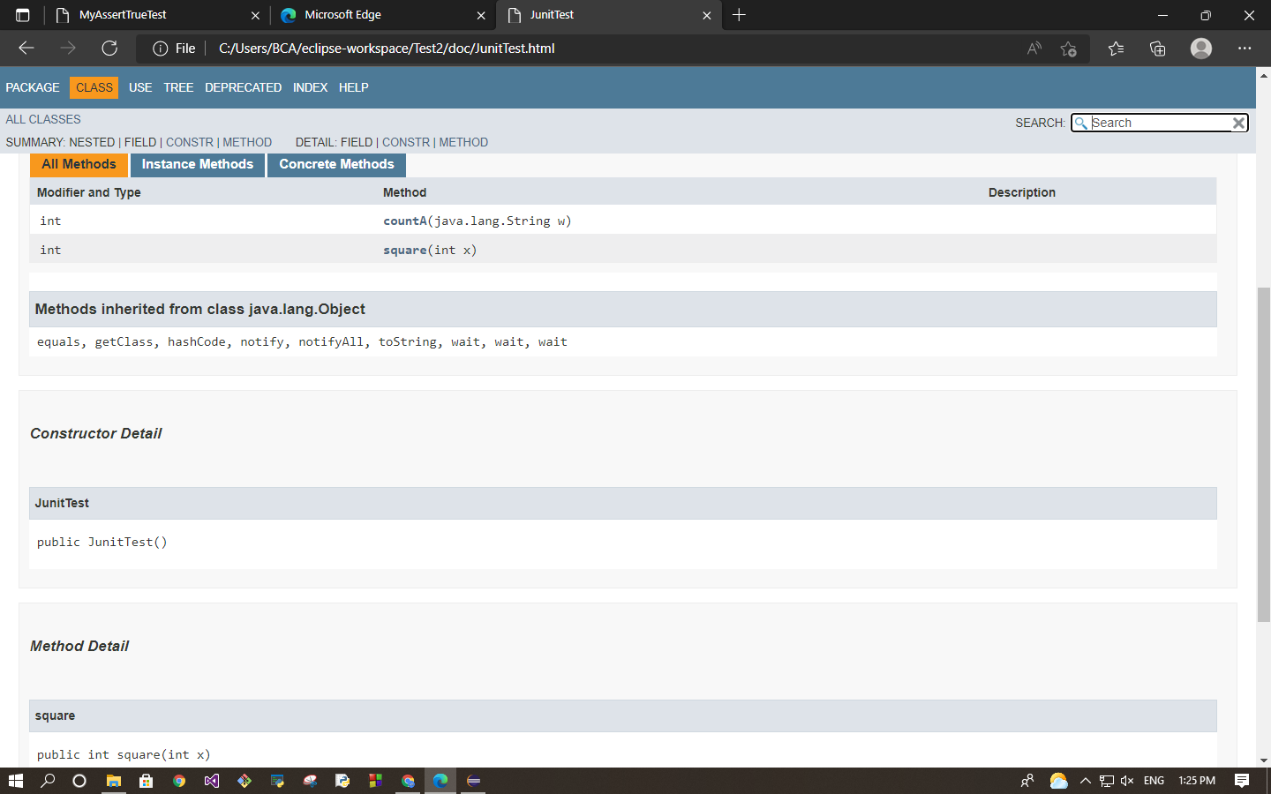
class Animals {
protected String name;

protected void display() {
System.out.println("I am an animal.");
}
}

class Dog extends Animals {

public void getInfo() {
System.out.println("My name is " + name);
}
}

class Main {
public static void main(String[] args) {

// create an object of the subclass
Dog labrador = new Dog();

// access protected field and method
// using the object of subclass
labrador.name = "Rocky";
labrador.display();

labrador.getInfo();
}
}

Case Tools Laboratory
Lab file

Experiment 1:

Create folder in any drive on PC

Open git bash

Type Commands

-> $ cd documents (drive name)
-> $ cd GitSafiya (folder name)
-> $ Git init (To initialize a git repository)

Add 3 files called (file1,file2,file3) to it and add some data in the files and save

$ touch newfile.txt

To add some data in your file use

$ nano newfile.txt

Ask git to keep track of files one by one committing the files

Add a file to the staging environment

$ git add.

Create your first commit!

$ git commit -m "Your message about the commit“

Check the commit using the following command

$ git status

Create a new repository on GitHub

if you want to work with a team, you can use GitHub to collaboratively modify the project's code.

Push files on github from your local repository

Push a branch to GitHub

$ git remote add origin <REMOTE_URL> # Sets the new remote

$ git remote -v # Verifies the new remote URL

Push the changes in your local repository to GitHub.

$ git push origin yourbranchname(master)

Date: 21/03/22

Create a pull request

To pull files from the another persons repository

$ git pull origin master

Clone a file available in GitHub

$ git clone remote_repository_URL

Try using:https://github.com/Gothamv/MuskCult

Create files add push into git hub

Pull files from github

Date : 28/03/22
Unit 2
Unit Testing
Aim: To study Unit testing tool: JUnit

Set up environment for unit testing

Install java development kit(JDK) on your machine

Visit https://junit.org/junit4/ Click on Download and install

junit.jar
hamcrest-core.jar

After downloading go to C drive create a folder called junit and paste two files that are download( junit.jar , hamcrest-core.jar )

Setting environment variables ,right click on PC click on properties

Click on advanced system settings

Click on environment variables

You have to see “JUNIT_HOME “ is there on “ c:\ junit” path

To check CLASSPATH

Introduction : UNIT TESTING is a type of software testing where individual units or components of a software are tested.
• Unit Testing is done during the development (coding phase) of an application by the developers. • Unit Tests isolate a section of code and verify its correctness.
JUnit is an open source
Unit Testing Framework for JAVA.
• It is useful for Java Developers to write and run repeatable tests.
• Erich Gamma and Kent Beck initially developed it. It is an instance of xUnit architecture.
• As the name implies, it is used for Unit Testing of a small chunk of code.

