**CSS**

1. **What are the benefits of using CSS?**

**Ans.** There are many benefits of using CSS like, it is very easy to code also their design is very consistency and CSS has a separation of content and style, there loading time is very fast and animations and effects are very easy to understand also it is print-friendly versions of web pages.

1. **What are the disadvantages of CSS?**

**Ans. The disadvantages of CSS are repeat in HTML files and increased file size also their security concerns and over-specificity and overriding styles and in the CSS the complex layouts and limited layout control are very problematic.**

1. What is the difference between CSS2 and CSS3?

Ans. CSS3 is a new version of CSS, and it is divided into many modules on the other hand CSS2 has a single document. Also, CSS3 have a special font analogous to Fonts and Typecast and CSS2 is simple selectors. There are no round borders, split text feature in CSS2 and CSS3 have special sequence of simple selectors.

1. Name a few CSS style components?

Ans. CSS style components are position, height, width, color, text-align, border, margin, padding etc.

1. What do you understand by CSS opacity?

Ans. The CSS opacity is property sets of the opacity level for an element, which describes the transparency-level from 0 to 1. Also, it is used for blending or overlaying.

1. How can the background color of an element be changed?

Ans. The background color of an element be changed by “background-color” property in the CSS. Colors can be different ways, such as keywords, RGBA, or HSL.

1. How can image repetition of the backup be controlled?

Ans. The “background-repeat” property is used to repetition of the backup be controlled. And this property will show the background image is repeated or not at all.

1. What is the use of the background-position property?

Ans. Background-position property is use for set the exet position of the background image.

1. Which property controls the image scroll in thebackground?

Ans. The controls of the image scroll in the background are “background-attachment” properties and it has scroll, local, and fixed of values.

1. Why should background and color be used as separate properties?

Ans. The background and color are different purposes. The color sets the only text colour, and background properties defines the background image, gradients, positioning.

1. How to center block elements using CSS1?

Ans. The block elements to center a box within another box, and the containing box into a flex by setting it display property to flex. Then the justify-content to horizontal centering.

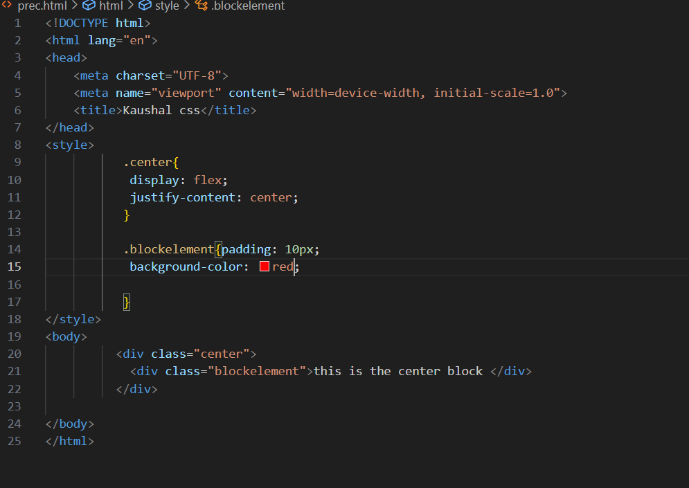

1. How to maintain the CSS specifications?

Ans. The maintain of the CSS specifications are follow the style guidelines for CSS if maintain consistent naming conventions for classes also CSS maintained by the world web consortium.

1. What are the ways to integrate CSS as a web page?

Ans. Internal CSS – the <style> tag in the <head> section of an HTML document. And External CSS involves defining the separate file, with a CSS extension. Inline style – Adding a CSS rules to an HTML using the style attribute.

1. What is embedded style sheets?

Ans. An embedded style sheets are declared within the <head> of an XHTML document. And the styling a document that has unique requirements.

1. What are the External style sheets?

Ans. A separate CSS file by creating a link within the head section of the webpage and that use the same link to access the stylesheet.

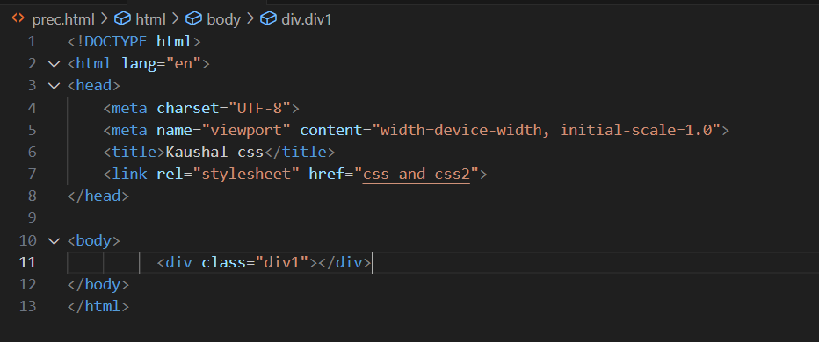

1. What are the advantages and disadvantages of using external style sheets?

Ans. Advantages:

In complex contexts, Methods like selector and grouping can be apply styles.

In external style, classes can be made for use on numerous HTML elements types forms of the site.

The styles of numerous documents can be organized from one single file.

Disadvantages:

There are implementing style sheets, to test web pages with multiple browsers to check compatibility issues.

The file may be deferred till the external style sheet is loaded.

1. What is the meaning of the CSS selector?

Ans. The meaning of the CSS selector is a pattern of elements and other terms that tell browsers which HTML elements should be selected to have the CSS property values inside the rule applied to them.

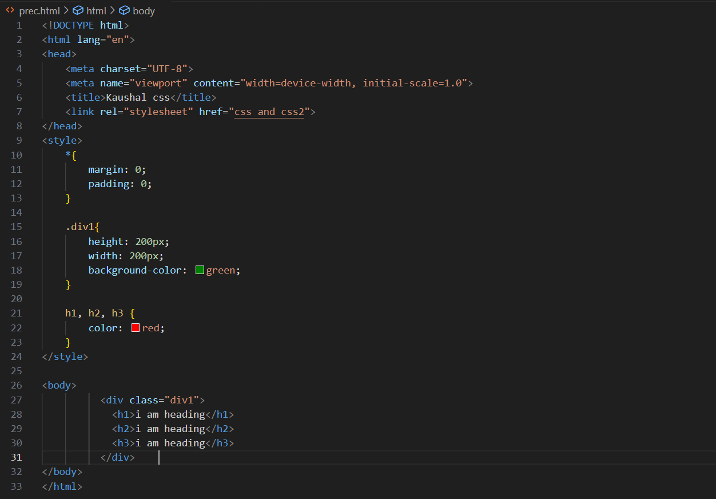

1. What are the media types allowed by CSS?

Ans. The target prints preview mode, print media type, and try to print a web page.

The computer screens is used by screen media type.it is the most common media type for styling web pages.

1. What is the rule set?

Ans. A rule set is selector list and an associated declaration block, together are called a ruleset, or often a rule. And it is define how an HTML element should be styled.

1. Create Layouts

Ans. Code in git-hub.

