# Flex-box

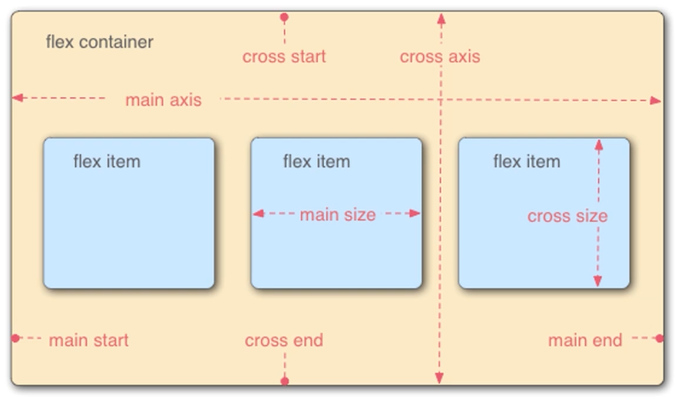

**exp**

css :

.continer {

display: flex;

}

## Properties for flex container

-> **flex-direction:**

row //default Horizontal

row-reverse

column // vertical

column-reverse

-> **flex-wrap:**

nowrap //default

wrap // responsive (come in new line if width is short)

-> **flex-flow:** {combination of direction and wrap}

ex:

flex-flow: column wrap;

-> **justify-content:**

center // all box in center

space-between // take a eqal space between box and use maximum width

space-evenly // take a eqal space between box and border

space-around // equal space for each box.

-> **align-items:**

center // vertically center

flex-end

flex-start // default

stretch // creat own space when wrapped

## Propertice for flex items

-> **order:** (jeno order moto ae 6elle jay)

2

ex:

.items-1 {

order: 2;

}

.items-2 {

}

.items-3 {

}

output:

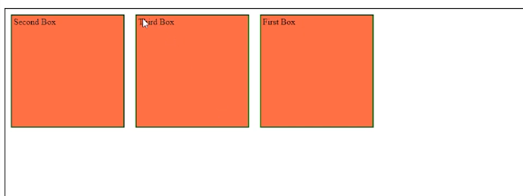

-> **flex-grow: 2;**

-> bigger width then othr. if width is samll all are same.

**-> flex-shrink: 2;** //oposie of grow

-> **flex-basis: 120px; // similer to width, height and flex-grow**

> when flex-direction set to row flex-basis will control width

> when flex-direction set to column flex-basis will control hight

-> **shothand**

flex: flex-grow flex-shrink flex-basis ;

flex: 2 2 230px;

-*> **align-self:**

flex-end //that solo box go to end of flex-end

flex-start // oposite of flex-end

center // vertically and horizontally center