01 — Arrays & Hashing
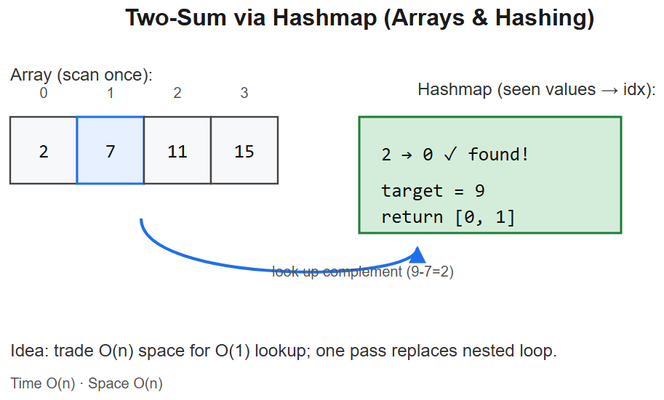

🧠 Pattern: Hash map / set for O(1) lookup
When you need to check "does X exist?" or count frequency while scanning an array — use a hash map / set. Converts many O(n²) brute forces into O(n).

Master template
def has_pair_sum(arr, target):
seen = set()
for x in arr:
if target - x in seen: # complement exists
return True
seen.add(x)
return False
- Time O(n), Space O(n)
- Key insight: scan once, store what you've seen, query in O(1)

Mental model
arr: [2, 7, 11, 15] target = 9
│
▼
seen = {} → looking for 9-2=7? no → seen = {2}
seen = {2} → looking for 9-7=2? YES → return True

Variation 1.1 — Two Sum (return indices) — LC 1
Change: store value → index, return indices when complement found.
def twoSum(nums, target):
seen = {} # val → idx
for i, x in enumerate(nums):
if target - x in seen:
return [seen[target - x], i]
seen[x] = i
return []
Logic: same scan-and-store pattern; key change is storing index alongside value.

Variation 1.2 — Contains Duplicate — LC 217
Change: just check membership, no complement.
def containsDuplicate(nums):
seen = set()
for x in nums:
if x in seen: return True
seen.add(x)
return False
# OR one-liner: return len(set(nums)) != len(nums)

Variation 1.3 — Valid Anagram — LC 242
Change: hash map as frequency counter of one string, decrement on the other.
from collections import Counter
def isAnagram(s, t):
return Counter(s) == Counter(t)
# OR manual:
def isAnagram2(s, t):
if len(s) != len(t): return False
cnt = {}
for c in s: cnt[c] = cnt.get(c, 0) + 1
for c in t:
if cnt.get(c, 0) == 0: return False
cnt[c] -= 1
return True
Logic: anagrams have identical character frequencies.

Variation 1.4 — Group Anagrams — LC 49
Change: key the hash map by a canonical signature (sorted string or 26-letter tuple).
from collections import defaultdict
def groupAnagrams(strs):
groups = defaultdict(list)
for s in strs:
key = tuple(sorted(s)) # or count tuple for O(n) per string
groups[key].append(s)
return list(groups.values())
Diagram:
"eat" → sorted="aet" ─┐
"tea" → sorted="aet" ─┼→ ["eat","tea","ate"]
"ate" → sorted="aet" ─┘
"tan" → sorted="ant" ─┐
"nat" → sorted="ant" ─┴→ ["tan","nat"]

Variation 1.5 — Top K Frequent Elements — LC 347
Change: count frequencies, then bucket sort by frequency (O(n)) or heap (O(n log k)).
from collections import Counter
def topKFrequent(nums, k):
return [x for x, _ in Counter(nums).most_common(k)]
# Bucket sort O(n):
def topKFrequent2(nums, k):
freq = Counter(nums)
buckets = [[] for _ in range(len(nums) + 1)]
for x, f in freq.items():
buckets[f].append(x)
result = []
for f in range(len(buckets) - 1, 0, -1):
result.extend(buckets[f])
if len(result) >= k:
return result[:k]
return result
Logic: bucket index = frequency. Walk buckets from highest down. Since max freq ≤ n, sized n+1.

Variation 1.6 — Product of Array Except Self — LC 238
Change: no division allowed → use prefix and suffix products (two passes).
def productExceptSelf(nums):
n = len(nums)
res = [1] * n
# prefix pass
p = 1
for i in range(n):
res[i] = p
p *= nums[i]
# suffix pass
s = 1
for i in range(n - 1, -1, -1):
res[i] *= s
s *= nums[i]
return res
Diagram:
nums: [1, 2, 3, 4]
prefix: [1, 1, 2, 6] (product of everything LEFT of i)
suffix: [24, 12, 4, 1] (product of everything RIGHT of i)
result: [24, 12, 8, 6]

Variation 1.7 — Longest Consecutive Sequence — LC 128
Change: put nums in set; only start counting at sequence starts (where x-1 not in set).
def longestConsecutive(nums):
nums_set = set(nums)
best = 0
for x in nums_set:
if x - 1 in nums_set: # not a sequence start
continue
length = 1
while x + length in nums_set:
length += 1
best = max(best, length)
return best
Logic: O(n) because each element is the "next" in only one streak.

Variation 1.8 — Valid Sudoku — LC 36
Change: three hash sets per dimension (rows, cols, 3×3 boxes).
def isValidSudoku(board):
rows = [set() for _ in range(9)]
cols = [set() for _ in range(9)]
boxes = [set() for _ in range(9)]
for r in range(9):
for c in range(9):
v = board[r][c]
if v == '.': continue
b = (r // 3) * 3 + c // 3
if v in rows[r] or v in cols[c] or v in boxes[b]:
return False
rows[r].add(v); cols[c].add(v); boxes[b].add(v)
return True
Diagram (box index):
[0][1][2]
[3][4][5] b = (r//3)*3 + c//3
[6][7][8]

Summary — what changes in each variation
Problem | What changes from the master template
Two Sum | Store value → index
Contains Duplicate | Skip complement check; just membership
Valid Anagram | Map as frequency counter
Group Anagrams | Key by canonical signature (sorted)
Top K Frequent | Count + bucket sort by frequency
Product Except Self | Two-pass prefix/suffix instead of hash
Longest Consecutive | Set + start-of-sequence detection
Valid Sudoku | 3 sets per dimension simultaneously

Interview tells
- "Pairs summing to target" / "complement" → hash map
- "Group by some property" → hash map with computed key
- "Top K most frequent" → Counter + bucket sort or heap
- "Detect duplicates / uniques" → set
- "Anagram / permutation of" → frequency Counter equality

🔬 Deep dive — why hashing works
A hash map stores keys in buckets indexed by hash(key) % capacity. With a good hash function and load factor <0.75, collisions are rare and amortised cost is O(1) for insert/lookup/delete. The cost we pay:
- Worst case O(n) if everything collides (adversarial hashing). Python dict uses randomised hashing to defend against this.
- Space O(n) — we trade memory to flatten the time curve.
- No order unless we use OrderedDict / dict (Python 3.7+ preserves insertion order).
Mental model: "I'll remember every value I've seen so I can answer membership and complement queries instantly."

⚠️ Common pitfalls
Pitfall | Fix
Checking if key in dict.keys() (Python) | Just if key in dict — O(1) instead of O(n)
Using a list when you need O(1) membership | Convert to set first
Forgetting hashing breaks on unhashable types | Use tuple not list as map key
Mutating a key after insertion | Hash becomes stale — value lost
Iterating + mutating the same dict | RuntimeError; iterate over a snapshot
Counting then over-writing in one loop | Use defaultdict(int) or Counter

🧩 More worked problems

Subarray Sum Equals K — LC 560
Prefix sum + hashmap. Count how many earlier prefixes equal prefix - k.
def subarraySum(nums, k):
cnt = {0: 1} # empty prefix
psum = ans = 0
for x in nums:
psum += x
ans += cnt.get(psum - k, 0) # answers ending here
cnt[psum] = cnt.get(psum, 0) + 1
return ans
Why initial `{0:1}`? A subarray starting at index 0 has prefix-before equal to 0.

Encode / Decode Strings — LC 271
Length-prefix each token to handle delimiters inside the data.
def encode(strs): return "".join(f"{len(s)}#{s}" for s in strs)
def decode(s):
res = []; i = 0
while i < len(s):
j = s.find("#", i)
ln = int(s[i:j]); i = j + 1
res.append(s[i:i+ln]); i += ln
return res

Happy Number — LC 202
Detect cycle in n → sum(digit²) chain using a set (or Floyd's tortoise/hare).

🎤 Interview-style questions
- Why O(1) average for dict lookup, and when does it degrade?
Hash distributes keys uniformly → constant probes per lookup. Degrades to O(n) under adversarial hashing or once load factor exceeds threshold and rehashing hasn't run.
- Group Anagrams: which key — sorted string or 26-letter count tuple?
Sorted string is O(k log k) per word; count tuple is O(k). For long words count wins; for short ones sorted is fine and simpler.
- Longest Consecutive — why O(n) and not O(n log n)?
We only start counting from sequence heads (x-1 absent). Each element is visited once as part of exactly one streak.
- When would you prefer a sorted structure over a hashmap?
When you need ordered traversal, range queries, or "smallest key ≥ x". Hashmaps don't support these.
- Top-K frequent — bucket sort vs heap?
Bucket sort O(n) when freq ≤ n. Heap O(n log k) is better for streaming (don't need all data up front).

📚 References
- Introduction to Algorithms (CLRS), Ch. 11 — Hash Tables
- LeetCode Explore card: Hash Table
- Python docs: collections.Counter, defaultdict

