
FACULTY OF TECHNOLOGY AND ENGINEERING
DEVANG PATEL INSTITUTE OF ADVANCE TECHNOLOGY
AND RESEARCH

DEPARTMENT OF COMPUTER ENGINEERING

A.Y 2026 – 27 Semester – 3

LAB MANUAL

CSUC201 Fundamentals of Data Structures and Algorithms


Practical 6: Stack Implementation using Array and Linked
List, with Expression Processing

Practical Aim :
To implement stack using array and linked list, and apply stack-based logic to expression
conversion, evaluation, and bracket validation problems.

Problem 1 :
A cafeteria stacks clean trays on a fixed-size counter. New trays are always placed on top, and customers always take from the top. The counter can hold at most n trays at a time — if it is full, no more trays can be added, and if it is empty, no tray can be taken. Given a sequence of place and take operations, implement this fixed-capacity tray stack and print the current top tray after each operation. Report an error if a place or take operation cannot be performed. Describe how your solution tracks whether the stack is full or empty. What are the exact conditions you check before a push and before a pop, and what does your program do when those conditions fail?

For Code:
https://github.com/KaushalPatel22/FDSA/tree/main/FDSAGITSUBMITION

Output: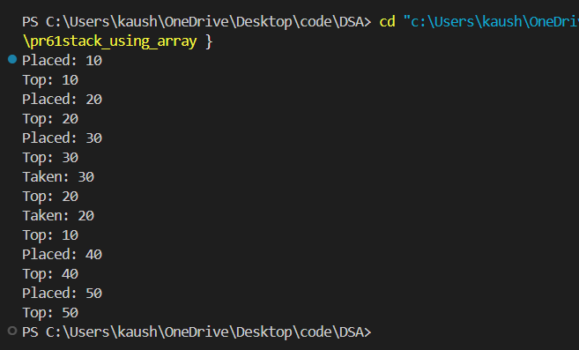

Problem Faced:
Understanding the top pointer and handling stack overflow and underflow conditions was the main challenge.

Outcome/Conclusion:
The stack was successfully implemented using an array. Push and pop operations were performed correctly with proper full and empty checks.

Problem 2 :
A web browser keeps track of pages visited so that the back button always returns to the most recently visited page. Unlike a fixed counter, the browser has no hard limit on how many pages it can remember — it grows as the user visits more pages and shrinks as they press back. Given a sequence of visit and back operations, implement this unlimited page history and print the current page after each operation. Describe how your solution differs from Problem 1 in how it handles memory. What happens in your solution when the user presses back on the very first page with no history left?

For Code:
https://github.com/KaushalPatel22/FDSA/tree/7b757e98950f9003ab582799d5dc37f284b72f8e/FDSAGITSUBMITION

Output:
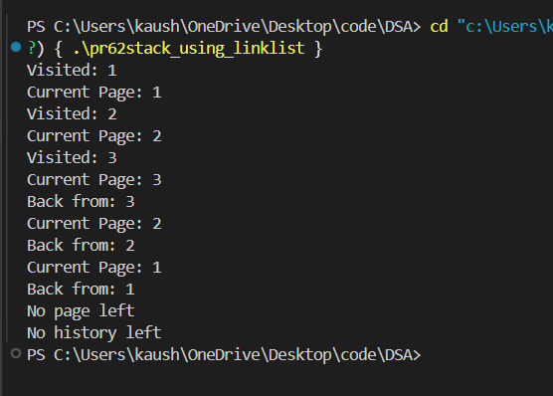

Problem Faced:
The main difficulty was understanding dynamic node creation and how the top pointer changes during push and pop operations.

Outcome/Conclusion:
The stack was successfully implemented using a linked list. It can grow dynamically according to available memory and handles an empty stack correctly.

Problem 3 :
A calculator application receives arithmetic expressions typed by users in the usual way — numbers and operators written in between, with brackets to control priority (e.g. 3 + 4 * 2 or (3 + 4) * 2). Internally the calculator needs to convert each expression into a form where operators appear after their operands, so it can evaluate them without needing to re-read brackets. Given an infix expression, convert it to the equivalent postfix form and print the result.
Describe the role the stack plays in your conversion. What does your solution do when it encounters a closing bracket, and what happens to the operators that were waiting on the stack at that point?

For Code:
https://github.com/KaushalPatel22/FDSA/tree/main/FDSAGITSUBMITION

Output:
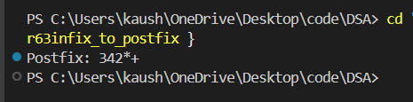

Problem Faced:
Understanding operator precedence, brackets, and deciding when to push or pop operators from the stack was the main challenge.

Outcome/Conclusion:
The infix expression was successfully converted to postfix using a stack. Operator precedence and brackets were handled correctly.

Key Questions / Analysis / Interpretation to be Evaluated During/After Implementation
- [Problem 1] A circular array is one way to reuse freed slots without shifting all elements. Without implementing it, explain what change would need to be made to your front and rear pointer logic to make the array behave circularly, and what new condition would indicate a full array.
ANS :
In a circular array, front and rear are updated using modulo:
(index + 1) % size
This makes them wrap around to the beginning. The array is full when the next rear position becomes equal to front.

- [Problem 2] Your linked list stack has no fixed capacity limit. But in practice, can it still run out of space? What determines the actual limit, and why is that limit invisible in your code?

ANS : Yes, a linked-list stack can still run out of space. Its limit depends on the available memory (RAM) of the system. It is not fixed in the code because nodes are created dynamically.

- [Problem 3] operator precedence determines the order in which operators are placed into the output. Without tracing any expression, explain what would go wrong in your output if your solution treated all operators as having equal precedence.
ANS : If all operators have equal precedence, operators may be placed in the wrong order in postfix form. This can produce an incorrect calculation result. * and / should have higher precedence than + and -.

