
FACULTY OF TECHNOLOGY AND ENGINEERING
DEVANG PATEL INSTITUTE OF ADVANCE TECHNOLOGY
AND RESEARCH

DEPARTMENT OF COMPUTER ENGINEERING

A.Y 2026 – 27 Semester – 3

LAB MANUAL

CSUC201 Fundamentals of Data Structures and Algorithms

Practical 1: Array Operations: Traversal, Rotation, and Frequency Analysis

Practical Aim : To implement fundamental array operations.
Problem 1 :
A bakery prepares n items every morning and places them in a display row. At the end of each
hour, the leftmost item is moved to the rightmost position to make room for fresh stock at the
front. Given the initial row and the number of hours h, print the final display order.
Describe the approach you used. How does it behave when h is very large, say 10 million? Is
there a way to get the correct result without performing the operation h times?

For Code:
https://github.com/KaushalPatel22/FDSA/tree/main/FDSAGITSUBMITION
Output:
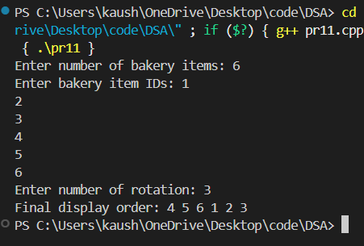
Problem Faced:
Understanding how to move the first element to the last position repeatedly was the main challenge. For a very large value of h, performing the operation one by one can take a lot of time.

Outcome/Conclusion:
The final display order was obtained successfully using left rotation. Since rotating n positions gives the original array, h % n can be used to reduce the number of rotations and make the solution efficient.

Problem 2 :
A library issues books to students and records each book's ID every time it is borrowed. At the end of the month, the librarian wants to find all books that were borrowed more than once, as those need priority restocking. Given the borrowing log, print all such book IDs. Describe the approach you used. How many times does your solution scan the data? If the library had 100,000 borrow records, would your approach still be practical? Can you think of a way that requires fewer passes?

For Code:
https://github.com/KaushalPatel22/FDSA/tree/main/FDSAGITSUBMITION
Output:
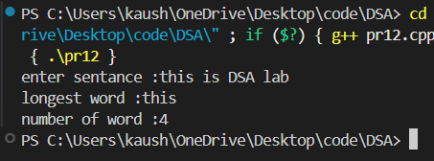
Problem Faced:
The main challenge was identifying which book IDs appeared more than once without missing any repeated values. Comparing every element with every other element can also become slow for a large number of records.
Outcome/Conclusion:
All book IDs borrowed more than once were identified successfully. A simple nested-loop approach works for small data, but using a frequency-counting method or hash map requires fewer comparisons and is more practical for large data such as 100,000 records.

Problem 3 :
A school newspaper editor wants to highlight the most impressive word from a submitted article on the front page. The word is chosen simply by length — the longest one wins. Given a sentence, print the winning word and how many letters it has. Describe the approach you used. What does your solution do when two words have the same length? Is that behavior intentional, and can you think of a way to handle it explicitly?

For Code:
https://github.com/KaushalPatel22/FDSA/tree/main/FDSAGITSUBMITION

Output:
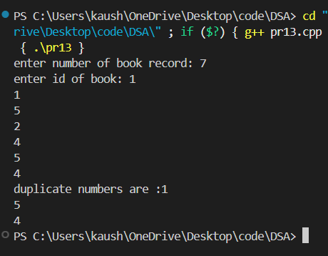

Problem Faced:
The main challenge was separating the sentence into words and comparing their lengths. Another case to consider is when two or more words have the same maximum length.

Outcome/Conclusion:
The longest word and its length were found successfully. The solution keeps the first longest word when two words have the same length. This behavior can be changed explicitly to print all words having the maximum length.

Key Questions / Analysis / Interpretation to be Evaluated During/After Implementation

- The display order repeats itself after a certain number of hours regardless of how large h gets. Without trying any specific example, explain why this repetition is inevitable and what determines when it first repeats.
Answer:
The display has a fixed number of n items. Each hour, all items shift one position to the left and the first item moves to the end. After exactly n rotations, every item returns to its original position. Therefore, the order repeats every n hours, and the first repetition occurs after n rotations.
- If the same book ID appears three times in the log, should it appear once or three times in your output? Does your solution handle this correctly, and how would you verify it?
Answer:
The book ID should appear only once because we only need to identify which books were borrowed more than once. The solution should avoid printing the same ID repeatedly. We can verify this by testing a log containing the same ID three times and checking that it appears only once in the output.
- The editor later decides that punctuation attached to a word, such as hello, or great!, should not count toward its length. How would this change your solution, and at which step would you handle it?
Answer:
We would remove punctuation marks from each word before calculating its length. This should be handled after splitting the sentence into words and before comparing their lengths. Then only the actual letters of the word would be counted.

