
FACULTY OF TECHNOLOGY AND ENGINEERING
DEVANG PATEL INSTITUTE OF ADVANCE TECHNOLOGY
AND RESEARCH

DEPARTMENT OF COMPUTER ENGINEERING

A.Y 2026 – 27 Semester – 3

LAB MANUAL

CSUC201 Fundamentals of Data Structures and Algorithms

Practical 2: Linear and Binary Search: Iterative and Recursive
Approaches

Practical Aim :
To implement linear and binary search using both iterative and recursive approaches.

Problem 1 :
A security guard at a parking lot checks vehicles one by one from the entrance to find a car with a specific license plate. Sometimes he starts from the entrance, sometimes he calls a helper who starts from where the guard left off. Given a list of license plates and a target plate, implement both approaches — one that checks plates one by one from the start, and one where the function calls itself to continue checking — and report the position of the target plate if found. Describe the approach you used. What happens in your solution if the target plate appears more than once in the list? Does it find the first occurrence, the last, or just any one?
For Code:
https://github.com/KaushalPatel22/FDSA/tree/main/FDSAGITSUBMITION

Output:
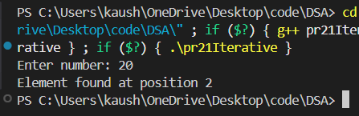

ProblemFace:
The main challenge was understanding how to check each element one by one and stop when the target was found. Implementing the recursive approach was also slightly difficult because the function calls itself for the next element.

Outcome/Conclusion:
Linear search was successfully implemented using both iterative and recursive approaches. The algorithm searches from the beginning and returns the first occurrence of the target. Its worst-case time complexity is O(n).

Problem 2 :
A librarian maintains a sorted catalog of book codes and needs to locate a specific code quickly. Instead of going through every book, she opens the catalog to the middle, checks whether the target is to the left or right, and repeats. Given a sorted list of book codes and a target code, implement both approaches — one using a loop and one where the function calls itself — and report the position of the target code. Describe the approach you used. What is the one condition your input must satisfy for this approach to work correctly? What would go wrong if that condition was not met?

For Code:
https://github.com/KaushalPatel22/FDSA/tree/main/FDSAGITSUBMITION
Output:
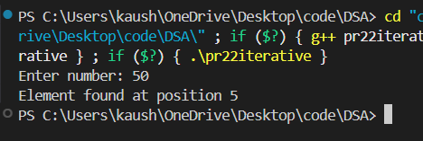
Problem Faced:
The main challenge was understanding how binary search uses the middle element to reduce the search area. Correctly updating low, high, and mid was important in both iterative and recursive approaches.
Outcome/Conclusion:
Binary search was successfully implemented using both iterative and recursive approaches. It finds elements efficiently in a sorted array with a worst-case time complexity of O(log n). The array must be sorted for the algorithm to work correctly.

Key Questions / Analysis / Interpretation to be Evaluated During/After Implementation

1. If the target plate appears near the end of a very long list, your solution still checks every plate before it. Can you think of any property the input would need to have for you to skip checking some plates entirely? What does Problem 2.2 tell you about this?
ANS : The input needs to have some useful property, such as being sorted. If the data is sorted, we can compare the target with the middle element and decide whether to search the left or right half. Problem 2 uses this property through binary search, which allows us to skip many elements instead of checking every element.

2. What is the consequence of applying your solution to a list that is not sorted? Would it always give a wrong answer, or only sometimes? Explain your reasoning without running any example.
ANS: It would give a wrong answer in some cases, but not necessarily every time. Binary search depends on the sorted order to decide which half can contain the target. Without sorting, that decision is not reliable. It might accidentally find the target, but it can also discard the half containing the target and report that it was not found.

