
FACULTY OF TECHNOLOGY AND ENGINEERING
DEVANG PATEL INSTITUTE OF ADVANCE TECHNOLOGY
AND RESEARCH

DEPARTMENT OF COMPUTER ENGINEERING

A.Y 2026 – 27 Semester – 3

LAB MANUAL

CSUC201 Fundamentals of Data Structures and Algorithms

Practical 3: Sorting Algorithms: Comparison-Based,
Counting-Based, and Digit-Based Strategies

Practical Aim :
To implement and compare multiple sorting algorithms and develop the ability to reason about which sorting strategy suits a given situation.

Problem 1 :
A teacher has a stack of student answer sheets with marks written on them and needs to arrange them in order before entering grades. She tries three different methods: in the first, she repeatedly compares adjacent sheets and swaps them if they are out of order; in the second, she finds the lowest-marked sheet each time and places it at the front; in the third, she picks each sheet one by one and inserts it into its correct position among the already-arranged sheets. Implement all three methods and for each one, print the sorted order of marks. Describe how each of the three methods works in your own words. If the sheets were already in order before the teacher started, which method would finish the fastest and why?

For Code:
https://github.com/KaushalPatel22/FDSA/tree/main/FDSAGITSUBMITION

Output:
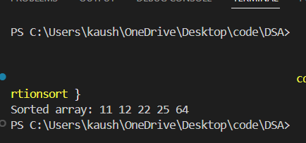

Problem Faced:
The main difficulty was understanding the difference between Bubble Sort, Selection Sort, and Insertion Sort because all three produce the same sorted result using different methods.

Outcome/Conclusion:
All three sorting algorithms were successfully implemented. Bubble Sort compares adjacent elements, Selection Sort selects the minimum element, and Insertion Sort inserts each element into its correct position. Insertion Sort performs efficiently when the data is already sorted.

Problem 2 :
A paint shop has buckets labeled with one of three colour codes — 0, 1, or 2 — but they are stored in a random order. The shop owner wants all 0s together, then all 1s, then all 2s, without using any extra storage. Given the list of colour codes, rearrange them in place and print the result. Describe the approach you used. Does your solution make more than one pass through the list? Can you think of a way to do it in exactly one pass?

For Code:
https://github.com/KaushalPatel22/FDSA/tree/7b757e98950f9003ab582799d5dc37f284b72f8e/FDSAGITSUBMITION

Output:
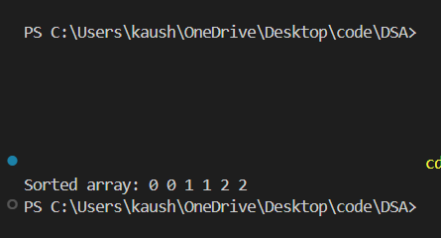

Problem Faced:
The main challenge was rearranging 0, 1, and 2 without using extra storage and understanding the roles of low, mid, and high.

Outcome/Conclusion:
The array was successfully sorted in place using the three-pointer approach. The algorithm requires only one traversal, runs in O(n) time, and uses O(1) extra space.

Key Questions / Analysis / Interpretation to be Evaluated During/After Implementation

- One of the three methods can detect early that the list is already sorted and stop without doing any more work. Which method is it, how would you add that detection, and why can the other two not do the same?
ANS:
Bubble Sort can detect early that the list is already sorted. We add a swapped variable and set it to true whenever a swap occurs. After a complete pass, if no swap occurred, the array is already sorted, so we stop.
The other two methods do not normally have this early-stop condition. Selection Sort still needs to find the minimum element from the unsorted part, while Insertion Sort still processes each element, even though it does very little work on an already sorted list.
- If your solution makes two passes through the list, can you identify which decision in your logic forces the second pass? Is there a way to restructure that decision to eliminate it?
ANS :
If we first count the number of 0s, 1s, and 2s and then rewrite the array using those counts, the rewriting step causes the second pass.
We can eliminate the second pass by using the three-pointer approach with low, mid, and high. It rearranges the elements while scanning the array, so the sorting is completed in one pass with O(n) time and O(1) extra space.

