
FACULTY OF TECHNOLOGY AND ENGINEERING
DEVANG PATEL INSTITUTE OF ADVANCE TECHNOLOGY
AND RESEARCH

DEPARTMENT OF COMPUTER ENGINEERING

A.Y 2026 – 27 Semester – 3

LAB MANUAL

CSUC201 Fundamentals of Data Structures and Algorithms

Practical 4: Singly Linked List: Dynamic Insertion, Deletion,
and Traversal

Practical Aim :
To implement core singly linked list operations and develop the ability to manipulate dynamic
sequences through real-world problem scenarios.

Problem 1 :
A hospital manages a queue of patient tokens. New critical patients must be added to the front,
routine patients are added to the end, and occasionally a patient with a priority number must be
inserted at a specific position in the queue. Given a sequence of such operations, implement all
three insertion types and print the final queue after each operation.
Describe how your insertion at a specific position works. What does your solution do if the
position given is greater than the current length of the queue? Is that handled explicitly or does it
cause an error?

For Code:
https://github.com/KaushalPatel22/FDSA/tree/main/FDSAGITSUBMITION

Output:
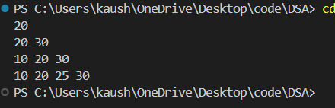

Problem Faced:
The main difficulty was understanding how nodes are connected using pointers. Inserting at different positions also required changing the next pointers correctly.

Outcome/Conclusion:
Front, end, and position insertion operations were successfully implemented using a singly linked list. Invalid positions were also handled properly.

Problem 2 :
The hospital also needs to remove a patient token from the queue when a patient leaves, print
all remaining tokens from last to first for an end-of-day audit, and display the full queue from
front to back at any point. Implement deletion by value, reverse printing, and forward traversal
on the same queue from Problem 4.1a. Describe how your reverse printing works. Does it use any extra storage, or does it work purely
by following the links? Can you think of another way to reverse-print without modifying the
original queue?

For Code:
https://github.com/KaushalPatel22/FDSA/tree/7b757e98950f9003ab582799d5dc37f284b72f8e/FDSAGITSUBMITION

Output:
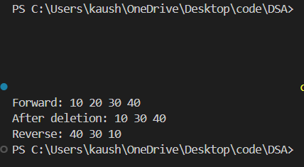

Problem Faced:
The main difficulty was understanding how to delete a node without breaking the remaining links. Reverse printing was also challenging because the linked list normally moves only from front to back.

Outcome/Conclusion:
Deletion by value, forward traversal, and reverse printing were successfully implemented using a singly linked list. Reverse printing was performed using recursion without modifying the original linked list.

Key Questions / Analysis / Interpretation to be Evaluated During/After Implementation

- [Problem 1] Inserting at a position beyond the current length of the list is an invalid operation. Should your solution silently insert at the end, report an error, or do something else entirely? Justify your choice and explain what assumption about the caller your choice makes.
ANS:
The solution should report an error when the position is beyond the current length of the list. Silently inserting at the end may give an unexpected result. This assumes that the caller provides a valid position and checks the error if an invalid position is given.
- [Problem 2] If the node to be deleted is the only node in the list, how many pointers need
to change and what must they be set to? How is this case structurally different from
deleting a node in the middle?
ANS :
If the node is the only node, only the head pointer needs to be changed. It must be set to NULL. In the middle of a list, the previous node's next pointer must be changed to point to the next node of the deleted node.

