Practical - 1
Practical Title: Project Initiation, Requirement Analysis, Sitemap, Wireframe, and GitHub Setup

Problem Definition: Initiate the semester-long StudentHub portal by identifying the problem scope, user roles, key modules, navigation flow, and minimum 10 pages. Create a sitemap, low-fidelity wireframe, project folder structure, README file, and GitHub repository.

Theory:

What is URL and parts of URL?
Answer: A URL (Uniform Resource Locator) is the address used to locate a particular resource on the Internet, such as a webpage, image, or file. It tells the browser where the resource is located and how it should be accessed.
For example:
https://www.example.com/student/index.html
Main parts of a URL are:
- https – Protocol used to communicate with the website securely.
- www – Subdomain of the website.
- example.com – Domain name of the website.
- /student/ – Path showing the location of the resource.
- index.html – Specific webpage or file being requested.

References:
https://developer.mozilla.org/en-US/docs/Learn_web_development/Howto/Web_mechanics/What_is_a_URL

- How does HTML file process in web browser?
Answer: When we open an HTML file or enter a website address in a browser, the browser first gets the HTML document. It then reads the HTML code from top to bottom and converts the HTML elements into a structure called the DOM (Document Object Model).
After that, the browser loads related CSS files, JavaScript files, images, and other resources. CSS is used to style the page, while JavaScript can add functionality and interaction. Finally, the browser combines everything and displays the webpage on the screen.

References:
https://developer.mozilla.org/en-US/docs/Web/Performance/Guides/How_browsers_work

3. How will page navigation flow managed among all HTML pages?
Answer: Page navigation in our StudentHub project will be managed using HTML links (<a> tags). Each navigation item, such as Home, Timetable, Attendance, Notes, and Faculty, will contain a link to its respective HTML file.

For example:

<a href="attendance.html">Attendance</a>

When the user clicks the link, the browser opens the specified HTML page. A common navigation bar can be included on all pages so that users can easily move between different sections of StudentHub. We will also maintain a proper sitemap to define the relationship and flow between all pages.

References:
https://developer.mozilla.org/en-US/docs/Web/HTML/Element/a

4. How will GitHub commits be maintained after each practical?
Answer: GitHub commits will be maintained after completing each practical or major change in the StudentHub project. First, we will check the modified files using git status. Then we will add the required files using git add, create a commit with a meaningful message using git commit, and upload the changes to GitHub using git push.

For example:

git add .
git commit -m "Completed Practical 1"
git push origin main

We will use clear commit messages such as “Added sitemap”, “Created wireframes”, or “Updated StudentHub navigation”. This will help us track the progress of the project and return to an earlier version if required.

References:
https://docs.github.com/en/pull-requests/committing-changes-to-your-project/creating-and-editing-commits/about-commits
https://docs.github.com/en/get-started/using-git/pushing-commits-to-a-remote-repository

Implementation/ Output/Result

The StudentHub sitemap and 11 low-fidelity wireframes were successfully created using draw.io. The wireframes show the basic layout, content sections, and navigation structure of each page before development.Main HTML Code Used
Result
The StudentHub wireframes were successfully created for all 11 pages, giving a clear basic structure and navigation plan for the website.

Evidence of Work (Screenshots)

Description: (Homepage)
Shows the basic layout of the StudentHub homepage, including navigation and quick access.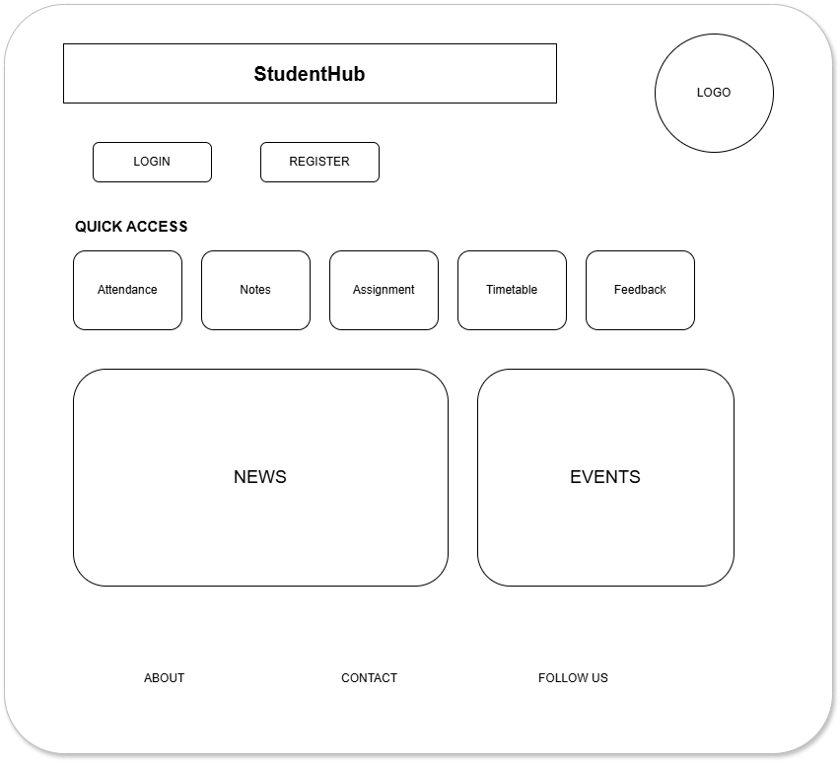

Description: (Login)
Shows the basic layout for student login with required login fields.
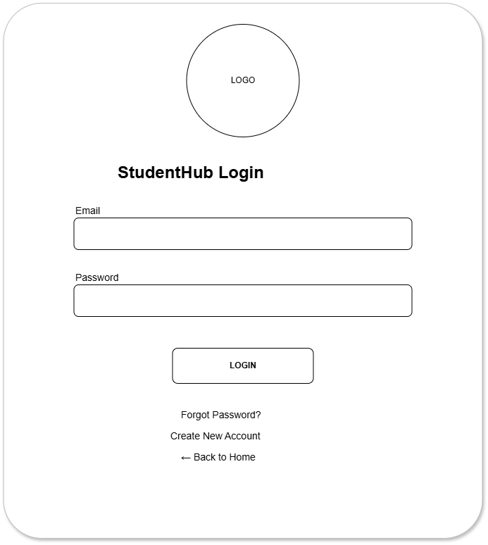

Description: (Registration)
Shows the layout for creating a new student account.
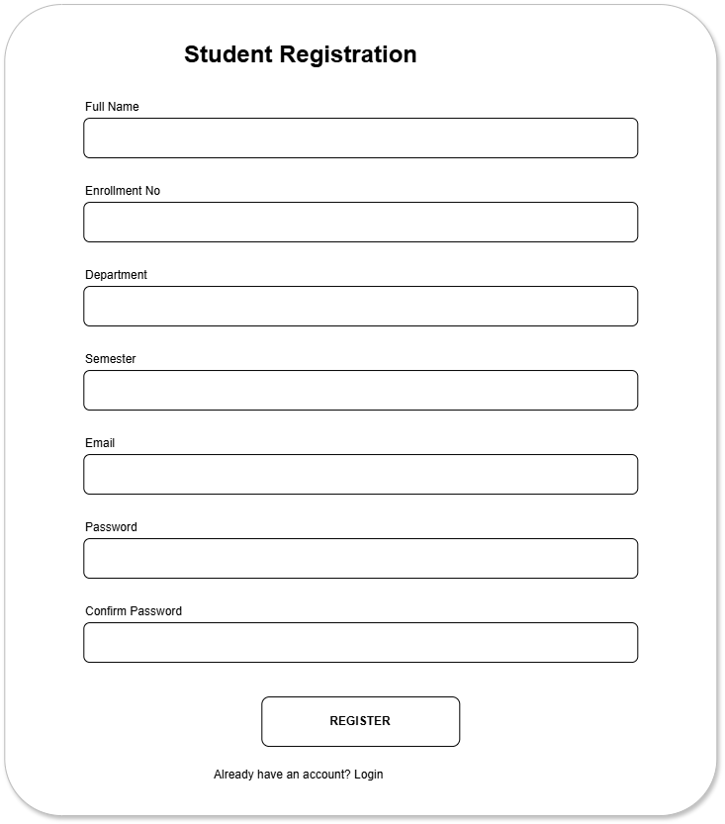

Description: (Dashboard)
Shows the main dashboard with important student information and options.
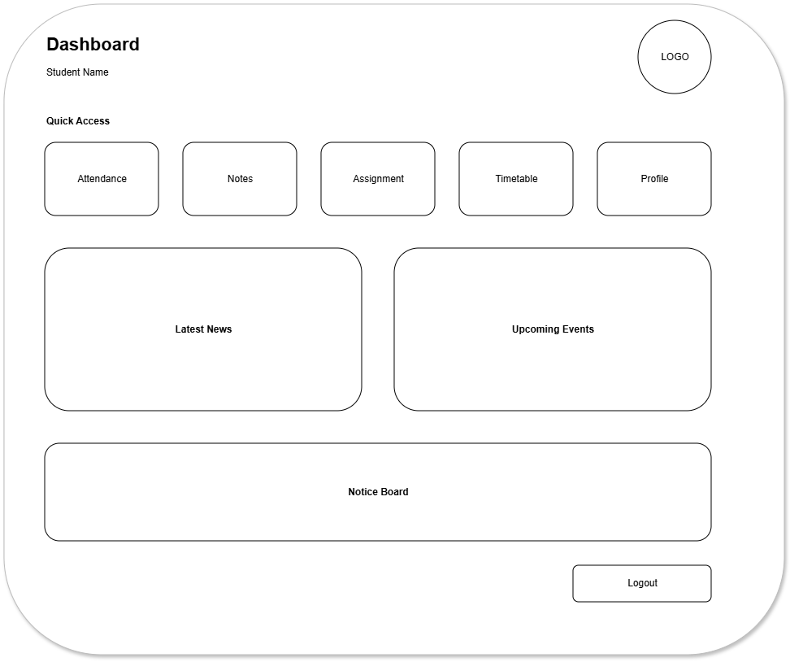

Description: (Notes)
Shows the layout for accessing and viewing study notes.
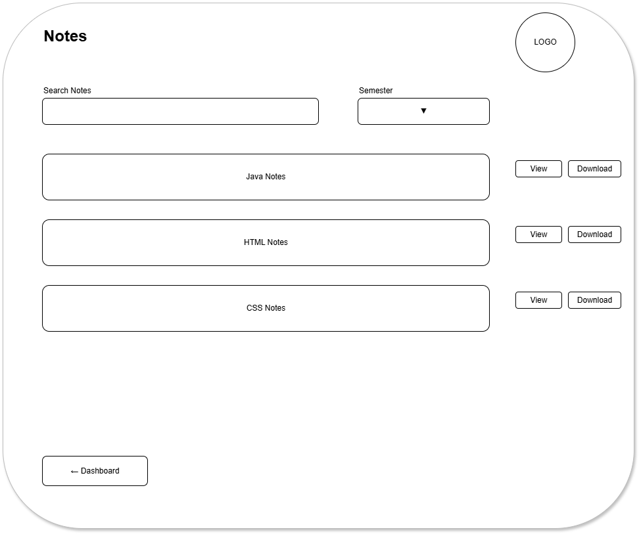

Description: (Assignment)
Shows the layout for viewing student assignments.
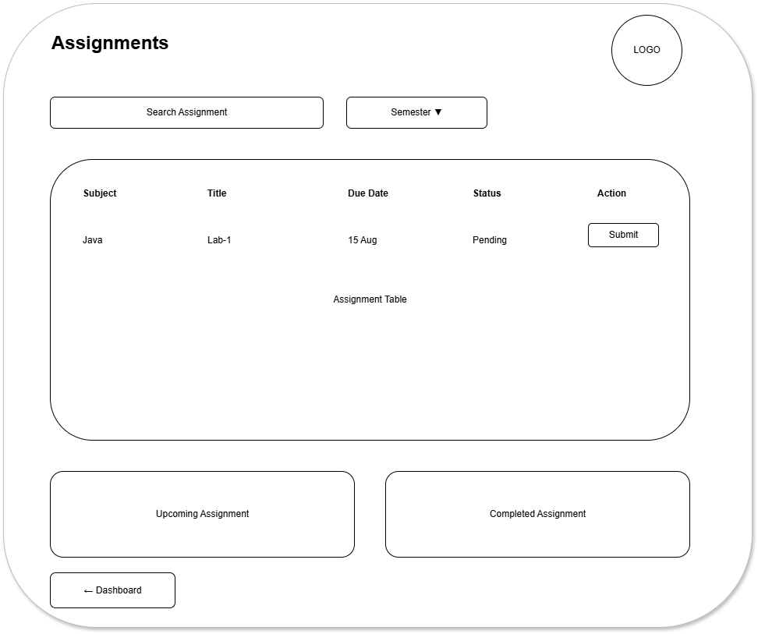

Description: (Attendance)
Shows the layout for displaying student attendance.
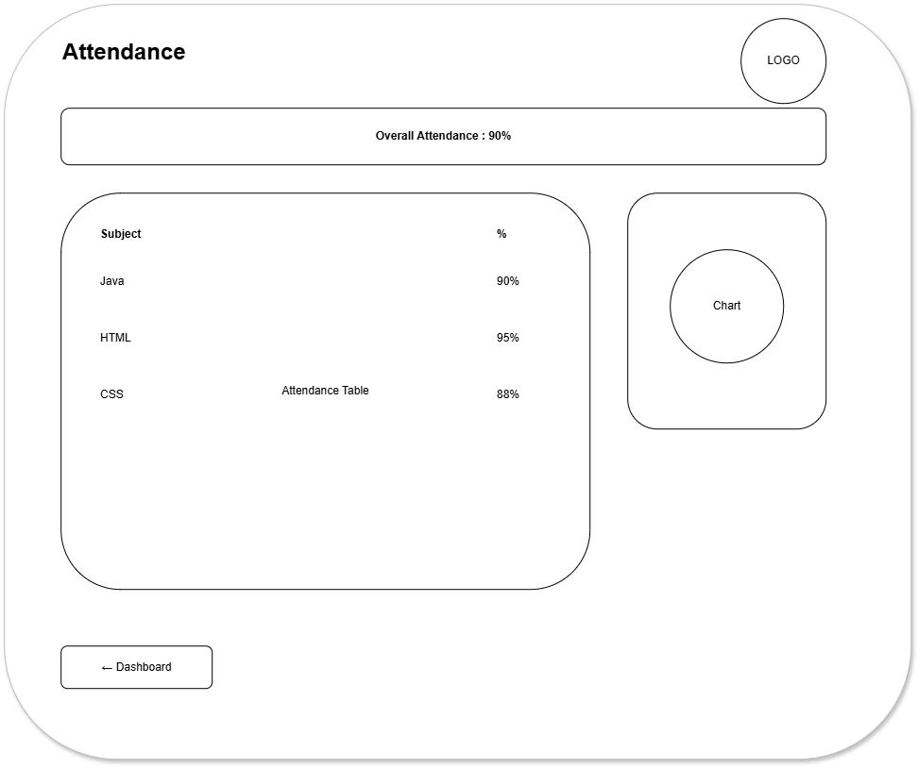

Description: (Feedback)
Shows the layout for submitting student feedback.
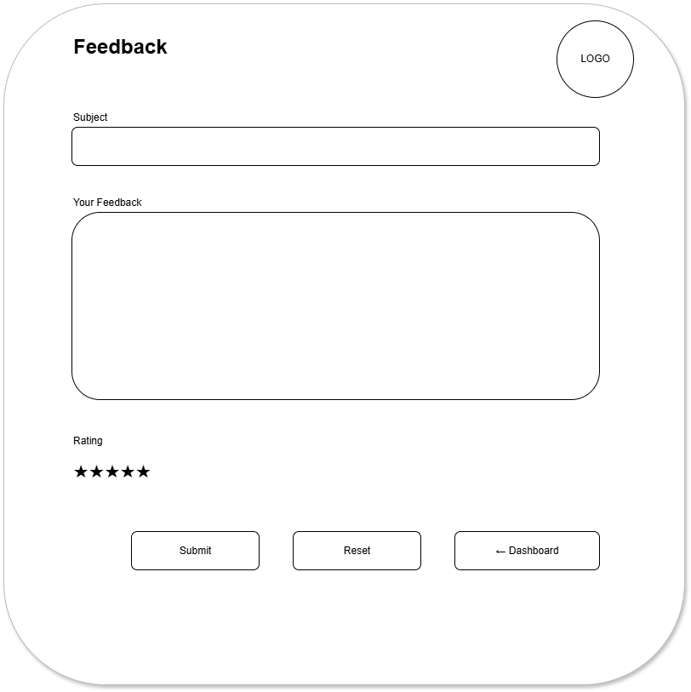

Description: (Profile)
Shows the layout for student profile information.
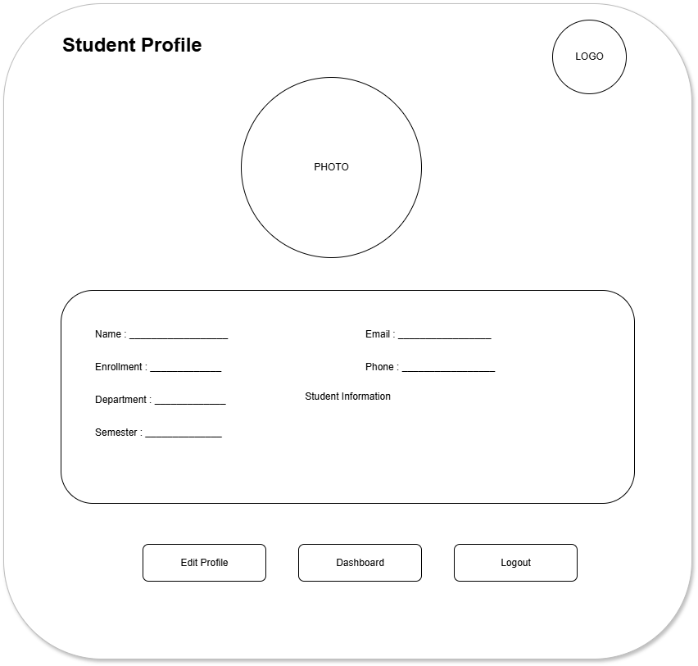

Description: (Timetable)
Shows the layout for displaying the student timetable.
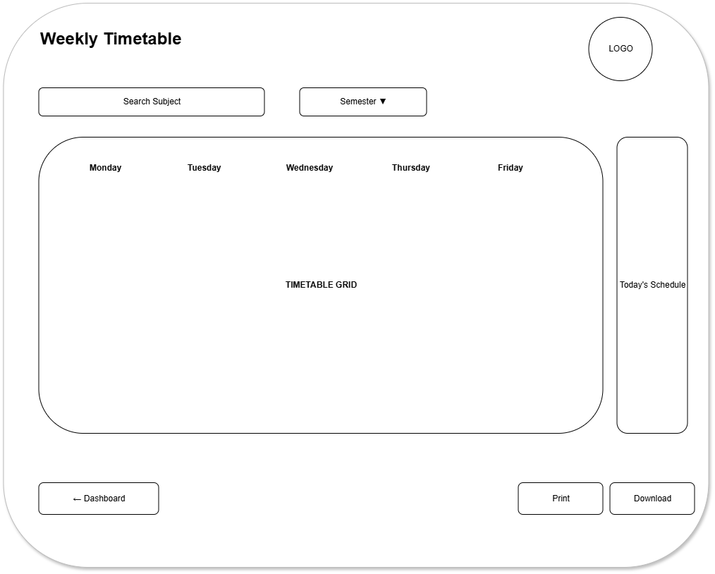

Description: (About)
Shows the basic layout containing information about StudentHub.
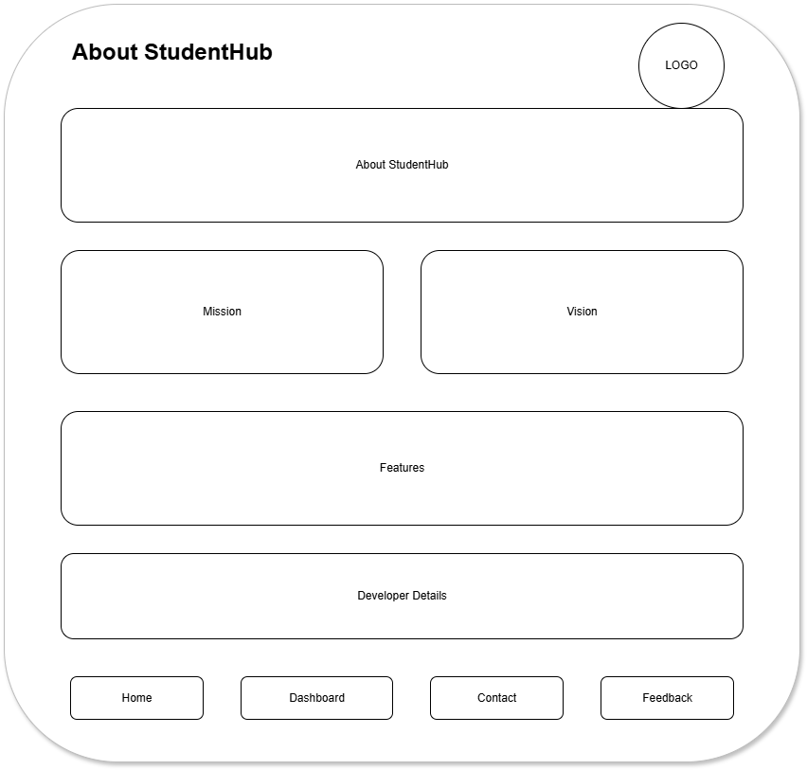

GitHub Repository Link:

https://github.com/KaushalPatel22/StudentHub

Challenges Faced:
- Deciding the layout of each page.
- Planning proper navigation between pages.
- Creating a simple and clear wireframe.

Learning Outcomes:
- Learned how to create a sitemap and wireframe.
- Learned to plan page layouts and navigation.
- Understood website structure before coding..

Faculty Remarks:

