PRACTICAL 2
Practical Title: Semantic HTML5 Pages with Accessibility-Ready Structure
Problem Definition: Develop static HTML5 skeletons for at least 10 Student Hub pages such as Home, About, Register, Login, Dashboard, Events, Profile, Contact, Admin, FAQ, and Feedback. Use semantic tags and accessibility-friendly structure.

- Theory

1.Are semantic tags such as header, nav, main, section, article, aside, and footer used properly?
Answer: Yes, semantic tags like header, nav, main, section and footer are used to arrange the page properly.
Reference :
https://developer.mozilla.org/en-US/docs/Glossary/Semantics

2.Are form labels, headings, image alt text, and navigation links accessible?
Answer: Yes, headings, form labels and navigation links are used properly so the pages are easy to use.
Reference :
https://www.w3.org/WAI/fundamentals/accessibility-principles/

3.Is the page structure consistent across all pages?
Answer: Yes, all pages have a similar structure with a header, navigation, main content and footer.
Reference:
https://developer.mozilla.org/en-US/docs/Learn_web_development/Core/Structuring_content

Implementation/ Output/Result

The StudentHub pages were implemented using semantic HTML tags such as <header>, <nav>, <main>, <section>, and <footer> to create a clear and organized page structure.

Evidence of Work (Screenshots)

Description: (Homepage)
Shows the main StudentHub page with navigation, welcome message, and quick access options.
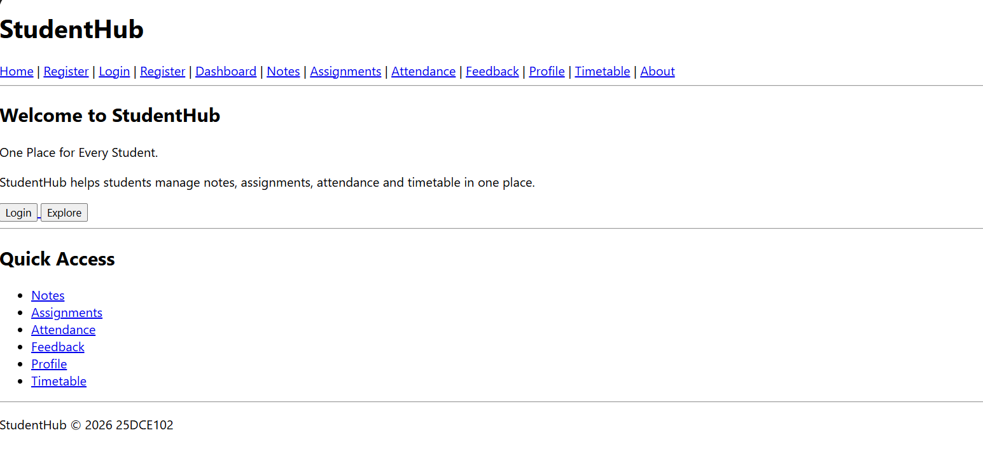
Description: (Login)
Provides a login form for students to enter their account details.
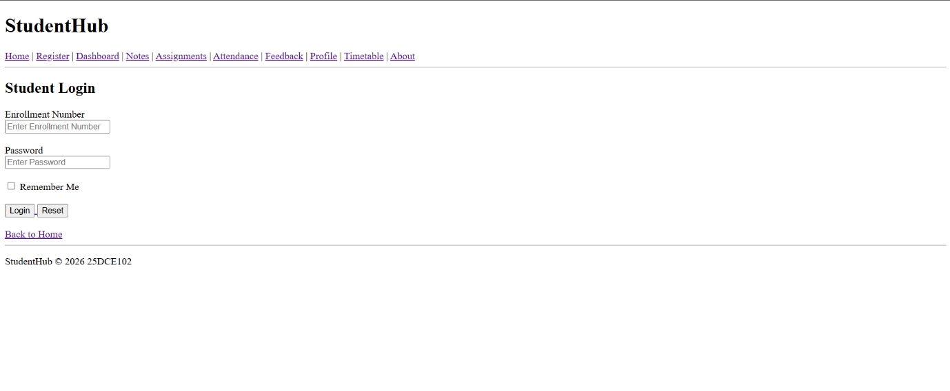

Description: (Registration)
Allows students to create a new StudentHub account.
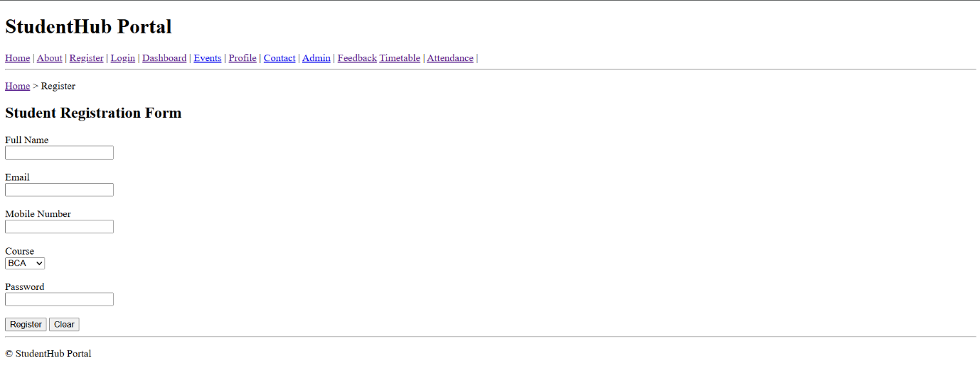
Description: (Dashboard)
Displays the main student information and available portal options.
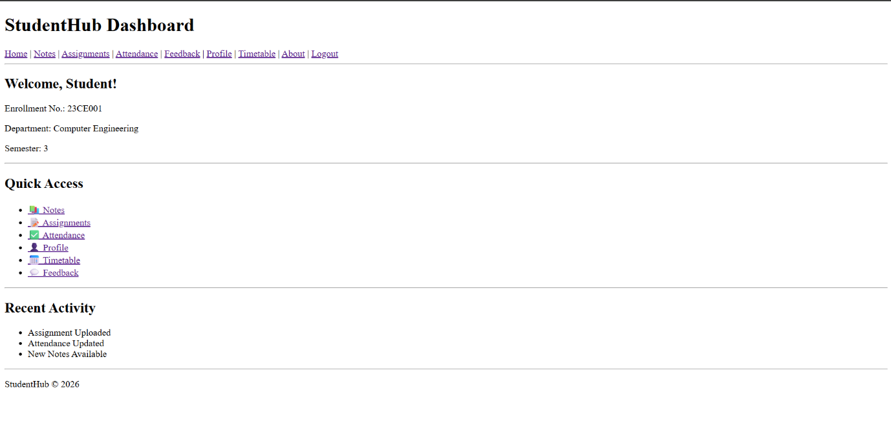

Description: (Notes)
Provides access to study notes and learning materials.
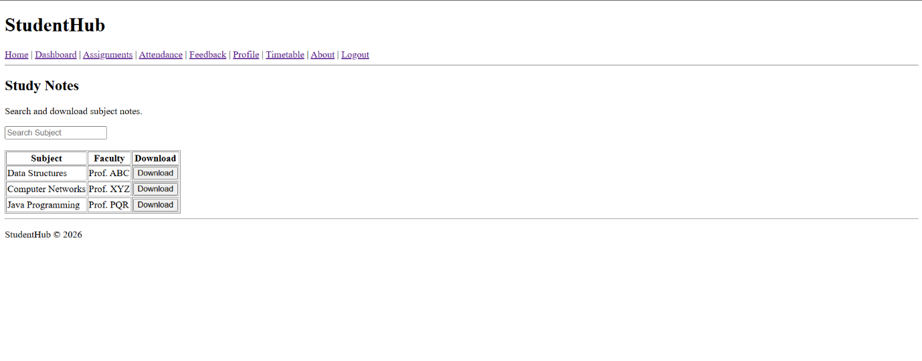
Description: (Assignments)
Shows student assignments and related information.
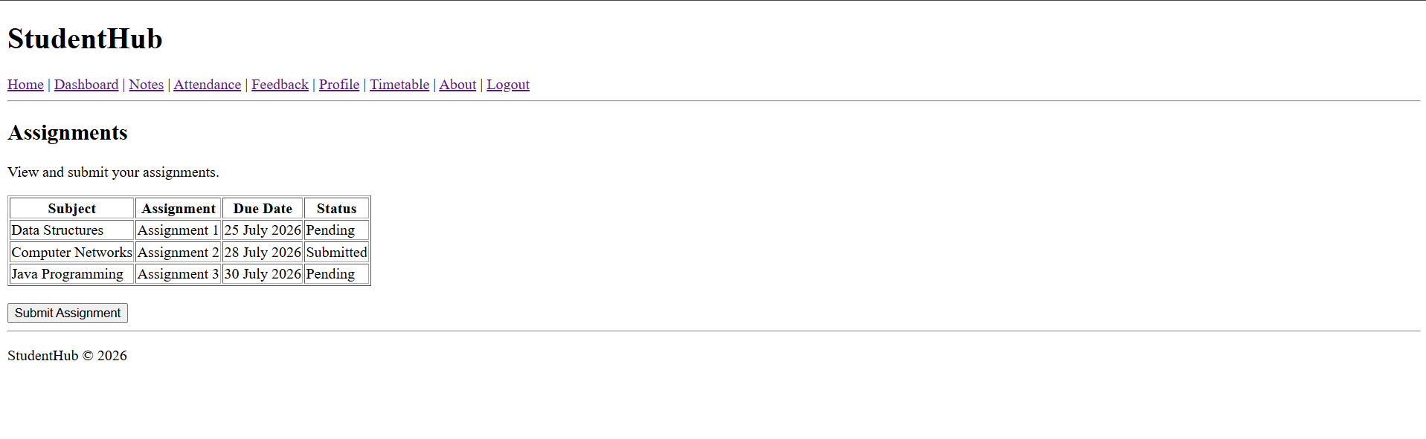
Description: (Attendance)
Displays the student's attendance information.
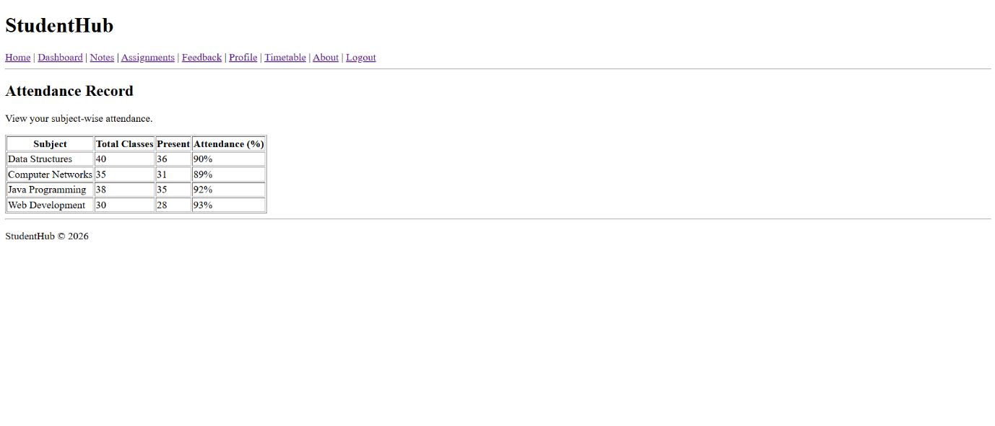

Description: (Feedback)
Provides a form for students to submit feedback.
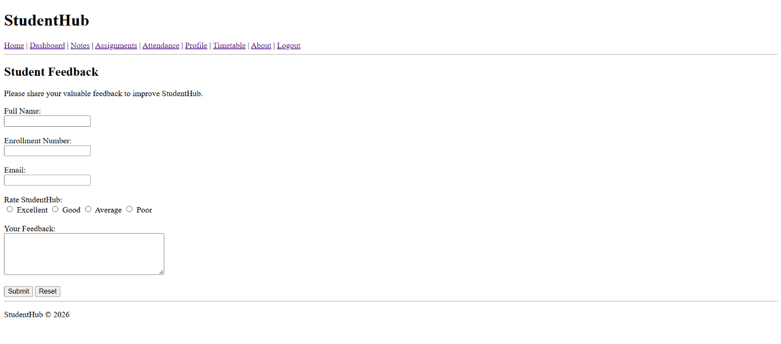

Description: (Profile)
Displays the student's personal and profile information.
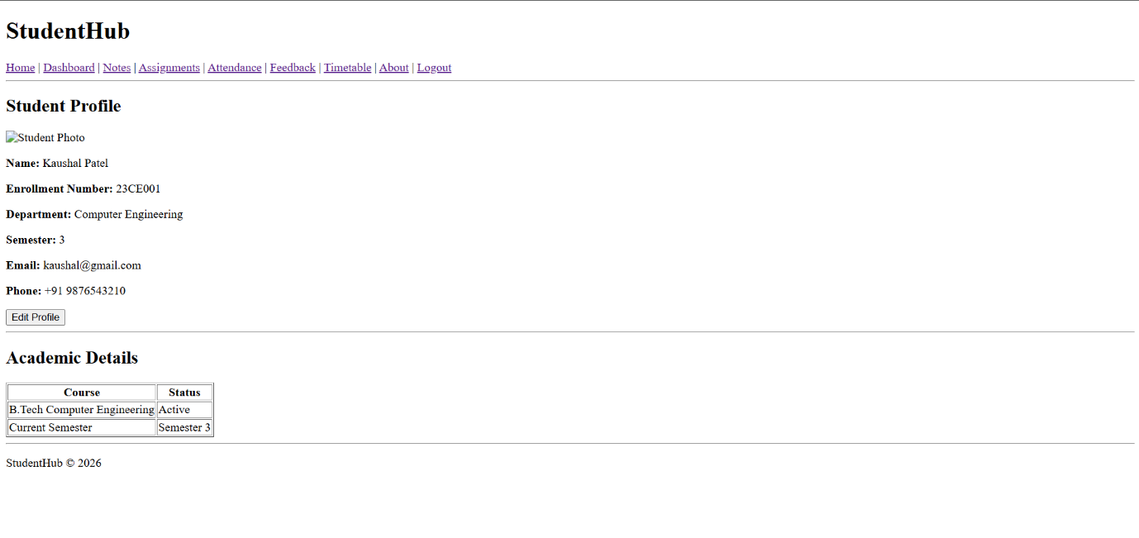

Description: (Timetable)
Shows the student's class timetable and schedule.
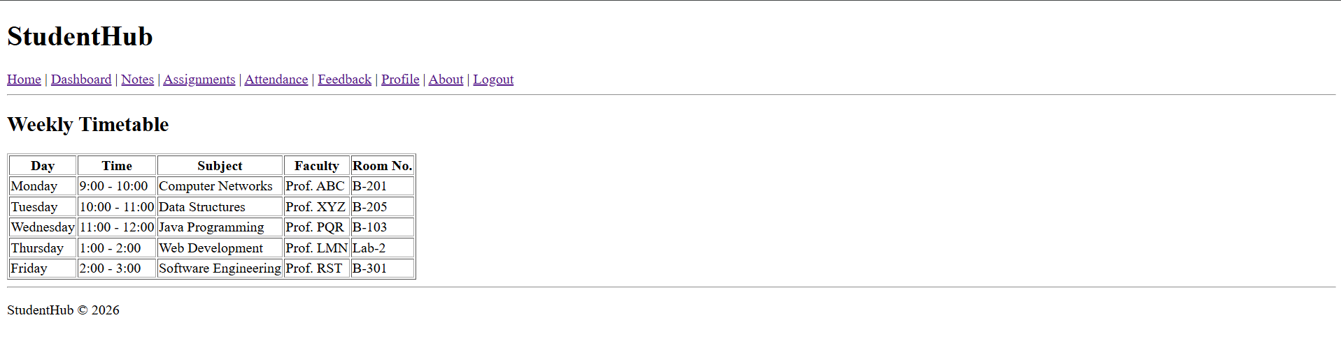
Description: (About)
Provides basic information about the StudentHub portal.
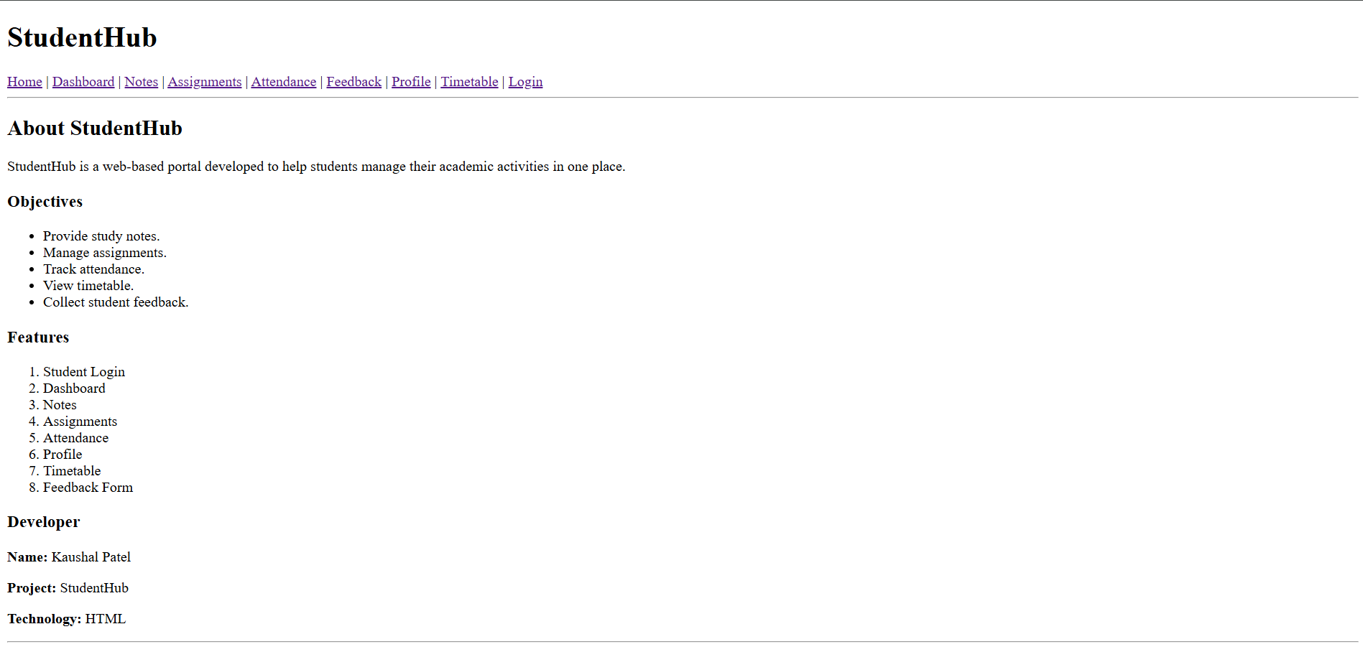

GitHub Repository Link:

https://github.com/KaushalPatel22/StudentHub

Challenges Faced:
• Understanding and using semantic HTML tags correctly.
• Maintaining the same page structure across all HTML pages.
• Creating proper navigation links between pages.
• Making forms, headings, and links easy to understand.

Learning Outcomes:
- Learned how to use semantic HTML tags.
- Learned basic web accessibility practices.
- Learned how to maintain a consistent page structure.
- Improved HTML page organization and navigation.

Faculty Remarks:

