Practical - 3
Practical Title: Responsive UI Design using CSS Grid, Flexbox, and Bootstrap/Tailwind
Problem Definition: Design responsive layouts for Home, About, Registration, Dashboard, and
Events pages using CSS Grid and Flexbox. Optional to use CSS
framework such as Bootstrap or Tailwind. Ensure mobile-first
responsiveness.

Theory:

- How does the layout adapt for mobile, tablet, and desktop screens?
ANS : The layout can adapt to different screen sizes using responsive design. CSS media queries can change the size, spacing, and arrangement of elements according to the screen width.
Reference:
https://developer.mozilla.org/en-US/docs/Learn_web_development/Core/CSS_layout/Responsive_Design
- Which layout technique is used and why?
ANS : CSS Flexbox can be used to arrange elements in rows or columns. It makes the layout easier to align and helps it adjust to different screen sizes.
Reference:
https://developer.mozilla.org/en-US/docs/Web/CSS/Guides/Flexible_box_layout
- Are typography, spacing, colors, and contrast readable?
ANS : Yes, proper font sizes, spacing, colors, and sufficient contrast are used to make the content clear and easy to read.
Reference:
https://www.w3.org/WAI/tips/designing/
- Is the framework used consistently without unnecessary inline CSS?
ANS : Yes, using an external CSS file keeps the styling separate from HTML and helps maintain a consistent design across all pages.
Reference:
https://developer.mozilla.org/en-US/docs/Learn_web_development/Core/Styling_basics/Getting_started

Implementation/ Output/Result

The StudentHub HTML pages were styled using CSS to improve the layout, spacing, fonts, colors, buttons, navigation, and overall appearance. The CSS was applied through an external stylesheet to maintain a consistent design across the pages.

Evidence of Work (Screenshots)
Description: (Homepage)
CSS is used to style the homepage layout, navigation, text, buttons, and spacing.
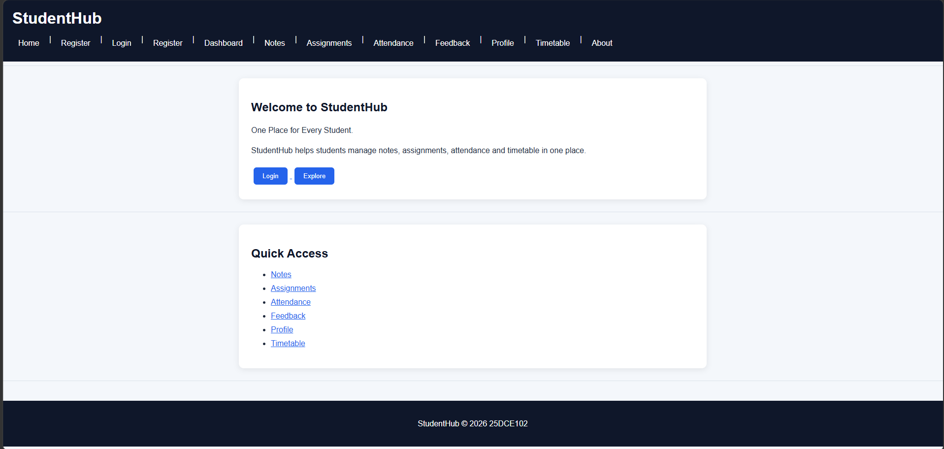
Description: (Login)
CSS is used to style the login form, input fields, buttons, and page layout.
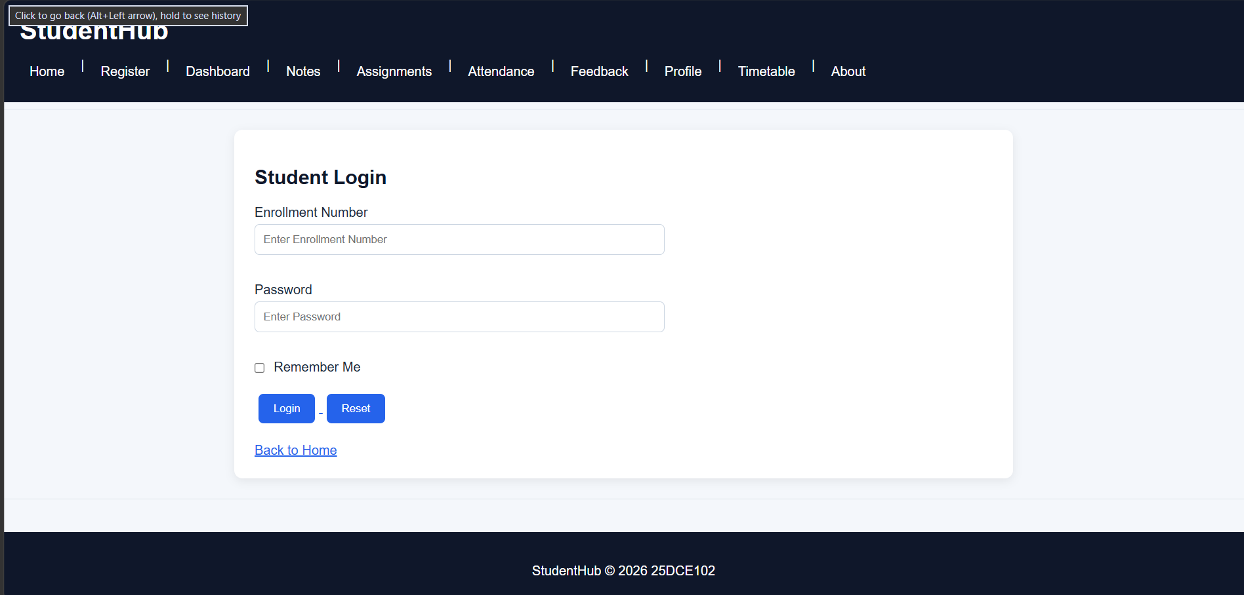
Description: (Registration)
CSS is used to style the registration form, fields, buttons, and overall spacing.
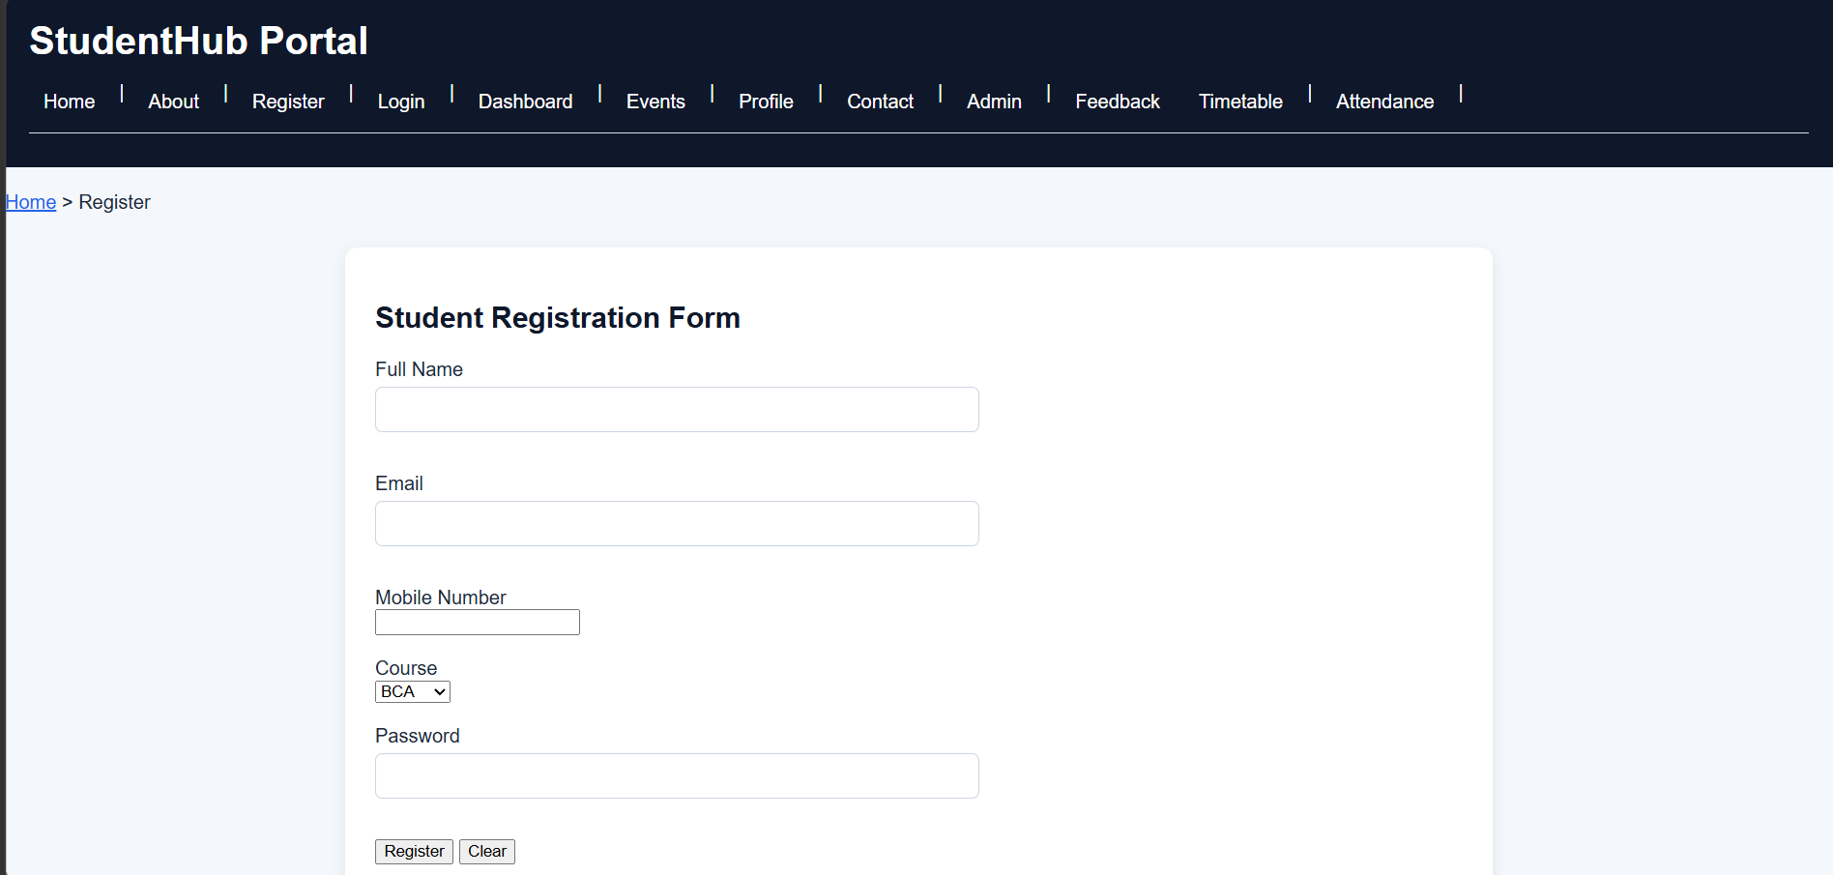
Description: (Dashboard)
CSS is used to organize the dashboard content and improve its visual appearance.


Description: (Notes)
CSS is used to style the notes section and arrange its content clearly.
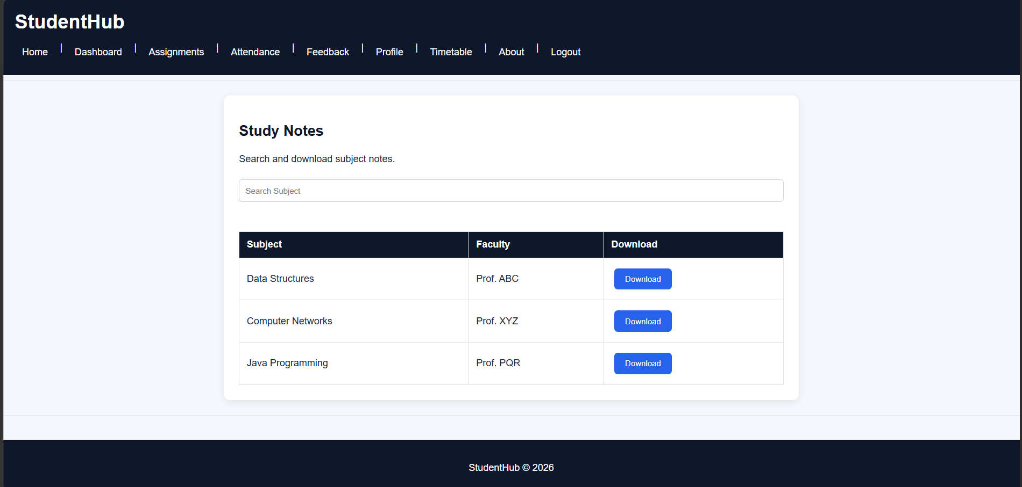
Description: (Assignment)
CSS is used to style the assignment section and organize assignment information.
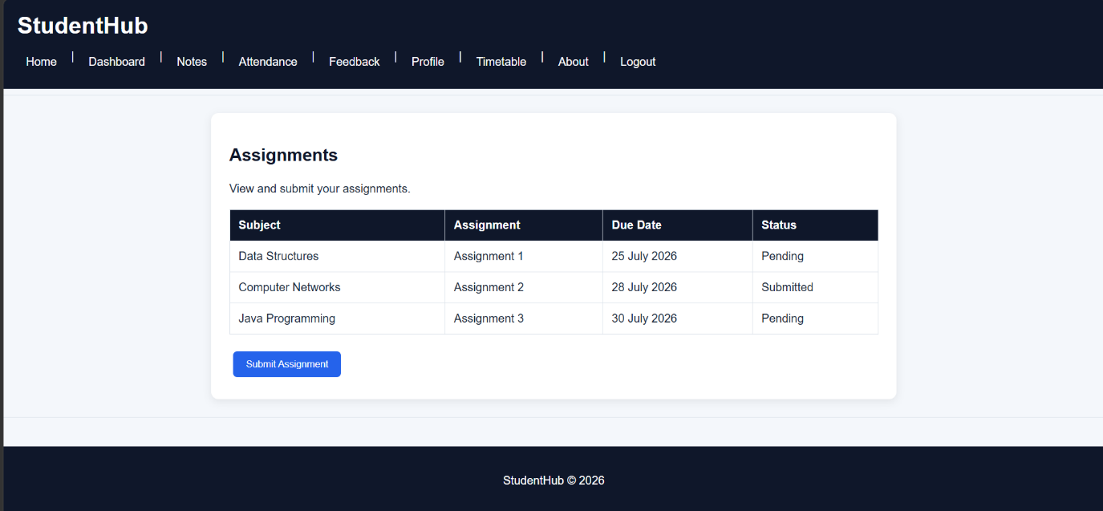

Description: (Attendance)
CSS is used to format the attendance information and maintain proper spacing.
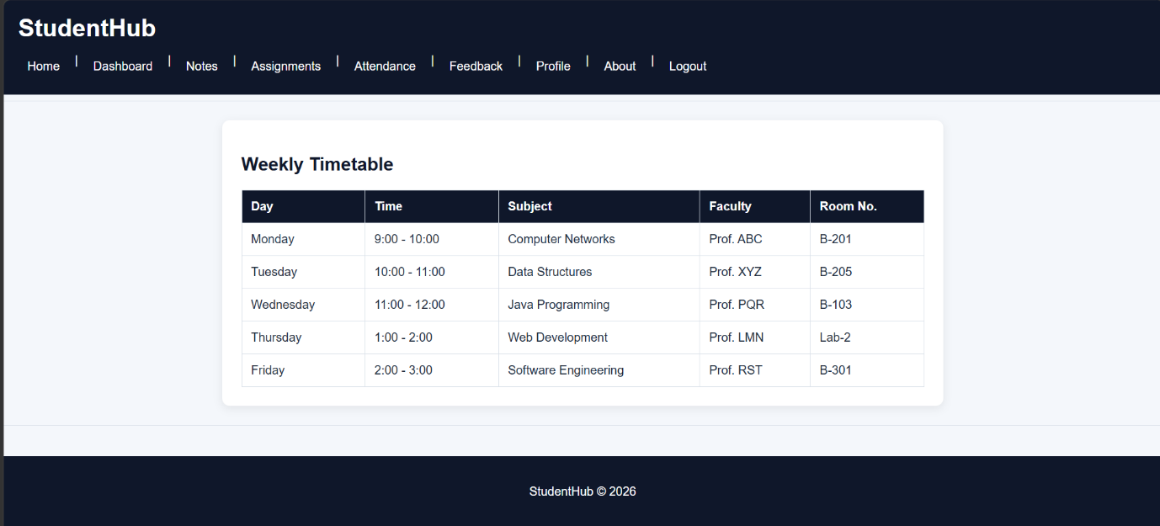
Description: (Feedback)
CSS is used to style the feedback form, input fields, and buttons.
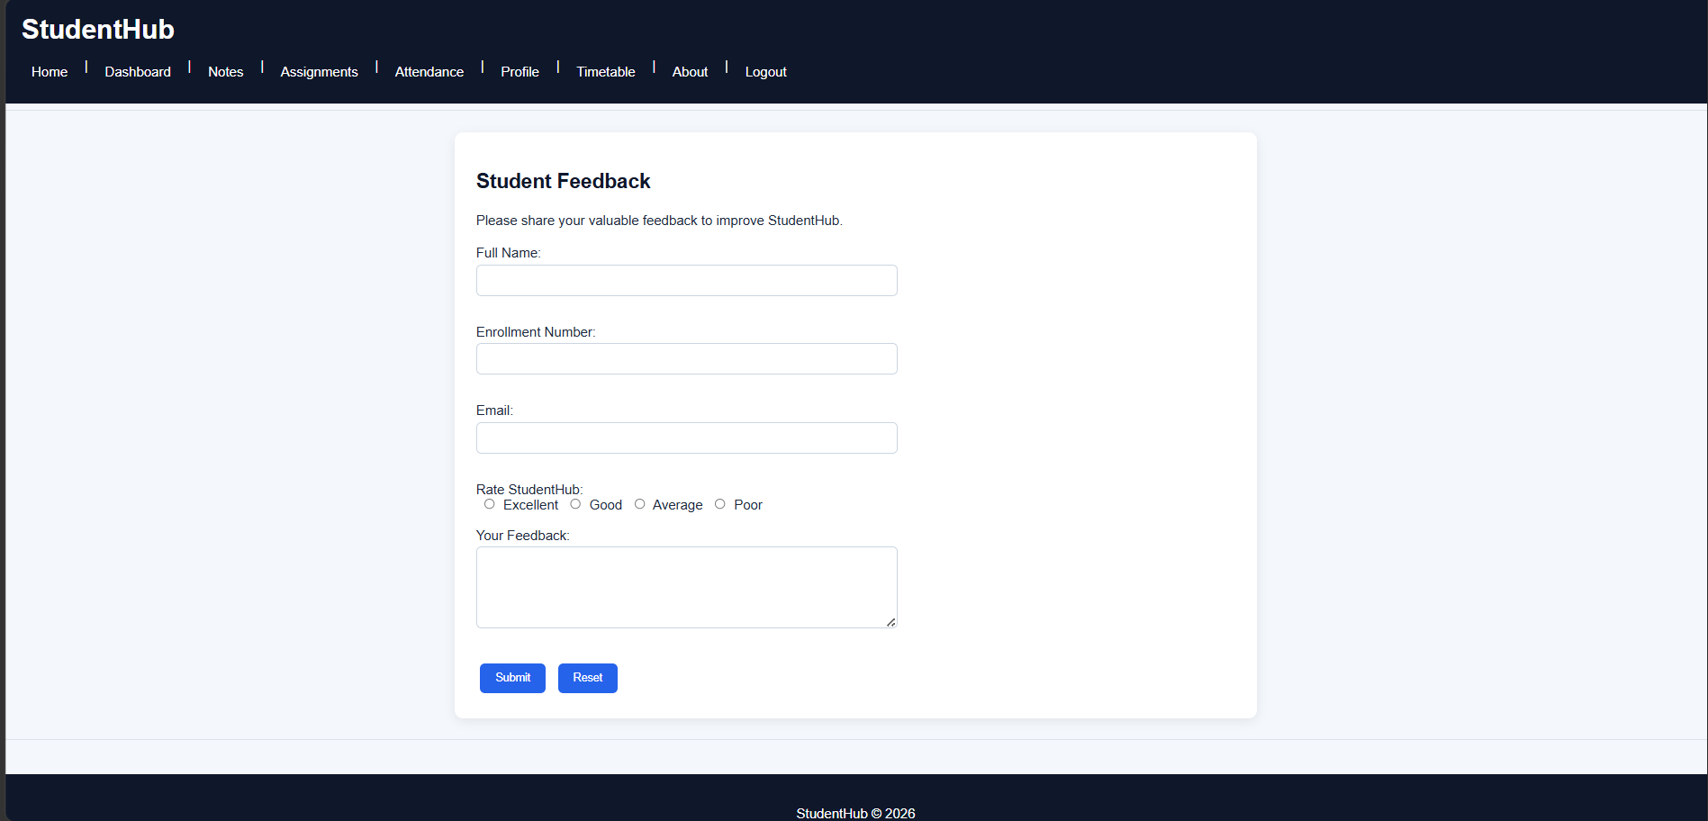

Description: (Profile)
CSS is used to arrange and style the student profile information.
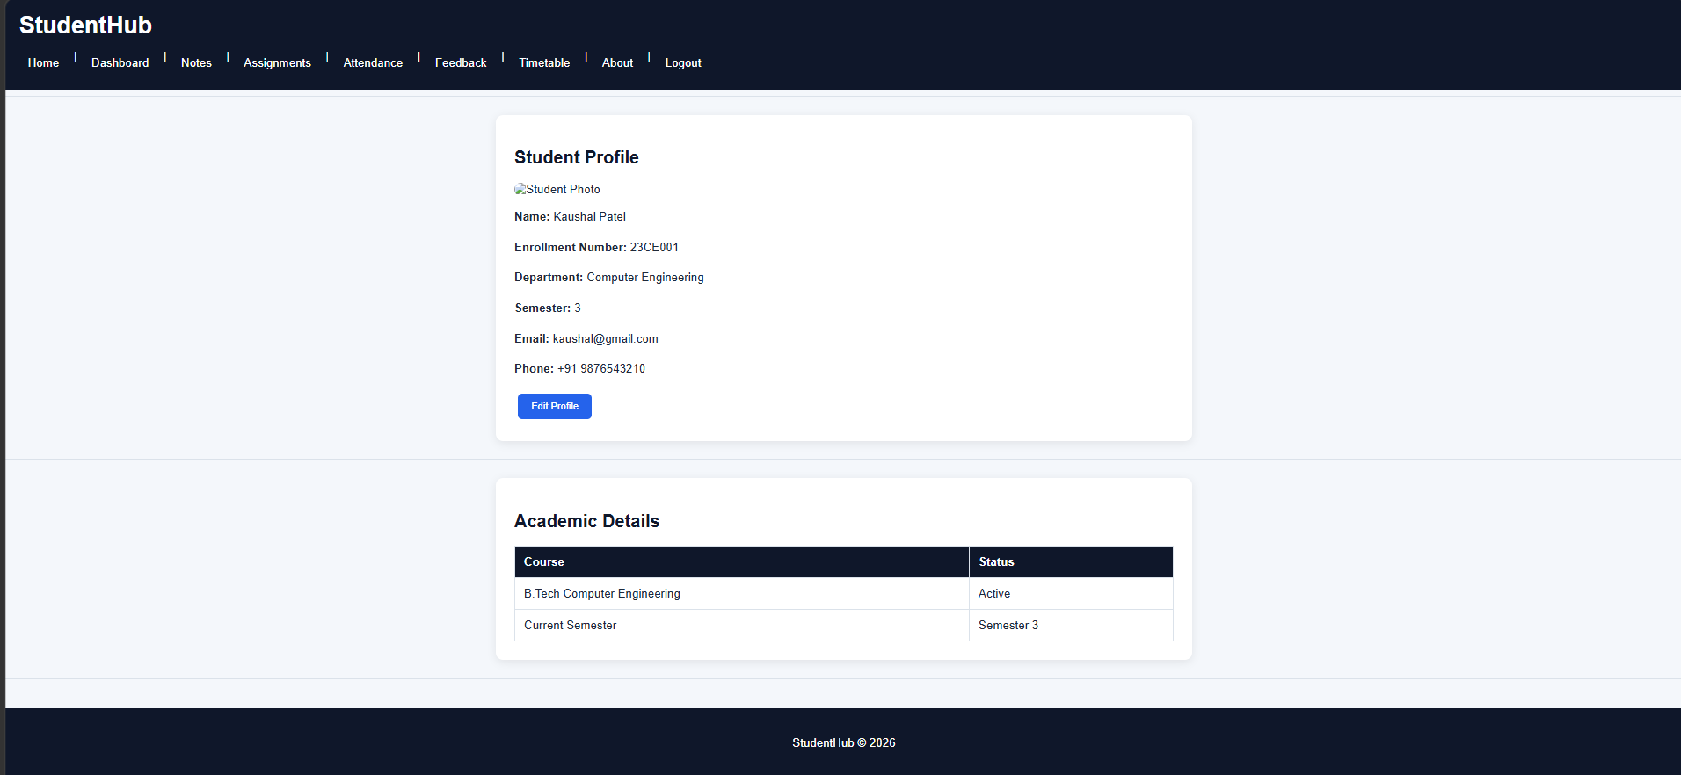
Description: (Timetable)
CSS is used to format the timetable and make its structure clear.
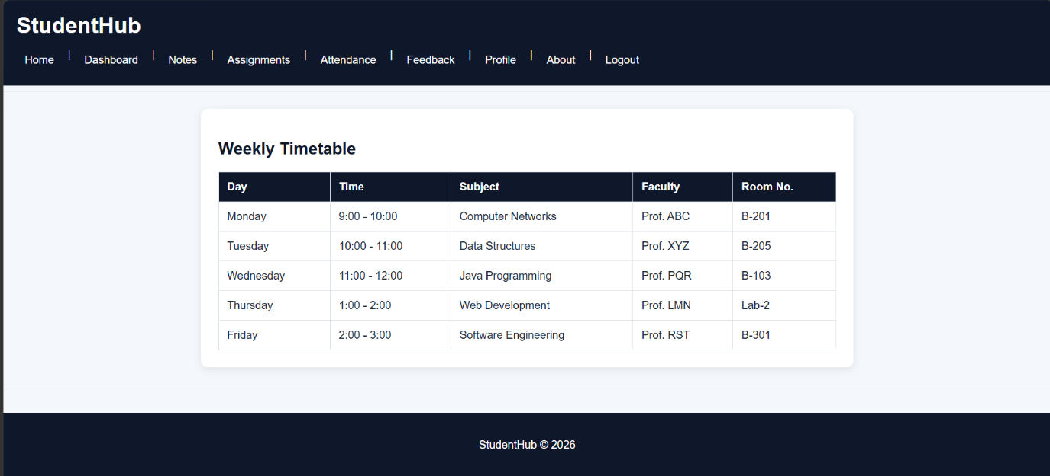

Description: (About)
CSS is used to style the About page content and maintain the overall website design.
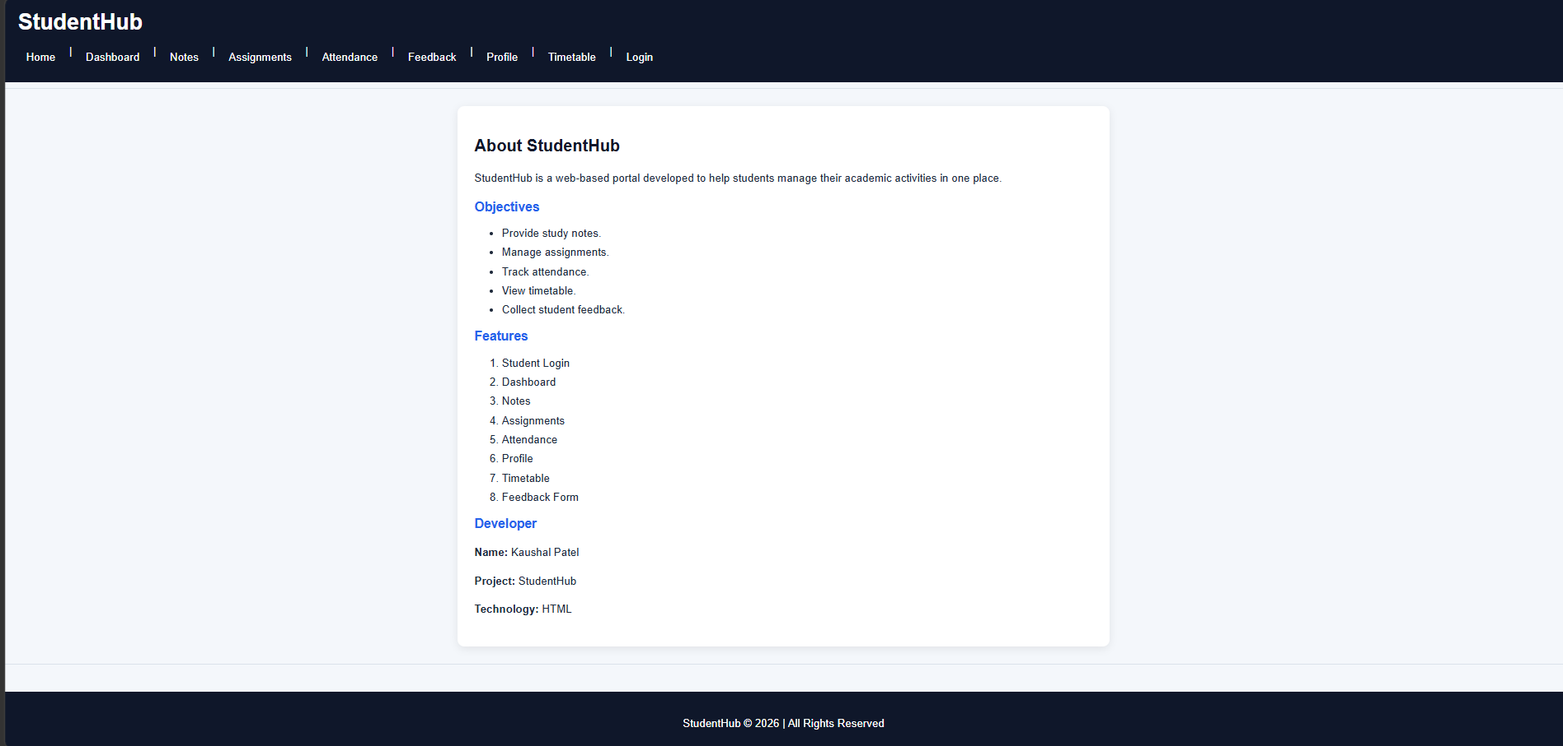

GitHub Repository Link:
https://github.com/KaushalPatel22/StudentHub

Challenges Faced:
• Choosing suitable CSS styles for the pages.
• Maintaining consistent spacing and layout.
• Making buttons, forms, and navigation look proper.
• Applying the same external CSS across all pages.

Learning Outcomes:
• Learned how to create and use an external CSS file.
• Learned to style HTML elements using CSS.
• Learned about layout, spacing, colors, and typography.
• Learned how to maintain a consistent design across pages.

