Practical – 5
Practical Title: Registration Form with Frontend Validation and User-Friendly Error Handling
Problem Definition: Create a student registration form with HTML5 input types and JavaScript validation for name, email, mobile number, password, confirm password, course, year, gender, and terms acceptance. Use Regular Expression for validations.

A. Theory
1. Are correct input types and attributes used?
ANS: HTML5 input types like email, tel, and password are used with attributes like required and pattern.
Reference: https://developer.mozilla.org/en-US/docs/Learn/Forms/HTML5_input_types
2. Are validation errors displayed near the relevant fields?
ANS: JavaScript displays error messages near invalid fields when the user submits the form.
Reference: https://developer.mozilla.org/en-US/docs/Learn/Forms/Form_validation
3. Is password strength checked?
ANS: Regular expressions check password length and the presence of uppercase letters, numbers, and special characters.
Reference: https://developer.mozilla.org/en-US/docs/Web/JavaScript/Guide/Regular_Expressions
4. Is the form accessible using keyboard and screen-reader-friendly labels?
ANS: Labels are linked to input fields, and keyboard navigation allows users to access the form easily.
Reference: https://www.w3.org/WAI/tutorials/forms/

B. Implementation / Output / Result
An HTML registration form was created with JavaScript validation using regular expressions. Error messages are displayed for invalid inputs, and successful validation allows the form to proceed.

C. Evidence of Work (Screenshots)
1. Registration Form: Student registration form with input fields.
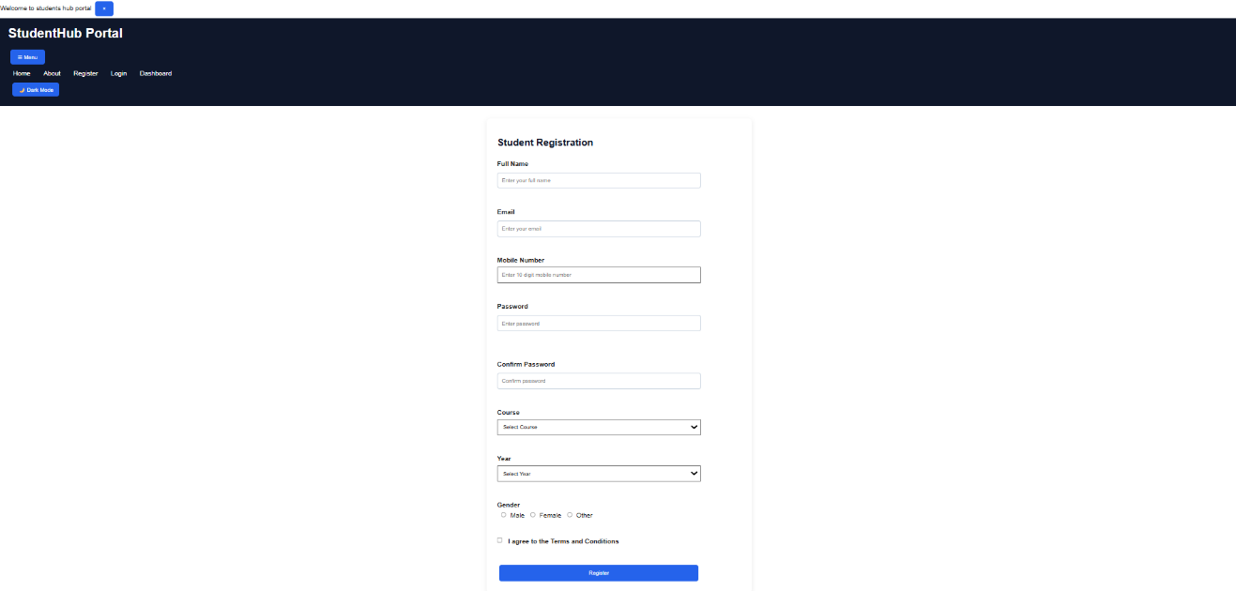
2. Validation Errors: Error messages displayed for invalid inputs.
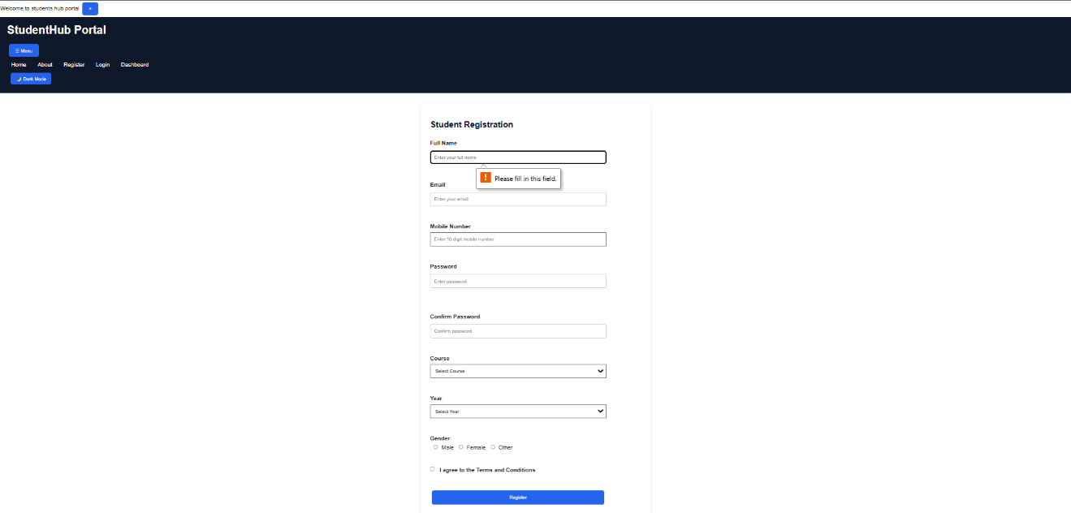
3. Success Message: Successful form validation.


GitHub Repository Link:
https://github.com/KaushalPatel22/StudentHub
D. Challenges Faced
- Writing regular expressions for email and password validation.
- Displaying error messages for invalid inputs.
- Preventing form submission when validation fails.
E. Learning Outcomes
- Learned regular expressions in JavaScript.
- Understood client-side form validation.
- Learned to display user-friendly error messages.
F. Faculty Remarks

