Practical – 6
- Practical Title: Rendering External JSON Data using Fetch API, Search and Filter
Problem Definition: Display event lists, student profiles, notices, or FAQs from external JSON files using Fetch API. Implement dynamic rendering, search, filter, sorting, and pagination.

A. Theory
1. How is JSON fetched, parsed, and rendered?
ANS: The fetch() API retrieves JSON data, the .json() method parses it, and JavaScript displays it on the webpage.
Reference: https://developer.mozilla.org/en-US/docs/Web/API/Fetch_API/Using_Fetch
2. Which array methods are used for search, filter, sort, and pagination?
ANS: filter() searches records, sort() arranges them, and slice() divides them into pages.
Reference: https://developer.mozilla.org/en-US/docs/Web/JavaScript/Reference/Global_Objects/Array
3. How are loading and error states handled?
ANS: A loading message is displayed while data is fetched, and try...catch handles errors.
Reference: https://developer.mozilla.org/en-US/docs/Web/JavaScript/Reference/Statements/try...catch
4. How is modularity maintained in JavaScript files?
ANS: Code is divided into separate functions for fetching data, rendering the interface, and handling events.
Reference: https://developer.mozilla.org/en-US/docs/Web/JavaScript/Guide/Modules

B. Implementation / Output / Result
A local JSON file was created to store sample records. The Fetch API was used to load and display the data dynamically. Search and sorting features were implemented using JavaScript array methods.

- Evidence of Work (Screenshots)

1. JSON Data Display: Dynamically displayed records.
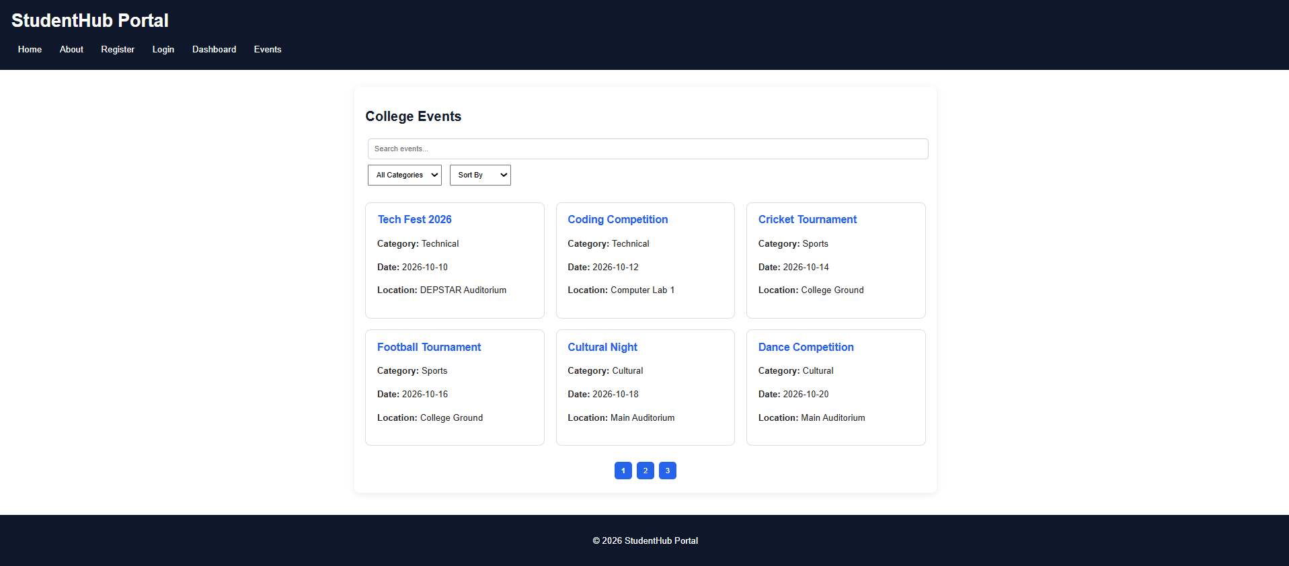
2. Search Feature: Records filtered using a search keyword.


3. Error Handling: Error message displayed when data loading fails.
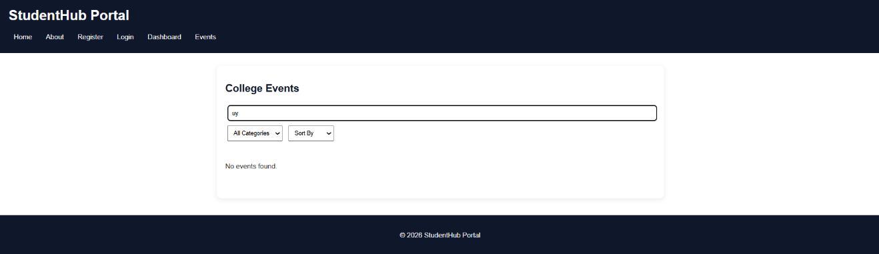
GitHub Repository Link:
https://github.com/KaushalPatel22/StudentHub

D. Challenges Faced
- Handling asynchronous data fetching.
- Updating displayed records after searching.
- Managing errors during data loading.
E. Learning Outcomes
- Learned to fetch and display JSON data.
- Understood array methods like filter() and sort().
- Learned dynamic DOM rendering and error handling.
F. Faculty Remarks

