Practical - 7
Practical Title: PHP Form Processing with Server-Side Validation and CSV/JSON File Storage
Problem Definition: Process submitted registration/contact form data using PHP. Validate and sanitize inputs on the server side and store records in CSV or JSON file format. Display success/error messages.

A. Theory
- Is the form submitted using POST?
ANS: Yes, the POST method sends form data in the HTTP request body instead of displaying it in the URL.
Reference: https://www.php.net/manual/en/reserved.variables.post.php
- Are inputs validated and sanitized server side?
ANS: Inputs are validated using filter_var() and sanitized using htmlspecialchars() to improve security and prevent XSS.
Reference: https://www.php.net/manual/en/filter.examples.validation.php
- Is file writing handled safely?
ANS: File operations use fopen(), fwrite(), and fclose() with proper error handling to store data safely.
Reference: https://www.php.net/manual/en/function.fopen.php
- Are success and error responses displayed clearly?
ANS: PHP displays appropriate success or error messages based on the validation and file-writing results.
Reference: https://www.php.net/manual/en/language.control-structures.if.php
B. Implementation / Output / Result
A PHP script was created to receive form data using POST. Inputs were validated and sanitized before saving records to a local JSON file. Success or error messages were displayed to the user.
C. Evidence of Work (Screenshots)
- Form Submission: Submitting the form with valid data.
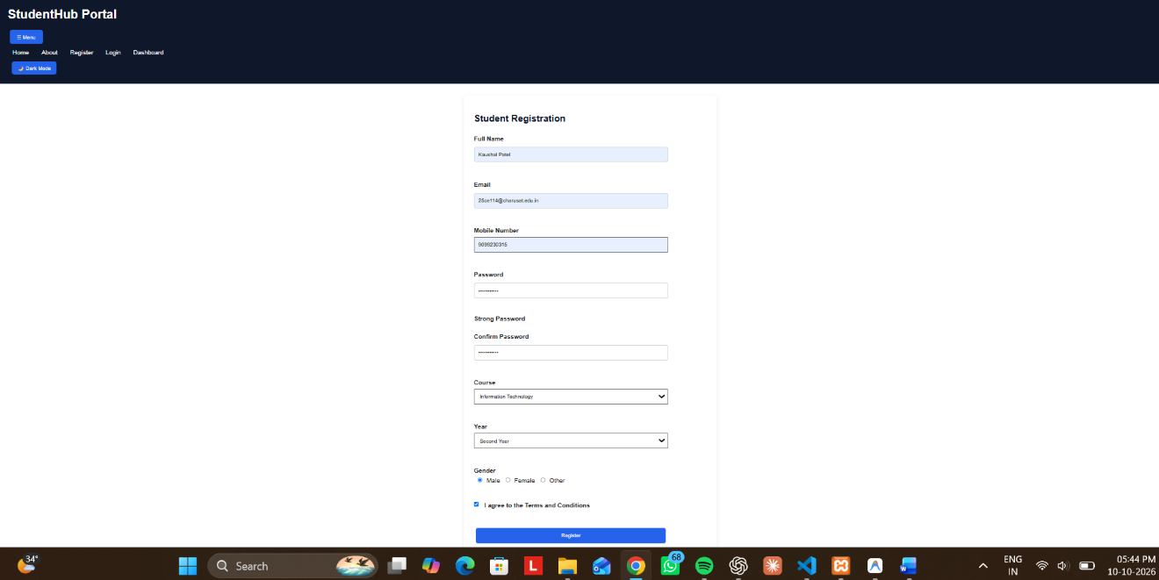
- Server Response: PHP displaying a success message.

- File Storage: Saved data in the JSON or CSV file.

GitHub Repository Link:
https://github.com/KaushalPatel22/StudentHub
D. Challenges Faced
- Handling file permissions in XAMPP.
- Reading and updating JSON data safely.
E. Learning Outcomes
- Learned to handle POST requests using PHP.
- Understood server-side validation and sanitization.
- Learned basic file reading and writing operations.
F. Faculty Remarks

