Practical - 8
Practical Title: MySQL Schema Design, ER Model, PDO Connectivity, and Prepared Statements
Problem Definition: Design the database for StudentHub with students, events and registrations. Create PHP database connection using MYSQL statements.

A. Theory
- Is the schema normalized properly?
ANS: Yes, normalization reduces data redundancy and improves data integrity in the students, events, and registrations tables.
Reference: https://dev.mysql.com/doc/refman/8.0/en/normalization.html
- Are primary keys and foreign keys correctly defined?
ANS: Primary keys uniquely identify records, while foreign keys link registrations with students and events.
Reference: https://dev.mysql.com/doc/refman/8.0/en/create-table-foreign-keys.html
- Is the database connection handled securely?
ANS: PDO is used to connect PHP with MySQL, and exception handling helps manage database errors.
Reference: https://www.php.net/manual/en/pdo.connections.php
B. Implementation / Output / Result
An ER model was designed for the StudentHub portal. Tables and relationships were created in MySQL using phpMyAdmin, and a db.php file was created to connect PHP with MySQL using PDO.
C. Evidence of Work (Screenshots)
- phpMyAdmin: Created tables and relationships.
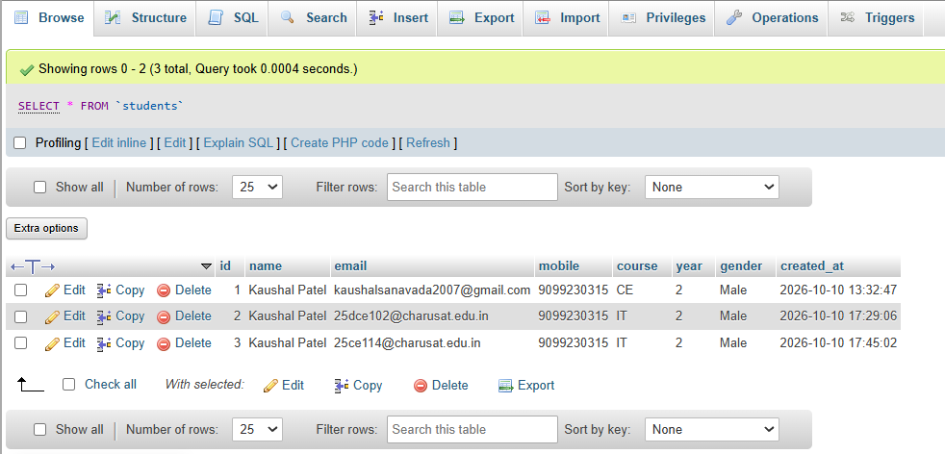
- Connection Test: PHP successfully connecting to the database.
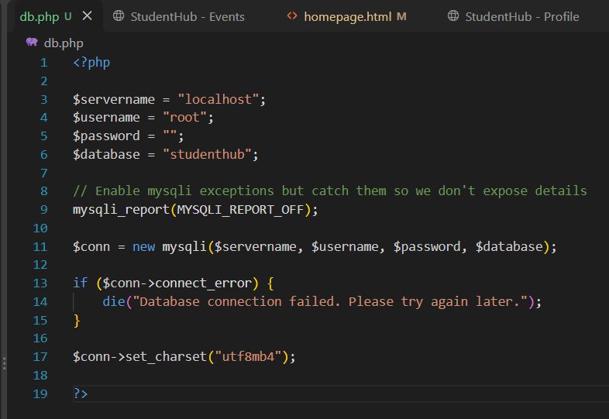

GitHub Repository Link:
https://github.com/KaushalPatel22/StudentHub
D. Challenges Faced
- Designing correct primary and foreign key relationships.
- Configuring the PDO connection string.
E. Learning Outcomes
- Learned relational database design and normalization.
- Understood table creation and relationships in MySQL.
- Learned PHP database connectivity using PDO.
F. Faculty Remarks

