Practical - 10:
Secure Login/Logout with Sessions, Role-Based Access, Timeout, and Remember-Me Token
Problem Definition: Develop secure login and logout functionality using PHP sessions. Verify password using password_verify(), regenerate session ID after login, restrict dashboard access, implement role-based redirection, session timeout, and optional secure remember-me token.

- Theory
- Are sessions started and destroyed securely?
ANS : Yes, session_start() starts the session, and logout.php clears session data and destroys the session using session_destroy().
- Is password_verify() used correctly?
ANS : Yes, password_verify() checks the entered password against the hashed password stored in the database.
- Is unauthorized dashboard access blocked?
ANS : Yes, auth.php checks whether the user is logged in and redirects unauthorized users to the login page. Role checks restrict access to the appropriate dashboard.
- Is session timeout implemented?
ANS : Yes, the session expires after 10 minutes of inactivity, and the user must log in again.
- Are admin and student users redirected to appropriate dashboards?
ANS : Yes, administrators are redirected to admin_dashboard.php, while students are redirected to student_dashboard.php after successful login.

B. Implementation / Output / Result
Implemented a secure login and logout system using PHP and MySQL with password verification, sessions, and role-based access.
The system successfully redirects users to their respective dashboards and prevents unauthorized access.

C. Evidence of Work (Screenshots)

1. Secure Login Page
Includes Remember-Me checkbox and 1-click test credentials buttons for fast evaluation:
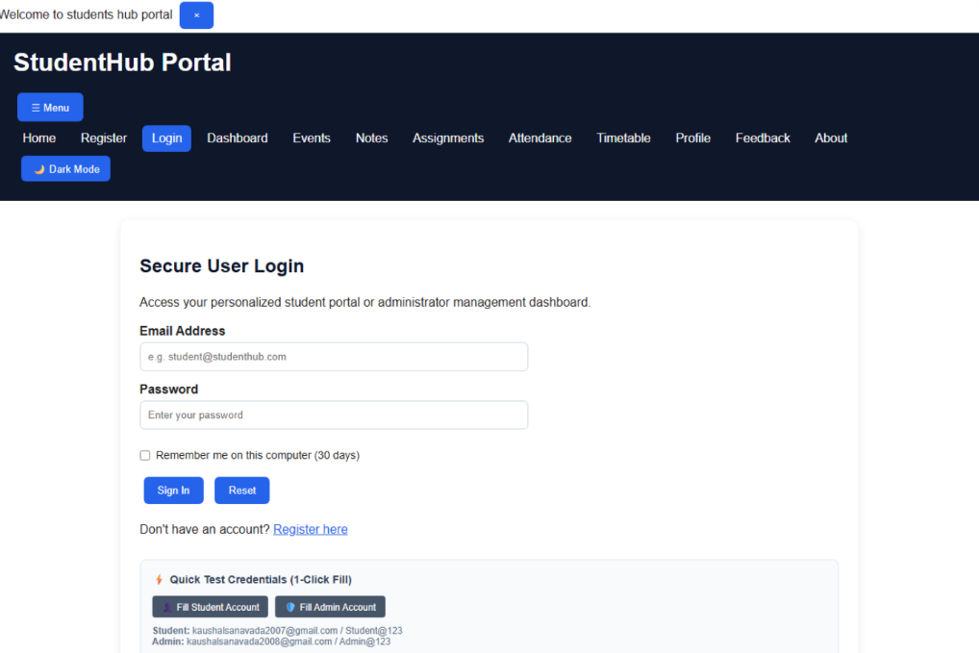

2. Login Failure (Friendly Alert)
Rejects incorrect passwords with a user-friendly alert, suppressing raw database errors:
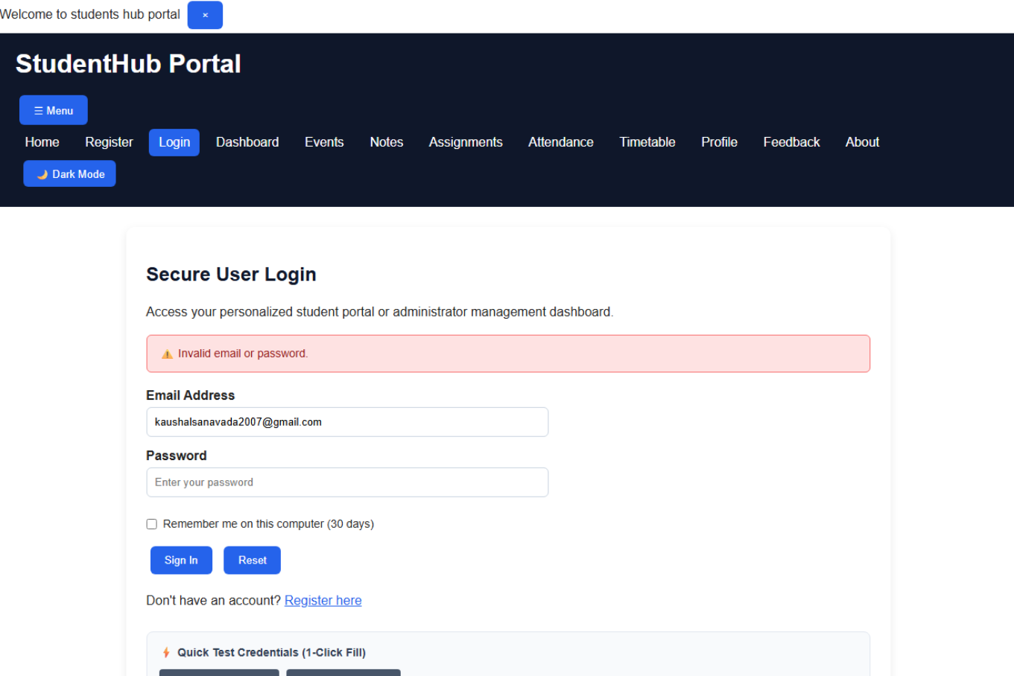

3. Student Dashboard (student_dashboard.php)
Protected by auth.php. Displays student name, email, role badge, last-login timestamp, active session ID, and live 10-minute inactivity countdown: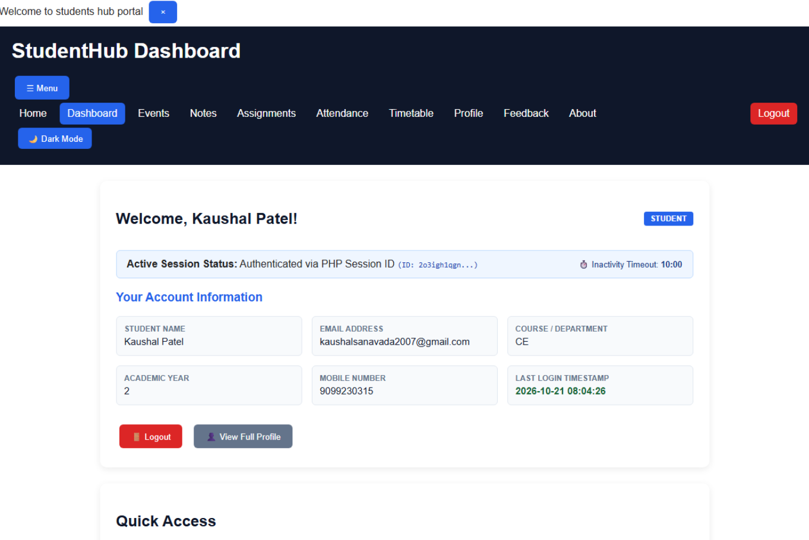
4. Unauthorized Access Blocked (RBAC Protection)
When a student account tries to access admin_dashboard.php, they are denied access and redirected to their student dashboard with an alert:
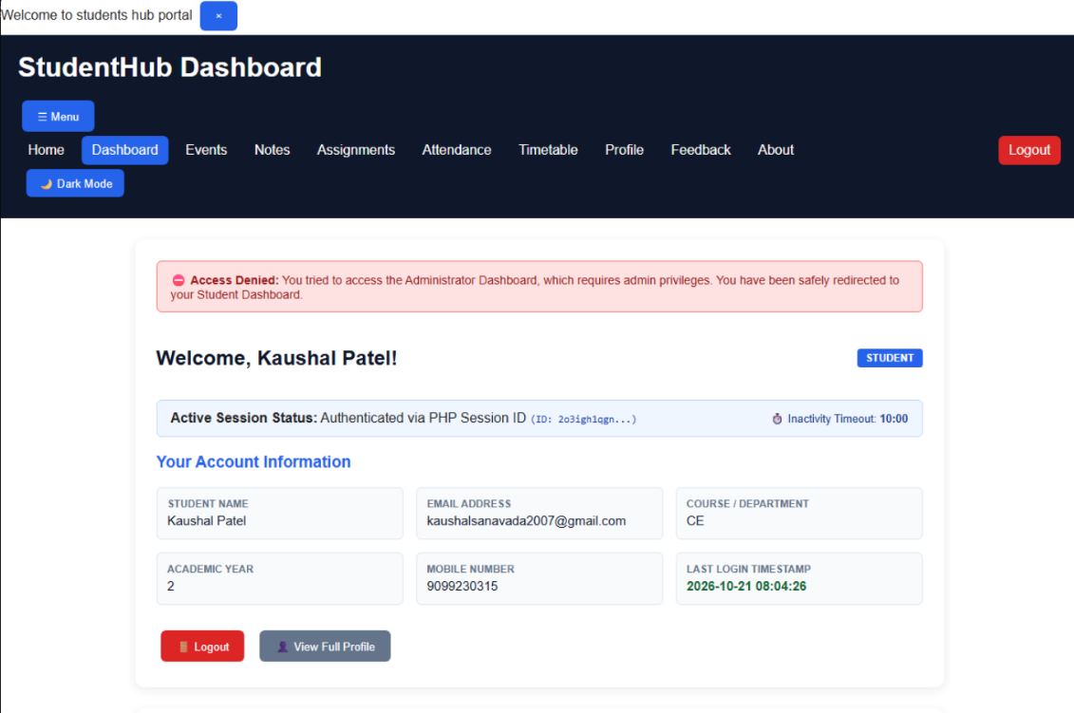

5. Administrator Dashboard (admin_dashboard.php)
Restricted to role === 'admin'. Features overview cards for Total Students, Total Admins, Total Accounts, quick navigation buttons, and a table of registered users:
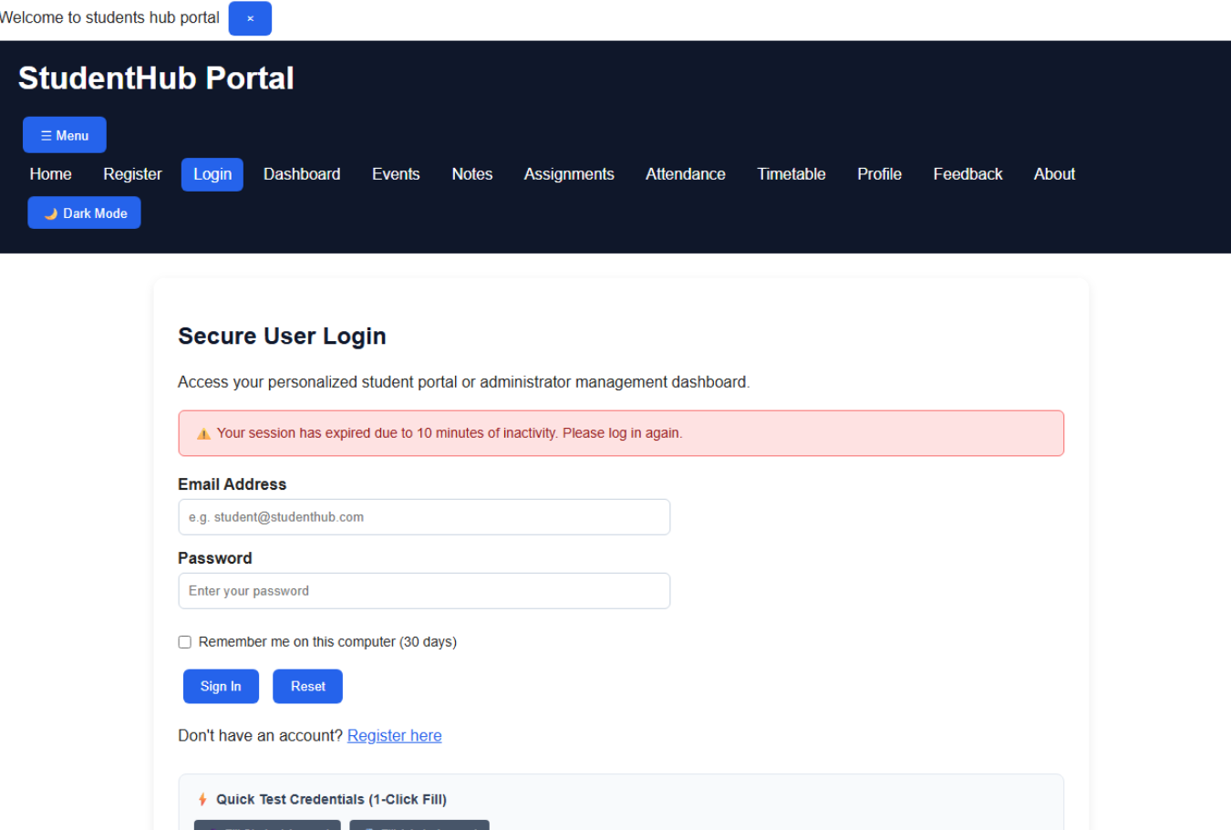

6. Inactivity Session Timeout
After 10 minutes of inactivity, the session and cookies are destroyed and the user is redirected to login with an alert:
7. Secure Logout (logout.php)
Revokes remember-me tokens, clears cookies, destroys the PHP session, and displays confirmation:
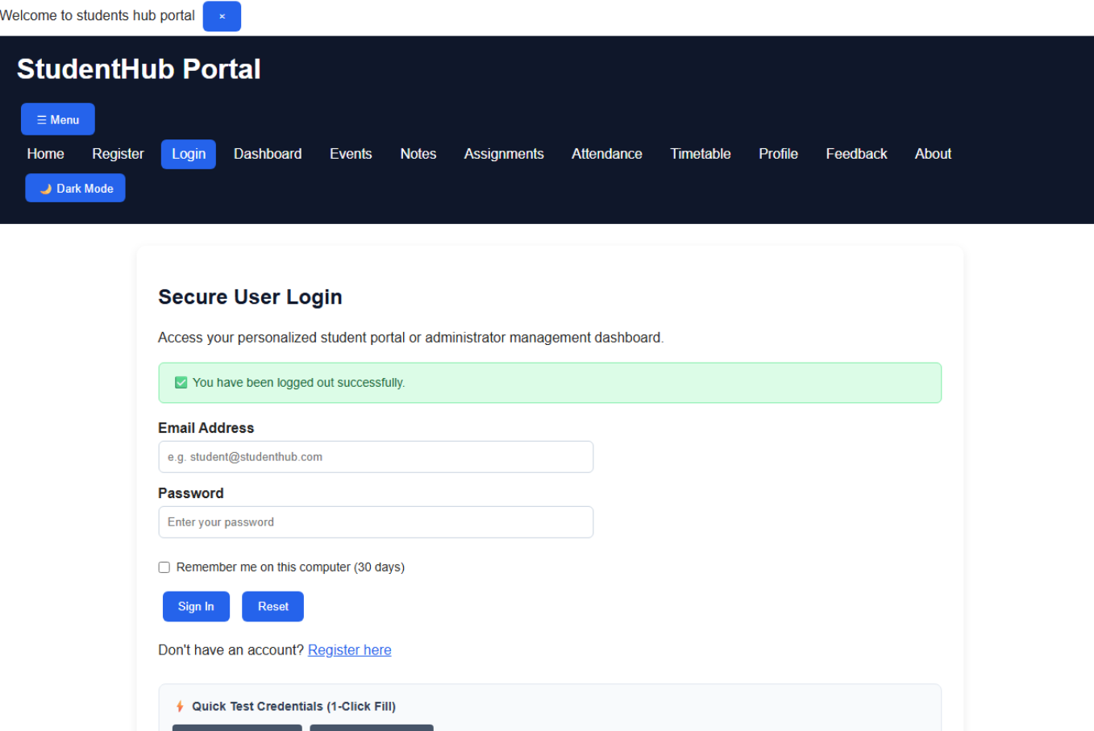

GitHub Repository Link:
https://github.com/KaushalPatel22/StudentHub

D .Challenges Faced:
Managing sessions and implementing role-based login authentication.
E. Learning Outcome:
Learned secure login, session management, and role-based dashboard access using PHP.

F. Faculty Remarks

