Practical - 9
Practical Title: Secure User Registration with Database Insert, Duplicate Email Check, and Password Hashing.
Problem Definition: Implement secure user registration by inserting user details into MySQL using MYSQLi. Validate input on frontend and backend, check duplicate email/username, hash passwords using password_hash(), and display appropriate messages.

- Theory
Q1. Is password_hash() used before storing passwords?
Ans: Yes, password_hash() hashes the password before storing it in the database.
Q2. Is duplicate email checking implemented?
Ans: Yes, a prepared SQL statement checks whether the email already exists before registration.
Q3. Are frontend and backend validations consistent?
Ans: Yes, frontend validation provides quick feedback, while backend validation checks the submitted data before saving it.

B. Implementation / Output / Result
Implemented secure user registration using PHP, MySQLi, validation, duplicate email checking, and password hashing.
Successfully stored student details securely in the MySQL database.
C. Evidence of Work (Screenshots)
- Screenshot showing successful user registration and hashed password stored in the MySQL database.

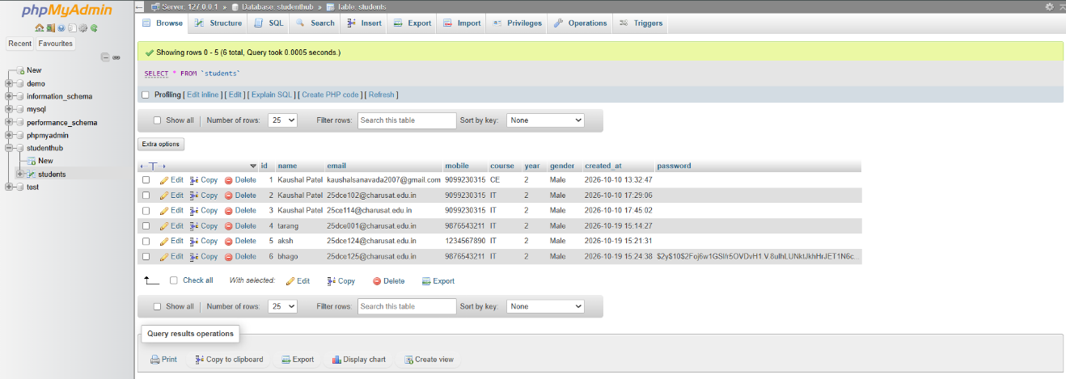

- check duplicate email/username

GitHub Repository Link:
https://github.com/KaushalPatel22/StudentHub

D. Challenges Faced
Initially, the password was not included in the database insertion query. I added a password column and updated the PHP code to hash and store passwords securely.

E. Learning Outcomes
Successfully implemented secure user registration in StudentHub using PHP and MySQLi. The system validates user input, checks duplicate email addresses, hashes passwords using password_hash(), and inserts student details into the MySQL database using prepared statements.

F. Faculty Remarks

