Loan Eligibility Assistant — Demo Walkthrough
Stack: Streamlit UI · LangChain · Claude Haiku (via gateway) · FAISS (RAG).
The app has two tabs: Policy Assistant (RAG Q&A over bank policy documents) and Eligibility Checker (rule engine + AI-formatted decision + personalized recommendations). The screens below follow a full end-to-end run in sequence.

1. Policy Assistant — Landing
Landing screen. The sidebar shows the active model, embeddings, and number of policy documents loaded. Two tabs are available, with sample questions to try.
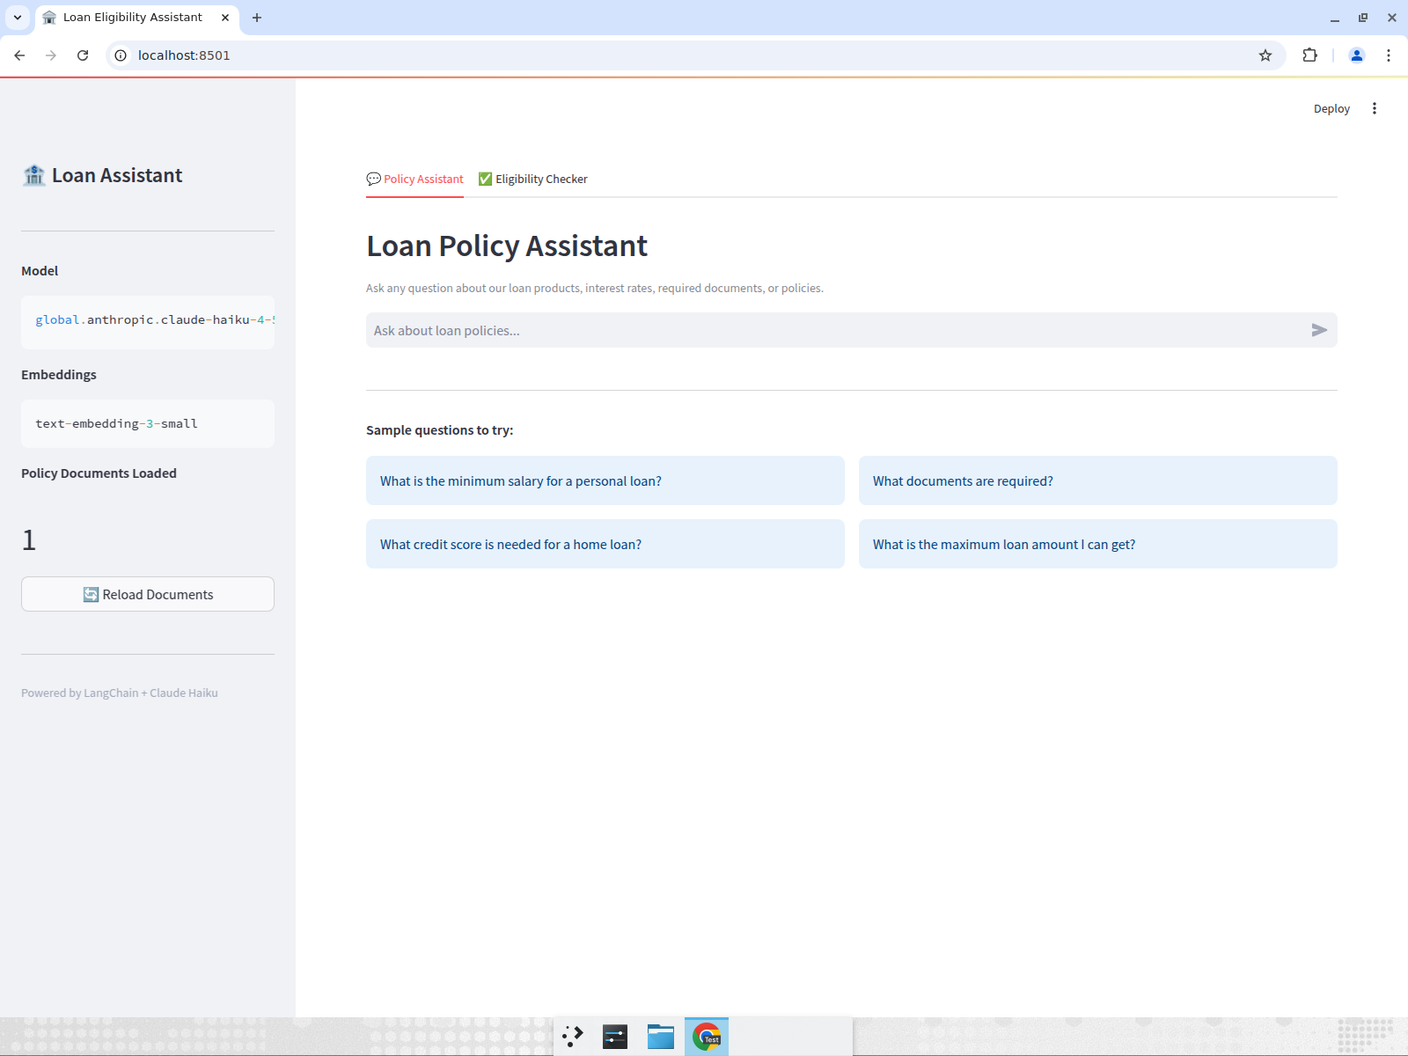

2. Policy Q&A (RAG) — Answer with Sources
Asked “What is the minimum salary for a personal loan?”. The assistant retrieves the relevant policy chunks via FAISS and answers (₹30,000), showing the source chunks it used.
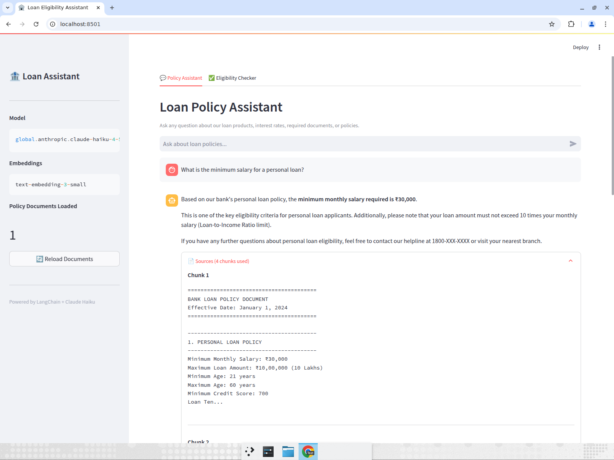

3. Eligibility Checker — Form Filled (Eligible Applicant)
The eligibility form filled for an eligible applicant: Priya Sharma, age 30, ₹60,000 monthly salary, ₹5,00,000 loan, credit score 750.
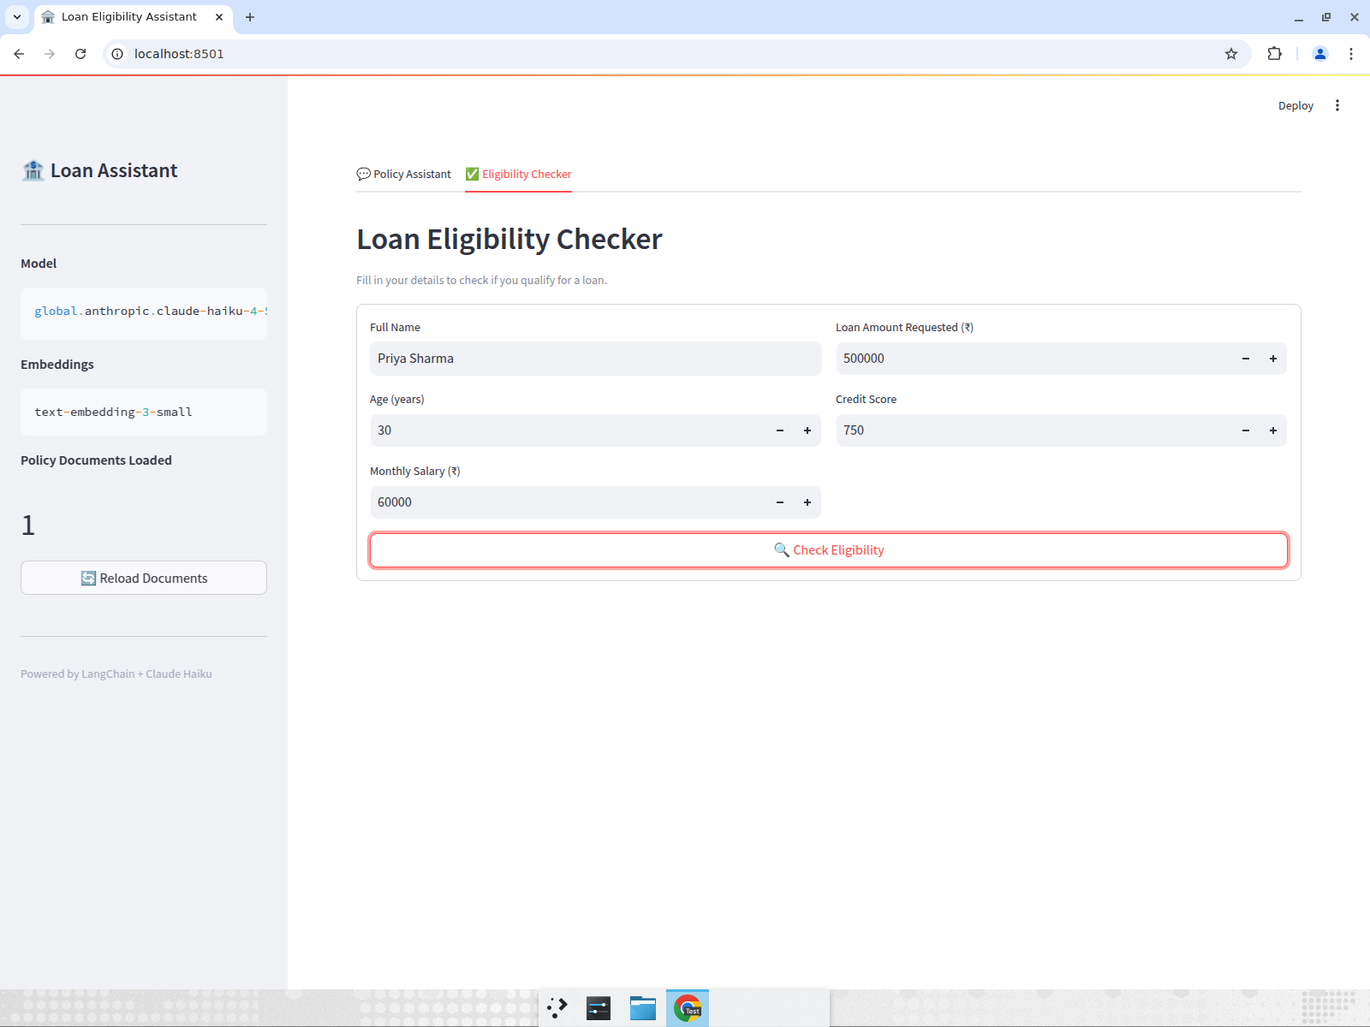

4. ELIGIBLE — AI Decision Letter
Verdict is ELIGIBLE. Claude generates a professional decision letter with a criteria review table (all rules PASS).
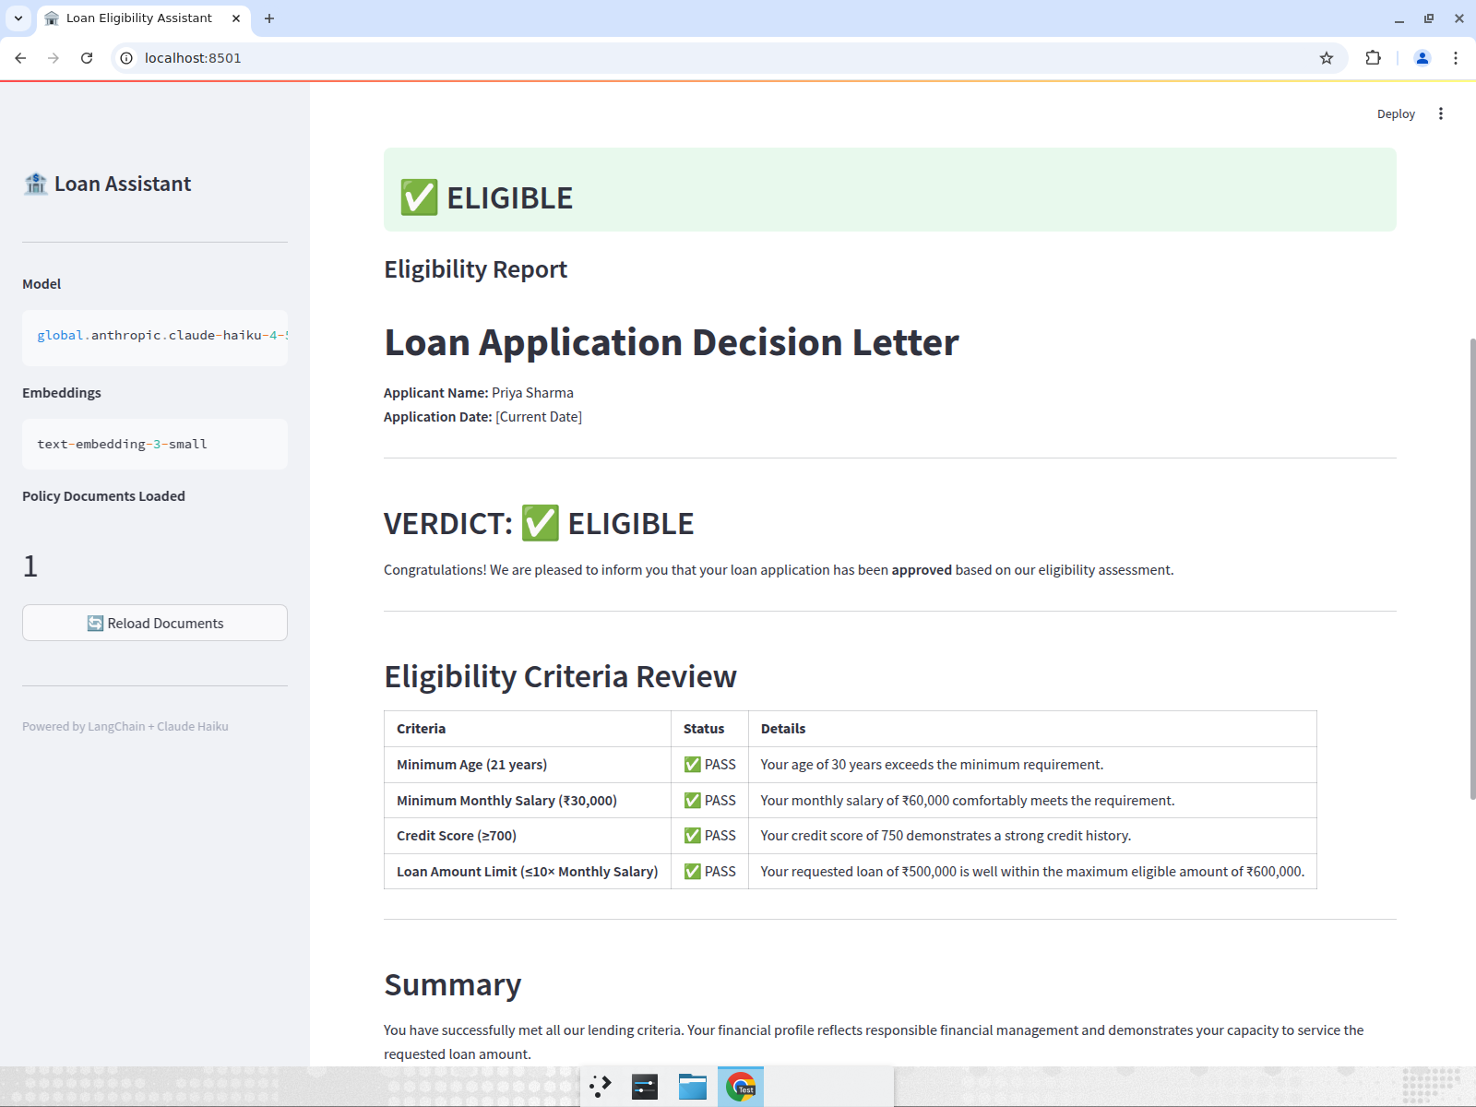

5. ELIGIBLE — Rule Breakdown
The per-rule breakdown below the letter: age, salary, credit score, and loan-to-income ratio, each with a pass explanation.
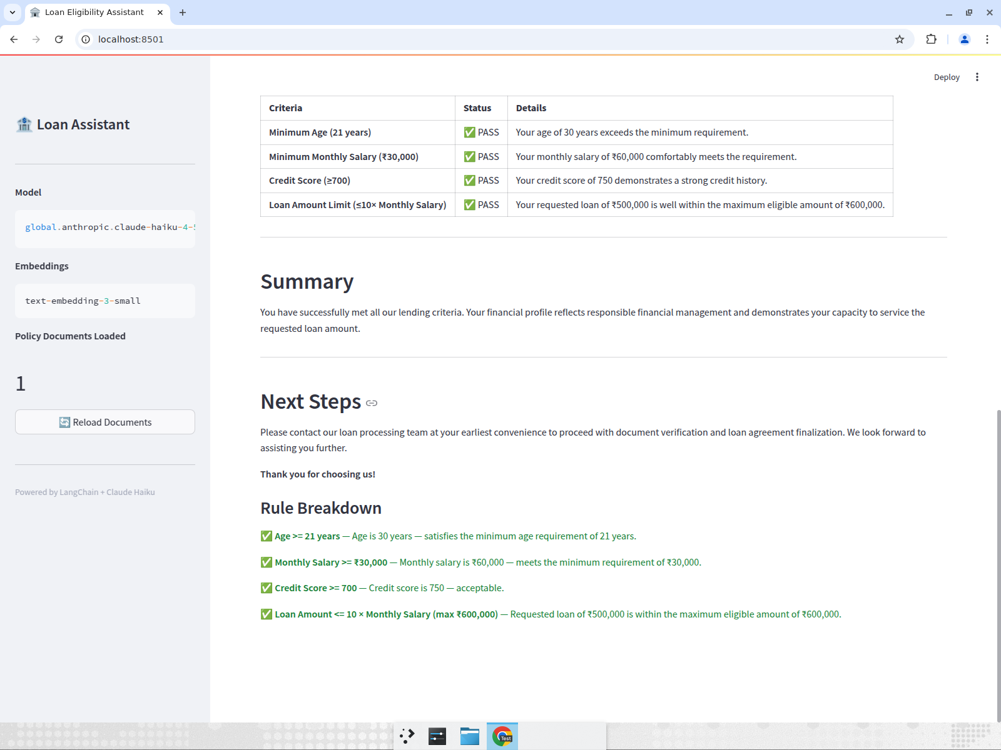

6. NOT ELIGIBLE — Verdict
A second applicant: Rahul Verma, ₹25,000 salary, credit score 640. The verdict is NOT ELIGIBLE.
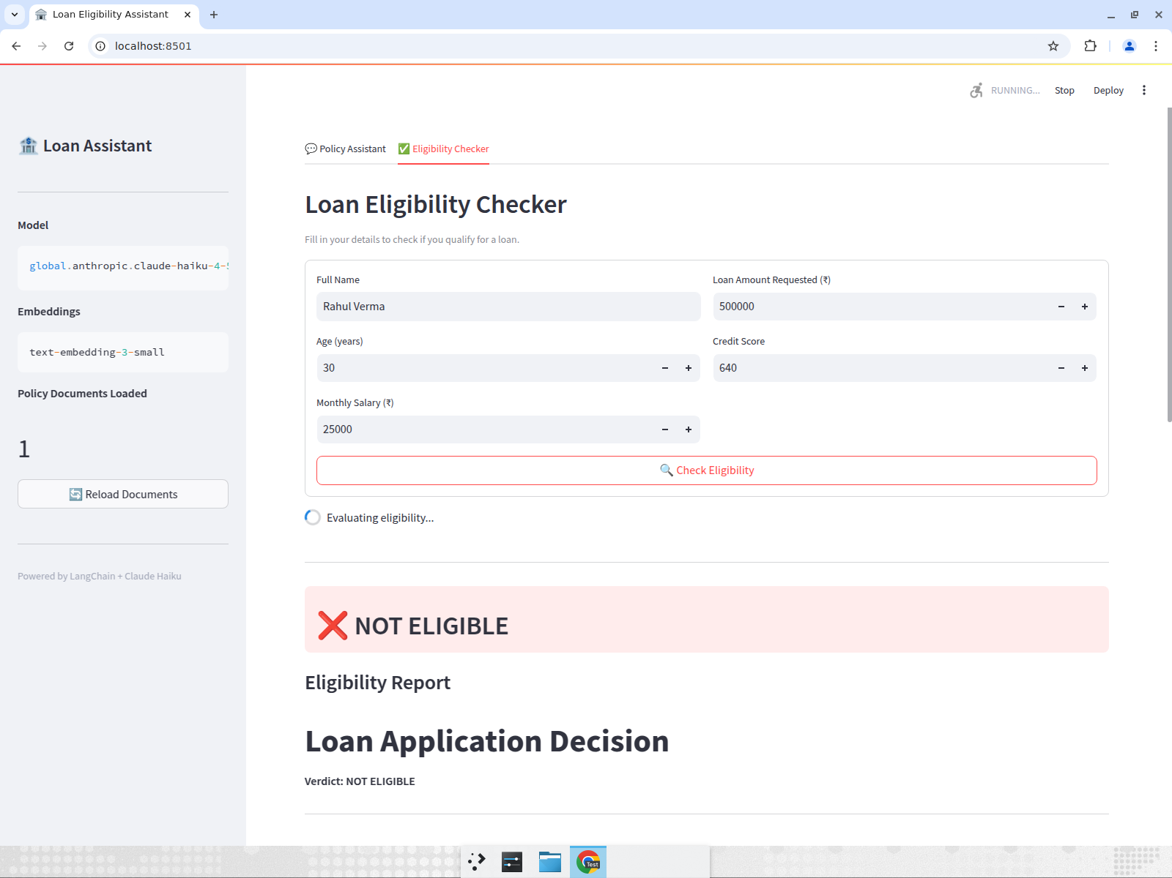

7. NOT ELIGIBLE — Report
The decision report lists which criteria failed (salary, credit score, loan-to-income) and a “What You Can Do” summary.
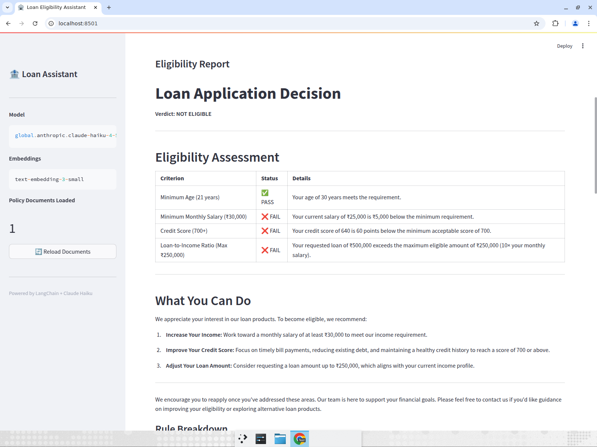

8. Personalized Recommendations
For rejected applicants, Claude generates a personalized improvement plan: raising income, improving credit score, adjusting loan amount, alternative loan products, and a 6-month action plan.
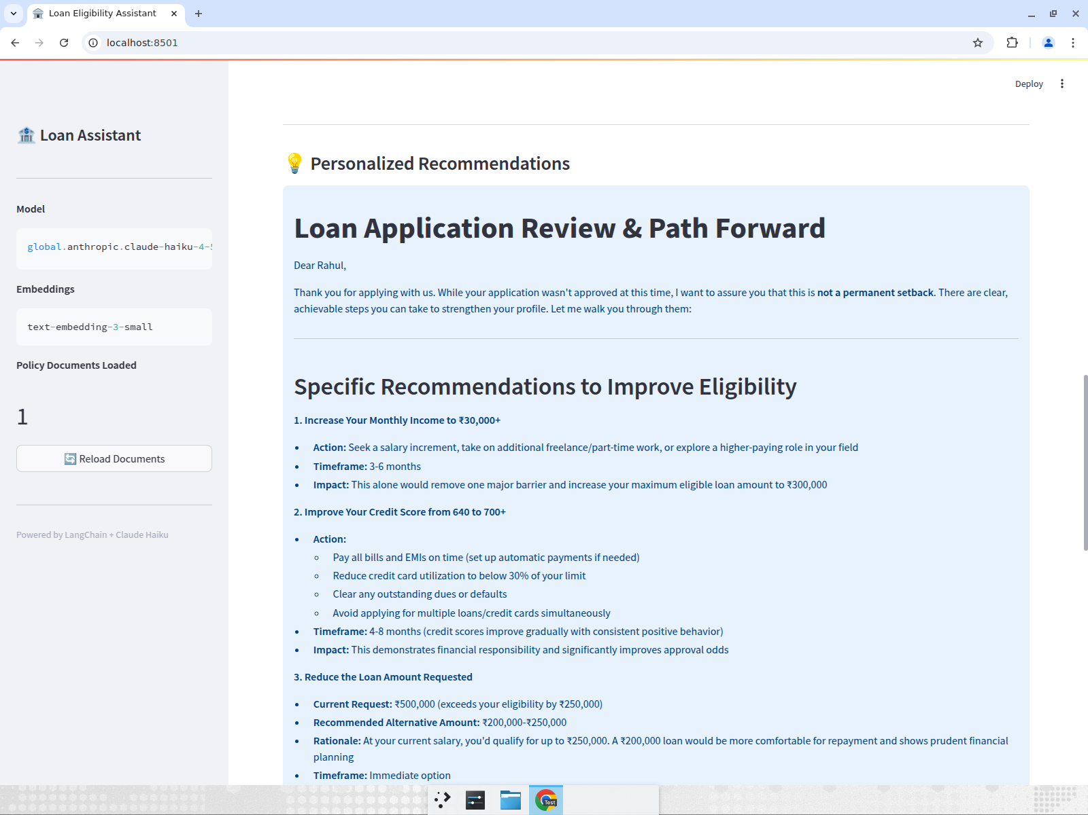

How to reproduce locally
python3 -m venv venv
./venv/bin/pip install -r requirements.txt
./venv/bin/pip install "httpx==0.27.2" # fixes anthropic 0.34.2 'proxies' kwarg issue
# Create .env with ANTHROPIC_API_KEY, ANTHROPIC_BASE_URL, ANTHROPIC_MODEL
./venv/bin/streamlit run app.py
Note: with a custom Anthropic gateway, the key may only allow global.anthropic.* models (e.g. claude-haiku-4-5) rather than the repo default claude-3-haiku-20240307.

