An Internship Report
Of
Web Development
Submitted
To
School of Computer Science and Engineering
IILM University, Greater Noida, U.P.
In partial fulfilment of the requirement of degree of
B-Tech (Computer Science and Engineering)

By
Roll Number of Student:- 25SCS1003004035
Name of Student: KAUSHAL SHARMA
Batch: 2026-27

CANDIDATE'S DECLARATION
I, KAUSHAL SHARMA, do hereby declare that the internship report titled "Web Development" has been completed by me to fulfil the requirement for the award of the degree of Bachelor of Technology in Computer Science and Engineering. All the references have been quoted and I have not taken as such any material from any other source. I affirm that this report is my own work and has not been submitted to any other institute for any degree/diploma requirement, and further I shall be solely responsible for any kind of copyright violation in this regard.
Signature:-
Student Name: KAUSHAL SHARMA
Roll No.: 25SCS1003004035

ACKNOWLEDGEMENT
I am using this opportunity to express my gratitude to everyone who supported me throughout the Internship Program. I am thankful for their aspiring guidance, invaluably constructive criticism and friendly advice during this work. I am sincerely grateful to them for sharing their truthful and illuminating views on a number of issues related to this work.
I would like to thank Codec Technologies and the AICTE National Internship Portal team for providing me the opportunity and the structured platform to learn and gain hands-on exposure in the domain of Web Development. I am also thankful to my assigned Project Head at Codec Technologies for the guidance and constructive feedback provided during the internship, and to my institute, IILM University, Greater Noida, and the faculty of the School of Computer Science and Engineering for their continuous support and encouragement.
I express my gratitude to my parents for their blessings.
Signature:
Student Name: KAUSHAL SHARMA
Roll No.: 25SCS1003004035

TABLE OF CONTENTS
1. Candidate's Declaration i
2. Acknowledgement ii
3. Internship Completion Certificate -
4. Project Description 1
4.1 Introduction 1
4.2 Organization Profile 2
4.3 Problem Statement 3
4.4 Project Objectives 3
4.5 Scope of the Project 4
4.6 Technologies and Tools Used 4
4.7 System Architecture 5
4.8 Methodology 6
4.9 Expected Outcomes 7
4.10 Certificate of Completion 8
5. Bibliography/References 9

3. INTERNSHIP COMPLETION CERTIFICATE
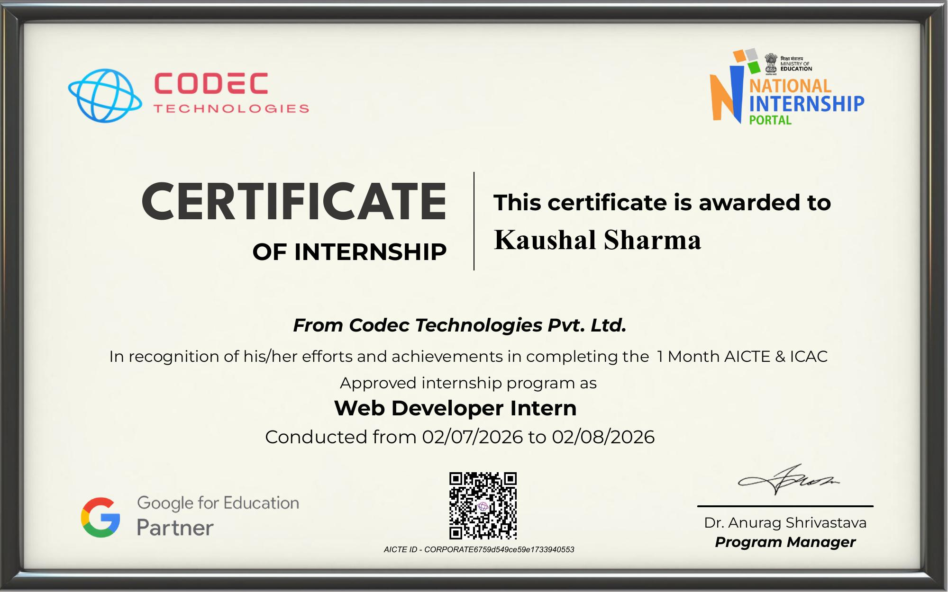

Internship Offer Letter
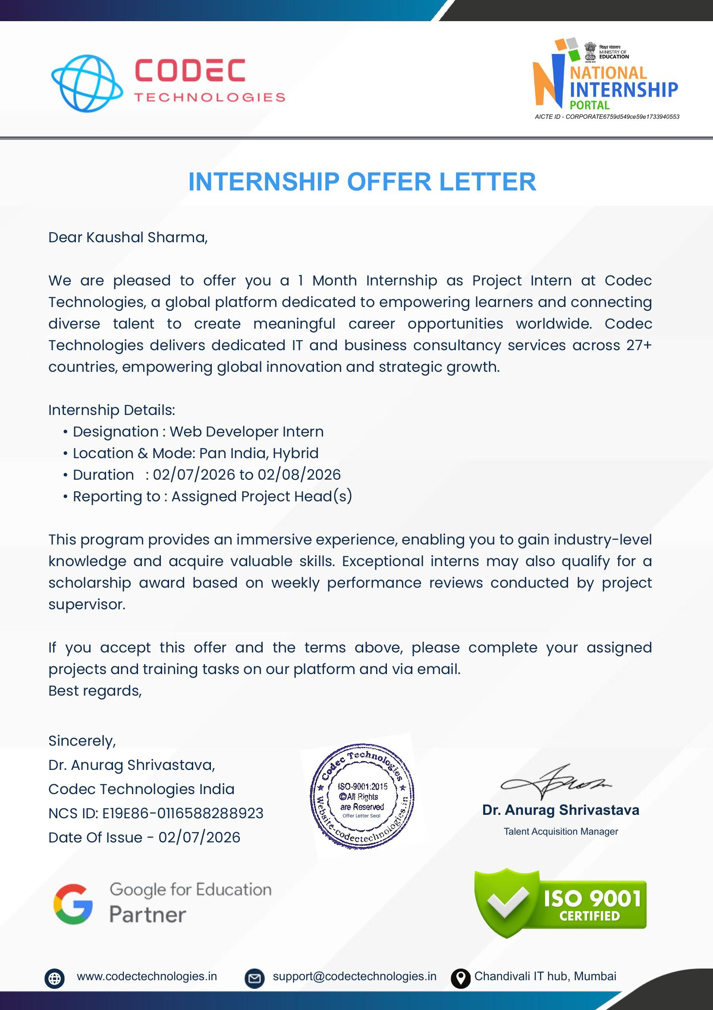

4. PROJECT DESCRIPTION

4.1 Introduction
This report presents a detailed account of the 1-month internship undertaken at Codec Technologies, in the domain of "Web Development". The internship was carried out from 02 July 2026 to 02 August 2026, in Pan India, Hybrid mode, as part of the requirement of the Bachelor of Technology (Computer Science and Engineering) programme at IILM University, Greater Noida. The primary aim of this internship was to bridge the gap between the theoretical understanding of frontend and backend web technologies and their real-world, production-grade application in building modern web systems. Over the course of the programme, the intern was exposed to industry-relevant tools, frameworks, and practices used to take a web application from design and component architecture to a fully functional, tested, and reviewed product, under the guidance of an assigned Project Head.
The internship followed a structured curriculum that combined conceptual learning with hands-on assignments, weekly performance reviews conducted by the project supervisor, and project documentation. On successful completion of all the assigned projects and training tasks, an Internship Certificate was awarded by Codec Technologies.

4.2 Organization Profile
Codec Technologies is a global platform dedicated to empowering learners and connecting diverse talent to create meaningful career opportunities worldwide. The organization delivers dedicated IT and business consultancy services across 27+ countries, empowering global innovation and strategic growth. Codec Technologies is an ISO 9001:2015 certified organization and a recognized Google for Education partner. It operates internship programmes under the AICTE National Internship Portal (NIP) framework (AICTE ID: CORPORATE6759d549ce59e1733940553) and is headquartered at the Chandivali IT Hub, Mumbai. The organization collaborates with academic institutions across India to design industry-aligned internship programmes that help engineering students strengthen their employability and gain practical, project-based exposure to emerging technology domains such as Web Development, IT consultancy, and business strategy.

4.3 Problem Statement
Although a large number of engineering students learn to build static, single-page academic web projects during their coursework, very few get exposure to the challenges involved in building responsive, production-grade web applications. Real-world web development requires addressing concerns that are largely absent from simple academic projects, including responsive UI/UX design across device breakpoints, synchronization of state between the client and the server, secure and reliable RESTful API integration, scalable and reusable component architecture, and performance optimization of assets and rendering. The problem addressed by this internship was to understand and practically implement, under the guidance of an assigned Project Head, an end-to-end web development workflow — from requirement analysis and UI/component design to backend API integration, testing, and review.

4.4 Project Objectives
- To understand the complete web development project lifecycle and industry terminology used in professional frontend and backend practice.
- To gain hands-on experience in building responsive, component-based user interfaces using modern frontend frameworks.
- To learn how frontend applications consume and integrate with backend services through RESTful APIs.
- To develop proficiency in version control workflows using Git and GitHub for collaborative development.
- To build a working understanding of client-side and server-side state management in modern web applications.
- To gain exposure to web performance optimization and basic web security considerations.
- To learn to work in a hybrid, distributed project team and report progress through structured, sprint-based weekly reviews.
- To apply the above concepts in a real-world, project-based assignment as part of the internship.

4.5 Scope of the Project
The scope of this internship spans the practical aspects of the end-to-end web development pipeline — starting from understanding the problem and requirements, to designing the user interface layout, developing modular and reusable component logic, integrating and testing backend API endpoints, and finally documenting and presenting the outcomes to the assigned Project Head. The internship also covered exposure to responsive design principles, API testing practices, and basic deployment concepts relevant to Codec Technologies' web development operations. The internship was carried out in Pan India, Hybrid mode and involved internal demonstration and testing only, without modifying any live enterprise production database.

4.6 Technologies and Tools Used
- Frontend: HTML5, CSS3, JavaScript (ES6+), React.js, Tailwind CSS
- Backend & APIs: Node.js, Express.js, RESTful APIs
- Database & State Management: MongoDB, Context API / Redux
- Tools & Version Control: Git, GitHub, Visual Studio Code, Postman
- Hosting & Deployment Basics: Vercel, Netlify
- Collaboration & Reporting: Weekly performance review documentation, email and platform-based reporting to the Project Head

4.7 System Architecture
The general architecture followed during the internship for a web-based solution can be summarized in the following layers:
- Client/Presentation Layer: Responsive user interfaces built with React.js components styled using Tailwind CSS, rendered in the browser.
- Routing & Middleware Layer: Client-side routing between application views and server-side Express.js middleware for handling requests, authentication checks, and validation.
- Business Logic/Controller Layer: Express.js controllers implementing the core application logic and orchestrating interaction between API routes and the database.
- Database/Persistence Layer: MongoDB used for structured storage and retrieval of application data, accessed through the backend service layer.
- Review Layer: The assigned Project Head reviews progress, code quality, and output through weekly performance reviews.

4.8 Methodology
The internship followed a structured, week-wise methodology combining conceptual learning, hands-on development, and weekly performance reviews, as summarized in the table below.
Week | Module | Description
1 | Onboarding, Web Stack Setup & Wireframing | Onboarding with Codec Technologies, introduction to the assigned Web Development project, setting up the front-end/back-end development environment, Git workflow configuration, and preparation of wireframes for the assigned web application.
2 | Frontend Component Development & Responsive UI Engineering | Hands-on development of reusable, component-based user interfaces using modern frontend technologies, translating wireframes into responsive layouts compliant across device breakpoints, under the guidance of the assigned Project Head.
3 | Backend API Integration, State Management & Endpoint Testing | Building and consuming RESTful API endpoints, integrating backend services with the frontend application, managing application state, and testing endpoints for correctness and reliability using Postman.
4 | Cross-browser Testing, Performance Optimization, Documentation & Final Review | Cross-browser and cross-device testing of the completed application, performance optimization of assets and rendering, preparation of project documentation, and final submission of the completed project and training tasks to the Project Head.

Each week concluded with a check-in with the assigned Project Head to evaluate progress, and the final week required submission of the completed project and training tasks, in line with the terms of the internship offer.

4.9 Expected Outcomes
- Ability to contribute to the development of a responsive web application as part of an industry team.
- Practical understanding of integrating frontend interfaces with backend services through RESTful APIs.
- Improved proficiency in debugging component-level and API-level issues in a full-stack application.
- Demonstrated compliance with responsive design principles across device breakpoints.
- Hands-on experience with Git-based version control workflows in a collaborative team setting.
- A completed web development project assignment, reviewed and signed off by the assigned Project Head.

4.10 Certificate of Completion
The Internship Offer Letter and the Internship Completion Certificate issued by Codec Technologies, confirming successful completion of the 1-month internship as a Web Developer Intern, are attached in Chapter 3 of this report.

5. BIBLIOGRAPHY/REFERENCES
1. Codec Technologies, "Internship Offer Letter," NCS ID: E19E86-0116588288923, Date of Issue: 02 July 2026.
2. Codec Technologies, "Certificate of Internship — Web Development," AICTE ID: CORPORATE6759d549ce59e1733940553, Conducted from 02 July 2026 to 02 August 2026.
3. MDN Web Docs, https://developer.mozilla.org/
4. React Documentation, https://react.dev/
5. Express.js Documentation, https://expressjs.com/
6. Node.js Documentation, https://nodejs.org/en/docs/
7. MongoDB Documentation, https://www.mongodb.com/docs/
8. Tailwind CSS Documentation, https://tailwindcss.com/docs

