**A**

**POJECT REPORT**

**ON**

**“INSURANCE MANAGMET SYSTEM”**

**SUBMITTED BY:**

**CHIKHALIYA PARAS**

**SOLANKI HIRAL**

**RATHOD HEENA**

**ACADAMIC YEAR OCTOBER 2018-2019**

**SUBMITTED TO:**

**SAURASHTRA UNIVERSITY**

**RAJKOT**



**COLLEGE NAME**

**SHREE H. J. DOSHI I.T. INSITUTE**

**JAMNAGAR**







**INDEX**

|  |  |  |
| --- | --- | --- |
| **NO** | **TITLE** | **PAGE** |
| **1** | Abstract | **04** |
| **2** | Profiles | **06** |
| **3** | **Introductions**   |  |  | | --- | --- | | 3.1 | Project Summary | | 3.2 | Purpose | | 3.3 | Scope | | **07** |
| **4** | **System Analysis**   |  |  | | --- | --- | | 4.1 | Study Of Current System | | 4.2 | Problem and Weakness Of Current System | | 4.3 | Feasibility study | | **10** |
| **5** | **System Design**   |  |  | | --- | --- | | 5.1 | Data Flow Diagram | | 5.2 | E R Diagram | | 5.3 | Data Dictionary | |  |
| **6** | Implementation And Testing |  |
| **7** | Screen Shot & User Manual |  |
| **8** | Limitation & Future Enhancement |  |
| **9** | Bibliography |  |

**[1].ABSTRACT**

**PROJECT TITLE:**

**“INSURANCE MANAGMET SYSTEM”**

**AIM OF PROJECT:**

Project making is a part of BCA. The student gets a chance to have practical knowledge of the software exposure as to gain control over programming languages .The objective of practical training of BCA levels is to develop among the student a feeling of software making in order to develop a practical base in them as supplement to the theoretical study of the computer application in general .

Such project making plays a domain role in developing practical view points, experience and also make them aware about the role situation of the software application.

This project is prepared under my knowledge, guidance given by our professors and especially thanks to concerned person, who has helped us to get knowledge on the project.

**PROJECT CATEGORY:**

Windows Tec.

**DECLARATION**

Heena Rathod , Paras Chikhaliya & Hiral Solanki the student of 5th semester of BCA (Bachelor of Computer Application) at **SHREE H.J. DOSHI I.T. INSTITUTE** Jamnagar declares against you that this windows application is developed by us and has been carried out under the supervision and guidance of H.J.Doshi Staff.

Date : 4th October,2016

Place : Jamnagar

**Yours faithfully**

Hiral Solanki

Paras Chikhaliya

Heena Rathod

**[2].PROFILES**

**Project Title:**

Insurance Management

**Project Type:**

Windows Application

**Front End:**

C#.Net

**Back End:**

SQL Server

**Software Requirement:**

Microsoft visual studio

**Project Duration:**

3 Months

**Partner Name:**

Paras Chikhaliya

Hiral Solanki

Heena Rathod

**Guidance by:**

Lect. Hirak Buch

**[3].INTRODUCTION**

**[3.1] Project Summary:**

The project Insurance is dedicated to the requirement of the Insurance company.

The Insurance Management is related to Policy Details, Premium Details, Branch Details and Agent Details.

The Insurance Management project center is in the following section.

**[3.2] Purpose**

All the entry fill up by the users , So the user get details of Insurance schedule. User can easily create new account of Customer. User can get details about new policies and premiums.

The insurance management system developed in Visual studio and SQL server for database.

The system maintain data of the users.

**[3.3]Scope**

This is windows base application.

This application used to collect Customer, Branch ,Agent ,Policy and Premium details.

This application about different parts of the insurance.

It is work on LAN network.

In this application, we can add data, Remove data and display data and update data.

**[4].SYSTEM ANALYSIS**

# SYSTEM ANALYSIS:-

Analysis is an important part of any project. If analysis is not done properly then whole project move in the wrong direction. It also provides a schedule for proper project work.

[4.1] PROBLEM & WEAKNESS OF CURRENT SYSTEM

The preliminary investigation starts as soon as someone either a user or a member of a particular department recognizes a problem or initiatives a request, to modify the current computerized system, or to computerize the current manual system. An important outcome of the preliminary investigation is determining whether the system requested is feasible or not. The Forms could not be refreshed after inserting whether syntax errors of the Controls.

# [4.2] Feasibility Study:

Feasibility study of the system is a very important stage during system design. Feasibility study is a test of a system proposal according to its workability impact on the organization, ability to meet user needs, and effective use of resources. Feasibility study decides whether the system is properly developed or not.

Following aspects are taken into account during feasibility study.

**[5].SYSTEM DESIGN**

**[8.1] DFD (Data Flow Diagram):**

The DFD (Data Flow diagram) is a graphical representation of ‘flow’ of data through on information system, modeling its process aspects. A DFD is often used as a preliminary step to create and overview of system, which can later be elaborated. DFD can also be used to for visualization of data processing.

A DFD shows what kind of information will be input to and output from system, where the data will come and go to and where the data will be started. It doesn’t show information about timing of process or information about whether process will operate in sequence or in paralled.

An External entity

Function

Data Store

Output

Data flow

Database set

Input/output

Data Store

Process

Data Flow Diagram (DFD) shows the flow of the data in to the system and processes and data stores. Data Flow Diagram has two types,

1. Logical Data Flow Diagram
2. Physical Data Flow Diagram

CONTEX LEVEL

CUSTOMER

Policy information

Fill up Information

Agent of customer

Policy Information

Agent

POLICY

New agent information

Customer branch

Branch Information

Customer Premium information

Premium details

New policy

BRANCH

PREMIUM

**Data Flow Diagram**

The DFD (Data Flow diagram) is a graphical representation of ‘flow’ of data through on information system, modeling its process aspects. A DFD is often used as a preliminary step to create and overview of system, which can later be elaborated. DFD can also be used to for visualization of data processing.

A DFD shows what kind of information will be input to and output from system, where the data will come and go to and where the data will be started. It doesn’t show information about timing of process or information about whether process will operate in sequence or in paralled.

An External entity

Function

Data Store

Output

Data flow

Database set

Input/output

Data Store

Process

Data Flow Diagram (DFD) shows the flow of the data in to the system and processes and data stores. Data Flow Diagram has two types,

1. Logical Data Flow Diagram
2. Physical Data Flow Diagram

Customer

Customer

Customer

Policy

Branch

Premium

Policy

Premium

Premium

Agent

Branch

**[5.2]E-R Diagram:**

The ER diagram model also called “An Entity RelationShip Diagram” is a graphical representation of entities and their relationship to each other, typically used in computing in regard to organization of data within databases or information system.

An entity relationship diagram is a data modeling technique that can help define business process and can be used as foundation for relational database.

Entity

Weak Entity

Relationship

Attribute

Multilevel Attribute

One

Zero or one

One or Many

One and only one

Many

Payment

Branch

Branch

Agent

Policy premium Agent

Policy

Premium

**[5.3]Data Dictionary :**

A database is a collection of information that is organized so that it can easily be accessed, managed and updated. In one view, database can be classified according to types of Content:

Bibliographic

Full-text

Numeric

Images

A database is an organized collection of data. It is collection of schemes, tables, queries, views and other objects. There are some tables are available in this project that listed below:

* tbl_AgentDateils
* tbl_BranchDateils
* tbl_CustomerDetails
* tbl_PolicyDetails
* tbl_PremiumPayment

**Tbl_AgentDateils**

This table is used to store Agent details.

|  |  |  |
| --- | --- | --- |
| Column Name | Data type | Allow Nulls |
| AgentId | Integer | Primary Key |
| AgentName | Varchar2 |  |
| Address | Varchar2 |  |
| ContactNo | Numeric |  |
| Email | Varchaar2 |  |
| Age | Numeric |  |
| Gender | Varchar2 |  |
| Qualification | Varchar2 |  |

**Tbl_BranchDateils:**

This table is used to store Branch information.

|  |  |  |
| --- | --- | --- |
| Column Name | Data type | Allow Nulls |
| BranchId | Integer | Primary Key |
| BranchName | varchar2 |  |
| Address | varchar2 |  |
| Phone | Numeric |  |

**Tbl_CustomerDetails:**

This table is used to store customer details.

|  |  |  |
| --- | --- | --- |
| Column Name | Data type | Allow Nulls |
| CustomerID | Int |  |
| CustomerName | varchar(50) |  |
| Address | varchar(50) |  |
| ContactNo | numeric(18, 0) |  |
| Email | varchar(50) |  |
| Age | numeric(18, 0) |  |
| Gender | varchar(50) |  |
| DOB | Date |  |
| Relation | varchar(50) |  |
| PolicyName | varchar(50) |  |
| Agent | varchar(50) |  |
| Premium | numeric(18, 0) |  |
| Branch_Name | varchar(50) |  |

Tbl_PolicyDetails:

This table is used to store policy details.

|  |  |  |
| --- | --- | --- |
| Column Name | Data type | Allow Nulls |
| PolicyId | Int |  |
| PolicyType | varchar(50) |  |
| PolicyAmount | numeric(18, 0) |  |
| PolicyDate | Date |  |
| PolicyTerm | varchar(50) |  |

Tbl_PremiumPayment:

This table is used to store Premium details.

|  |  |  |
| --- | --- | --- |
| Column Name | Data type | Allow Nulls |
| PremiumId | Int |  |
| PolicyName | varchar(50) |  |
| PaidAmount | numeric(18, 0) |  |
| DateOfPayment | Date |  |
| Charges | numeric(18, 0) |  |

**[6]. Implementation & Testing**

Testing is vital for the success of any system. The purpose of system testing is to identify & correct errors in candidate’s system. System testing makes a logical assumption that if all the part of the system is correct, the goal will be successful achieved. Inadequate testing leads to prone errors even after months of successful system implementation.

**Program Testing:**

All the programs in the System have been checked & all the syntaxes

as well as the logical errors had been removed. All the inputs have been tested with dummy data. The adequate care is taken for the outputs that meet the user requirements.

**Validation Checks:**

All the checks for the validation have been done. Each & every data is

Checked for validation and is processed by the system. The system is protected against unauthorized or faulty data. The validations are also been confirmed with the user.

**Procedure & validation testing:**

Dummy data was prepared and compiled in the normal manual way. The same was entered in the computerized system and compared with the manual data to ascertain the accuracy.

Simultaneously invalid data were also entered to ascertain the efficiency of computerized system and as per testing these results were getting as result.

**Output consideration**:

All the reports were produced & documented as per the general requirements of business organizations. The reports are in the required as per the usual requirements. The formats, depending on the need of organization, can vary as compared to designed formats.

**[7].Screen Shot & User Manual**

**Login Form:**

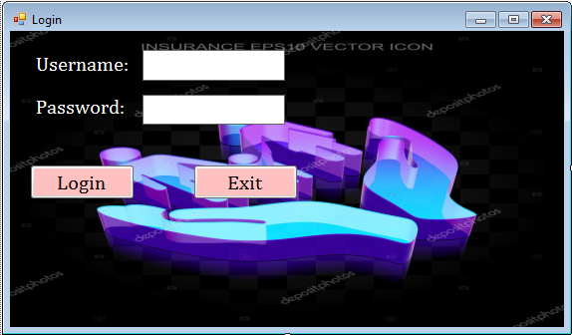

**Main form:**

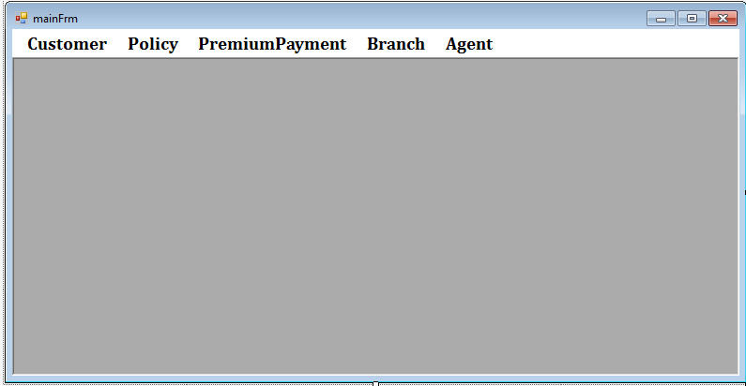

**Customer form:**

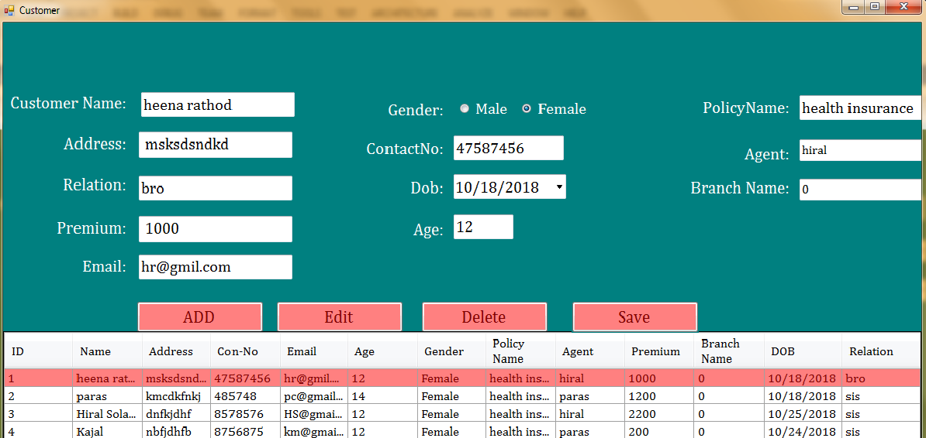

**PolicyDetails:**

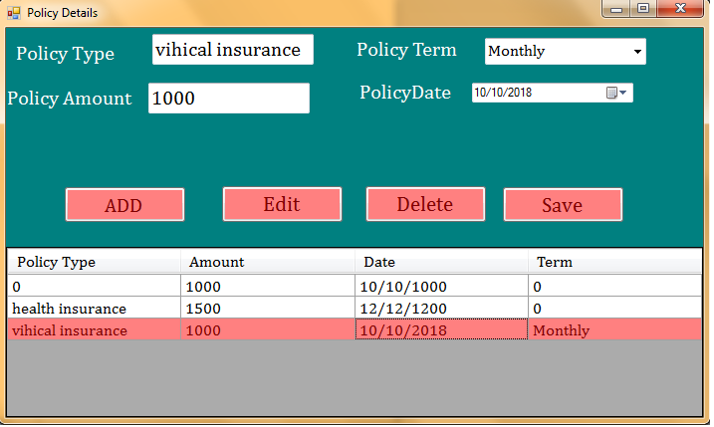

**PremiumDetails:**

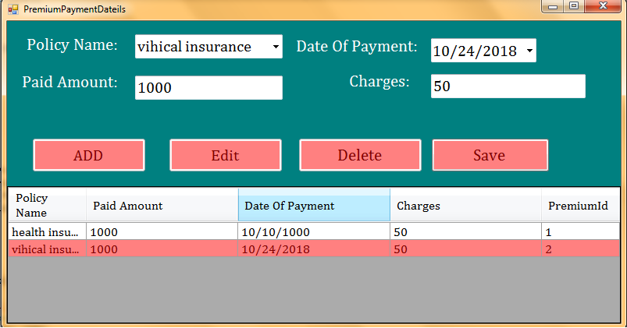

**AgentDetails:**

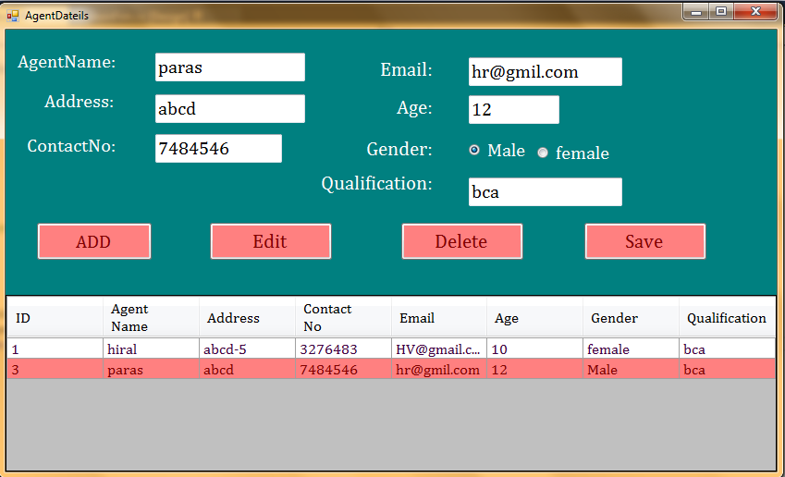

**BranchDetails:**

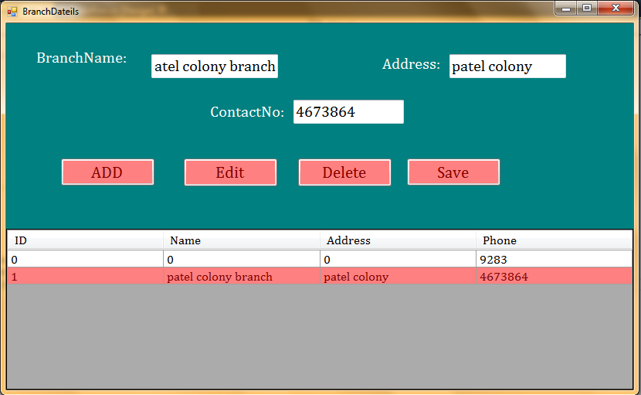

**PolicyRepor**

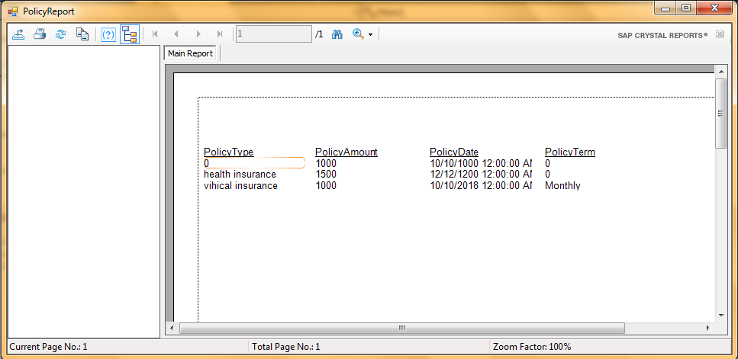

**Premium report**

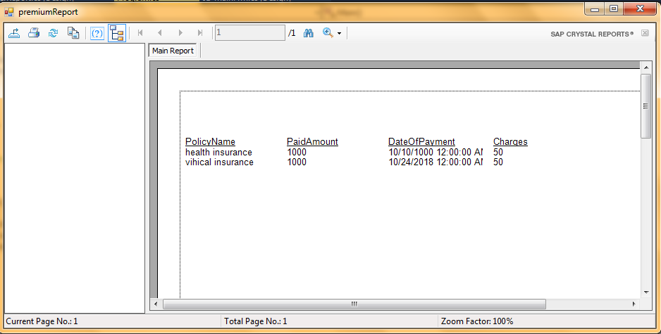

**Branch Report**

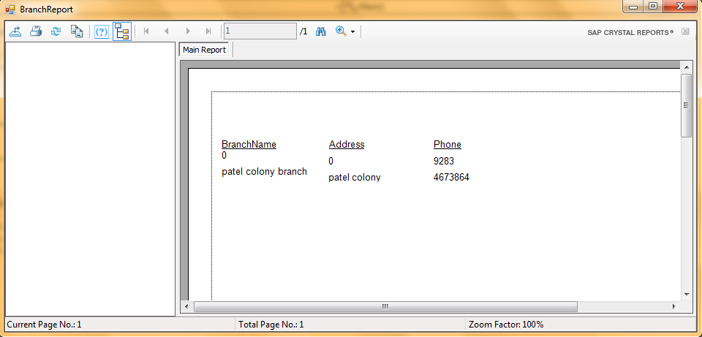

**AgentReport:**

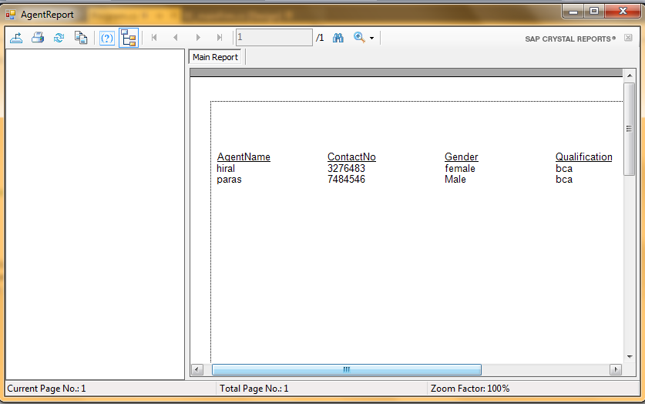

**[8].Limitation & Future Enhancement**

Limitation

* It’s not work on WAN network.

Features

* User can create new customer account.
* User can Add , Delete , Display and update details
* Collect amount of premium and policy.

**[9]. BIBLIOGRAPHY**

# Books

* + C#.Net
  + Designing using C#

# Web Sites

* [www.google.com](http://www.google.com)
* [www.C#.net Core.com](http://www.C#.net Core.com)