State Management

WAP to demonstrate use of cookie:

Design View:

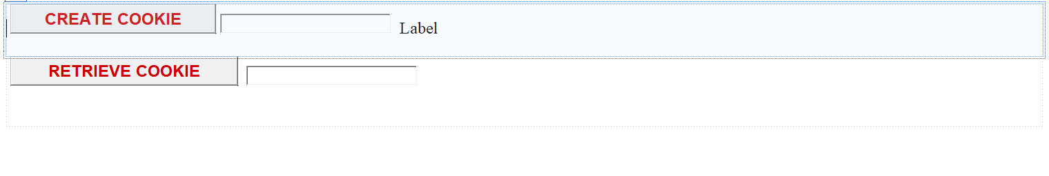

Default.aspx.cs

using System;

using System.Collections.Generic;

using System.Linq;

using System.Web;

using System.Web.UI;

using System.Web.UI.WebControls;

public partial class _Default : System.Web.UI.Page

{

protected void Page_Load(object sender, EventArgs e)

{

}

protected void Button1_Click(object sender, EventArgs e)

{

Response.Cookies["name"].Value = txtcreatecookie.Text;

Response.Cookies["name"].Expires = DateTime.Now.AddMinutes(1);

Label1.Text = "Cookie Created";

txtcreatecookie.Text = "";

}

protected void Button2_Click(object sender, EventArgs e)

{

if (Request.Cookies["name"] == null)

{

txtretrieve.Text = "No cookie found";

}

else

{

txtretrieve.Text = Request.Cookies["name"].Value;

}

}

}

WAP To Demostrate ViewState

Design View:

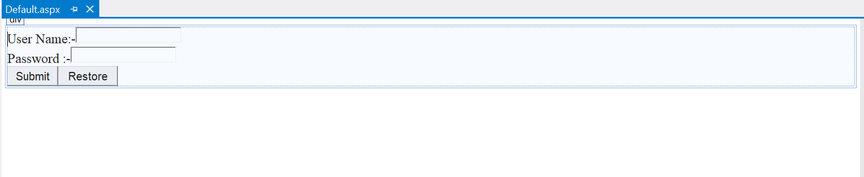

using System;

using System.Collections.Generic;

using System.Linq;

using System.Web;

using System.Web.UI;

using System.Web.UI.WebControls;

public partial class _Default : System.Web.UI.Page

{

public string a, b;

protected void Page_Load(object sender, EventArgs e)

{

}

protected void Button1_Click(object sender, EventArgs e)

{

//TextBox1 and TextBox2 Value is Assigning on the variable a and b

//a = TextBox1.Text;

//b = TextBox2.Text;

///after clicking on Button TextBox value Will be Cleared

//TextBox1.Text = TextBox2.Text = string.Empty;

//Value of Textbox1 and TectBox2 is assigin on the ViewState

ViewState["name"] = TextBox1.Text;

ViewState["password"] = TextBox2.Text;

////after clicking on Button TextBox value Will be Cleared

//TextBox1.Text = TextBox2.Text = string.Empty;

}

protected void Button3_Click(object sender, EventArgs e)

{

////value of variable a and b is assingning on TextBox1 and Textbox2

//TextBox1.Text = a;

//TextBox2.Text = b;

if (ViewState["name"] != null)

{

TextBox1.Text = ViewState["name"].ToString();

}

if (ViewState["password"] != null)

{

TextBox2.Text = ViewState["password"].ToString();

}

}

}

WAP To demonstrate use of session.

Default.aspx/Design view

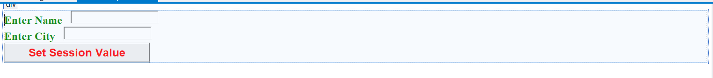

Default.aspx.cs

using System;

using System.Collections.Generic;

using System.Linq;

using System.Web;

using System.Web.UI;

using System.Web.UI.WebControls;

public partial class _Default : System.Web.UI.Page

{

protected void Page_Load(object sender, EventArgs e)

{

}

protected void Button1_Click(object sender, EventArgs e)

{

Session["name"] = txtname.Text;

Session["city"] = txtcity.Text;

Response.Redirect("next.aspx");

}

}

Next.aspx/Design View

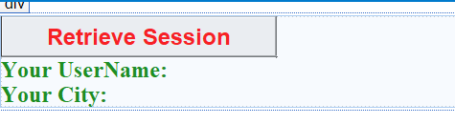

Next.aspx.cs

using System;

using System.Collections.Generic;

using System.Linq;

using System.Web;

using System.Web.UI;

using System.Web.UI.WebControls;

public partial class next : System.Web.UI.Page

{

protected void Page_Load(object sender, EventArgs e)

{

}

protected void Button1_Click(object sender, EventArgs e)

{

lblname.Text = Session["name"].ToString();

lblcity.Text = Session["city"].ToString();

}

}

WAP to demonstrate use of Application State:

Design View/Default.aspx



Default.aspx.cs

using System;

using System.Collections.Generic;

using System.Linq;

using System.Web;

using System.Web.UI;

using System.Web.UI.WebControls;

public partial class Default2 : System.Web.UI.Page

{

protected void Page_Load(object sender, EventArgs e)

{

Label1.Text = "visit no:" + Application["visit"].ToString();

}

}

Global.asax

<%@ Application Language="C#" %>

<script runat="server">

void Application_Start(object sender, EventArgs e)

{

// Code that runs on application startup

Application["visit"] = 0;

}

void Application_End(object sender, EventArgs e)

{

// Code that runs on application shutdown

}

void Application_Error(object sender, EventArgs e)

{

// Code that runs when an unhandled error occurs

}

void Session_Start(object sender, EventArgs e)

{

// Code that runs when a new session is started

Application["visit"] = Convert.ToInt32(Application["visit"]) + 1;

}

void Session_End(object sender, EventArgs e)

{

// Code that runs when a session ends.

// Note: The Session_End event is raised only when the sessionstate mode

// is set to InProc in the Web.config file. If session mode is set to StateServer

// or SQLServer, the event is not raised.

}

</script>