1. **Write a program to do the following operations.** 
   * **Create a Binary Tree by collecting information from users.**
   * **Create a Binary Search Tree by collecting information from users.**
   * **Traverse the created trees using ○ preorder ○ postorder ○ inorder ○ levelorder**
   * **Search Element in Binary Search Tree**
   * **Find Internal Nodes, External Nodes, Total Nodes and Height of Tree**

**Code :**

|  |
| --- |
| #include <stdio.h>  #include <stdlib.h.>  struct node  {  int data;  struct node *left;  struct node *right;  };  // Create Node  struct node* create(int value) {  struct node* newNode = malloc(sizeof(struct node));  newNode->data = value;  newNode->left = NULL;  newNode->right = NULL;  return newNode;  }  struct node* insertInBinaryTree(struct node* node, int data)  {  if (node == NULL)  return create(data);    if (data < node->data)  node->left = insertInBinaryTree(node->left, data);  else if (data > node->data)  node->right = insertInBinaryTree(node->right, data);    return node;  }  struct node* searchInBST(struct node* root, int key){  if(root==NULL) return NULL;  if(key==root->data) return root;  else if(key<root->data){  return searchInBST(root->left, key);  }  else{  return searchInBST(root->right, key);  }  }  struct node* createBinerytree(struct node* root)  {  int n;  int f = 0;  int r = 0;  n = 100;  struct node* q[n];  struct node *new,*temp;  int data;  int ri;  int le;  printf("\nEnter root node : ");  scanf("%d", &data);  new = create(data);  root = new;  q[r++] = new;  do  {  temp = q[f++];  printf("\nEnter Child of %d\n", temp->data);  printf("Right child :");  scanf("%d", &ri);  printf("Left child :");  scanf("%d", &le);  if (ri > 0)  {  new = create(ri);  temp->right = new;  q[r++] = new;  }  if (le > 0)  {  new = create(le);  temp->left = new;  q[r++] = new;  }  } while (f != r);  return root;  }  void inOrder(struct node* root){  if(root==NULL)return;  inOrder(root->left);  printf("%d -> ",root->data);  inOrder(root->right);  }  void preOrder(struct node* root){  if(root==NULL)return;  printf("%d -> ",root->data);  preOrder(root->left);  preOrder(root->right);  }  void postOrder(struct node* root){  if(root==NULL)return;  postOrder(root->left);  postOrder(root->right);  printf("%d -> ",root->data);  }  void levelOrder(struct node* root) {  if (root == NULL) return;  struct node* queue[1000];  int front = 0, rear = 0;  queue[rear++] = root;  while (front < rear) {  struct node* node = queue[front++];  printf("%d -> ", node->data);  if (node->left != NULL)  queue[rear++] = node->left;  if (node->right != NULL)  queue[rear++] = node->right;  }  }  int countInternalNodes(struct node* root) {  if (root == NULL)  return 0;  if (root->left == NULL && root->right == NULL)  return 0;    return countInternalNodes(root->left) + countInternalNodes(root->right)+1;  }  int countExternalNodes(struct node* root) {  if (root == NULL)  return 0;  if (root->left == NULL && root->right == NULL)  return 1;  return countExternalNodes(root->left) + countExternalNodes(root->right);  }  int countNodes(struct node* root) {  if (root == NULL)  return 0;    return 1 + countNodes(root->left) + countNodes(root->right);  }  int height(struct node* root) {  if (root == NULL)  return -1;  int leftHeight = height(root->left);  int rightHeight = height(root->right);  return 1 + (leftHeight > rightHeight ? leftHeight : rightHeight);  }  int main(){  // Create Binary Tree  printf("************* Binary Tree ******************");  struct node* root;  root =createBinerytree(root);    printf("\n\nInorder Traversal :\n");  inOrder(root);  printf("\n\nPreorder Traversal :\n");  preOrder(root);  printf("\n\nPostorder Traversal :\n");  postOrder(root);  printf("\n\nLevelorder Traversal :\n");  levelOrder(root);  // Create BST  printf("\n\n************* Binary Search Tree ******************\n");  int Bnodes,data;  printf("\nEnter The Number of Node in Binary Search Tree :");  scanf("%d",&Bnodes);  struct node* broot = NULL;  printf("Enter 1 node :");  scanf("%d",&data);  broot =insertInBinaryTree(broot,data);  for(int i=2; i<=Bnodes; i++){    printf("\nEnter %d node : ",i);  scanf("%d",&data);  insertInBinaryTree(broot,data);  }  // Search in BST  int sdata;  printf("\n\nEnter element for Search in BST :");  scanf("%d",&sdata);    struct node* n = searchInBST(broot, sdata);  if(n!=NULL){  printf("Found: %d", n->data);  }  else{  printf("Element not found");  }  printf("\n\nInorder Traversal :\n");  inOrder(broot);  printf("\n\nPreorder Traversal :\n");  preOrder(broot);  printf("\n\nPostorder Traversal :\n");  postOrder(broot);  printf("\n\nLevelorder Traversal :\n");  levelOrder(broot);  printf("\n\nInternal Node in BST : %d\n",countInternalNodes(broot));  printf("\nExternal Node in BST : %d\n",countExternalNodes(broot));  printf("\nTotal Node in BST : %d\n",countNodes(broot));  printf("\nHeight Node in BST : %d\n",height(broot));  return 0;    } |

**Output :**

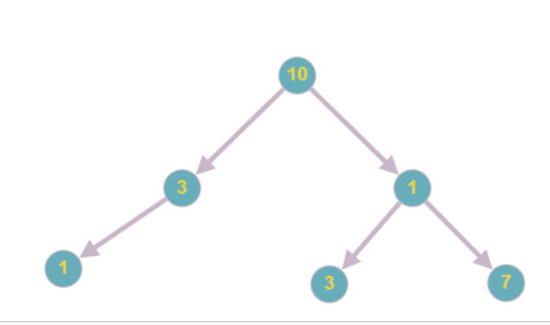 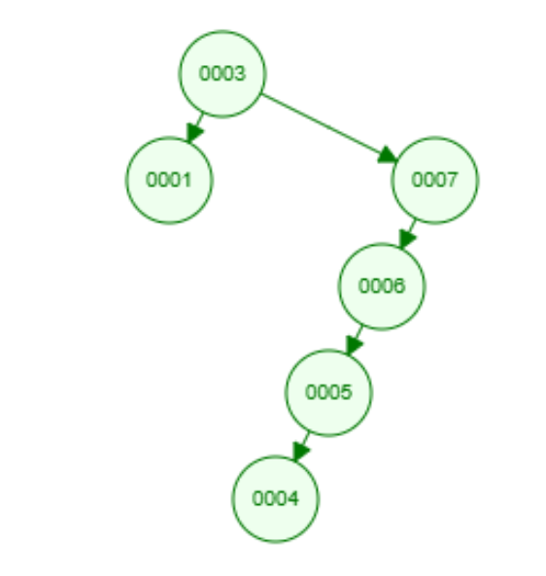

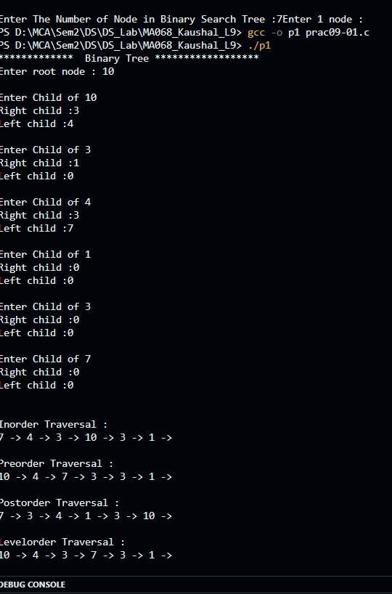 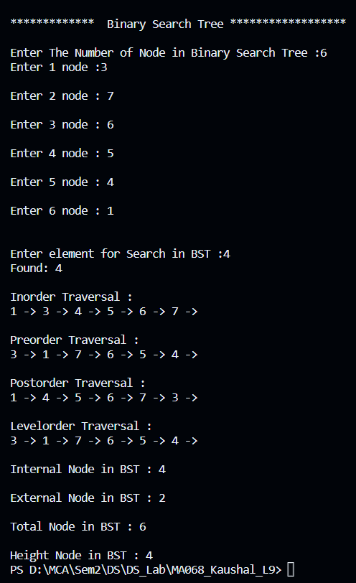

1. **Write a program to do the following operations.**

**● Create an array from user input.**

**● Search Element in an array using linear search - prints iteration done to find the element**

**● Search Element in an array using binary search - prints iteration done to find the element**

**Code:**

|  |
| --- |
| #include <stdio.h>  int linearSearch(int arr[],int n,int key){  int i,count=0;  for(i=0; i<n; i++)  {  if(key==arr[i])  {  printf("%d is itration Done in Linear Search.",i+1);  return i;  }  }  printf("%d is itration Done in Linear Search.",i);  return -1;;  }  void bubbleSort(int arr[],int n){  for(int i=0; i<n; i++)  for(int j=0; j<i; j++)  if(arr[j]>arr[j+1])  {  int temp=arr[j];  arr[j]=arr[j+1];  arr[j+1]=temp;  }    }  int binarySearch(int arr[],int n,int key){  int l=0;  int r=n-1;  int count=0;    while (l <= r) {  //int m = l + (r - l) / 2;  int m=(r+l)/2;  count++;  if (arr[m] == key)  {  printf("%d is itration Done in Binary Search.",count);  return m;  }    if (arr[m] < key)  l = m + 1;  else  r = m - 1;  }  printf("%d is itration Done in Binary Search.",count);  return -1;  }  int main(){  int n;    //Create Array  printf("\nEnter Number of element :");  scanf("%d",&n);  int arr[n];  for(int i=0; i<n; i++){  printf("\nEnter Value for %d element :",i);  scanf("%d",&arr[i]);  }  int Lkey;  printf("\nEnter Value for Linear search :");  scanf("%d",&Lkey);  int FoundIndexL=linearSearch(arr,n,Lkey);  if(FoundIndexL==-1)  printf("\n %d not Found in Array",Lkey);  else  printf("\n %d Found %d index in Array",Lkey,FoundIndexL);  int Bkey;    printf("\n\nEnter Value for Binary search :");  scanf("%d",&Bkey);  bubbleSort(arr,n);  printf("\nArray is sorted\n");    int FoundIndexB=binarySearch(arr,n,Bkey);  if(FoundIndexB==-1)  printf("\n %d not Found in Array",Bkey);  else  printf("\n %d Found %d index in Array",Bkey,FoundIndexB);  //Print array  printf("\n[");  for(int i=0; i<n; i++){  printf(" %d ,",arr[i]);  }  printf("\b]");  return 0;  } |

**Output :**

