1. **Write a PHP script to create a REST API where one can manage data related to the user and post generated by the user.**

**User table in MySQL will have basic details like - user_id(PK), name, email, phone, address, city, country UserPost table in MySQL will have basic details like - id, user_id(FK), post_content, post_date, post_time, post_last_edited_time, post_edit_count, post_isdeleted Your API/ Class should be able to**

**○ List all users**

**○ List user of based on id**

**○ List of Post created by user**

**○ Create post for particular user**

**○ Edit Post for particular user**

**○ Delete Post for particular user.**

**Output:**

**○ List all users**

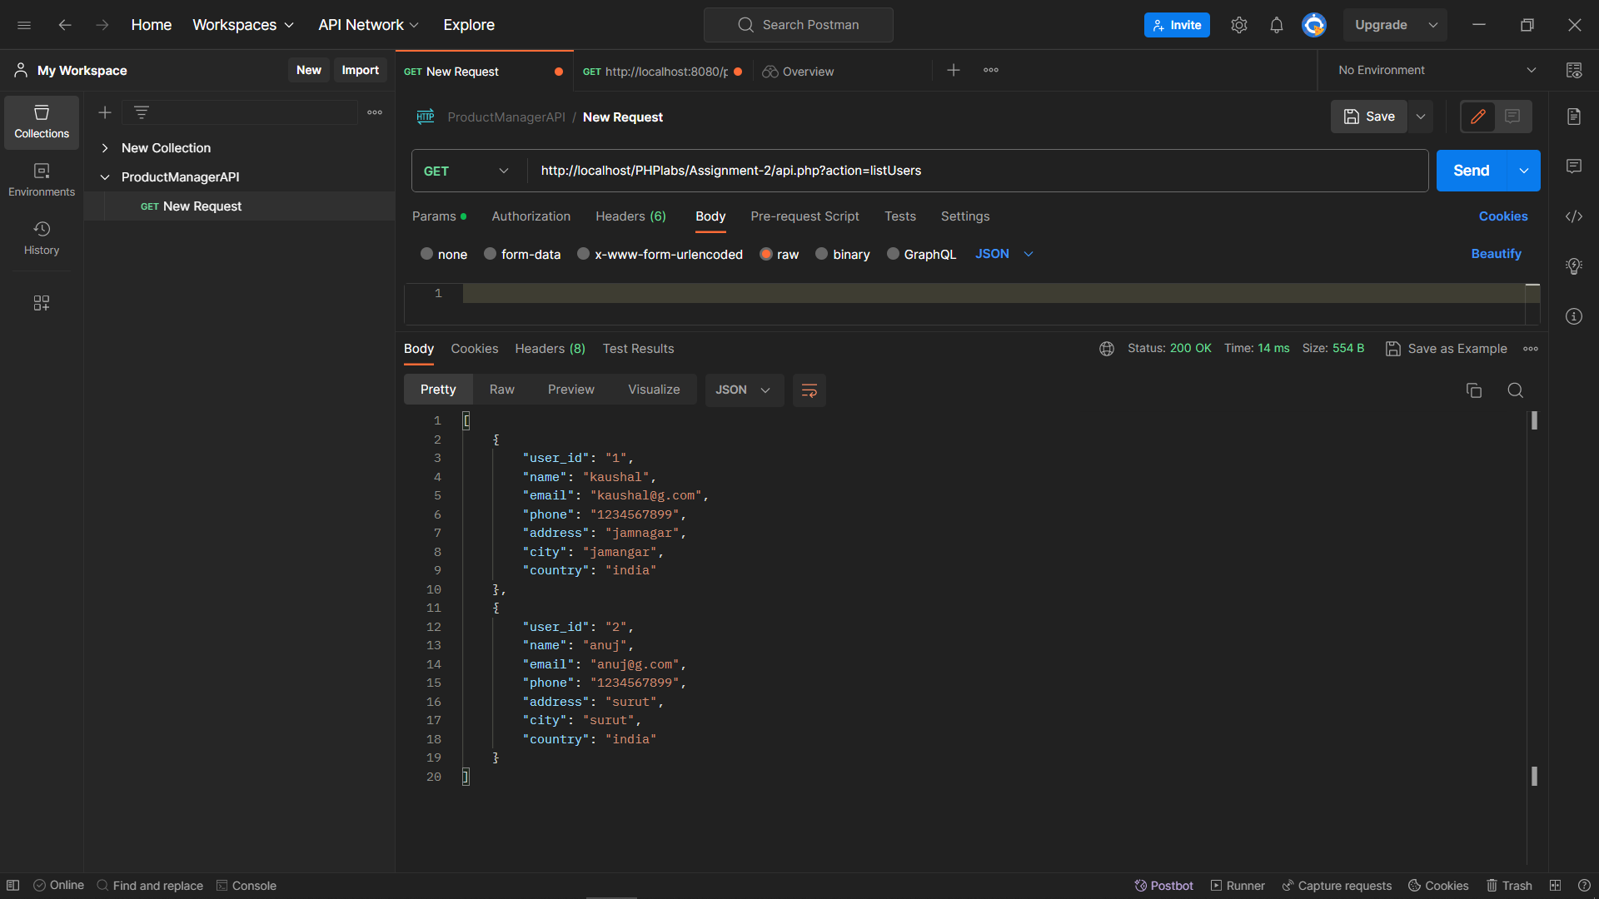

**○ List user of based on id**

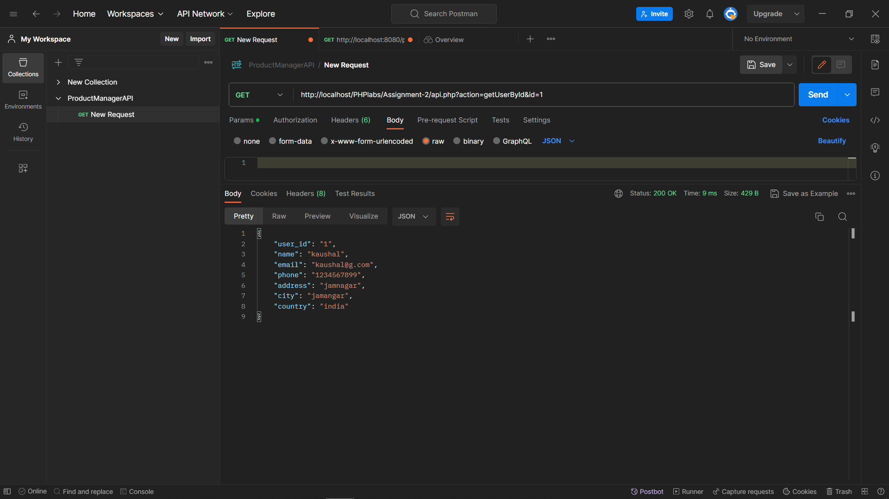

**○ List of Post created by user**

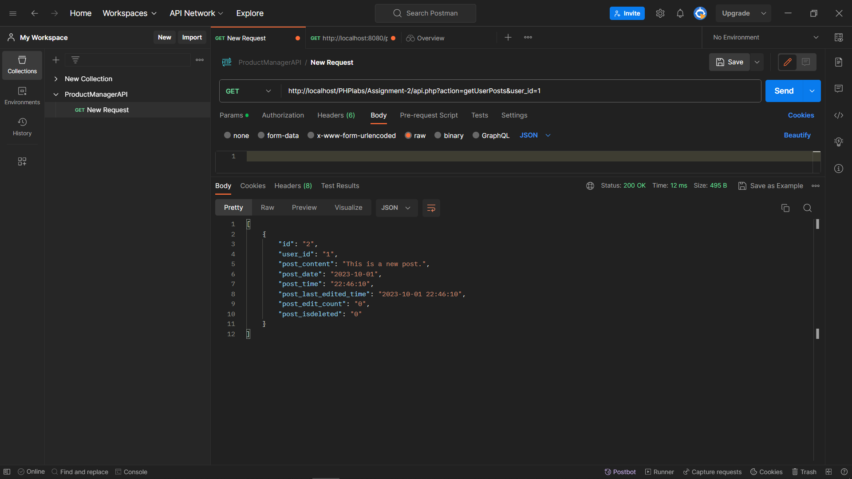

**○ Create post for particular user**

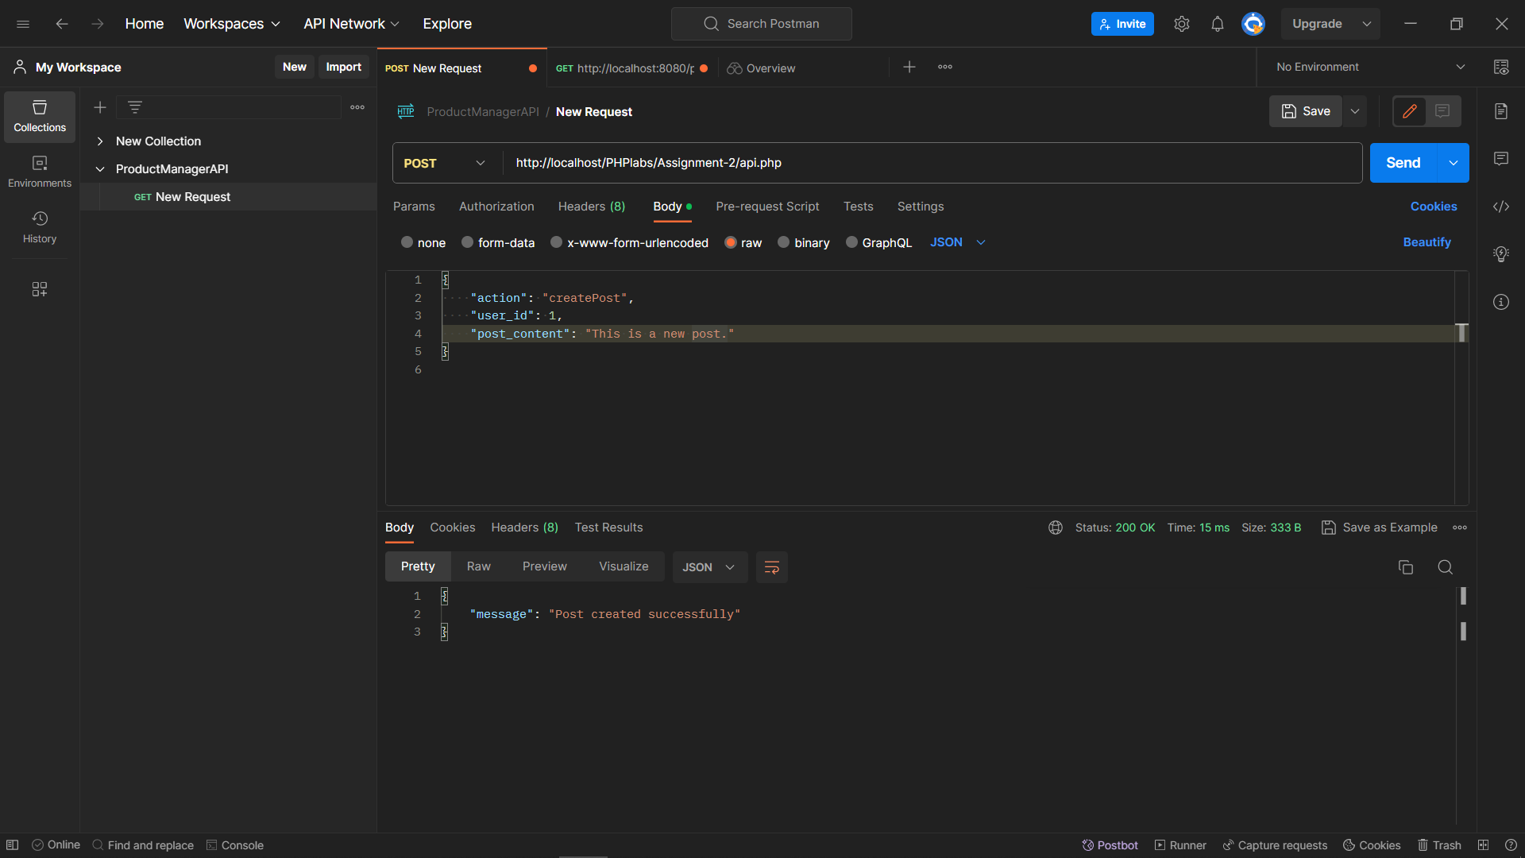

**○ Edit Post for particular user**

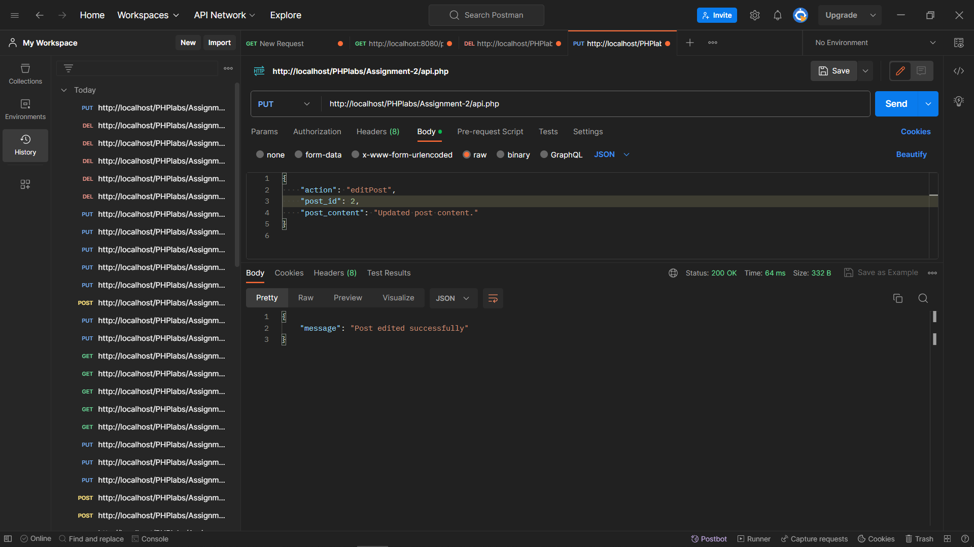

**○ Delete Post for particular user.**

