**Practical- 10**

**PHP-Mysql Database**

**1.Do the following example.**

**a. From the phpMyAdmin dashboard create database Person and create a table personinfo having field name, age and city. Create a PHP application for user registration by making a HTML registration page which takes the person name,age,city. When the user clicks on the insert button it inserts the record into the table person. When the user clicks on the display button it will display all records in appropriate html format. Use MySQLi Procedural methods for the same.**

**b. Consider the above example for Person, extend it by adding the functionality of update. Create a page for the user where all records are displayed in the table along with the Update button as the last column. When the user presses the update button the respective record is opened in a new page for updating where the user can update the value of city and age. When the user clicks on save. The records should get updated and the updated list or records should be displayed back along with the update button. Use MySQLi Class for the implementation.**

**c. Consider the above example for Person, add the functionality of delete. Create a page for the user where all records are displayed in the table along with the Delete button as the last column. When the user presses the delete button the respective record gets deleted from the table and displays an appropriate message to the user along with the updated list or records should be displayed back along with the delete button. Use PDO for the implementation.**

**Code:**

**conn.php**

|  |
| --- |
| <?php  $servername = "localhost";  $username = "root";  $password = "";  $dbname = "person";  ?> |

**home.php**

|  |
| --- |
| <?php  include 'conn.php';  $conn = mysqli_connect($servername, $username, $password,$dbname);  if(isset($_GET["submit"])) {  echo "after ";  $insert_sql = "INSERT INTO personinfo(name, age,city) VALUES ('$_GET[pname]',$_GET[page],'$_GET[pcity]')";  $qry = $conn->query($insert_sql);  if($qry == true)  {  echo "Data inserted successfully.";  }  else  {  echo "Data has not been inserted!<BR>";  echo "Reason: ", $conn->error;  }  // $conn->close();  }  if($_GET['isDeleted'] == "True"){  echo "<h1>Recored deleted<h1>";  }  ?>  <!DOCTYPE html>  <html lang="en">  <head>  <meta charset="UTF-8">  <meta name="viewport" content="width=device-width, initial-scale=1.0">  <title>Home page</title>  </head>  <body>  <h1> Home page </h1>  <form action="home.php" method="GET" >  <h3>  Enter Name :<input type="text" name = "pname"> <br>  Enter Age :<input type="number" name = "page"><br>  Enter City :<input type="text" name = "pcity"><br>  <input type="submit" name="submit">  </h3>  </form>  <?php include 'display.php'; ?>  </body>  </html> |

**display.php**

|  |
| --- |
| <!DOCTYPE html>  <html lang="en">  <head>  <meta charset="UTF-8">  <meta name="viewport" content="width=device-width, initial-scale=1.0">  <title>Document</title>  </head>  <body>  <?php    $query = "SELECT * from personinfo";    if ($result=mysqli_query($conn,$query))  {    ?>  <table border="1">  <tr>  <th>ID</th>  <th>Name</th>  <th>age</th>  <th>city</th>  <th>Opration</th>  </tr>  <?php  while ($row=mysqli_fetch_row($result))  {  ?>  <tr>  <td><?php echo $row[0] ?></td>  <td><?php echo $row[1] ?></td>  <td><?php echo $row[2] ?></td>  <td><?php echo $row[3] ?></td>  <td><a href="update.php?id=<?php echo $row[0] ?>">Update </a>  <a href="delete.php?id=<?php echo $row[0] ?>">Delete </a></td>  </tr>  <?php  }    mysqli_free_result($result);  }  mysqli_close($conn);  ?>  </table>  </body>  </html> |

**delete.php**

|  |
| --- |
| <?php  include "conn.php";  $conn = new PDO("mysql:host=$servername;dbname=$dbname", $username, $password);    $conn->setAttribute(PDO::ATTR_ERRMODE, PDO::ERRMODE_EXCEPTION);    $sql = "DELETE FROM personinfo WHERE pid=$_GET[id]";    $conn->exec($sql);    header("Location: home.php?isDeleted=True");  ?> |

**update.php**

|  |
| --- |
| <?php  include 'conn.php';    $conn = new mysqli($servername,$username, $password,$dbname);  $recode = array("null","","null","null");  if(isset($_GET["submit"])){  echo 'aft submited';  $sql = "UPDATE personinfo SET age=$_GET[uage] AND city='$_GET[ucity]' WHERE pid=$_GET[id]";    $result = $conn->query($sql);  if($result)  {  echo "Data updated successfully.";  }  else  {  echo "Error occurred while updating the record!<BR>";  echo "Reason: ", $conn->error;  }  }else{  $f_query = "SELECT * FROM personinfo WHERE pid = $_GET[id]";  $res = $conn->query($f_query);  $recode = $res->fetch_row();  }  //$conn->close();    ?>  <!DOCTYPE html>  <html lang="en">  <head>  <meta charset="UTF-8">  <meta name="viewport" content="width=device-width, initial-scale=1.0">  <title>Update</title>    </head>  <body>  <h1> Update page </h1>  <form action="update.php" method="GET" >  <h3>  <input type="hidden" name = "id" value="<?php echo $recode[0]; ?>" >  Enter Name :<input type="text" name = "uname" value="<?php echo $recode[1]; ?>" readonly > <br>  Enter Age :<input type="number" name = "uage" value="<?php echo $recode[2]; ?>" ><br>  Enter City :<input type="text" name = "ucity" value="<?php echo $recode[3]; ?>" ><br>  <input type="submit" name="submit" >  <br><a href="home.php">Home</a>  </h3>  </form>    <?php  include 'display.php';  ?>  </body>  </html> |

**Output:**

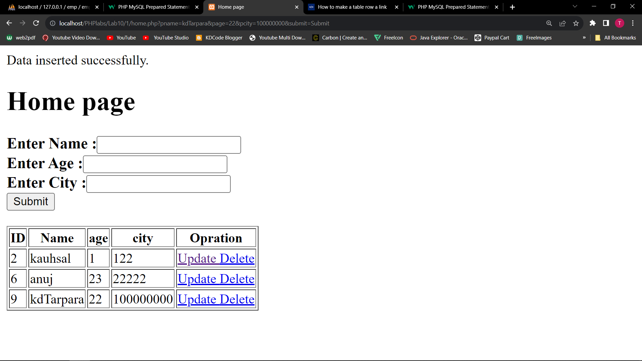

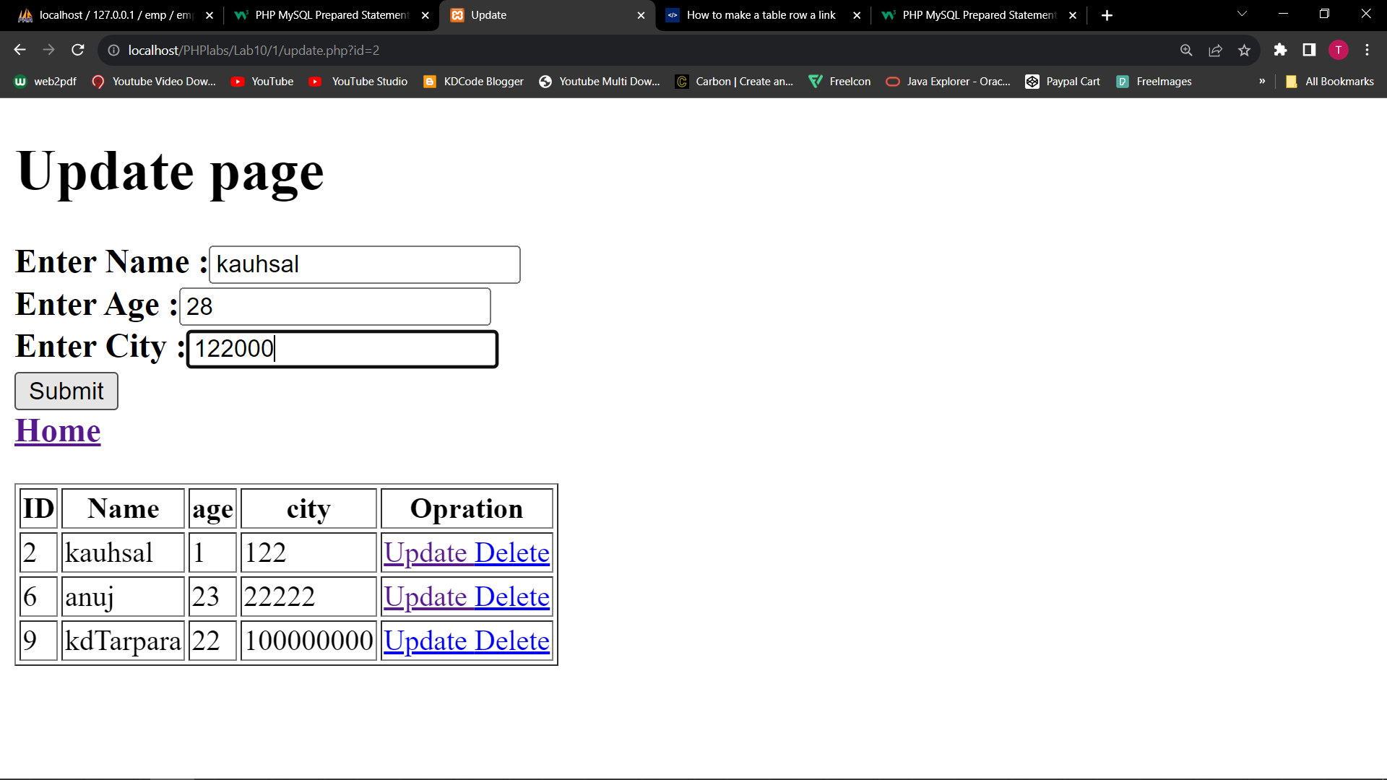

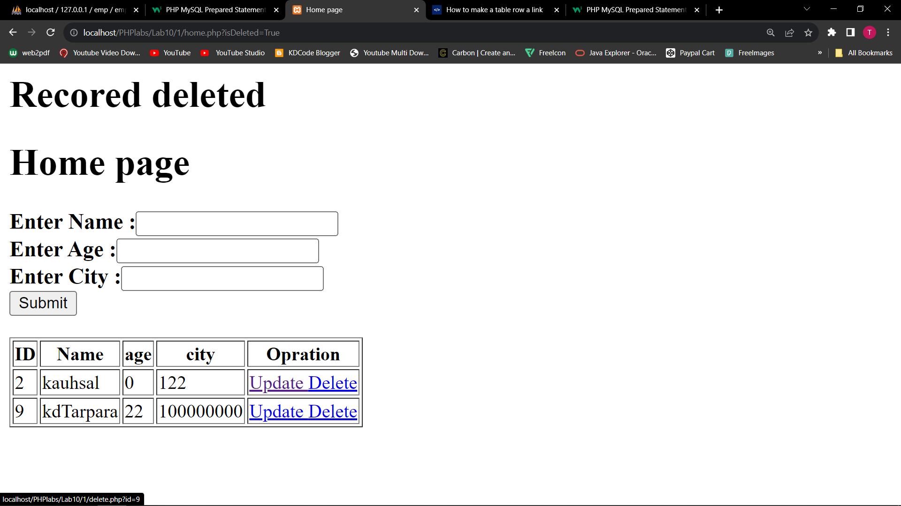

**2. Create an Employee records maintaining application in PHP. Application will maintain**

**personal and salary data of the employee. The application will have the following**

**functionalities.**

**a. Add an employee**

**b. Edit salary details of the employee**

**c. Delete an employee.**

**d. Display single employee details in a decorated HTML page.**

**e. Display all employees in a decorated HTML page.**

**Make use of prepared statements for this example. You can either select MySQLi Class or PDO for the samCode:**

**Code:**

**conn.php**

|  |
| --- |
| <?php  $servername = "localhost";  $username = "root";  $password = "";  $dbname = "emp";  $conn = new mysqli($servername,$username, $password,$dbname);  ?> |

**delete.php**

|  |
| --- |
| <?php  include "conn.php";      $sql = "DELETE FROM empinfo WHERE eid=$_GET[id]";    $conn->query($sql);    header("Location: home.php?isDeleted=True");  ?> |

**display.php**

|  |
| --- |
| <!DOCTYPE html>  <html lang="en">  <head>  <meta charset="UTF-8">  <meta name="viewport" content="width=device-width, initial-scale=1.0">  <title>Document</title>  <style>  body {  font-family: Arial, sans-serif;  background-color: #f7f7f7;  margin: 0;  padding: 0;  display: flex;  flex-direction: column;  align-items: center;  justify-content: center;  height: 100vh;  }  table {  width: 80%;  border-collapse: collapse;  margin-top: 20px;  }  th, td {  padding: 15px;  text-align: left;  border-bottom: 1px solid #ddd;  }  th {  background-color: #f2f2f2;  }  tr:nth-child(even) {  background-color: #f2f2f2;  }  tr:hover {  background-color: #ddd;  }  a {  text-decoration: none;  color: #007bff;  margin-right: 10px;  }  </style>  </head>  <body>  <?php  $query = "SELECT * FROM empinfo";  if ($result = mysqli_query($conn, $query)) {  ?>  <table>  <tr>  <th>ID</th>  <th>Name</th>  <th>Age</th>  <th>Salary</th>  <th>Operation</th>  </tr>  <?php  while ($row = mysqli_fetch_row($result)) {  ?>    <a href="form.css">    <tr>  <td><?php echo $row[0] ?></td>  <td><?php echo $row[1] ?></td>  <td><?php echo $row[2] ?></td>  <td><?php echo $row[3] ?></td>  <td>  <a href="update.php?id=<?php echo $row[0] ?>">Update </a>  <a href="delete.php?id=<?php echo $row[0] ?>">Delete </a>  <a href="s_emp.php?id=<?php echo $row[0] ?>">Show Details </a>  </td>  </tr>  </a>  <?php  }  mysqli_free_result($result);  }  mysqli_close($conn);  ?>  </table>  </body>  </html> |

**home.php**

|  |
| --- |
| <?php  include 'conn.php';    if(isset($_GET["submit"])) {      $stmt = $conn->prepare("INSERT INTO empinfo (name, age, sal) VALUES (?, ?, ?)");  $stmt->bind_param("sss", $_GET['ename'],$_GET['eage'],$_GET['esal']);  $stmt->execute();    if($stmt == true)  {  echo "Data inserted successfully.";  }  else  {  echo "Data has not been inserted!<BR>";  echo "Reason: ", $conn->error;  }  // $conn->close();  }  if(isset($_GET['isDeleted'])){  echo "<h1>Recored deleted<h1>";  }  ?>  <!DOCTYPE html>  <html lang="en">  <head>  <meta charset="UTF-8">  <meta name="viewport" content="width=device-width, initial-scale=1.0">  <title>Home page</title>    <link rel="stylesheet" href="form.css">  </head>  <body>    <h1> Home page </h1>  <form action="home.php" method="GET" >  <h3>  Enter Name :<input type="text" name = "ename"> <br>  Enter Age :<input type="number" name = "eage"><br>  Enter Salary :<input type="text" name = "esal"><br>  <input type="submit" name="submit">  </h3>  </form>  <?php include 'display.php'; ?>  </body>  </html> |

**s_emp.php**

|  |
| --- |
| <?php  include 'conn.php';  if(isset($_GET['id'])) {  $employeeId = $_GET['id'];      $query = "SELECT * FROM empinfo WHERE eid = $employeeId";  $result = mysqli_query($conn, $query);    if(mysqli_num_rows($result) > 0) {  $employee = mysqli_fetch_assoc($result);  } else {    echo "Employee not found!";  exit();  }  } else {    echo "Invalid request!";  exit();  }  ?>  <!DOCTYPE html>  <html lang="en">  <head>  <meta charset="UTF-8">  <meta name="viewport" content="width=device-width, initial-scale=1.0">  <title>Employee Details</title>  <style>  body {  font-family: Arial, sans-serif;  background-color: #f7f7f7;  margin: 0;  padding: 0;  display: flex;  flex-direction: column;  align-items: center;  justify-content: center;  height: 100vh;  }  .container {  background-color: #fff;  padding: 20px;  border-radius: 8px;  box-shadow: 0 4px 8px rgba(0, 0, 0, 0.1);  text-align: left;  }  .details {  margin-bottom: 20px;  }  .details strong {  margin-right: 10px;  }  .back-button {  margin-top: 20px;  }  </style>  </head>  <body>  <div class="container">  <h1>Employee Details</h1>  <div class="details">  <p><strong>ID:</strong> <?php echo $employee['eid']; ?></p>  <p><strong>Name:</strong> <?php echo $employee['name']; ?></p>  <p><strong>Age:</strong> <?php echo $employee['age']; ?></p>  <p><strong>Salary:</strong> <?php echo $employee['sal']; ?></p>  </div>  <a href="home.php" class="back-button">Back to Home</a>  </div>  </body>  </html> |

**update.php**

|  |
| --- |
| <?php  include 'conn.php';  $recode = array("null","","null","null");    if(isset($_GET["submit"])){    $sql = "UPDATE empinfo SET sal=$_GET[usal] WHERE eid=$_GET[id]";    $result = $conn->query($sql);  if($result)  {  echo "<h2>Data updated successfully.";  }  else  {  echo "Error occurred while updating the record!<BR>";  echo "Reason: ", $conn->error;  }  }else{  $f_query = "SELECT * FROM empinfo WHERE eid = $_GET[id]";  $res = $conn->query($f_query);  $recode = $res->fetch_row();  }  //$conn->close();    ?>  <!DOCTYPE html>  <html lang="en">  <head>  <meta charset="UTF-8">  <meta name="viewport" content="width=device-width, initial-scale=1.0">  <title>Update</title>  <link rel="stylesheet" href="form.css">  </head>  <body>  <h1> Update page </h1>  <form action="update.php" method="GET" >  <h3>  <input type="hidden" name = "id" value="<?php echo $recode[0]; ?>" >  Enter Name :<input type="text" name = "uname" value="<?php echo $recode[1]; ?>" readonly > <br>  Enter Age :<input type="number" name = "uage" value="<?php echo $recode[2]; ?>" readonly ><br>  Enter City :<input type="number" name = "usal" value="<?php echo $recode[3]; ?>" ><br>  <input type="submit" name="submit" >  <br><a href="home.php">Home</a>  </h3>  </form>    <?php  include 'display.php';  ?>  </body>  </html> |

**Form.css**

|  |
| --- |
| body {  font-family: Arial, sans-serif;  background-color: #f7f7f7;  margin: 0;  padding: 0;  display: grid;  flex-direction: column;  align-items: center;  justify-content: center;  height: 100vh;  }  h1 {  color: #333;  }  form {  background-color: #fff;  padding: 20px;  border-radius: 8px;  box-shadow: 0 4px 8px rgba(0, 0, 0, 0.1);  margin-top: 20px;  text-align: left;  }  input[type="text"],  input[type="number"] {  width: 100%;  padding: 10px;  margin: 8px 0;  box-sizing: border-box;  border: 1px solid #ccc;  border-radius: 4px;  }  input[type="submit"] {  width: 100%;  background-color: #4caf50;  color: white;  padding: 14px 20px;  margin: 8px 0;  border: none;  border-radius: 4px;  cursor: pointer;  }  input[type="submit"]:hover {  background-color: #45a049;  } |

**Output:**

