**Practical-6**

**Session Management, File handling and Error handling**

1. **Create a php page which takes the student’s name and marks of three subjects from the user. Manage all information via session and display all information on the next page.**

**Code:**

**6_1index.php**

|  |
| --- |
| <!DOCTYPE html>  <html>  <head>  <title>Student Information</title>  </head>  <body>  <h1>Enter Student Information</h1>  <form method="post" action="6_1Display.php">  <label for="name">Student Name:</label>  <input type="text" name="name" required><br><br>  <label for="subject1">Subject 1 Marks:</label>  <input type="number" name="subject1" required><br><br>  <label for="subject2">Subject 2 Marks:</label>  <input type="number" name="subject2" required><br><br>  <label for="subject3">Subject 3 Marks:</label>  <input type="number" name="subject3" required><br><br>  <input type="submit" value="Submit">  </form>  </body>  </html> |

**6_1Display.php**

|  |
| --- |
| <!DOCTYPE html>  <html>  <head>  <title>Student Information</title>  </head>  <body>  <h1>Student Information</h1>  <?php  session_start();  if ($_SERVER["REQUEST_METHOD"] == "POST") {  $_SESSION["name"] = $_POST["name"];  $_SESSION["subject1"] = $_POST["subject1"];  $_SESSION["subject2"] = $_POST["subject2"];  $_SESSION["subject3"] = $_POST["subject3"];  }  if (isset($_SESSION["name"])) {  echo "<p>Name: {$_SESSION["name"]}</p>";  echo "<p>Subject 1 Marks: {$_SESSION["subject1"]}</p>";  echo "<p>Subject 2 Marks: {$_SESSION["subject2"]}</p>";  echo "<p>Subject 3 Marks: {$_SESSION["subject3"]}</p>";  } else {  echo "<p>No student information found.</p>";  }  echo "<hr>Today is " . date("d/m/Y") . "<br>";  echo "The time is " . date("h:i:sa");  ?>  </body>  </html> |

**Output:**

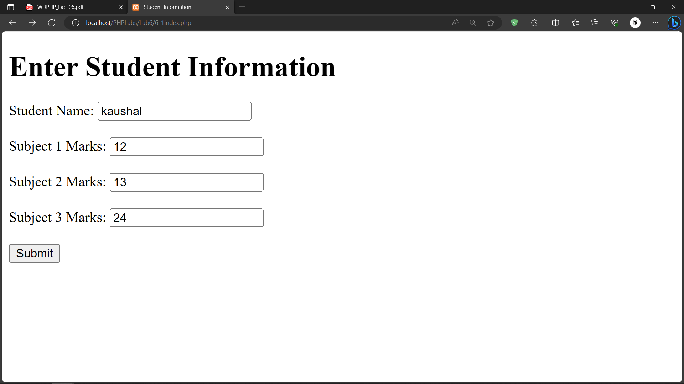

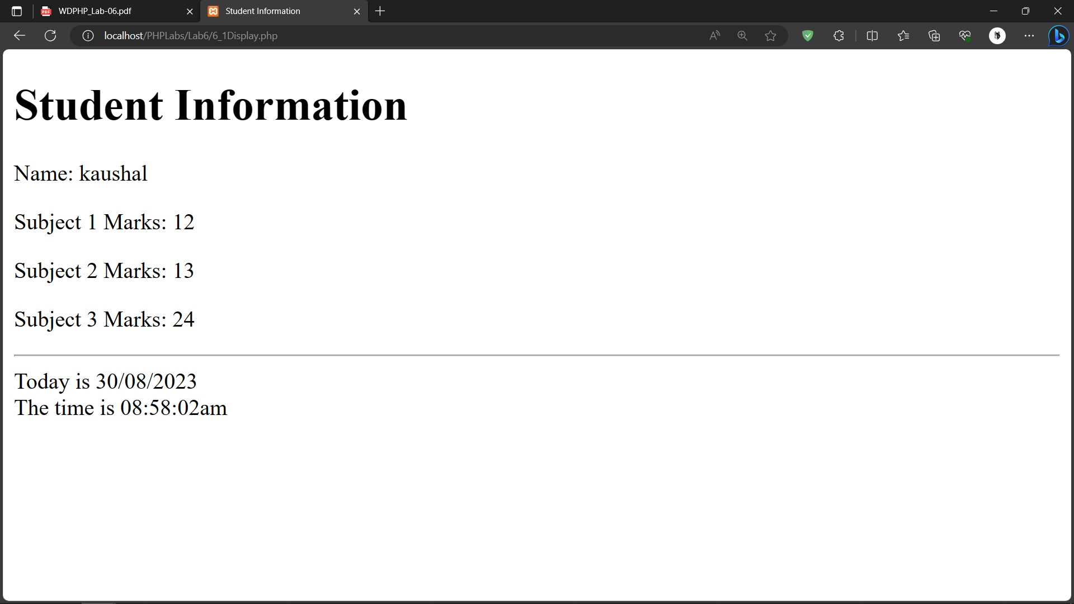

**2. Create php code which do following task**

**Signup.php : take username and password from user and select hobbies(from checkbox) & store information as session variable. Store password in encrypted format using md5 encryption.**

**Viewhobbie.php : if session variable username not set display “login required” message else display the hobbies of respective user in a well designed page.**

**Singout.php : clear the session variables.Code:**

**Signup.php**

|  |
| --- |
| <!DOCTYPE html>  <html>  <head>  <title>Sign Up</title>  </head>  <body>  <h1>Sign Up</h1>  <form method="post" action="viewhobbies.php">  <label for="username">Username:</label>  <input type="text" name="username" required><br><br>  <label for="password">Password:</label>  <input type="password" name="password" required><br><br>  <label>Hobbies:</label><br>  <input type="checkbox" name="hobbies[]" value="Reading"> Reading<br>  <input type="checkbox" name="hobbies[]" value="Gaming"> Gaming<br>  <input type="checkbox" name="hobbies[]" value="Traveling"> Traveling<br><br>  <input type="submit" value="Sign Up">  </form>  </body>  </html> |

**Viewhobbie.php**

|  |
| --- |
| <?php  session_start();  if ($_SERVER["REQUEST_METHOD"] == "POST") {  $_SESSION["username"] = $_POST["username"];  $_SESSION["password"] = md5($_POST["password"]);  $_SESSION["hobbies"] = isset($_POST["hobbies"]) ? $_POST["hobbies"] : array();  header("Location: viewhobbies.php");  }  if (!isset($_SESSION['username'])) {  echo "Login required.";  } else {  echo "<h1>Welcome, {$_SESSION['username']}!</h1>";  echo "<h2>Your Hobbies:</h2>";  if (isset($_SESSION['hobbies']) && is_array($_SESSION['hobbies'])) {  echo "<ul>";  foreach ($_SESSION['hobbies'] as $hobby) {  echo "<li>$hobby</li>";  }  echo "</ul>";  } else {  echo "You haven't selected any hobbies yet.";  }  echo "<a href='signout.php'>Sign Out</a>";  echo "<hr>Today is " . date("d/m/Y") . "<br>";  echo "The time is " . date("h:i:sa");  }  ?> |

**signout.php**

|  |
| --- |
| <?php  session_start();  session_unset();  session_destroy();  header("Location: signup.php");  exit();  ?> |

**Output:**

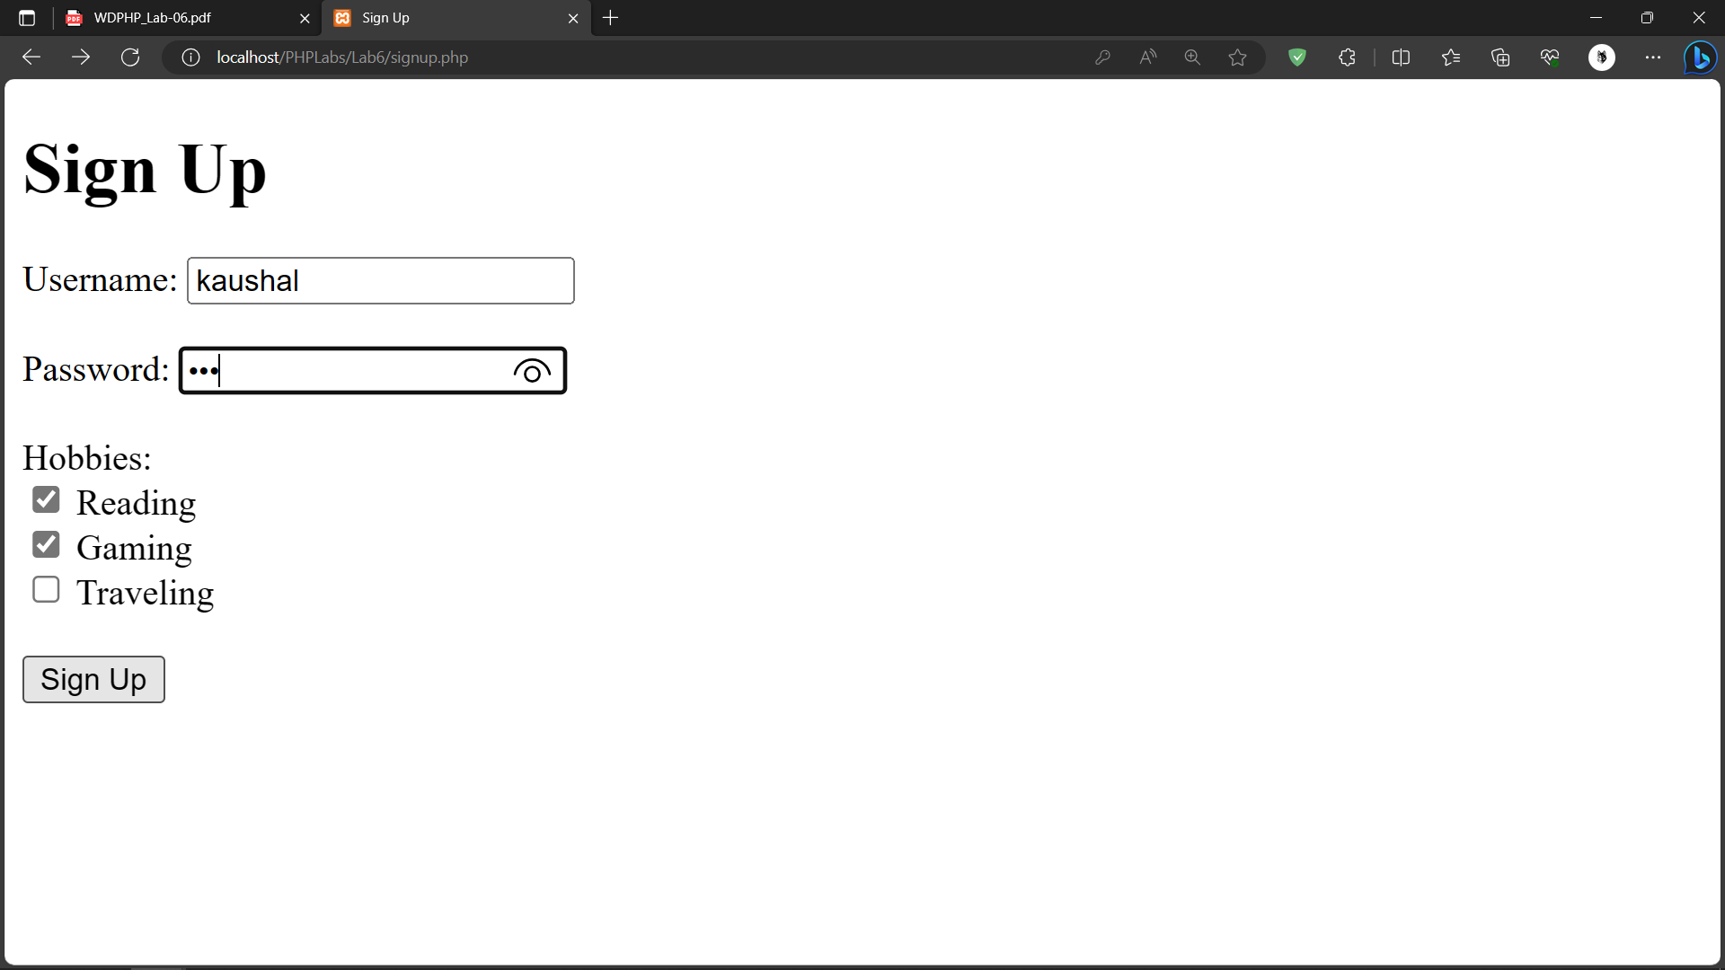

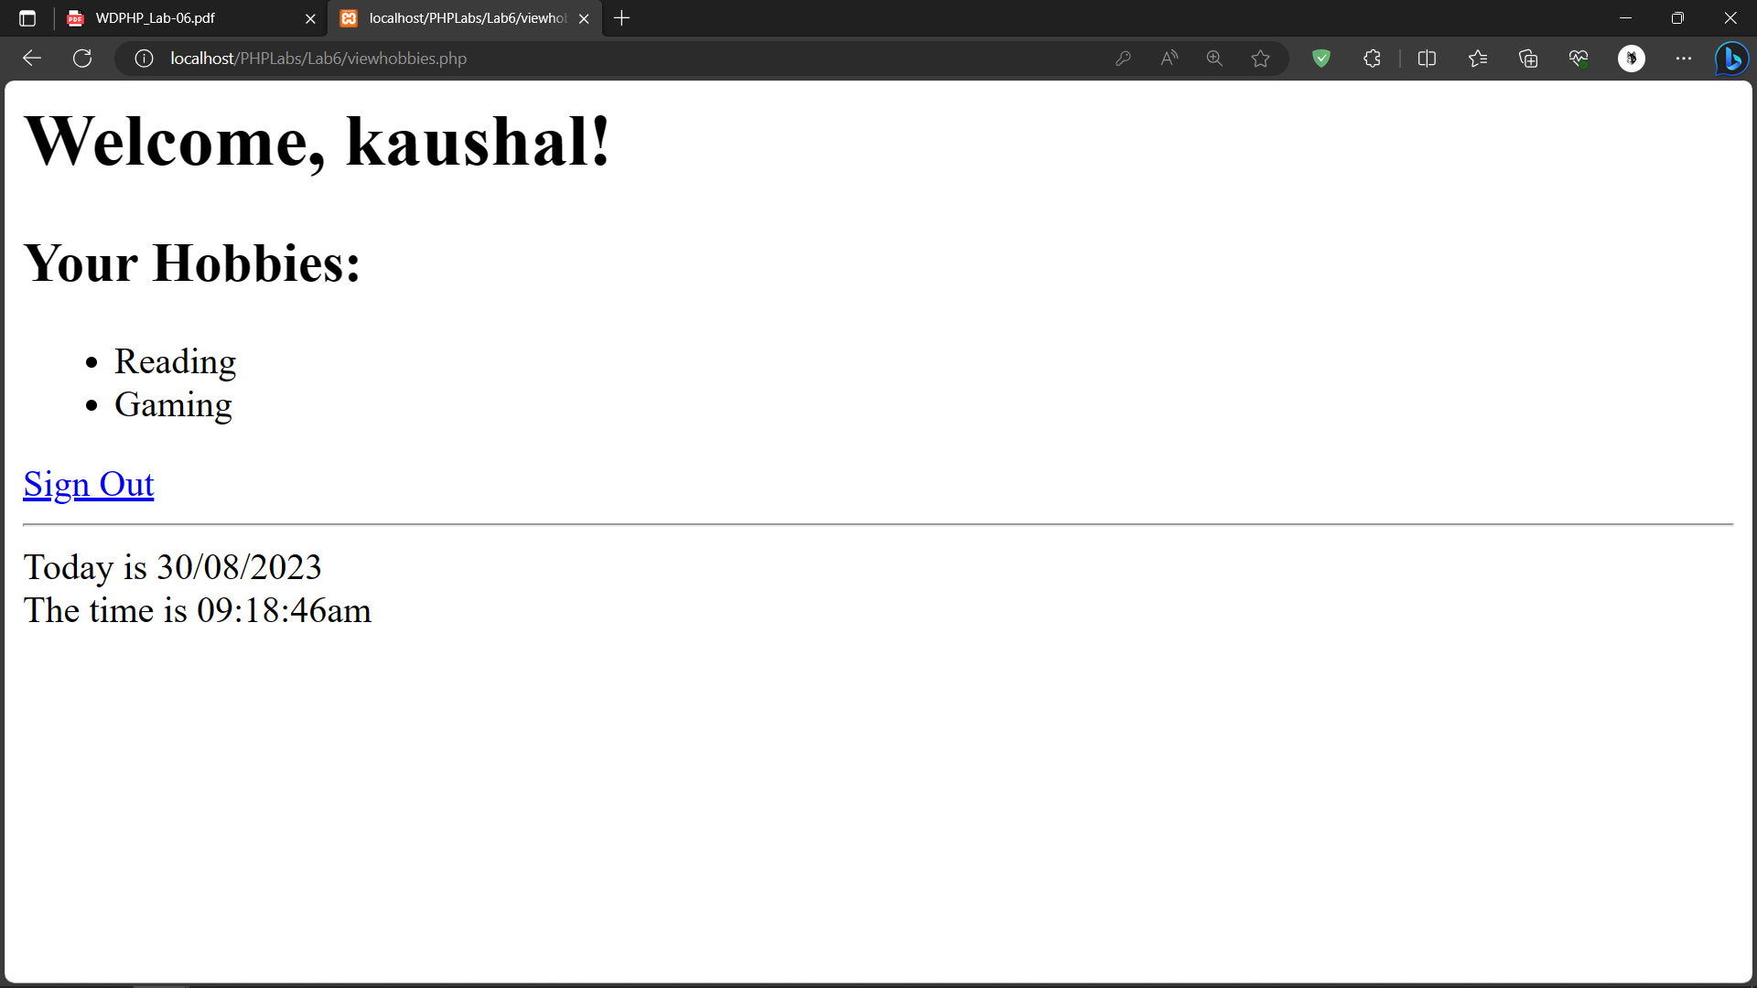

1. **Develop a HTML form which takes the file name and string form the user. Create a php script which creates or opens a file (if it already exists) and appends the string into the given file when the write button is clicked. On click on read button it displays the content of the file into the browser.**

**Code:**

**6_3.php**

|  |
| --- |
| <!DOCTYPE html>  <html>  <head>  <title>File Operations</title>  </head>  <body>  <h1>File Operations</h1>    <form method="post" action="file_operations.php">  <label for="filename">File Name:</label>  <input type="text" name="filename" required><br><br>    <label for="content">Enter Text:</label>  <textarea name="content" rows="4" cols="50" required></textarea><br><br>    <input type="submit" name="write" value="Write">  <input type="submit" name="read" value="Read">  </form>  </body>  </html> |

**File_operations.php**

|  |
| --- |
| <?php  session_start();  if ($_SERVER["REQUEST_METHOD"] == "POST") {  $_SESSION["username"] = $_POST["username"];  $_SESSION["password"] = md5($_POST["password"]);  $_SESSION["hobbies"] = isset($_POST["hobbies"]) ? $_POST["hobbies"] : array();  header("Location: viewhobbies.php");  }  if (!isset($_SESSION['username'])) {  echo "Login required.";  } else {  echo "<h1>Welcome, {$_SESSION['username']}!</h1>";  echo "<h2>Your Hobbies:</h2>";  if (isset($_SESSION['hobbies']) && is_array($_SESSION['hobbies'])) {  echo "<ul>";  foreach ($_SESSION['hobbies'] as $hobby) {  echo "<li>$hobby</li>";  }  echo "</ul>";  } else {  echo "You haven't selected any hobbies yet.";  }  echo "<a href='signout.php'>Sign Out</a>";  echo "<hr>Today is " . date("d/m/Y") . "<br>";  echo "The time is " . date("h:i:sa");  }  ?> |

**Output:**

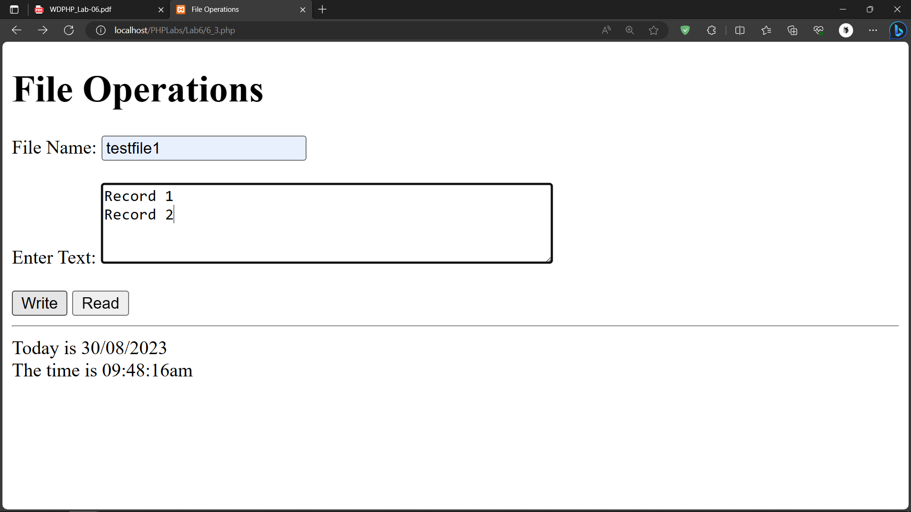

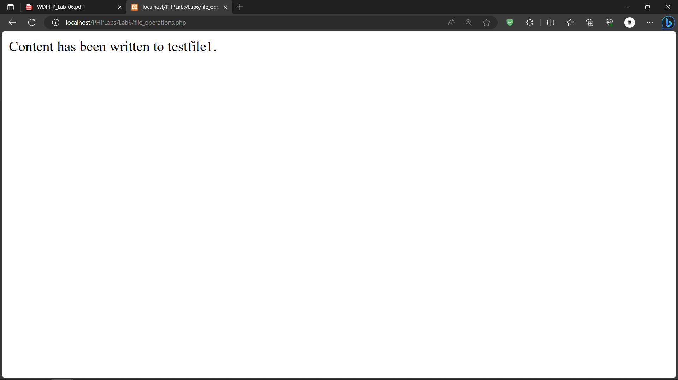

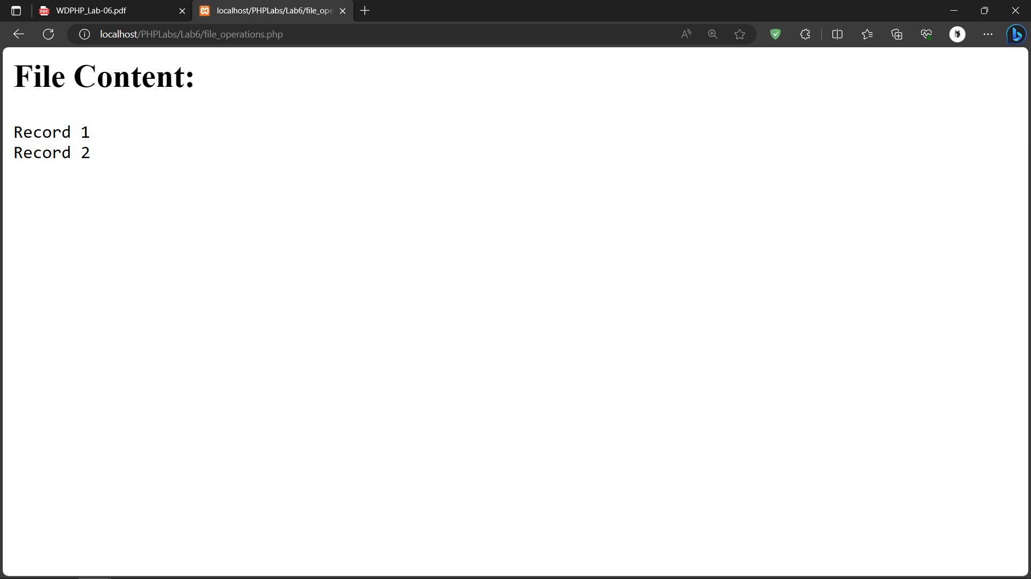

**4. Create a php application which has a login page, a product page, cart display page, purchase message page and logout page. Users can login into the system using username and password which are validated from an already stored file on the server. Once a user is logged in successfully the user can select a product to buy and quantity to buy. User can review the selected product with invoice details in cart page and click on buy to purchase and can signout from application.**

**Code**

**index.php**

|  |
| --- |
| <!DOCTYPE html>  <html>  <head>  <title>Login Page</title>  </head>  <body>  <h1>Login</h1>  <form method="post" action="login.php">  <label for="username">Username:</label>  <input type="text" name="username" required><br><br>  <label for="password">Password:</label>  <input type="password" name="password" required><br><br>  <input type="submit" value="Login">  </form>  <?php  echo "<hr>Today is " . date("d/m/Y") . "<br>";  echo "The time is " . date("h:i:sa");  ?>  </body>  </html> |

**login.php**

|  |
| --- |
| <?php  session_start();  if ($_SERVER["REQUEST_METHOD"] == "POST") {  $username = $_POST["username"];  $password = $_POST["password"];  $users = json_decode(file_get_contents("users.json"), true);  if (isset($users[$username]) && $users[$username]["password"] == $password) {  $_SESSION["username"] = $username;  header("Location: products.php");  exit();  } else {  echo "Invalid username or password. <a href='index.php'>Try again</a>";  }  }  ?> |

**logout.php**

|  |
| --- |
| <?php  session_start();  session_destroy();  header("Location: index.php");  exit();  ?> |

**products.php**

|  |
| --- |
| <?php  session_start();  if (!isset($_SESSION["username"])) {  header("Location: index.php");  exit();  }  ?>  <!DOCTYPE html>  <html>  <head>  <title>Product Selection</title>  </head>  <body>  <h1>Welcome, <?php echo $_SESSION["username"]; ?>!</h1>  <h2>Product Selection</h2>  <form method="post" action="cart.php">  <label for="product">Select a Product:</label>  <select name="product">  <option value="product1">Product 1</option>  <option value="product2">Product 2</option>  </select><br><br>  <label for="quantity">Quantity:</label>  <input type="number" name="quantity" required><br><br>  <input type="submit" value="Add to Cart">  </form>  <a href="cart.php">View Cart</a><br>  <a href="logout.php">Logout</a>  </body>  </html> |

**purchase.php**

|  |
| --- |
| <?php  session_start();  if (!isset($_SESSION["username"])) {  header("Location: index.php");  exit();  }unset($_SESSION["cart"]);  ?>  <!DOCTYPE html>  <html>  <head>  <title>Purchase Confirmation</title>  </head>  <body>  <h1>Thank You for Your Purchase, <?php echo $_SESSION["username"]; ?>!</h1>  <p>Your order has been placed successfully.</p>  <a href="products.php">Continue Shopping</a><br>  <a href="logout.php">Logout</a>  </body>  </html> |

**cart.php**

|  |
| --- |
| <?php  session_start();  if (!isset($_SESSION["username"])) {  header("Location: index.php");  exit();  }  if ($_SERVER["REQUEST_METHOD"] == "POST") {  $product = $_POST["product"];  $quantity = $_POST["quantity"];    // Store product and quantity in the session  $_SESSION["cart"][$product] = $quantity;  }  ?>  <!DOCTYPE html>  <html>  <head>  <title>Cart</title>  </head>  <body>  <h1>Your Cart</h1>  <table>  <tr>  <th>Product</th>  <th>Quantity</th>  </tr>  <?php  if (isset($_SESSION["cart"])) {  foreach ($_SESSION["cart"] as $product => $quantity) {  echo "<tr>";  echo "<td>$product</td>";  echo "<td>$quantity</td>";  echo "</tr>";  }  }  ?>  </table>  <form method="post" action="purchase.php">  <input type="submit" value="Buy">  </form>  <a href="products.php">Continue Shopping</a><br>  <a href="logout.php">Logout</a>  </body>  </html> |

**Output:**

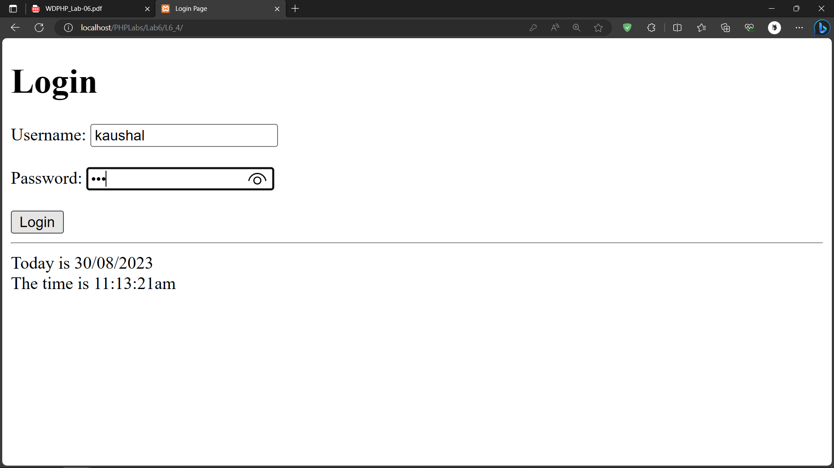 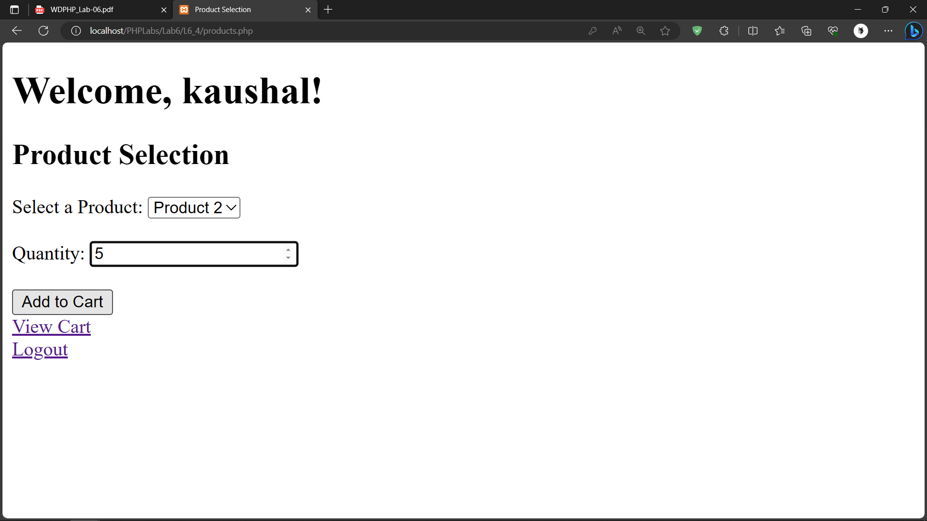

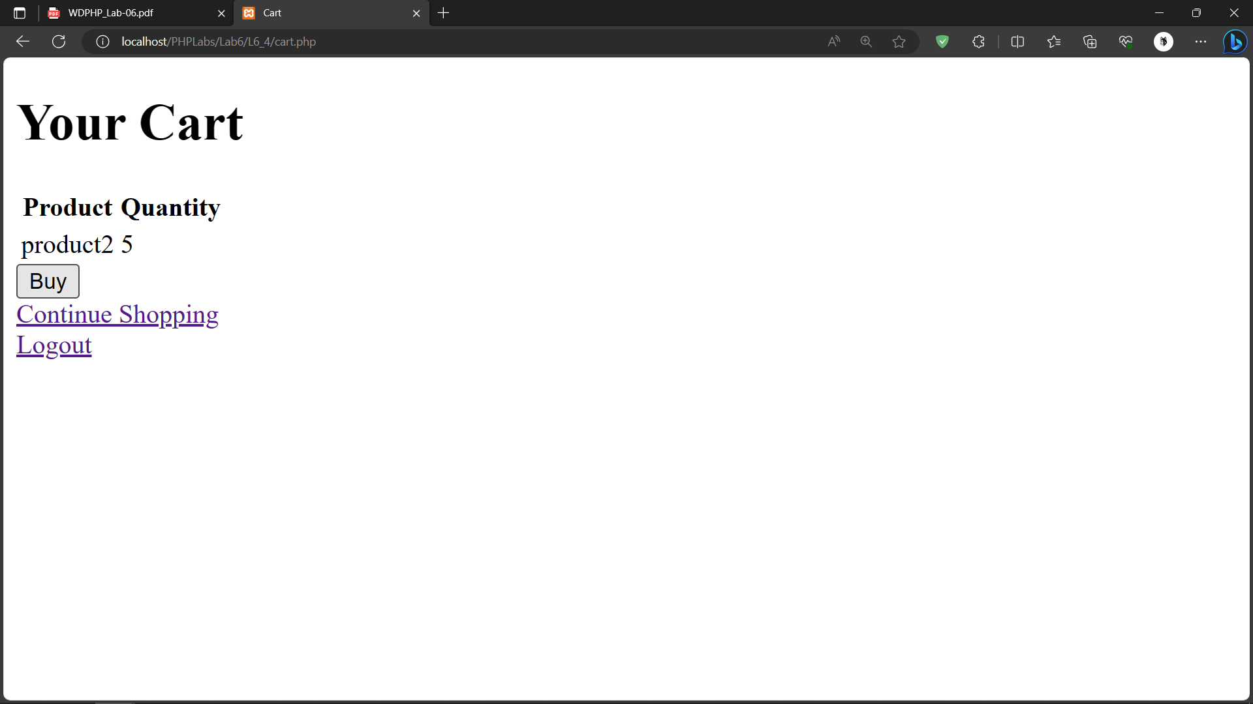

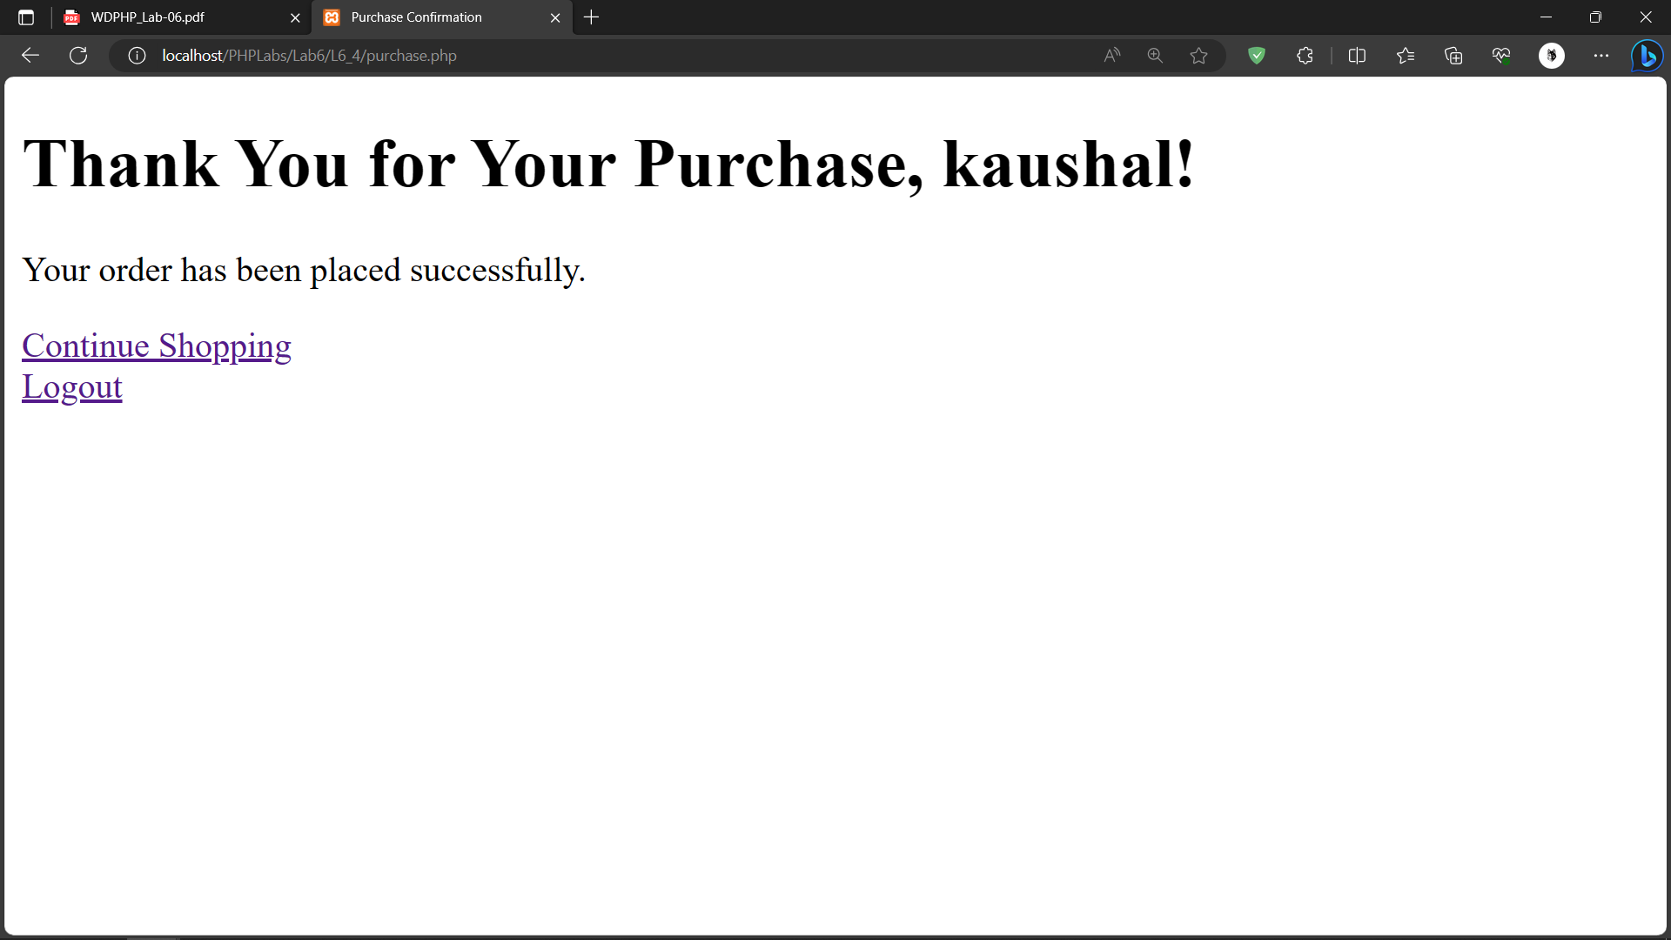

**5. Develop a PHP form to get students marks of 5 subjects and generate results. Take the following inputs: Exam No, Course (Drop Down), Student photo and Semester. The photo should not be greater than 25 kb in size and must be in JPEG format. Check necessary validation and provide the option to upload the photograph on click on upload button. Display the rest of the detail on the browser on click on submit buttonpage.**

**Code:**

**index.php**

|  |
| --- |
| <!DOCTYPE html>  <html>  <head>  <title>Student Result Form</title>  </head>  <body>  <h1>Student Result Form</h1>  <form method="post" action="process.php" enctype="multipart/form-data">  <label for="exam_no">Exam No:</label>  <input type="text" name="exam_no" required><br><br>  <label for="course">Course:</label>  <select name="course" required>  <option value="Math">Math</option>  <option value="Science">Science</option>  <option value="History">History</option>  </select><br><br>  <label for="student_photo">Student Photo (JPEG, max 25KB):</label>  <input type="file" name="student_photo" required><br><br>  <label for="semester">Semester:</label>  <input type="text" name="semester" required><br><br>  <h2>Enter Marks for 5 Subjects:</h2>  <?php  for ($i = 1; $i <= 5; $i++) {  echo "<label for='subject{$i}'>Subject {$i}:</label>";  echo "<input type='number' name='subject{$i}' min='0' max='100' required><br><br>";  }  ?>  <input type="submit" name="submit" value="Submit">  </form>  </body>  </html> |

**Process.php**

|  |
| --- |
| <!DOCTYPE html>  <html>  <head>  <title>Student Result</title>  </head>  <body>  <h1>Student Result</h1>  <?php  if ($_SERVER["REQUEST_METHOD"] == "POST") {  $exam_no = $_POST["exam_no"];  $course = $_POST["course"];  $semester = $_POST["semester"];    $uploadDir = "uploads/";  $photoName = $_FILES["student_photo"]["name"];  $photoTmpName = $_FILES["student_photo"]["tmp_name"];  $photoSize = $_FILES["student_photo"]["size"];    $photoPath = $uploadDir . $photoName;    $allowedExtensions = array("jpg", "jpeg");  $fileExtension = strtolower(pathinfo($photoName, PATHINFO_EXTENSION));    if (in_array($fileExtension, $allowedExtensions) && $photoSize <= 200000) {  move_uploaded_file($photoTmpName, $photoPath);  } else {  echo "Invalid photo format or size. Please upload a valid JPEG image (max 2 MB).";  exit();  }    $totalMarks = 0;  for ($i = 1; $i <= 5; $i++) {  $subject = "subject{$i}";  $marks = $_POST[$subject];  $totalMarks += $marks;  echo "<p>Subject {$i}: {$marks}</p>";  }    echo "<p>Exam No: {$exam_no}</p>";  echo "<p>Course: {$course}</p>";  echo "<p>Semester: {$semester}</p>";  echo "<p>Total Marks: {$totalMarks}</p>";  echo "<img src='{$photoPath}' alt='Student Photo' width='150'><br>";    echo "<hr>Today is " . date("d/m/Y") . "<br>";  echo "The time is " . date("h:i:sa");    } else {  echo "Form not submitted.";  }  ?>  </body>  </html> |

**Output:**

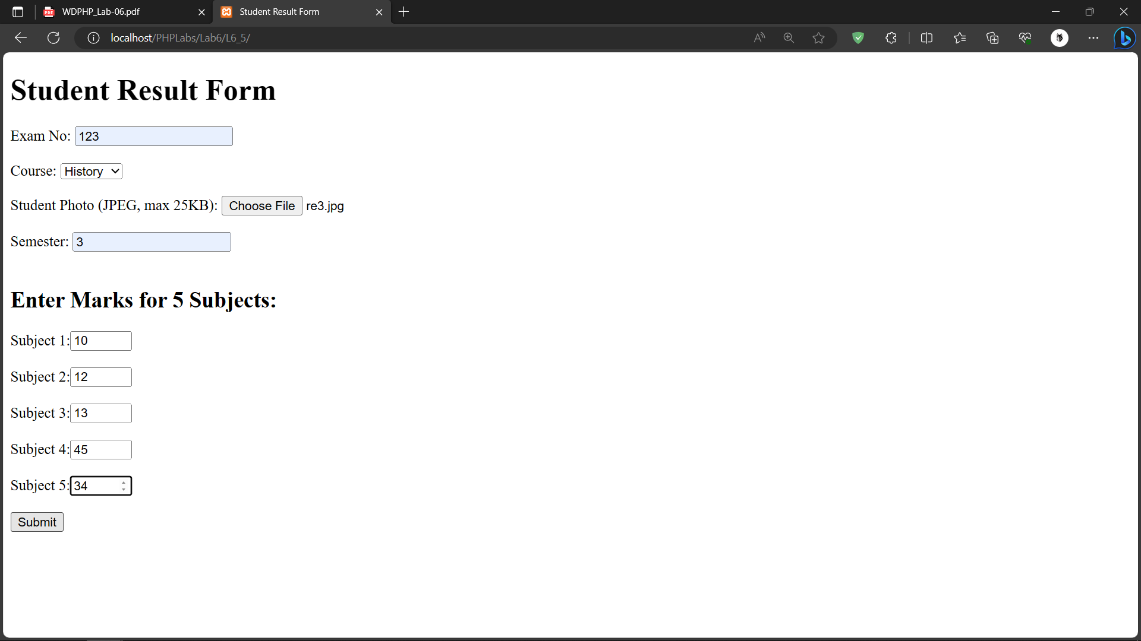

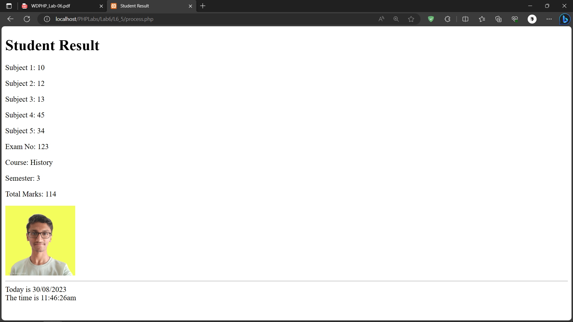

**6. Create a php script to demonstrate different types of errors.(Notice, warning, error) Code:**

**6_6.php**

|  |
| --- |
| <!DOCTYPE html>  <html>  <head>  <title>Error Demo</title>  </head>  <body>  <h1>Error Demo</h1>  <?php  echo "<hr>Today is " . date("d/m/Y") . "<br>";  echo "The time is " . date("h:i:sa")."<br>";  // Notice Erro  echo $undefinedVariable;  // Warning Error  $file = 'non_existent_file.txt';  $fileHandle = fopen($file, 'r');  // Fatal Error  function divide($a, $b) {  if ($b == 0) {  trigger_error("Division by zero is not allowed.", E_USER_ERROR);  }  return $a / $b;  }  $result = divide(10, 0);  echo "Result: $result";  echo "<hr>Today is " . date("d/m/Y") . "<br>";  echo "The time is " . date("h:i:sa");  ?>  </body>  </html> |

**Output:** 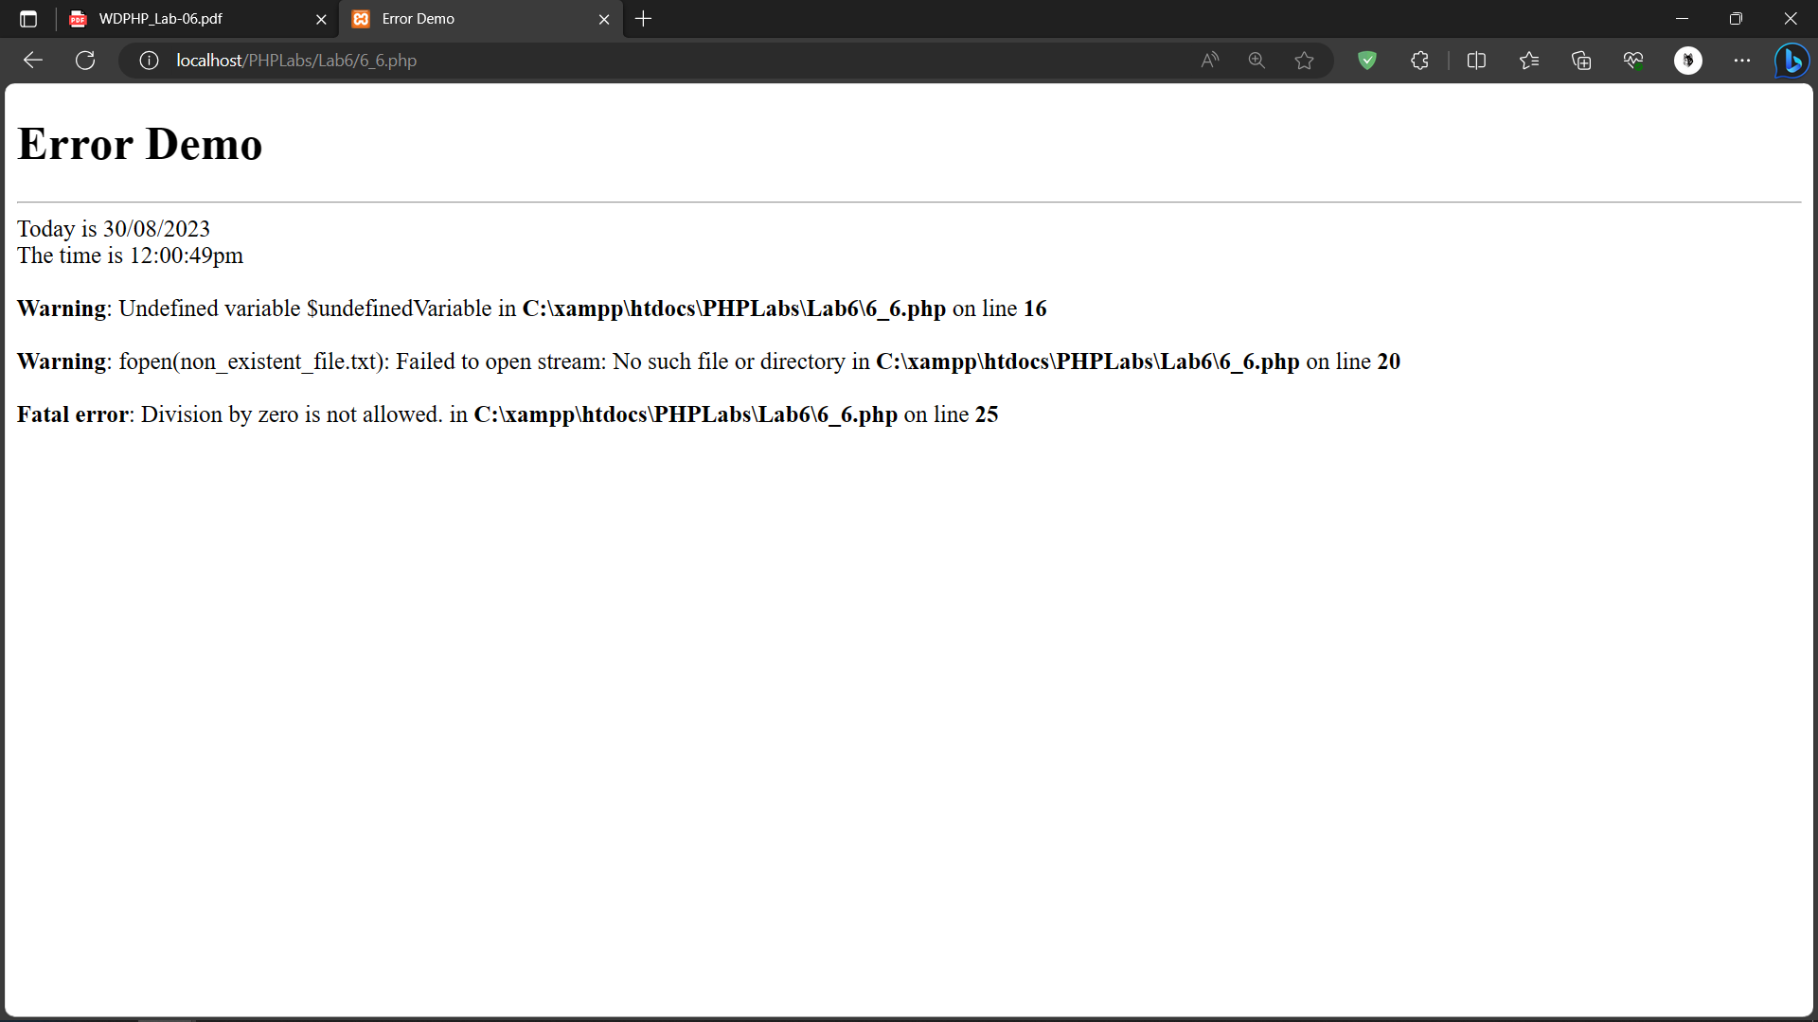

**7. Create PHP script for a custom error handling function in which two parameters are passed. If the first parameter is less than the second parameter then it should display a warning. If any of the parameters is not a number then it should generate fatal error.**

**Code:**

**6_7.php**

|  |
| --- |
| <?php  function customErrorHandler($num1, $num2) {    echo "<hr>Today is " . date("d/m/Y") . "<br>";  echo "The time is " . date("h:i:sa");  if (!is_numeric($num1) || !is_numeric($num2)) {  trigger_error("Both parameters must be numbers.", E_USER_ERROR);  }    if ($num1 < $num2) {  trigger_error("Warning: The first parameter is less than the second parameter.", E_USER_WARNING);  }  }  set_error_handler("customErrorHandler");  $num1 = "not a number";  $num2 = 10;  customErrorHandler($num1, $num2);  ?> |

**Output:**

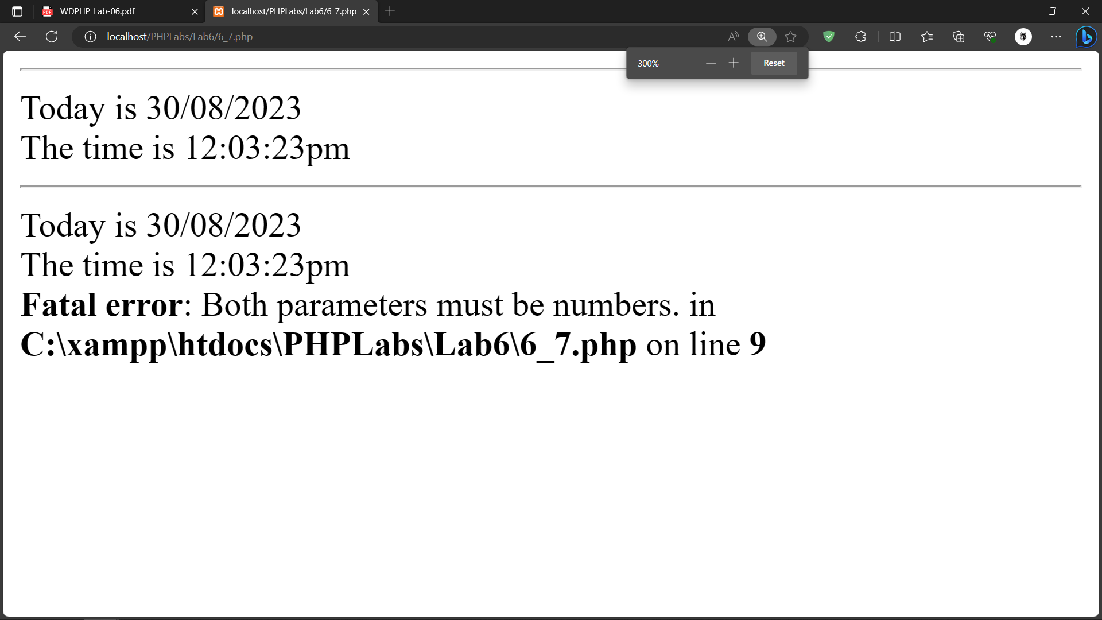

**8. Create a php script which triggers an error/warning if the number entered by the user is negative with an appropriate message.**

**Code:**

**6_8.php**

|  |
| --- |
| <!DOCTYPE html>  <html>  <head>  <title>Negative Number Check</title>  </head>  <body>  <h1>Negative Number Check</h1>  <?php  if ($_SERVER["REQUEST_METHOD"] == "POST") {  $number = $_POST["number"];  if ($number < 0) {    trigger_error("Warning: The number you entered is negative.", E_USER_WARNING);  } else {  echo "You entered a positive number: $number";  }  }  ?>  <form method="post" action="<?php echo $_SERVER["PHP_SELF"]; ?>">  <label for="number">Enter a Number:</label>  <input type="number" name="number" required><br><br>  <input type="submit" value="Check">  </form>  echo "<hr>Today is " . date("d/m/Y") . "<br>";  echo "The time is " . date("h:i:sa")."<br>";  </body>  </html> |

**Output:**

