**Practical-5**

**PHP From Handing and Cookie Management**

1. **Use HTML form created in practical -1 . Enter respective data into each and using the post method pass the data and display the data to the data.php page on click on submit button.**

**Code: Home.php**

<!DOCTYPE html>

<html>

<head>

<title>Registration Form</title>

</head>

<body>

<form method="post" action="./data.php">

<h1>Registration Form</h1>

<input type="text" name="name" placeholder="Enter username" /><br /><br />

<input type="password" name="pass" placeholder="Enter password" /><br /><br />

<input type="text" name="branch" placeholder="Enter branch" /><br /><br />

<input type="text" name="contact" placeholder="Enter contact no" /><br /><br />

<input type="submit" name="sbt" value="Register" />

</form>

</body>

</html>

**data.php**

<?php extract($_POST); if (isset($sbt)) {

echo "<h4>";

echo "Name is $name " . "<br>";

echo "Password is : " . $pass . "<br>"; echo "Contact is : " . $contact . "<br>"; echo "Branch is : " . $branch . "<br>"; echo "</h4>";

echo "<hr>Today is " . date("d/m/Y") . "<br>"; echo "The time is " . date("h:i:sa");

}

?>

**Output:**

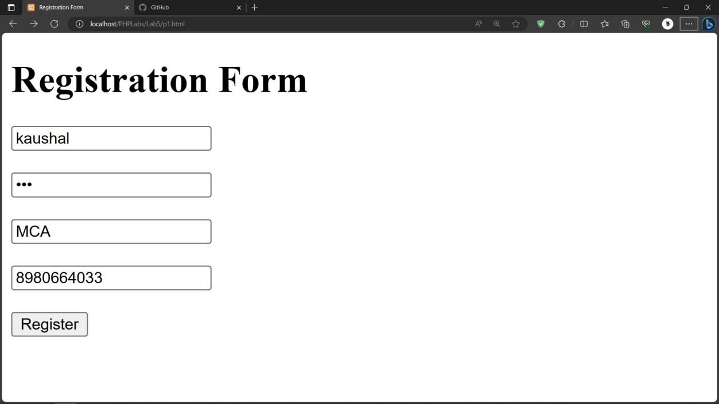

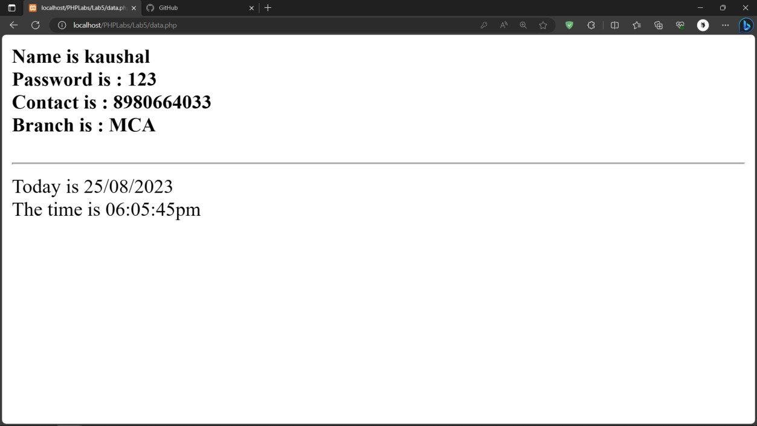

1. **Create a HTML form that reads 2 numbers and has 4 buttons for operation:- Add, Difference, Product. Based on the button clicked by the user the result should be displayed as output.**

**Code:**

<!DOCTYPE html>

<html lang="en">

<body>

<form method="POST" name ="frm">

<?php

extract($_REQUEST); if(isset($sbt))

{

switch($sbt)

{

case "+":

echo("Result is : " . ($no1 + $no2)); break;

case "-":

echo("Result is : " . ($no1 - $no2)); break;

case "*":

echo("Result is : " . ($no1 * $no2)); break;

case "/":

echo("Result is : " . ($no1 / $no2));

break;

}

echo "<br><br>";

}

?>

<input type="number" placeholder="Enter 1st no" name="no1" min="0" required> <br><br>

<input type="number" placeholder="Enter 2nd no" name="no2" min="0" required> <br><br>

<input type="Submit" name="sbt" value="+">

<input type="Submit" name="sbt" value="-">

<input type="Submit" name="sbt" value="*">

<input type="Submit" name="sbt" value="/">

<?php

echo "<hr>Today is " . date("d/m/Y") . "<br>"; echo "The time is " . date("h:i:sa");

?>

</form>

</body>

</html>

**Output:**

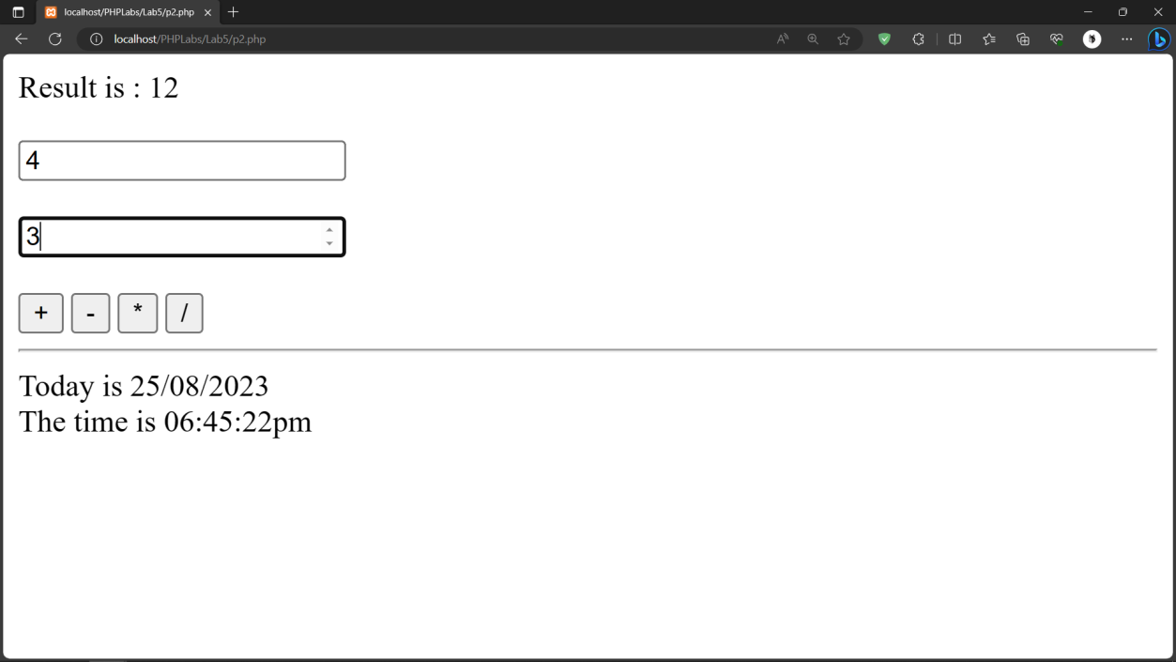

1. **Create an HTML form which takes 10 numbers (comma separated) and redirect control to findsum.php create a php script which stores the numbers into an array and displays the total of the array.**

**Code: P3.**

<!DOCTYPE html>

<html lang="en">

<body>

<form method="POST" name="frm" action="./view.php">

<h3>Sum No

<input type="text" placeholder="Enter 10 no" name="no" required />

<input type="Submit" name="sbt" value="Submit" />

</h3>

</form>

</body>

</html>

**View.php**

<?php extract($_REQUEST); if (isset($sbt)) {

$arr = explode(",", $no); echo "No is : <br>";

$result = array_sum($arr); foreach ($arr as $ele) {

echo $ele . "<br>";

}

echo "<br>Sum is : $result<br>";

echo "<hr>Today is " . date("d/m/Y") . "<br>"; echo "The time is " . date("h:i:sa");

}

?>

**Output:**

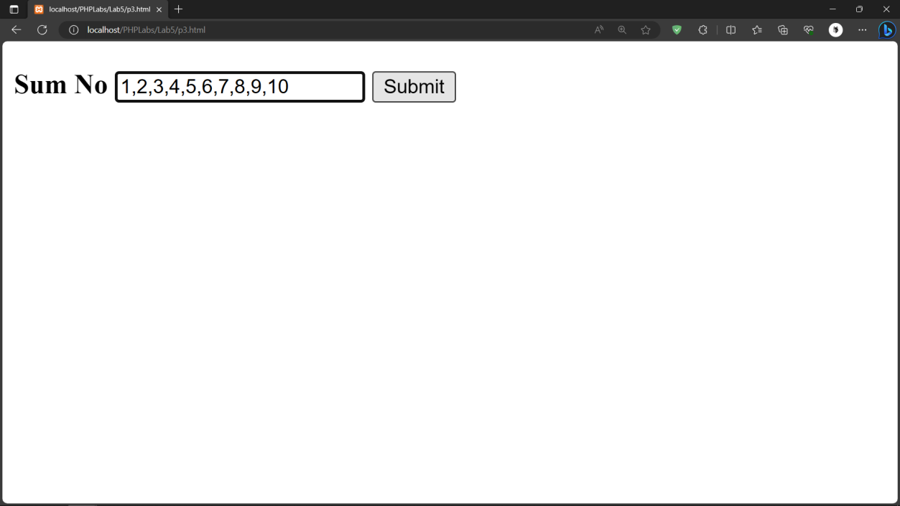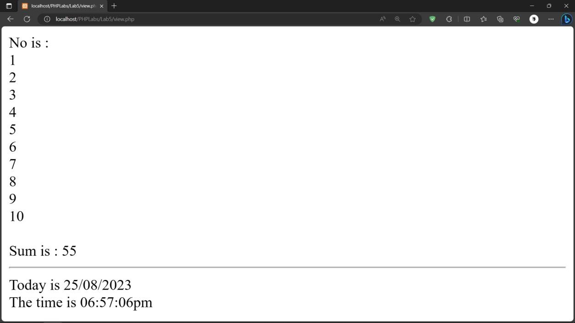

1. **Create a page signin.php , which takes the username, age ,city from user on click of submit button set the cookies values for each and display values on next page view.php**

**Code Signin.php**

<!DOCTYPE html>

<html lang="en">

<body>

<form method="POST" name="frm" action="./view2.php">

<input type="text" placeholder="Enter user name" name="uname" required /><br><br>

<input type="number" placeholder="Enter age" name="age" max="100" min="0" required /><br><br>

<input type="text" placeholder="Enter city" name="city" required /><br><br>

<input type="Submit" name="sbt" value="Submit" />

</form>

</body>

</html>

**View.2php**

<?php extract($_REQUEST); if (isset($sbt)) {

setcookie("uname", $uname); setcookie("age", $age); setcookie("city", $city);

print "User name is :" . $_COOKIE["uname"] . "<br>";

print "Age is :" . $_COOKIE["age"] . "<br>";

print "City is :" . $_COOKIE["city"] . "<br>"; echo "<hr>Today is " . date("d/m/Y") . "<br>"; echo "The time is " . date("h:i:sa");

}

?>

**Output:**

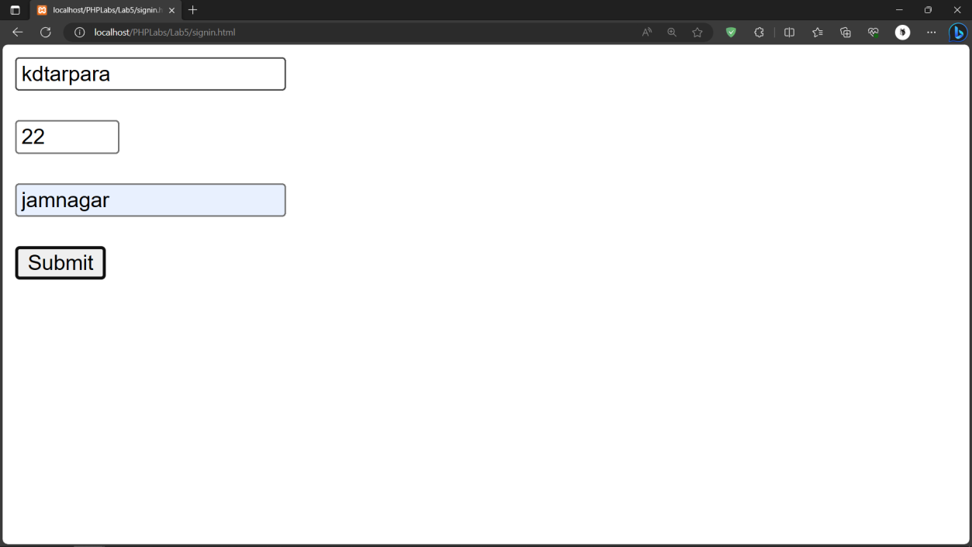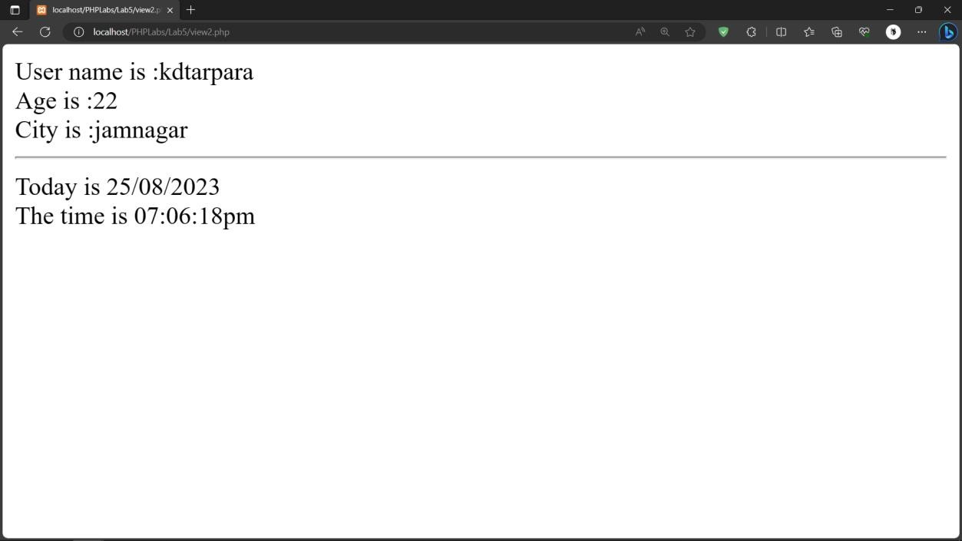

1. **Create a php page which takes the student’s name and marks of three subjects from the user. It stores all information as cookies and displays all information on the next page.**

# Code:

**p5.php**

<!DOCTYPE html>

<html lang="en">

<head >

<style>

input{

width: 150px;

}

</style>

</head>

<body>

<form method="POST" name ="frm" action="./data2.php">

<input type="text" placeholder="Enter name" name="fname" required><br><br>

<input type="number" placeholder="Enter 1st subject mark" name="m1" max="100" min="0" required><br><br>

<input type="number" placeholder="Enter 2nd subject mark" name="m2" max="100" min="0" required><br><br>

<input type="number" placeholder="Enter 3rd subject mark" name="m3"max="100" min="0" required><br><br>

<input type="Submit" name="sbt" value="Submit">

|  |  |  |
| --- | --- | --- |
| } | setcookie("m1", setcookie("m2", setcookie("m3", | $m1);  $m2);  $m3); |
| ?> |  |  |

**data.2php**

</form>

</body>

</html>

<?php extract($_REQUEST);

if(isset($sbt))

{

setcookie("fname", $fname);

<?php

if (isset($_COOKIE)) {

echo ("Name is : " . $_COOKIE['fname'] . "<br>");

echo ("1st sub mark is : " . $_COOKIE['m1'] . "<br>");

echo ("2nd sub mark is : " . $_COOKIE['m2'] . "<br>");

echo ("3rd sub mark is : " . $_COOKIE['m3'] . "<br>"); echo "<hr>Today is " . date("d/m/Y") . "<br>";

echo "The time is " . date("h:i:sa");

}

?>

# Output:

