TRIBHUVAN UNIVERSITY
BHAKTAPUR MULTIPLE CAMPUS
Dudhpati- 17, Bhaktapur


Lab Sheet of
Computer Networking

Submitted to: Submitted by:
Mr. Madan Nath Ankur Raya
Roll No: 05

Table of Contents

Experiment  No: | Title
1 | To explore various types of network cables and demonstrate the construction of both cross-wired and straight-through cables using a clamping tool.
2 | Study of following Network Devices in Detail.  - Repeater  - Hub  - Switch  - Bridge  - Router  - Gate Way
3 | Study of network IP  - Classification of IP address  - Sub netting  - Super netting
4 | Connect the computers in Local Area Network.
5 | Study of basic network command and Network configuration commands.
6 | Configure a Network topology using packet tracer software.
7 | Configure a Network topology using packet tracer software.
8 | Configure a Network using Distance Vector Routing protocol.  - RIP
9 | Configure Network using Link State Vector Routing protocol.  - OSPF

EXPERIMENT-1

Objective: To explore various types of network cables and demonstrate the construction of both cross-wired and straight-through cables using a clamping tool.
Apparatus (Components): RJ-45 connector, Clamping Tool, Twisted pair cable
Procedure: To do these practical following steps should be done:

- Begin by removing approximately 2 inches of the plastic covering from the end of the cable. Take extra caution during this step to avoid damaging the wires inside. Any nicks or cuts could affect the cable's performance or potentially make it unusable. Double-check the wires for any damage. If you find any, simply trim off the entire end and start fresh.
- Gently separate the wires while ensuring you maintain a firm grip on the base of the jacket with your other hand. It's crucial to prevent the wires from untwisting too far inside the jacket. According to specifications, Category 5 cable should have only half an inch of untwisted wire at the end; exceeding this length would result in the cable being out of specification. Currently, you likely have significantly more than half an inch of untwisted wire.
- You'll need to install two end jacks onto your cable. If you're using a pre-made cable with one end already removed, you'll only need to install the jack on the remaining end, which is the crossed-over end. Below, you'll find two diagrams illustrating how to arrange the cables for each type of cable end. Take a moment to determine which end you're creating and refer to the corresponding picture below for guidance.

Diagram shows you how to prepare Cross wired connection:
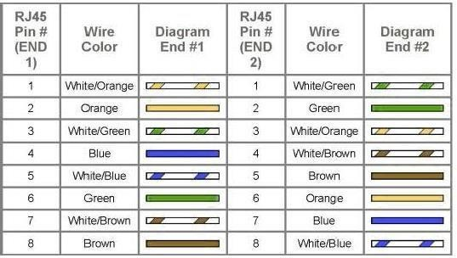

Diagram shows you how to prepare straight through wired connection:


EXPERIMENT-2

Objective: Study of following Network Devices in Detail.
  - Repeater
  - Hub
  - Switch
  - Bridge
  - Router
  - Gate Way
Apparatus (Software): No software or hardware needed.
Procedure: Following should be done for this practical:
- Repeater: Functioning at Physical Layer. A repeater is an electronic device that receives a signal and retransmits it at a higher level and/or higher power, or onto the other side of an obstruction, so that the signal can cover longer distances. Repeater has two ports, so cannot be used to connect for more than two devices.

- Hub: An Ethernet hub, active hub, network hub, repeater hub, hub or concentrator is a device for connecting multiple twisted pair or fiber optic Ethernet devices together and making them act as a single network segment. Hubs work at the physical layer (layer 1) of the OSI model. The device is a form of multiport repeater. Repeater hubs also participate in collision detection, forwarding a jam signal to all ports if it detects a collision.

- Switch: A network switch or switching hub is a computer networking device that connects network segments. The term commonly refers to a network bridge that processes and routes data at the data link layer (layer 2) of the OSI model. Switches that additionally process data at the network layer (layer 3 and above) are often referred to as Layer 3 switches or multilayer switches.

- Bridge: A network bridge connects multiple network segments at the data link layer (Layer 2) of the OSI model. In Ethernet networks, the term bridge formally means a device that behaves according to the IEEE 802.1 D standards. A bridge and switch are very much alike; a switch being a bridge with numerous ports. Switch or Layer 2 switch is often used interchangeably with bridge. Bridges can analyze incoming data packets to determine if the bridge is able to send the given packet to another segment of the network.

- Router: A router is an electronic device that interconnects two or more computer networks, and selectively interchanges packets of data between them. Each data packet contains address information that a router can use to determine if the source and destination are on the same network, or if the data packet must be transferred from one network to another. Where multiple routers are used in a large collection of interconnected networks, the routers exchange information about target system addresses, so that each router can build up a table showing the preferred paths between any two systems on the interconnected networks.

- Gate Way: In a communications network, a network node equipped for interfacing with another network that uses different protocols.
  - A gateway may contain devices such as protocol translators, impedance matching devices, rate converters, fault isolators, or signal translators as necessary to provide system interoperability. It also requires the establishment of mutually acceptable administrative procedures between both networks.
  - A protocol translation/mapping gateway interconnects networks with different network protocol technologies by performing the required protocol conversions.

EXPERIMENT-3

Objective: Study of network IP
- Classification of IP address
- Sub netting
- Super netting

Apparatus (Software): NA
Procedure: Following is required to be study under this practical.
  - Classification of IP address
As show in figure we teach how the Ip addresses are classified and when they are used.

Class | Address Range | Supports
Class A | 1.0.0.1 to 126.255.255.254 | Supports 16 million hosts on each of 127 networks.
Class B | 128.1.0.1 to  191.255.255.254 | Supports 65,000 hosts on each of 16,000 networks
Class C | 192.0.1.1 to  223.255.254.254 | Supports 254 hosts on each of 2 million networks.
Class D | 224.0.0.0 to  239.255.255.255 | Reserved for multicast groups.
Class E | 240.0.0.0 to  254.255.255.254 | Reserved.

  - Sub netting:
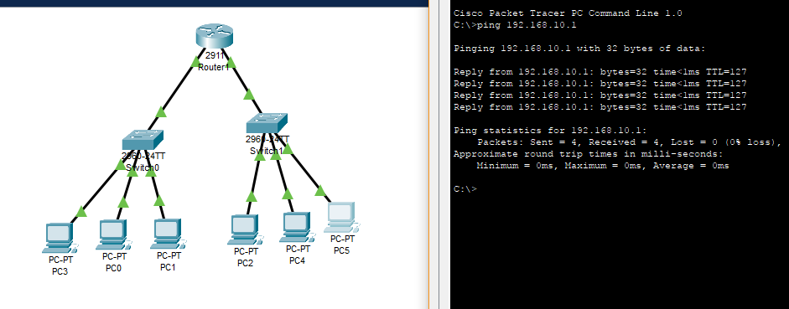
Why we Develop sub netting and how to calculate subnet mask and how to identify subnet addres.

  - Super netting:
Why we develop super netting and how to calculate super net mask and how to identify super net address.

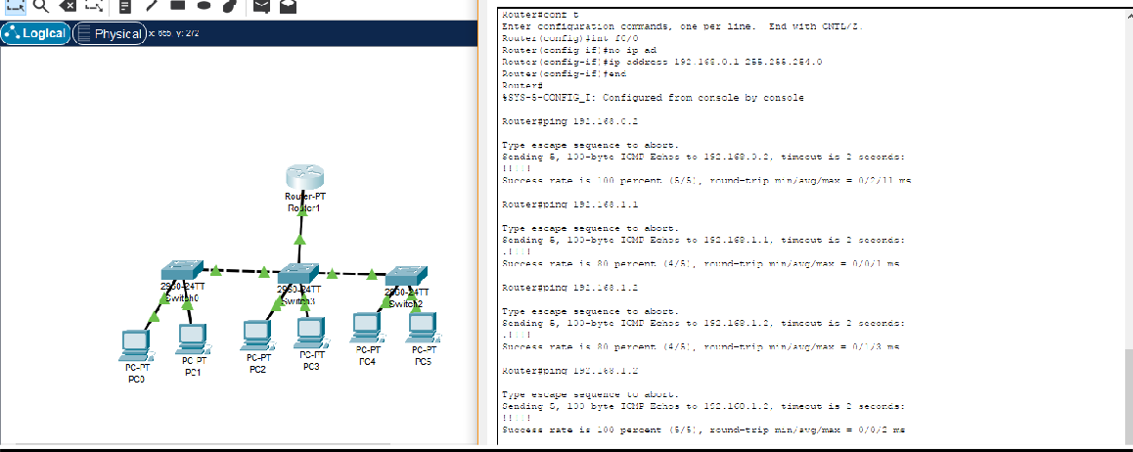

EXPERIMENT-4

Objective: Connect the computers in Local Area Network.

Procedure:
On the host computer
On the host computer, follow these steps to share the Internet connection:
- Log on to the host computer as Administrator or as Owner.
- Click Start, and then click Control Panel.
- Click Network and Internet Connections.
- Click Network Connections.
- Right-click the connection that you use to connect to the Internet. For example, if you connect to the Internet by using a modem, right-click the connection that you want under Dial-up / another network available.
- Click Properties.
- Click the Advanced tab.
- Under Internet Connection Sharing, select the Allow other network users to connect through this computer's Internet connection check box.
- If you are sharing a dial-up Internet connection, select the Establish a dial-up connection whenever a computer on my network attempts to access the Internet check box if you want to permit your computer to automatically connect to the Internet.
- Click OK. You receive the following message:
When Internet Connection Sharing is enabled, your LAN adapter will be set to use IP address 192.168.0.1. Your computer may lose connectivity with other computers on your network. If these other computers have static IP addresses, it is a good idea to set them to obtain their IP addresses automatically. Are you sure you want to enable Internet Connection Sharing?
- Click Yes.
The connection to the Internet is shared to other computers on the local area network (LAN).
The network adapter that is connected to the LAN is configured with a static IP address of 192.168.0.1 and a subnet mask of 255.255.255.0

On the client computer
To connect to the Internet by using the shared connection, you must confirm the LAN adapter IP configuration, and then configure the client computer. To confirm the LAN adapter IP configuration, follow these steps:
- Log on to the client computer as Administrator or as Owner.
- Click Start, and then click Control Panel.
- Click Network and Internet Connections.
- Click Network Connections.
- Right-click Local Area Connection and then click Properties.
- Click the General tab, click Internet Protocol (TCP/IP) in the connection uses the following items list, and then click Properties.
- In the Internet Protocol (TCP/IP) Properties dialog box, click Obtain an IP address automatically (if itis not already selected), and then click OK.
Note: You can also assign a unique static IP address in the range of 192.168.0.2 to 192.168.0.254. For example, you can assign the following static IP address, subnet mask, and default gateway:
- IP Address 192.168.31.202
- Subnet mask 255.255.255.0
- Default gateway 192.168.31.1
- In the Local Area Connection Properties dialog box, click OK.
- Quit Control Panel.

EXPERIMENT-5

Objective: Study of basic network command and Network configuration commands.
Apparatus (Software): Command Prompt and Packet Tracer.

Procedure:
To do this EXPERIMENT- follows these steps:
In this EXPERIMENT- students have to understand basic networking commands e.g., ping, tracert etc.
All commands related to Network configuration which includes how to switch to privilege mode and normal mode and how to configure router interface and how to save this configuration to flash memory or permanent memory.

This command includes
- Configuring the Router commands
- General Commands to configure network
- Privileged Mode commands of a router
- Router Processes & Statistics
- IP Commands
- Other IP Commands e.g., show Ip route etc.

ping:
ping (8) sends an ICMP ECHO_REQUEST packet to the specified host. If the host responds, you get an ICMP packet back. Sound strange? Well, you can “ping” an IP address to see if a machine is alive. If there is no response, you know something is wrong.
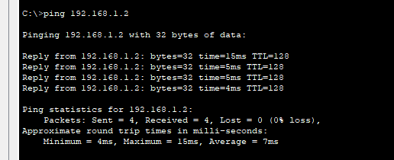

traceroute:
traceroute is a command which can show you the path a packet of information taken from your computer to one you specify. It will list all the routers it passes through until it reaches its destination, or fails to and is discarded. In addition to this, it will tell you how long each 'hop' from router to router takes.
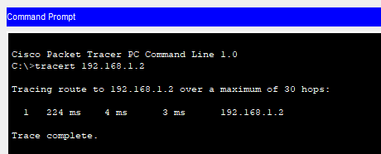

EXPERIMENT-6

Objective: Configure a Network topology using packet tracer software.
Apparatus (Software): Packet tracer Software
Procedure: To implement this practical following network topology is required to be configured using the commands learned in previous practical.
After configuring the given network, a packet should be ping from any one machine to another.

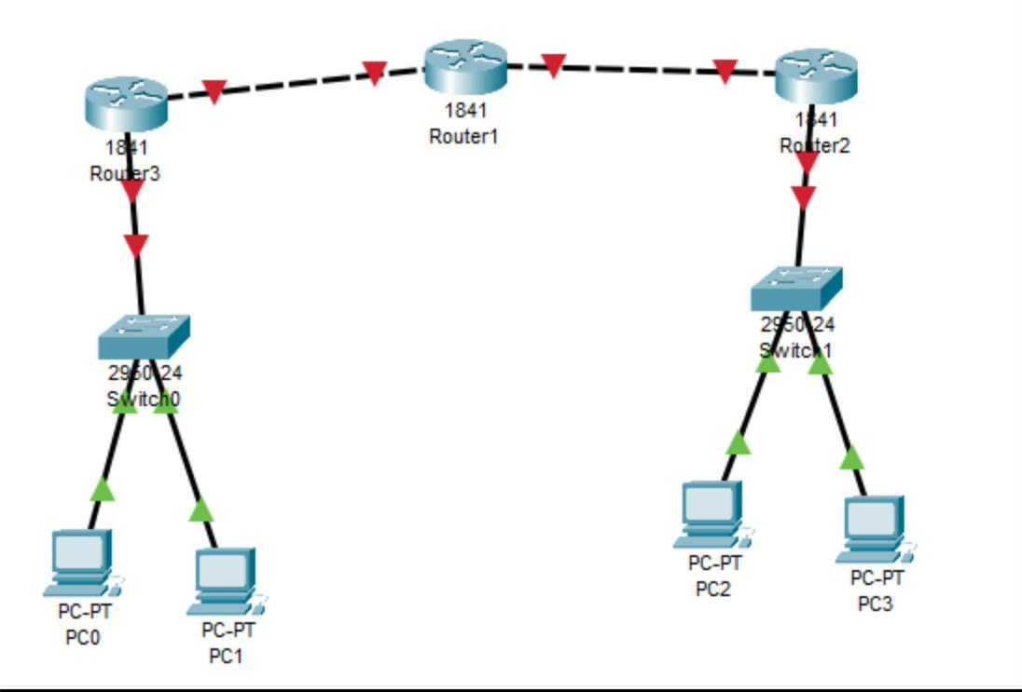

EXPERIMENT-7

Objective: Configure a Network topology using packet tracer software.
Apparatus (Software): Packet tracer Software
Procedure: To implement this practical following network topology is required to be configured using the commands learned in previous practical.
After configuring the given network, a packet should be ping from any one machine to another.

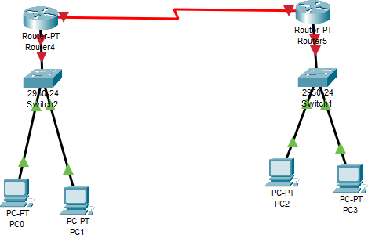

EXPERIMENT-8

Objective: Configure a Network using Distance Vector Routing protocol.
- RIP
Apparatus (Software): packet tracer software

Procedure:
- Develop a Topology shown in figure given below.
- Configure all Routers
- Implement RIP protocols in Router to configure Network.

RIP Configuration
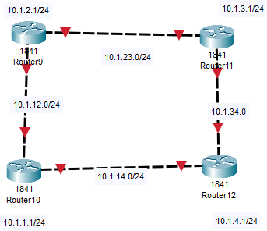

EXPERIMENT-9

Objective: Configure Network using Link State Vector Routing protocol.
  - OSPF
Apparatus (Software): Packet Tracer Software

Procedure:
- Develop a Topology shown in figure given below.
- Configure all the workstations
- Configure all switches
- Configure all Routers
- Implement OSPF protocols in Router to configure Network.

