**TEAM 4 Medical Assist**

**Requirements and Testcases.**

**LOGIN (S1)**

**Requirements for S1 (Login Screen)**

S1.001

Login Screen Should contains a Title called “Welcome”

S1.002

Login screen should have two fields for username and password

S1.003

Login screen should have two buttons at the bottom “Login” and “Reset”

S1.004

When entered username and password and click on Login and if the credentials are correct it should navigate to the next screen (Main screen)

S1.005

When click on reset the username and password fields should be blank.

ScreenShots:

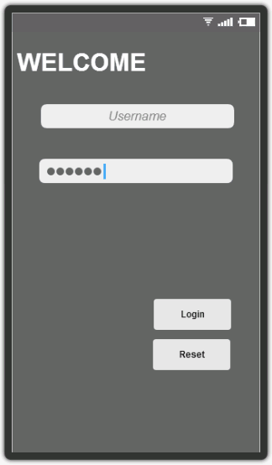

Fig_S1

**Test cases for Screen 1:**

|  |  |  |  |
| --- | --- | --- | --- |
| Test Case No. | Test Condition | Test case | Expected Result |
| TC_S1.001 | Default fields in Login screen | When we enter into app login screen should be there | Login screen should be loaded when app is loaded and there should be fields like Username, password, login and reset |
| TC_S1.002 | Login Check | Enter credentials and click on Login | User able to enter username and password and login correctly |
| TC_S1.003 | Reset button check | Click on reset | When click on reset button username and password fields should become blank |
| TC_S1.004 | Login failed | Enter wrong credentials and click on login | When User entered wrong credentials a toast should appear saying login failed. |

MainScreen(S2)

**Requirements for S2 (Main Screen)**

The layout of the “*Main*” is as described below:

The main screen should have the following buttons in the upper section of the screen.

S2.001

Screen should have appointments button. When clicked on appointments button it should redirect to the appointments screen.

S2.002

Screen should have manage button. When clicked on appointments button it should redirect to the manage screen.

S2.003

Screen should have View Records button. When clicked on appointments button it should redirect to the View Records screen.

S2.004

Screen should have Take Logs button. When clicked on appointments button it should redirect to the Take Logs screen.

S2.005

Screen should have Remainders button. When clicked on appointments button it should redirect to the Remainders screen.

S2.006

In the lower part of the main screen there should be list view which is updated dynamically.

Screenshots:

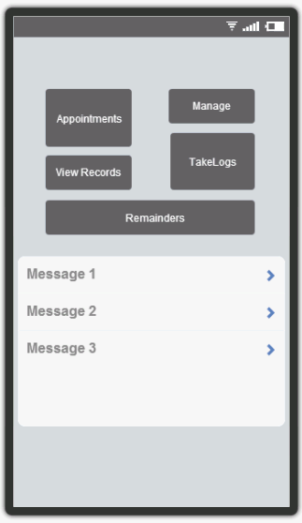

Fig_S2

**Test cases for main screen :**

|  |  |  |  |
| --- | --- | --- | --- |
| Test case No. | Test Condition | Test case | Expected result |
| TC_S2.001 | Verification of navigation of main screen to appointments screen | Click on Appointments screen | User able to redirect to appointments screen when clicked on appointments button |
| TC_S2.002 | Verification of navigation of main screen to manage screen | Click on manage screen | User able to redirect to manage screen when clicked on manage button |
| TC_S2.003 | Verification of navigation of main screen to View Records screen | Click on View Records screen | User able to redirect to appointments screen when clicked on View Records button |
| TC_S2.004 | Verification of navigation of main screen to TakeLogs screen | Click on TakeLogs screen | User able to redirect to TakeLogs screen when clicked on TakeLogs button |
| TC_S2.005 | Verification of navigation of main screen to Remainders screen | Click on Remainders screen | User able to redirect to Remainders screen when clicked on Remainders button |

**Appointments (S3)**

**Requirements for S3 (Appointments Screen)**

S3. 001

On button press on the main screen, the “*Appointments_Main*” should be displayed.

The layout of the “*Appointments_Main*” is as described below:

S3. 002

Should display the screen based on the current orientation: Landscape/Portrait in Appointments page.

S3. 003

The Appointments screen should have a button called “Schedule”. When clicked on it Schedule screen should be opened.

S3. 004

The Appointments screen should have a list of appointments recently made. When we click on the appointment a popup “Brief description of appointment” should appear.

S3. 005

On clicking the popup “Brief description of appointment” (Appointments Screen) it should navigate to “Detailed description of appointment” screen.

S3.002 to S3.005 is represented as Fig_S3.1.

The layout of the “Appointments_schedule” is as described below:

S3. 006

Should have a text field “New Doctor” and “+” button in Schedule screen. When clicked on “+”, Add Appointment screen should be opened. When clicked on “New Doctor” button, it should redirect to New Doctor screen.

S3. 007

The Schedule Screen should have two buttons “Recent” and “All” and a navigation facility between them.

S3. 008

When clicked on “Recent” a list view of Doctors with whom appointments are recently made should appear. (Schedule Screen)

S3. 009

When clicked on “All” a list view of all doctors added should appear.

S3.006 to S3.009 is represented as Fig_S3.2.

The layout of the “Appointments_Add Appointment” is as described below:

S3. 010

A screen with list view of “Doctor”, “Time”, “Date”, “Notes” should appear in Add Appointment screen.

S3. 011

Under Doctor field: A drop down of Doctors List should appear.

S3. 012

Under Time field: Time picker should appear.

S3. 013

Under Date Field: Date picker should appear.

S3. 014

Under Notes Field: A Text box should appear.

S3. 015

Finally A “Sent Request” button should appear in the bottom. When clicked on it a toast “Sent Request to doctor” should appear and redirected to main screen.

S3.010 to S3.015 is represented as Fig_S3.3.

The layout of the “Appointments_New Doctor” is as described below:

S3. 016

A screen with title as New Doctor should appear.

S3. 017

A text field “Doctor Details” should appear.

S3. 018

Under Doctor Details section there should be a list view of:

1. “Name”: Doctor Name
2. “Specialization” : Specialization of the Doctor
3. “Hospital Name” : Hospital in which he works.
4. “Notes” : Any extra notes about him.
5. Finally A “Add” button should appear in the bottom. When clicked on it a toast “Sent Request to doctor” should appear and redirected to main screen.

The representation is as Fig_S3.4.

The layout of the “Appointments_Detailed Description of Appointment” is as described below:

S3. 019

A screen with title as “Detailed Description of Appointment” with a notes in a text field under the title should appear.

**Screen Shots:**

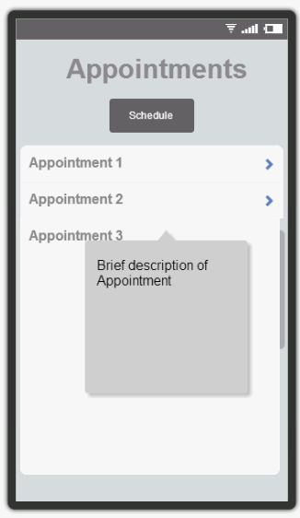

Fig_S3.1

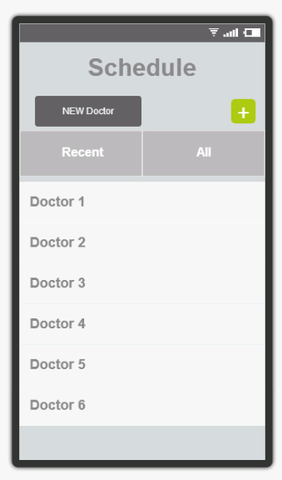

Fig_S3.2

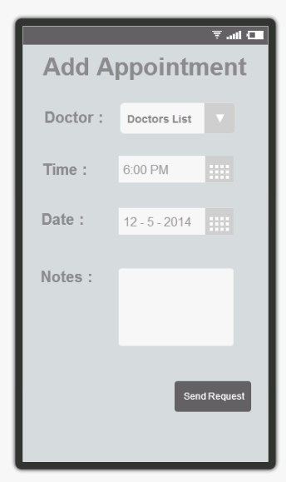

Fig_S3.3

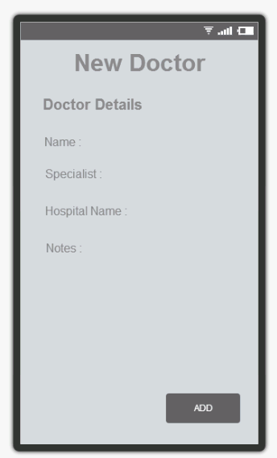

Fig_S3.4

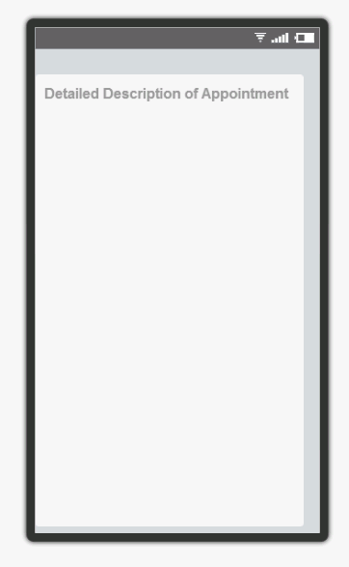

Fig_S3.5

**Test cases for Appointments**

|  |  |  |  |
| --- | --- | --- | --- |
| Test case No. | Test Condition | Test case | Expected Result |
| TC_S3.001 | Verification of navigation to Appointments screen | Click on “Appointments” button | Appointments screen should appear |
| TC_S3.002 | Verification of navigation to Schedule screen | Click on “Schedule” button | Schedules screen should appear |
| TC_S3.003 | Verification of popup in appointments screen | Click on one of the appointment listed | A popup “Brief description of Appointment” should appear with some notes regarding the appointment. |
| TC_S3.004 | Verification of navigation to Detailed Description screen | Click on one of the appointment listed and click on the popup which is result of click on an appointment | When we click on the popup then it should redirect to the Detailed description of appointment screen appears. |
| TC_S3.005 | Verification of navigation from detailed description screen to appointments screen | Click on back of the mobile (either swipe to back or back option) | Screen should navigate to appointments screen |
| TC_S3.006 | Navigation between tabs “Recent” and “All” in schedule screen | Click on recent and then on all | When we click on recent the list view should refresh and get the doctors list of recently contacted and when we click on all the total doctors list should be displayed |
| TC_S3.007 | Navigation to New Doctor screen | Click on “New Doctor” button in schedule screen | When we click on “New Doctor” button screen the page should redirect to New Doctor page |
| TCS_S3.008 | Default fields in New Doctor page | Click on “New Doctor” in schedule screen | When New doctor page is loaded there should be fields under Doctor Details like:  Name, Specialist, Hospital name, Notes |
| TCS_S3.009 | Navigation to main page and appeareance of a toast | Click on add button | When we click on add button it should redirect to main page and a toast should appear saying Request sent to Doctor |
| TCS_S3.010 | Navigation to schedule page | Click on back button in mobile | When we click on back button in mobile it should redirect to the Schedule screen. |
| TCS_S3.011 | Default tabs and lists in Add Appointment screen | When we click on Schedule button in appointment screen | When page is loaded there should be a drop down select under Doctor field, Time Picker under Time filed, Date picker under Date field and a text box under notes field and a Send Request button at the bottom |
| TCS_S3.012 | Correct display of the doctors list | click on the drop down button under Doctors field. | When we click on the drop down there should be a list of doctors and user able to select one of the doctor. |
| TCS_S3.013 | Navigation to appointment screen | Click on back button on mobile | It should redirect to the appointment button. |
| TCS_S3.014 | Navigation to Add Apppointment page | Click on “+” button in schedule screen | When we click on “+” button screen the page should redirect to New Doctor page |

MANAGE (S4)

I. Description:

Manage screen is used to manage all the setting of the app

**Requirements for Manage Screen(S4)**

S4. 001

On button press on the main screen, the “*Manage_Main*” should be displayed.

S4. 002

The layout of the “*Manage_Main*” is as described below:

1) Should display the screen based on the current orientation: Landscape/Portrait.

2) The screen should have the following four buttons, arranged in as list for portrait mode and as a grid for the Landscape mode.

(a) Doctors

(b) Devices

(c) Requests

(d) Account Settings

A representation of the screen in an Fig_1.

3) The button should respond to user touch and open their respective screen, as described below:

(a) Button “*Doctors*”: Should open the “Doctors Main” screen.

(b) Button “*Devices*”: Should open the “Devices Main” screen.

(c) Button “*Requests*”: Should open the “Requests Main” screen.

(d) Button “*Account Settings*”: Should open the “Account Settings Main” screen.

S4. 003

The layout of the “*Doctors Main*” screen should be as shown in Fig_2.

S4. 004

This user should be able to navigate between the two tabs by clicking on them.

S4. 005

Under the “Current” tab, this screen should show the list of all the doctors linked to this patient. The Fig_2 is a representation of the data.

S4. 006

Under the “Search” tab, the user should be able to search for doctors using a name search. On doing do the app should list all the registered doctors who match the search description.

S4. 007

The layout of the “Search” tab should be as shown in Fig_3

S4. 008

On clicking on any of the listed doctors, the app should display from the “Doctor Detail” Screen. The layout and implementation details for this screen are described in a different section in this requirements document.

S4. 009

The layout of the “Devices Main” screen should be as shown in Fig_4.

S4. 010

This screen has two tabs - “Connected” and “Add”, the user should be able to navigate between the tabs by pressing on the tab.

S4. 011

The “Connected” tab should show the list of the devices connected.

S4. 012

On clicking on a device, a popup containing a brief description of the of the device should appear.

S4. 013

On clicking on any other part of the screen the popup should disappear.

S4. 014

On clicking on the popup, the app should display the “Device Detail” screen.

S4. 015

The “Device Detail” screen should have the layout as described in Fig_5 and Fig_6.

S4. 016

On the “Device Detail” screen, if the device is not connected. The screen should show an option to connect to the device.

S4. 017

On the “Device Detail” screen, if the device is connected. The screen should show an option to disconnect from the device.

S4. 018

The “Device Detail” screen should show a radio button to allow for the device to be upload the data to a remote doctor in real time.

S4. 019

This screen should show any pending and all requests that were sent to this user. The layout of this screen is as shown in Fig_7.

S4. 020

The screen has two table - “Current” and “Past”. The screen should open under “Current” tab and the user should be able to switch to the “Past” tab by clicking on it.

S4. 021

The “Current” tab should show any 'active' requests to the user.

S4. 022

On clicking on a request, the app should show a popup containing buttons to accept and decline the request.

S4. 023

If the user clicks on the accept button, the app should accept the connection.

S4. 024

If the user clicks on the decline button, the app should decline the connection.

S4. 025

On accepting the connection, the app should take the user the “Doc Detail” page.

S4. 026

On the “Past” tab, the app should display all the past requests along with the users response. See Fig_8 for a representation of this tab.

II. Screenshots

Fig_1

Fig_2

Fig_3

Fig_4

Fig_5

Fig_6

Fig_7

Fig_8

**III. Test Cases – Manage**

|  |  |  |  |
| --- | --- | --- | --- |
| Test No | Test Condition | Test Case | Expected Result |
| TCS4.001.1 | Verification of the Access to the Manage Main screen | Click on the “Manage” button on the Main Screen. | The Manage Main screen should appear. |
| TCS4.002.1 | Verification of the Layout of Manage Main Screen | Check the layout of the manage main screen. | The layout should be similar to as described in Fig_1 of the Requirements. |
| TCS4.002.2 | Verification of the Layout of Manage Main Screen | Check if the layout is compatible with Portrait and Landscape layouts. | The layout should be displayed correctly in both orientations. |
| TCS4.002.3 | Verification of the Layout of Manage Main Screen | Check if all the four buttons are shown on the Screen. | All the four buttons shown in the Fig_1 of the requirements should be present. |
| TCS4.002.4 | Verify the link to “Doctors Main” screen | Click the “Doctors” button. | The app should display the Doctors Main screen. |
| TCS4.002.5 | Verify the link to “Devices Main” screen | Click the “Devices” button. | The app should display the Devices Main screen. |
| TCS4.002.6 | Verify the link to “Requests” screen | Click the “Requests” button. | The app should display the Requests screen. |
| TCS4.002.7 | Verify the link to “*Account Settings Main*” screen | Click the “*Account Settings*” button. | The app should display the *Account Settings* Main screen. |
| TCS4.003.1 | Layout of the Doctors Main screen. | Check the layout of the Doctors Main screen. | The layout of the Doctors Main Screen should be as shown in the Fig_2 of the requirements. |
| TCS4.003.3 | Default tab on the Doctors Main Screen. | See the default tab for the Doctors Main screen. | The “Current” tab should be the default tab. |
| TCS4.004.1 | Navigation between the tabs in the Doctors Main Screen. | Click on the Current and Search tabs to check if the navigation is possible. | User should be able to navigate between the two tabs by clicking on the tabs. |
| TCS4.005.1 | Current Screen - Information on the current tab. | Check if all the connected doctors are shown on the Current tab. | All connected doctors should be shown on the current tab. |
| TCS4.006.1 | Search Screen – Searching for new doctors. | Search of a doctor on the Search tab. | All registered docs should be shown on the Search tab. |
| TCS4.007.1 | Search Screen – Layout . | Check the layout of the search screen. | The layout of the search screen should be as shown in Fig_3 in the requirements. |
| TCS4.008.1 | Search Screen – Selecting a doctor. | Check if the doctors details can be seen on selecting the doctor. | On clicking on a search result, the corresponding Doctors details should be shown on a different screen. |
| TCS4.009.1 | Devices Screen – Layout | Check the layout of the Devices Main screen. | The layout should be as per Fig_4 in the requirements document. |
| TCS4.010.1 | Devices Screen – Tabs on the screen. | Check the tabs shown on the screen and the default tab. | The screen should have two tabs and should have Connected tab as the default. |
| TCS4.011.1 | Connected screen – Information on the screen. | Check the data displayed on the Connected screen. | This screen should should the list of all the devices connected to the app. |
| TCS4.012.1 | Connected screen – Information on the screen. | Click on a device shown on the Connected screen. | A pop up should appear showing the device name and condition. |
| TCS4.014.1 | Connected screen – Information on the screen. | Click on the pop up displayed on the screen. | The Device Detail screen shown. |
| TCS4.013.1 | Connected screen – Information on the screen. | Click on the Search screen, out side the pop up. | The pop up should close. |
| TCS4.015.1 | Device Detail screen – Screen layout. | Check the layout of the device detail screen. | For an unconnected device the Detail screen should be as described in Fig_5 of the requirements.  For a connected device the Detail screen should be as described in Fig_6 of the requirements. |
| TCS4.019.1 | Requests Screen – Layout | Check the layout of the Requests Screen. | The layout should be as described in Fig_ 7 of the requirements. |
| TCS4.020.1 | Requests Screen – Layout | Check the tabs on the screen and the default tab. | The layout should have two tabs and the Current tab should be default. |
| TCS4.020.2 | Requests Screen – Layout | Check the navigation between the tabs. | The user should be able to navigate between the tabs by clicking on them. |
| TCS4.021.1 | Current screen – Information on the screen. | Check the current tab for requests. | This screen should show all the active requests for this user. |
| TCS4.022.1 | Current screen – Actions on the screen. | Approve or Decline the requests by clicking on the request. | A pop up should appear, with buttons for the user to approve or decline the connection. |
| TCS4.023.1 | Current screen – Actions on the screen. | User approves a request. | The app will open the Doctor Detail screen.  The Doctor should appear on the connected list in the “Doctors” screen. |
| TCS4.024.1 | Current screen – Actions on the screen. | User declines a request. | The Doctor should not appear on the connected list in the “Doctors” screen. |
| TCS4.026.1 | Past screen – Information on the screen. | User clicks on the Past tab. | The app will open the past screen and will get the list of all the request sent to this user along with the accept/decline status. |

**Reminders (S5)**

**I. Description:**

Remainders screen is used to view various reminders like scheduled appointments of the doctor or the patient in a row form.

**Requirements for Reminders screen (S5)**

S5. 000

From the main menu if we click on Reminders button we will go to reminders screen.

S5.001

reminders screen must listview to view various reminders .

S5. 003

Each row must have a picture (if any was taken by the patient of the ailment),

S5. 004

Each row must have two sub rows

S5. 005

The first sub row must contain name of the doctor/patient, the type of doctor or the type of ailment, and the second sub row must contain the date and time of the appointment.

S5. 006

When a user clicks on any row, a pop up screen must open

S5. 007

Popup screen must show the summary of the appointment. (It will contain the description of the appointment)

S5. 008

pop up screen must contain two buttons “back” and “open”

S5. 009

Clicking on back button will take back to the listview.

S5. 010

Clicking on open button will open a screen “describing the reminder”.

S5. 011

“Describing the reminder” screen must contain the detailed description of the appointment. This will include all the pictures taken or any videos or notes taken etc

S5. 012

“Describing the reminder” screen must contain three buttons named “reschedule” to change the appointment, “back” to go to back screen , and “settings” to give user options like selecting kind of alarm he wants, like vibrate or a ringtone and any such more options.

**II. Screen Shots:**

**Reminders screen**

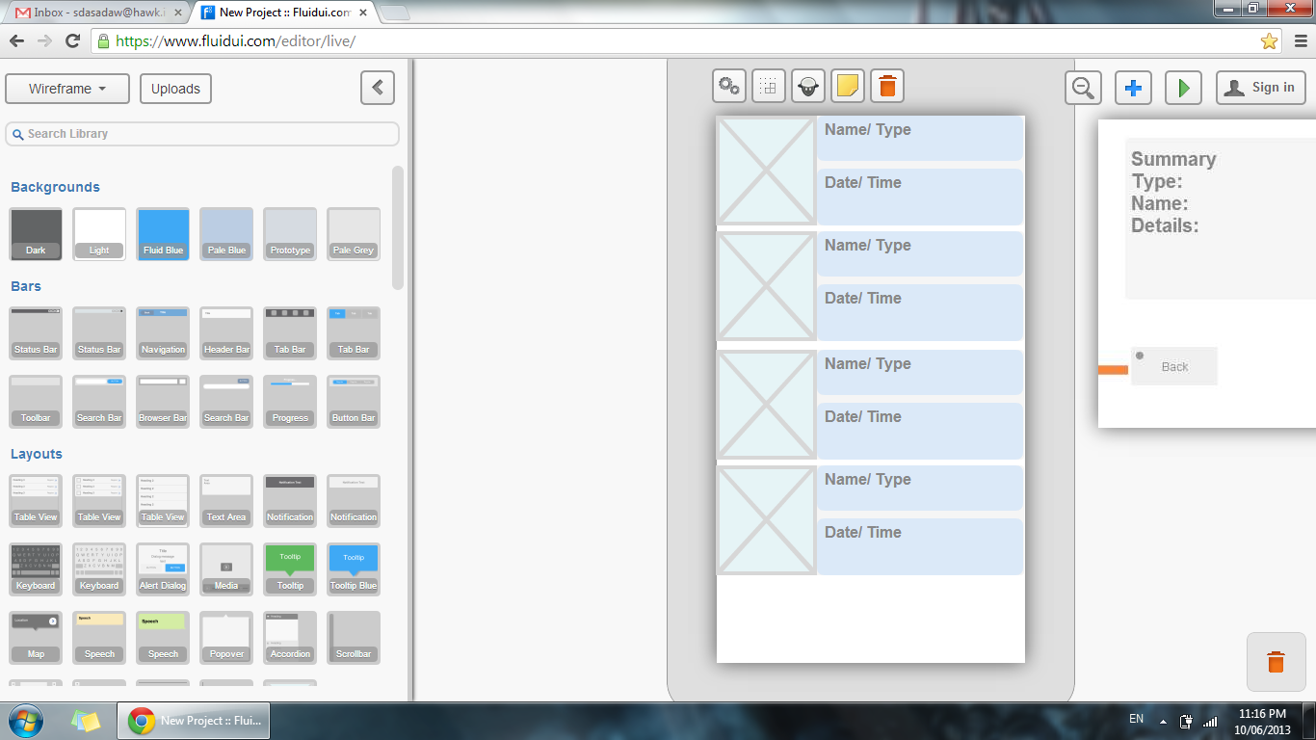

**Popup screen**

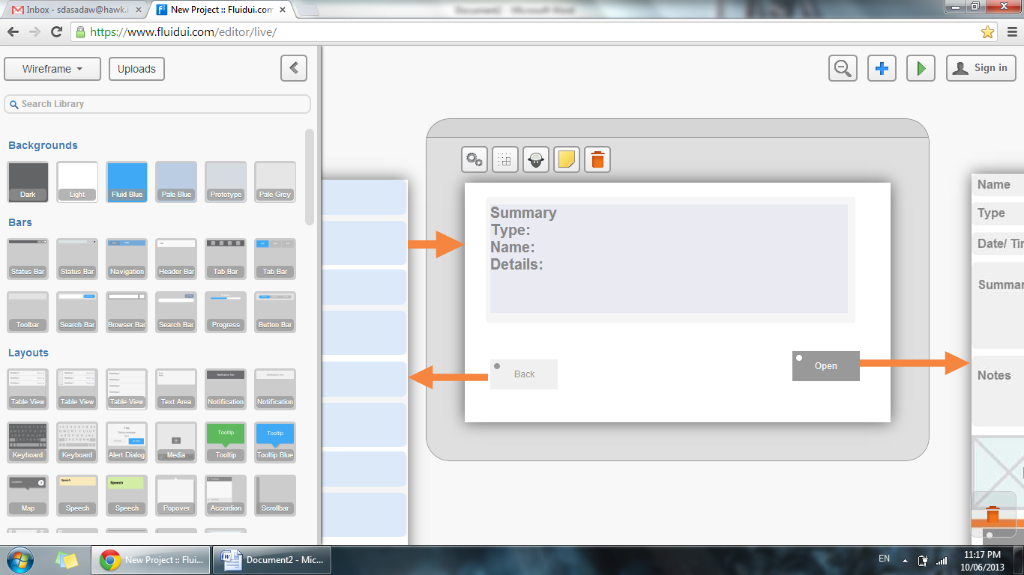

**Describing the reminder screen**

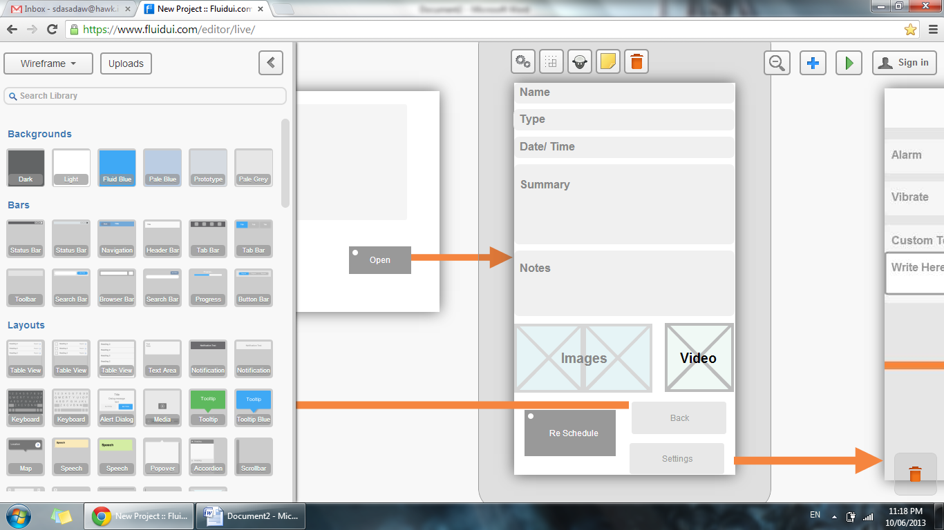

**III. Test Cases (Reminders):**

|  |  |  |  |
| --- | --- | --- | --- |
| TC_S5.001 | Verification of navigation from main screen to remainders screen | Click on remainders button in main screen | Remainders screen should be loaded with out any errors. |
| TC_S5.002 | List view of Remainders | View the lists in remainders page | When remainders screen is loaded User be able to see the list view of the Remainders |
| TC_S5.003 | Checking of the rows in remainders screen | View the pictures in each row of the remainders | When remainder screen is loaded user be able to view the picture if any taken that corresponding to the particular remainder |
| TC_S5.004 | List view of the remainders Check | View the sub rows in each row | When remainder screen is loaded user be able to view two sub rows in each row corresponding to the remainder |
| TC_S5.005 | Row check of each remainder | View the sub rows in each row | When remainder screen is loaded user be able to view two sub rows in each remainder and in first sub row there should be doctor/patient name/type of doctor/type of ailment, Second sub row should contain the date and time of the appointment of corresponding remainder correctly |
| TC_S5.006 | Remainder description check | Click on any remainder | When click on any remainder user be able to see a popup containing the summary of the appointment |
| TC_S5.007 | Popup check | Click on any remainder | When click on any remainder User be able to see two buttons in the popup they are: back and open |
| TC_S5.008 | Back button check | Click on back button in popup appeared when clicked on any remainder | When click on back button user be able to redirect to the remainders screen |
| TC_S5.009 | Open button check | Click on open button in popup appeared when clicked on any remainder | When click on open button user be able to view a screen describing the remainder |
| TC_S5.010 | Describing remainder screen check | Click on open button in popup appeared when clicked on any remainder | When click on open button user be able to view a screen describing the appointment details and any pictures/videos if taken in it with out any errors. |
| TC_S5.011 | Describing remainder screen default buttons check | Click on open button in popup appeared when clicked on any remainder | In describing remainder page user be able to view buttons reschedule, back, settings. |
| TC_S5.012 |  |  |  |

Medical Records (s6)

**Description:**

With the Medical Records feature we are going to provide to the doctor a platform where to look at his patients records.

The patients select the doctors that can view his record

Requirements:

S4.01 It MUST have a list of records displayed with the last date modified.

S4.01 It must permit to the doctor to see the record but not to delete it

S4.02 It would be good to allow the doctor to edit the record when it is displayed.

Screenshots:

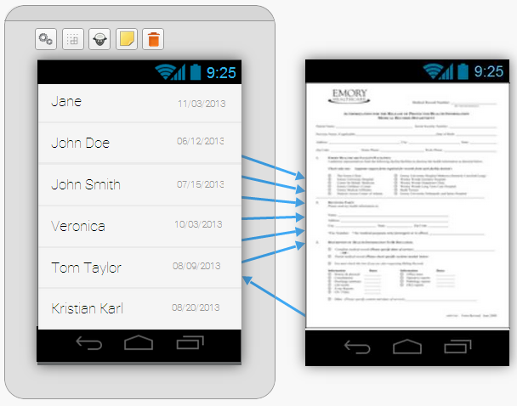

**Test cases:**

A doctor cannot see medical records without permission.

TCS6.01.1 A patient cannot see medical records of other people

TCS6.01. 2 If a Medical Record is deleted then it cannot be displayed.

TCS6.01.3 If a doctor edits a record then the other doctors see this document updated

Take Log Screen (S7)

**I. Description:**

Take log screen is used to take photos, videos, notes by patient and send them to doctor

**Requirements for Take Log Screen (S7)**

S7. 000

From the main menu if we click on Take log we will go to Take log screen.

S7.001

Take log screen must have 2 tabs.

S7. 003

1st tab must be “View logs” and second tab must be “Add logs”

S7. 004

By default control is in “view logs” page.“View logs” page will display all previously stored logs.

S7. 005

Clicking on one of these logs will take you to “Details” page.

S7. 006

Details page must display full description of a log along with video and photos if any.

S7. 007

Details page you must have Delete and send buttons. Delete is used to delete the log and Send is used for sending the log to a doctor/s of your choice.

S7. 008

Clicking on Send button will take you to “Select Doctor” page where you will have to select the doctors to whom you wish to send the log.

S7. 009

Selecting a doctor and clicking on send button will generate a popup screen with “Done” button. This is to indicate that the sending of log was successful.

S7. 010

Clicking on “Done” must take the control back to “view logs” page.

S7. 011

Clicking on “ADD Logs” must display Addlogs screen.

S7. 012

“Add logs” page must have a text field to take notes, “Capture Video” button to take video and “Capture Image” button to take photos

S7. 013

“Add logs” page must also have “Reset” and “Save” button.

S7. 014

Clicking on “Save” button must save the log and redirect to “view logs” screen with the new log displayed as one of the entry.

S7. 015

Reset button must reset all the field

**II. Screen Shots:**

1. “view logs”(S7.1)

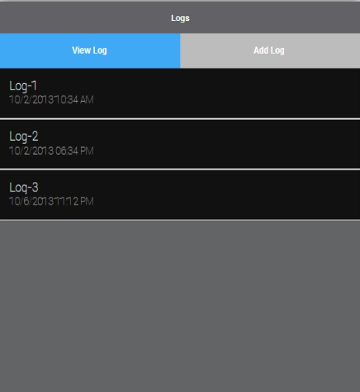

1. “Add logs”(S7.2)

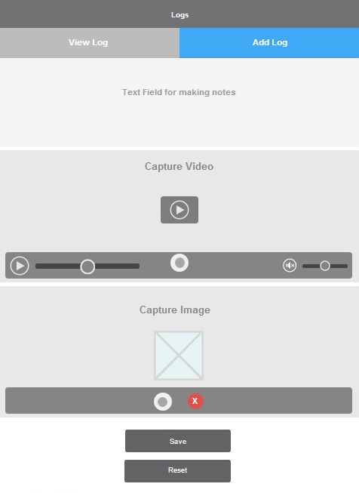

1. “Details”(S7.1.1)

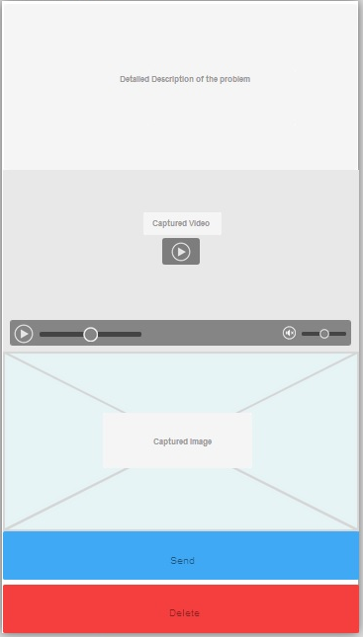

1. “Select Doctor”(S7.1.1.1)

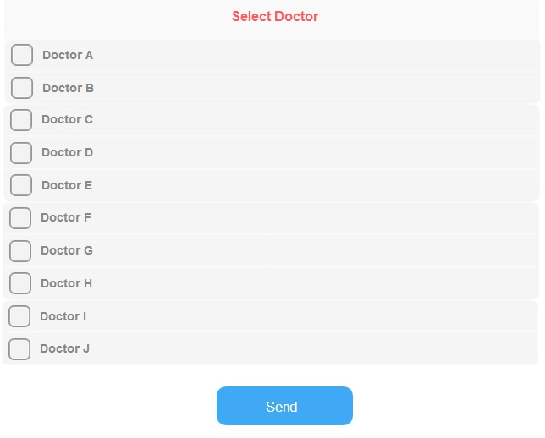

1. “Done” button(S7.1.1.1.1)

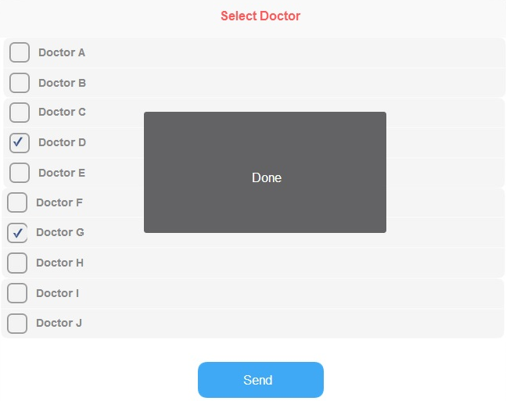

**III. Test Cases (Take Logs):**

|  |  |  |  |
| --- | --- | --- | --- |
| Test No | Test Condition | Test Case | Expected Result |
| TCS7.001.1 | Verification of the Access to the Takelogs screen | Click on the “TakeLogs” button on the Main Screen. | The TakeLogs screen should appear. |
| TCS7.001.2 | Verification of the Layout of Takelogs Screen | Check the layout of the manage main screen. | The layout should be similar to as described in Fig_1 of the Requirements. |
| TCS7.001.3 | Verification of the Layout of Takelogs Screen | Check if the layout is compatible with Portrait and Landscape layouts. | The layout should be displayed correctly in both orientations. |
| TCS7.002.1 | Verification of tabs on Takelogs Screen | Check if layout screen has two tabs | The screen must have two tabs |
| TCS7.003.1 | Verification of tabs names on Takelogs Screen | Check if layout screen has two tabs named “View logs” and “Add logs” | Two tabs must be named as “View Logs” and “Add logs” |
| TCS7.004.1 | Verification of control on View logs screen | Check if control is in View logs screen | Control must be in View logs screen |
| TCS7.004.2 | Verification of View logs screen content | Check if View logs screen is displaying previously stored logs | View logs screen must be showing previously stored logs |
| TCS7.005.1 | Verification of navigation from view logs screen to details screen | Check if a log is clicked it is navigated to Details screen | Details screen must be opened |
| TCS7.006.1 | Verification of Details screen content | Check if Content of details screen is related to appropriate log | Details screen must display full description of a log along with video and photos if any |
| TCS7.007.1 | Verification of buttons in Details screen | Check if Details screen has Delete and Send buttons | Details screen you must have Delete and send buttons |
| TCS7.007.2 | Verification of delete button function in Details screen | Check if delete button is deleting the current log | Current log must be deleted |
| TCS7.007.3 | Verification of send button function in Details screen | Check if send button is navigating to Select Doctor Screen | Select Doctor screen must be opened. |
| TCS7.008.1 | Verification of “Select Doctor” Screen | Check if “Select Doctor” Screen is displaying Doctors list | Doctors list must be displayed |
| TCS7.009.1 | Verification of Doctor selection in “Select Doctor” Screen | Check if doctors can be selected in “Select Doctor” Screen | User must be able to select doctors |
| TCS7.009.2 | Verification of popup generation on clicking send button | Check if popup is generated on clicking send button | Popup must be generated on clicking send button |
| TCS7.009.3 | Verification of popup | Check if popup has Done button | Generated popup must contain Done button |
| TCS7.010.1 | Verification of navigation from popup to view logs screen | Check if clicking on done button is navigating to view logs screen | Clicking on done button must navigate to view logs screen |
| TCS7.011.1 | Verification of ADD Logs tab opening | Check if clicking on ADD Logs tab opens ADD Logs screen | Ckicking on ADD tab must open Add Logs screen |
| TCS7.012.1 | Verification of ADD Logs content | Check if ADD Logs screen has notes textfield and “Capture Video” button and “Capture Image” button | ADD Logs screen must contain “notes” textfield and “Capture Video” button and “Capture Image” button |
| TCS7.012.2 | Verification of Notes textfeild in ADD Logs screen | Check if Notes textfeild is accepting text | Notes textfeild must accept text from user |
| TCS7.012.3 | Verification of “Capture Image” button in ADD Logs screen | Check if “Capture Image” button is accepting pictures | “Capture Image” button must open appropriate app for capture photos |
| TCS7.012.4 | Verification of “Capture Video” button in ADD Logs screen | Check if “Capture Video” button is accepting videos | “Capture Video” button must open appropriate app for capture videos |
| TCS7.013.1 | Verification of Reset and save buttons in “Add logs” screen | Check if “Add logs” screen has Reset and save buttons | “Add logs” screen must contain Reset and save buttons |
| TCS7.014.1 | Verification of functionality of Save button | Check if save button is saving the current log and redirecting to view logs screen with a new log updated | “Save” button must save the log and redirect to “view logs” screen with the new log displayed as one of the entry |
| TCS7.015.1 | Verification of functionality of reset button | Check if reset button is resetting all the contents fields in add logs screen | Reset button must reset the entire fields on add logs screen |