Selected Project Proposals
Two shortlisted options for team discussion. Each proposal covers problem, users, flow, architecture, data, evaluation, risks and semester split. Diagrams are abstract and bound to change.

Proposal A. App Terms and Privacy Checker under DPDP Act 2023

Problem
Citizens accept app Terms and Privacy Policies without knowing what data is collected, for what purpose, how long it is kept, who it is shared with, and how to opt out or seek redressal. Policies are long, versioned poorly and written in legal English.
The product takes a policy URL or PDF and returns a short practice table plus gap flags mapped to DPDP Act 2023 principles, with quotes and follow up questions for the company. It reports missing disclosures. It never declares legal breach.

Users and goals
- Primary user: citizen choosing or reviewing an app.
- Goal: faster comprehension plus evidence for each flag.
- Non goal for Semester 1: judging Terms of service beyond privacy, or cross app ranking.

User flow
- Paste URL or upload PDF, system detects version and date.
- Section aware parse keeps headings such as collection, purpose, retention and sharing.
- Practice table appears with per row quotes.
- Gap flags appear with DPDP reason and source link.
- User copies questions to ask the company.

Architecture
- Ingest: URL fetch plus PDF parse, heading aware chunking, version and date store.
- Policy classifier: multi label tags for collection, purpose, retention, sharing, minors and redressal. Start zero shot, later fine tune a long context encoder.
- Grounding index: separate RAG over DPDP Act 2023 plus MeitY FAQs, hybrid search plus reranker.
- Reasoner: links each flag to Act quotes, keeps quote spans.
- Summariser: constrained summary, no new facts, quote first then simplify.

How components interact
Ingest feeds both the classifier and the quote store. The classifier proposes practice tags. The grounding index supplies Act evidence. The reasoner joins tag plus evidence into a flag only when both agree. The UI shows table, flags and sources together.

Architecture diagram
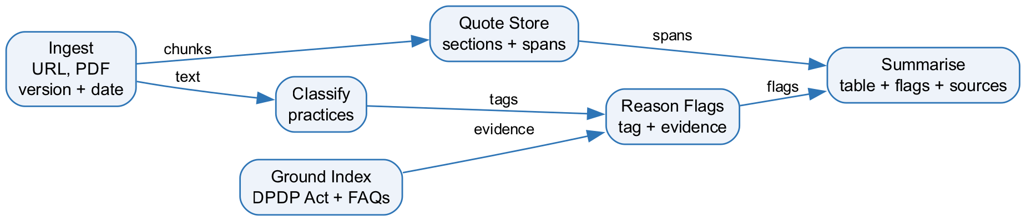
Figure A. Abstract flow. Ingest splits to quotes and tags, evidence joins at flags, UI shows table plus sources.

Data plan
- DPDP Act 2023 from India Code plus MeitY drafts and FAQs.
- Sample of popular Indian app policies scraped for research use, with date cached.
- Own labels for 50 to 100 policies across six to eight practice tags.

Evaluation
- Label F1 per practice tag.
- Quote grounding rate: share of flags with valid spans.
- Comprehension lift: can users answer what is collected and how to opt out.

Risks
- Policies change often, so stale cache misleads. Mitigation is version stamp plus refresh prompt.
- Wording must stay at missing disclosure, not breach verdict.

Semester split
- Semester 1: privacy policy only, single language, core eval.
- Semester 2: Terms coverage, cross app comparison, better Hindi.

Proposal B. Board and ROC Paperwork Assembler plus Calendar

Problem
Early private limited startups struggle with Companies Act paperwork. A director change, share allotment or AGM needs the right board resolution, register updates and MCA filing checklist with due dates. Founders rely on scattered samples and miss steps.
The product maps an event to documents. The user answers slots once and receives a resolution draft, a register update list, a filing checklist and calendar entries, then tracks status to filed. It assists preparation. It does not replace professional sign off.

Users and goals
- Primary users: founder plus accountant, with a reviewer path for a professional.
- Goal: correct pack plus no missed date for covered events.
- Non goal for Semester 1: full company secretarial automation or direct MCA filing.

User flow
- Pick event: director change, share allotment or AGM.
- Answer slots: names, DIN, dates, share counts.
- Preview resolution plus registers plus checklist plus dates.
- Export pack and add reminders.
- Mark steps filed and store references.

Architecture
- Event map: event to required documents, registers and filings.
- Template engine: versioned board resolutions with slot validation.
- Checklist engine: per event steps with MCA reference links.
- Procedure RAG: small index over Companies Act extracts plus MCA help pages for how to file notes.
- Calendar store: due dates, reminders and status tracking.

How components interact
The event choice selects templates and checklist rules. Slots fill the resolution. The procedure index supplies filing notes. The calendar derives dates from event date plus statutory limits. Status updates flow back to the same case file.

Architecture diagram
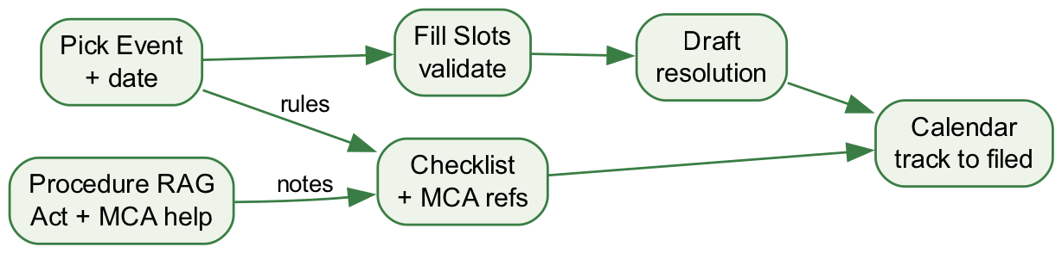
Figure B. Abstract flow. Event drives slots and checklist, procedure notes join checklist, calendar tracks to filed.

Data plan
- Companies Act 2013 sections plus MCA help pages for covered events.
- Own curated checklists per event, versioned and dated.
- Sample slots for two events to drive tests.

Evaluation
- Checklist accuracy against current MCA guidance.
- Template correctness by spot check.
- Date correctness for statutory limits.
- Task completion: can a new user reach a filed ready pack.

Risks
- Forms, fees and limits change. Mitigation is dated checklists plus clear review flag.
- Scope creep across events. Mitigation is freezing to two events in Semester 1.

Semester split
- Semester 1: director change plus AGM only, tracker minimal.
- Semester 2: share allotment, vault, more events, reviewer role.

