DEENBANDHU CHHOTU RAM UNIVERSITY OF SCIENCE AND TECHNOLOGY
REGISTRATION & EXAMINATION FROM FOR SEMESTER 8TH ACADEMIC YEAR 2025-2026
B.TECH-COMPUTER SCIENCE AND ENGINEERING

STUDENT DETAILS

NAME OF STUDENT: Kaushal ROLL NO.: 22001001054
SECTION: A CATEGORY: General
GENDER: Male ADMISSION TYPE: HOGC
STUDENT MOBILE NO.: 8950597954 STUDENT EMAIL: kaushal1308sindhu@gmail.com
FATHER NAME: Dheeraj MOTHER NAME: Mukesh Devi
FATHER MOBILE NUMBER: 9253187539 FATHER EMAIL: dheerajsingh3537@gmail.com
COMMUNICATION ADDRESS: Gali no.7, Shiv Colony, Sonipat, Haryana, 131001
STUDENT BANK ACC.NO.: 1457000101132032 IFSC code: PUNB0145700

I wish to register for the following subjects in the Scheme of Learning of B.TECH COMPUTER SCIENCE AND ENGINEERING during the Semester 8th of Academic Year2025-26
List of core Courses
Sl.No. | Semester | Course Code | Course Name | Slot
1. | 8th | CSE484C | Professional Training
2. | 8th | GPCSE | General Fitness for the Profession
List of ED Course
Preferences | Semester | Course Code | Course Name | Slot
List of Choices for OPEN ELECTIVE Course
Preferences | Semester | Course Code | Course Name | Slot
- I am aware that I will alide by the decision of the DCRUST authorities with respect to the elective course that will be allotted to me.
- I hereby undertake that I am aware of the attendance rules of DCRUST for B.Tech. Courses and will follow them diligently.
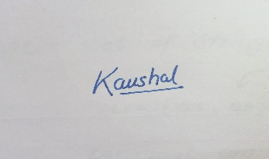
Signature of Student

Registered in B. TECH- COMPUTER SCIENCE AND ENGINEERING during the 8th Semester of Academic Year2025-2026.

Signature of Registration Officer Date of Registration

